Supplementary Material: Calibration Analysis of Machine Learning Models for Predicting Restoration Failures

Metrics Used
Metric | Description | Ideal Value
Calibration Slope | The slope of a logistic regression model fit on the predicted probabilities. A slope < 1 suggests overfitting (predictions are too extreme), while a slope > 1 suggests underfitting. | 1.0
CITL (Calibration-in-the-Large) | The intercept of the same logistic regression model. It measures the average difference between predicted probabilities and the overall outcome incidence. A value < 0 indicates overestimation. | 0.0
O/E Ratio (Observed/Expected) | The ratio of the number of observed events to the number of expected events (the sum of predicted probabilities). | 1.0
Brier Score | The mean squared error between the predicted probabilities and the actual outcomes. It measures both calibration and discrimination. | Lower is better

CaCIA Trial (Permanent Teeth)
The table below summarizes the calibration performance for the models predicting restoration failure in permanent teeth. The Neural Network model demonstrated the best calibration, evidenced by the lowest Brier score (0.1350) and a calibration slope (0.707) closest to the ideal value of 1.0. However, all models tended to overestimate the risk of failure, as indicated by calibration slopes below 1 and negative CITL values.

Table 1: Calibration Metrics for the CaCIA Trial Dataset

Model | Calibration Slope | CITL | O/E Ratio | Brier Score | Observed Events | Expected Events
Decision Tree | 0.230 | -1.938 | 0.326 | 0.1891 | 16 | 49.1
Random Forest | 0.539 | -1.814 | 0.301 | 0.1654 | 16 | 53.2
XGBoost | 0.406 | -2.051 | 0.259 | 0.2253 | 16 | 61.8
CatBoost | 0.309 | -1.784 | 0.397 | 0.1555 | 16 | 40.3
Neural Network | 0.707 | -1.546 | 0.360 | 0.1350 | 16 | 44.5

Figure 1: Calibration Plots for the CaCIA Trial Dataset
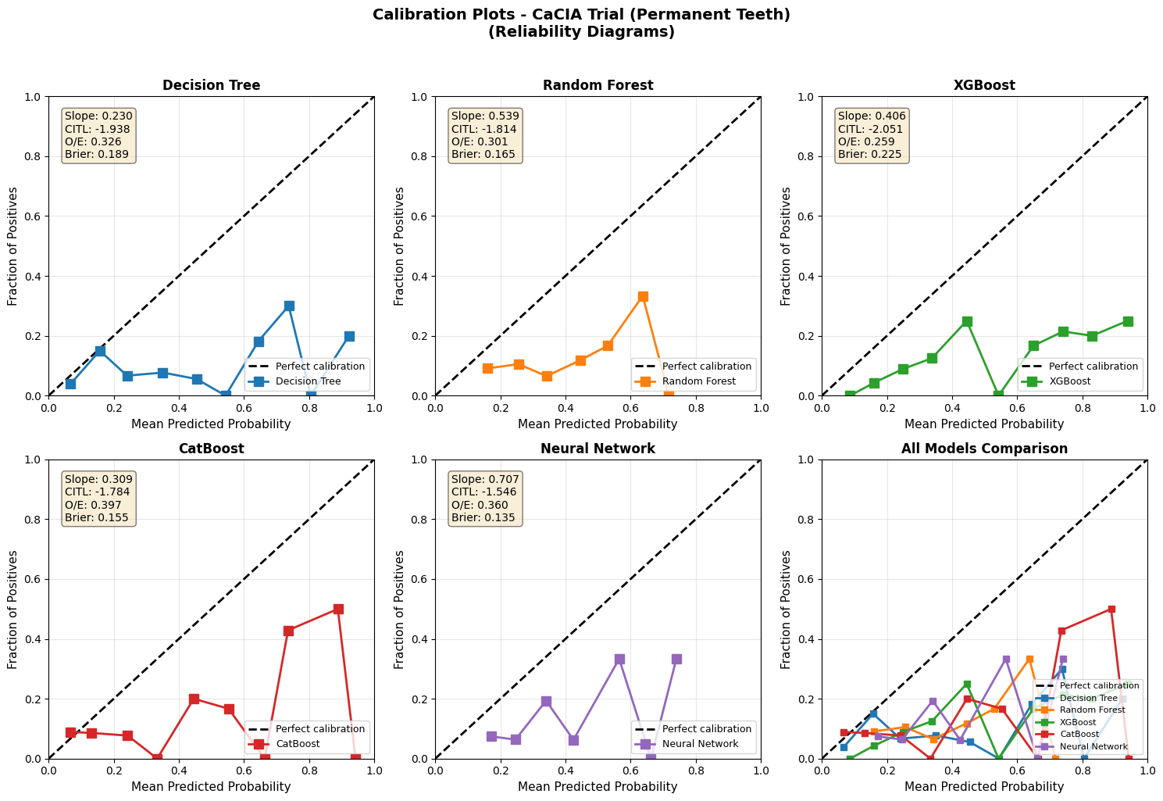
Reliability diagrams for the five models. The dashed line represents perfect calibration. Points below the line indicate over-prediction, while points above indicate under-prediction.

CARDEC Trial - Any Failure (Primary Teeth)
For the dataset predicting any type of failure in primary teeth, the Neural Network and CatBoost models showed the best calibration performance with the lowest Brier scores (0.2030 and 0.2046, respectively). The Random Forest, XGBoost, and CatBoost models exhibited slopes greater than 1, suggesting their probability estimates were too moderate (underfitting). In contrast, the Neural Network had a slope closer to 1 (0.835), indicating better calibration.

Table 2: Calibration Metrics for the CARDEC Trial (Any Failure) Dataset

Model | Calibration Slope | CITL | O/E Ratio | Brier Score | Observed Events | Expected Events
Decision Tree | 0.745 | -0.350 | 0.846 | 0.2259 | 60 | 71.0
Random Forest | 1.715 | -0.331 | 0.890 | 0.2109 | 60 | 67.4
XGBoost | 2.028 | -0.400 | 0.880 | 0.2196 | 60 | 68.2
CatBoost | 1.630 | -0.321 | 0.893 | 0.2046 | 60 | 67.2
Neural Network | 0.835 | -0.189 | 0.924 | 0.2030 | 60 | 65.0

Figure 2: Calibration Plots for the CARDEC Trial (Any Failure) Dataset
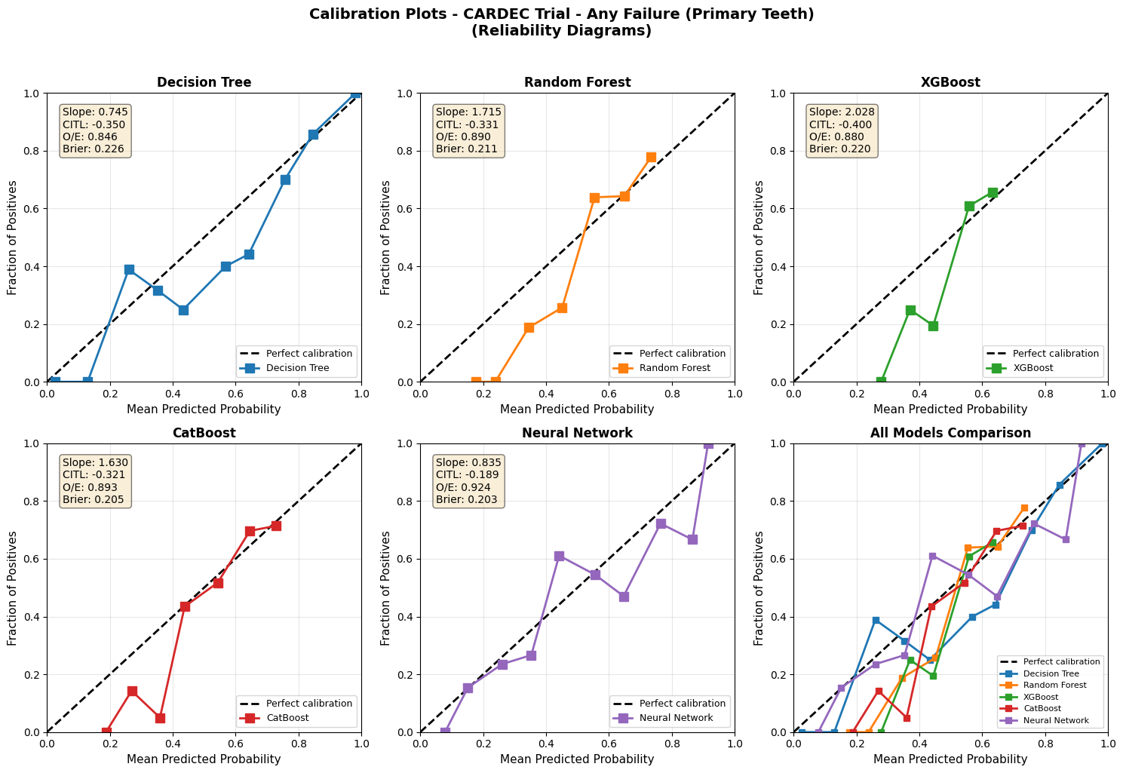

CARDEC Trial - Replacement (Primary Teeth)
In the analysis for predicting only replacement failures, the Random Forest model showed the best calibration, with a calibration slope of 0.954 and an O/E ratio of 1.053, both very close to the ideal value of 1.0. This is also reflected in its low Brier score (0.1987). The other models, particularly Decision Tree, showed poor calibration for this outcome.

Table 3: Calibration Metrics for the CARDEC Trial (Replacement) Dataset

Model | Calibration Slope | CITL | O/E Ratio | Brier Score | Observed Events | Expected Events
Decision Tree | 0.017 | -0.695 | 0.857 | 0.3127 | 62 | 72.3
Random Forest | 0.954 | 0.052 | 1.053 | 0.1987 | 62 | 58.9
XGBoost | 0.328 | -0.328 | 1.138 | 0.2335 | 62 | 54.5
CatBoost | 0.396 | -0.206 | 1.217 | 0.2257 | 62 | 50.9
Neural Network | 0.744 | 0.193 | 1.337 | 0.2067 | 62 | 46.4

Figure 3: Calibration Plots for the CARDEC Trial (Replacement) Dataset
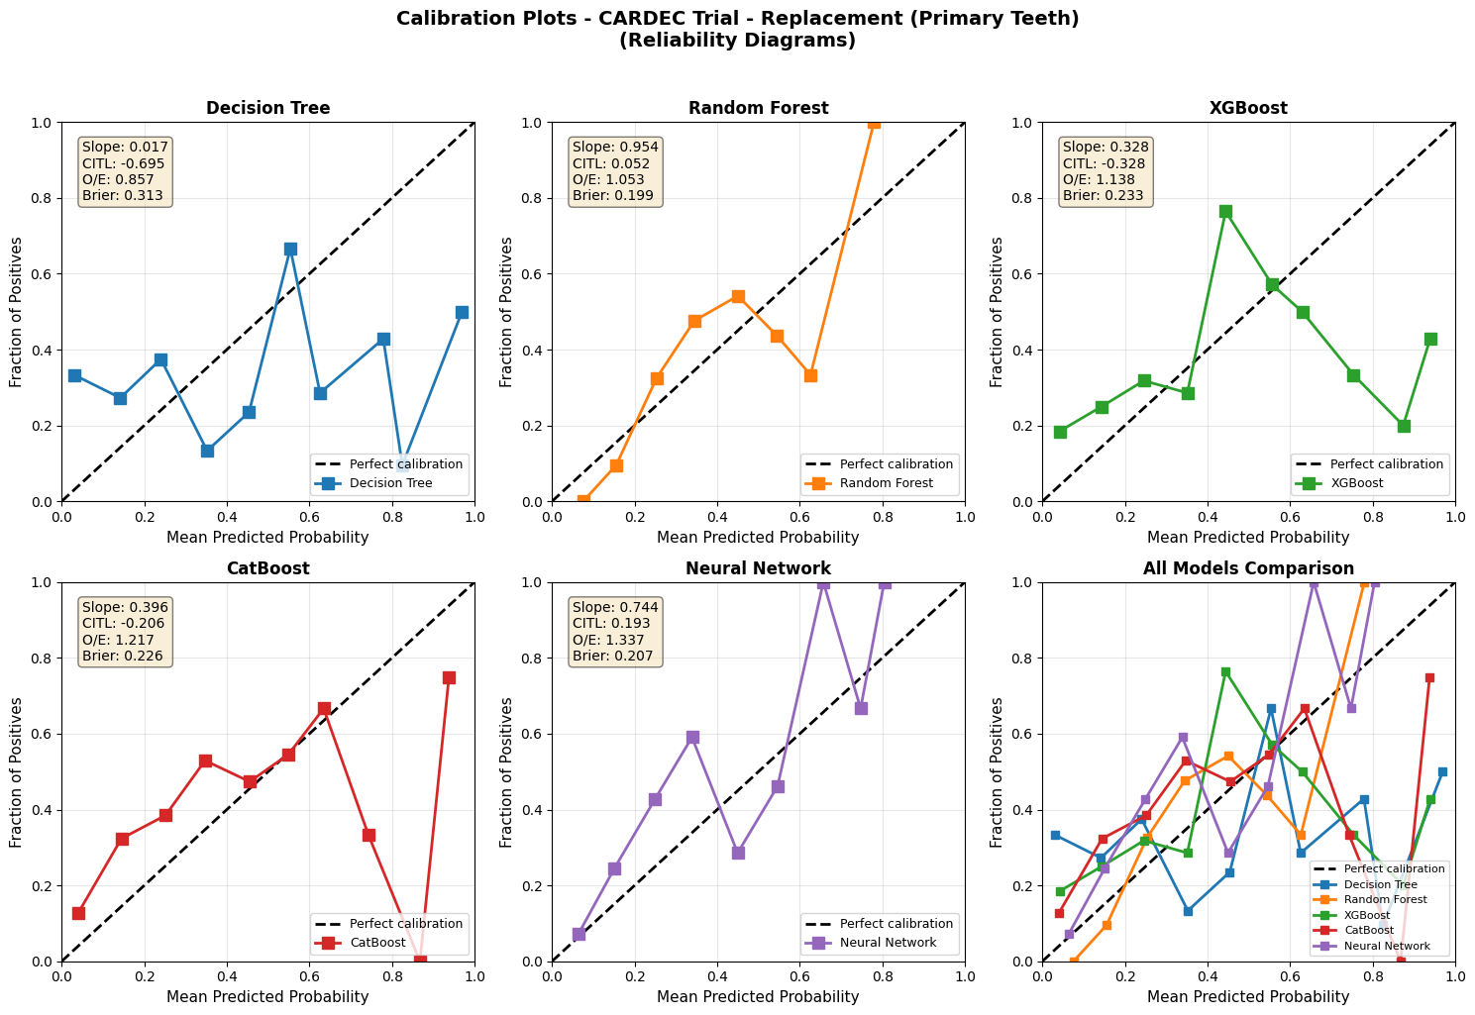

References
[1] Collins, G. S., Reitsma, J. B., Altman, D. G., & Moons, K. G. (2015). The TRIPOD Statement: A Guideline for Reporting Clinical Prediction Models. Annals of Internal Medicine, 162(1), 55-63.

