**WRITING TASK**

Writing task 1

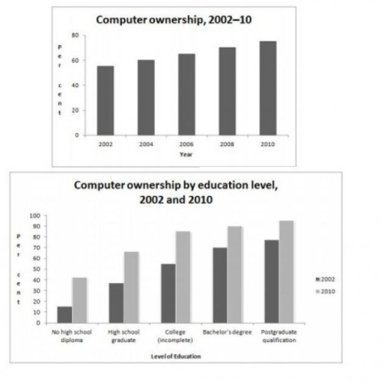

The graphs above give information about computer ownership as a percentage of the population between 2002 and 2010, and by level of education for the years 2002 and 2010.

Summarize the information by selecting and reporting the main features and make comparisons where relevant. Write at least 150 words.

Writing 1

The two bar charts provide information about the per cent of the population who had computers between 2002 and 2010 and the per cent of the population by education level who owned a computer in 2002 and 2010.

Overall, the rate of computer ownership of the population increased gradually throughout the period and it increased on all education levels. At the end of the period most of postgraduate people owned a computer, while at the beginning of the period it was just a few people, who did not have a high school diploma, had one.

The computer ownership rate of the population was about 60% in 2002. Then, the rate had a slightly increase hitting above 60% in 2004. From 2004 to 2008, the same rate rose approximately 10%. Finally in 2010 the rate was about 75%.

We can see how more educational qualified the people are, the computer ownership rate increases, and it increased on all education levels by 2002 to 2010. In 2002 the computer ownership rate of people who did not have a high school diploma was about 15%, in comparison to 2010 when the rate of people who did not have a high school diploma jumped to above 40%, that is, an increment of 25%. Most people who went to college had a computer in 2002, this same rate jumped to above 80% in 2010. Almost 80% of postgraduate people owned a computer had a computer in 2002, this rate hit about 90% in 2010, the highest rate by 2002 to 2010.

Writing task 2

**A person’s worth nowadays seems to be judged according to social status and material possessions. Old-fashioned values, such as honour, kindness and trust, no longer seem import**

**To what extent do you agree or disagree with this opinion? Give reasons for your answer and include any relevant example from your own knowledge or experience. Write at least 250 words.**

Being judged according to social status and material possessions is not a nowadays thought, but, certainly, in modern times the old-fashioned values, such as honor, kindness and trust seem not been so important. This essay will discuss how judging person’s worth was intensified by social media and how old-fashioned values seem no longer important.

As we learn on school, humanity was always divided by social status and this is very clear on monarchies eras. Even nowadays is clear the social class separation on urban centers, where it is not difficult to find discrimination against poor people. Honor, kindness and trust are values that humans still care of to build relationships, from friendship to marriage. But evidently, these values were overlapped by the social status and material possessions by the time the social medias have come.

With social medias, as Instagram or Facebook, people keep abreast of what other people are doing, so it creates a “competition” to see who has a coolest life and that includes sharing pictures or videos of their goods or where they were. In addition, this type of competition was enhanced by brands which pay these people, who are known as digital influencers, to show its products casing a battle for who is the one that capture more attention of the public.

So, with the help of social medias algorithms, people with high social status or expensive possessions gain spotlight showing off things, not moral or kindness weakening the old-fashioned values which are the foundation for the healthy human relationships.