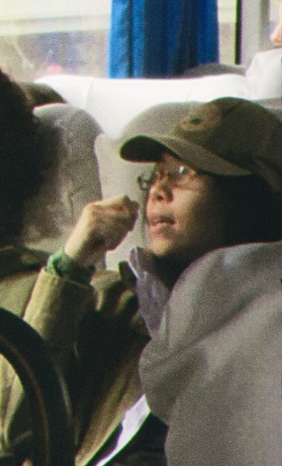
Vitória Teresa

Biology BSc
Junior researcher | Public health, environmental
governance & data analysis

Profile
Biology undergraduate at the Federal University of Santa Catarina
(UFSC) and junior researcher investigating Brazil's cultivated-meat
regulatory scene. I combine public-health research, regulatory
analysis, data work, and student-led collaboration. I am especially
interested in how evidence, institutions, environmental governance,
and rights shape decisions about emerging technologies and public risks.

Experience & leadership

Junior researcher
Brazil cultivated-meat regulatory scene

Data analysis assistant intern
Descarbonize - analysis, research support, and data communication in a Brazilian-European startup

Member, Innovation & Technology Board
AltProtein Project, UFSC - research and outreach connected to GFI Brasil

Student representative
UFSC Biological Sciences Course Board

Education & selected learning
2026 - now

2026 - now

2026 - now

2026 - now

BSc in Biological Sciences - Federal University of Santa Catarina (UFSC) 2026 - now
AI Risk Fundamentals - Lens Academy | 25 hours, online + synchronous 2026
International Climate Policy and Advocacy Course (ICPAC) - Care About Climate 2026
Public Health Surveys - University of Sao Paulo (USP) | 20 hours 2026

Relevant interests
- Environmental law, rights, and accountable governance of public risks
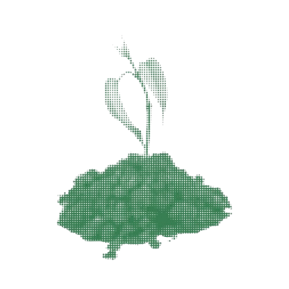
- Chemicals, waste, pollution, and the relationship between regulation and
public health
- Latin American scientific, intellectual, and philosophical traditions
- Effective altruism frameworks and responsible, evidence-based AI use

Skills & languages
Research: literature and policy review, regulatory mapping, public-health
questions, scientific communication
Data: Python, R, Pandas, geospatial and visualization workflows
Languages: Portuguese (native), English (fluent), French (beginner)


vv.ss.teresa@gmail.com | vitoriaconrado.github.io

