|  |  |  |  |
| --- | --- | --- | --- |
| **Table S1. Significant TWAS genes for major depressive disorder.** | | | |
| **Tissue name** | **Total number** | **Number of significant genes** | **Percentage of the significant genes** |
| Skin_Sun_Exposed_Lower_leg | 1778 | 96 | 5.40% |
| Brain_Cerebellar_Hemisphere | 1366 | 73 | 5.34% |
| Skin_Not_Sun_Exposed_Suprapubic | 1728 | 91 | 5.27% |
| Heart_Left_Ventricle | 1453 | 76 | 5.23% |
| Whole_Blood | 1493 | 78 | 5.22% |
| Brain_Cerebellum | 1442 | 75 | 5.20% |
| Pituitary | 1461 | 76 | 5.20% |
| Brain_Nucleus_accumbens_basal_ganglia | 1361 | 70 | 5.14% |
| Brain_Putamen_basal_ganglia | 1279 | 65 | 5.08% |
| Heart_Atrial_Appendage | 1538 | 78 | 5.07% |
| Spleen | 1437 | 72 | 5.01% |
| Brain_Caudate_basal_ganglia | 1320 | 66 | 5.00% |
| Small_Intestine_Terminal_Ileum | 1357 | 67 | 4.94% |
| Thyroid | 1787 | 88 | 4.92% |
| Brain_Hypothalamus | 1229 | 60 | 4.88% |
| Prostate | 1377 | 67 | 4.87% |
| Adipose_Subcutaneous | 1649 | 80 | 4.85% |
| Brain_Spinal_cord_cervical | 1134 | 55 | 4.85% |
| Brain_Cortex | 1455 | 70 | 4.81% |
| Artery_Aorta | 1606 | 77 | 4.79% |
| Nerve_Tibial | 1823 | 87 | 4.77% |
| Adrenal_Gland | 1365 | 65 | 4.76% |
| Liver | 1283 | 61 | 4.75% |
| Muscle_Skeletal | 1599 | 76 | 4.75% |
| Artery_Tibial | 1738 | 82 | 4.72% |
| Colon_Sigmoid | 1527 | 72 | 4.72% |
| Testis | 1822 | 85 | 4.67% |
| Brain_Substantia_nigra | 1100 | 51 | 4.64% |
| Colon_Transverse | 1551 | 72 | 4.64% |
| Ovary | 1338 | 62 | 4.63% |
| Brain_Anterior_cingulate_cortex | 1267 | 58 | 4.58% |
| Kidney_Cortex | 918 | 42 | 4.58% |
| Lung | 1725 | 79 | 4.58% |
| Esophagus_Mucosa | 1679 | 76 | 4.53% |
| Esophagus_Muscularis | 1698 | 77 | 4.53% |
| Brain_Amygdala | 1114 | 50 | 4.49% |
| Pancreas | 1434 | 64 | 4.46% |
| Artery_Coronary | 1327 | 58 | 4.37% |
| Brain_Frontal_Cortex | 1352 | 59 | 4.36% |
| Cells_Cultured_fibroblasts | 1689 | 72 | 4.26% |
| Stomach | 1410 | 59 | 4.18% |
| Adipose_Visceral_Omentum | 1605 | 67 | 4.17% |
| Esophagus_Gastroesophageal_Junction | 1542 | 64 | 4.15% |
| Vagina | 1162 | 48 | 4.13% |
| Minor_Salivary_Gland | 1213 | 50 | 4.12% |
| Cells_EBV_transformed_lymphocytes | 1178 | 48 | 4.07% |
| Brain_Hippocampus | 1246 | 50 | 4.01% |
| Breast_Mammary_Tissue | 1581 | 61 | 3.86% |
| Uterus | 1191 | 46 | 3.86% |

Note: TWAS: Transcriptome-Wide Association Studies.

**Table S2. LPA fit indices for a one-class, two-class, three-class, and four-class solution for the cumulative lifetime stress dimensions.**

|  |  |  |  |  |
| --- | --- | --- | --- | --- |
| **Number of profiles** | **1** | **2** | **3** | **4** |
| AIC | 76096 | 72998 | 71970 | 71441 |
| BIC | 76236 | 73212 | 72260 | 71805 |
| ssaBIC | 76147 | 73076 | 72075 | 71805 |
| Entropy | — | 0.95 | 0.96 | 0.82 |
| Log-likelihood | — | -36456 | -35927 | -35647 |
| Difference in log-likelihood | — | ≤0.01 | ≤0.01 | ≤0.01 |

Note: AIC, Akaike’s information criteria; BIC, Bayesian information criteria; LPA: latent profile analysis; ssaBIC, the sample size adjusted Bayesian information criteria.

**Table S3. LPA fit indices for a one-class, two-class, three-class, and four-class solution for the deprivation dimensions.**

|  |  |  |  |  |
| --- | --- | --- | --- | --- |
| **Number of profiles** | **1** | **2** | **3** | **4** |
| AIC | 15153 | 14299 | 14166 | 13908 |
| BIC | 15183 | 14349 | 14236 | 13997 |
| ssaBIC | 15164 | 14318 | 13940 | 13940 |
| Entropy | — | 0.93 | 0.94 | 0.73 |
| Log-likelihood | — | -7139 | -7069 | -6936 |
| Difference in log-likelihood | — | ≤0.01 | ≤0.01 | ≤0.01 |

Note: AIC, Akaike’s information criteria; BIC, Bayesian information criteria; LPA: latent profile analysis; ssaBIC, the sample size adjusted Bayesian information criteria.

**Table S4. LPA fit indices for a one-class, two-class, three-class, and four-class solution for the threat dimensions.**

|  |  |  |  |  |
| --- | --- | --- | --- | --- |
| **Number of profiles** | **1** | **2** | **3** | **4** |
| AIC | 16908 | 15621 | 15210 | 15059 |
| BIC | 16938 | 15671 | 15280 | 15149 |
| ssaBIC | 16919 | 15639 | 15235 | 15235 |
| Entropy | — | 0.97 | 0.92 | 0.90 |
| Log-likelihood | — | -7800 | -7591 | -7511 |
| Difference in log-likelihood | — | ≤0.01 | ≤0.01 | ≤0.01 |

Note: AIC, Akaike’s information criteria; BIC, Bayesian information criteria; LPA: latent profile analysis; ssaBIC, the sample size adjusted Bayesian information criteria.

|  |  |  |  |  |  |  |  |  |
| --- | --- | --- | --- | --- | --- | --- | --- | --- |
| **Table S5. Significant genes, threat and their interaction terms for major depressive disorder in different tissues.** | | | | | | | | |
| **Tissue name** | **Total number** | **Significant a** | **Significant a and c** | **Significant a and b** | **Significant b and c** | **Significant c only** | **Significant a, b and c** |
| Adipose_Subcutaneous | 1649 | 10(0.61%) | 3(0.18%) | 57(3.46%) | 32(1.94%) | 14(0.85%) | 5(0.30%) |
| Adipose_Visceral_Omentum | 1605 | 12(0.75%) | 3(0.19%) | 58(3.61%) | 34(2.12%) | 21(1.31%) | 2(0.12%) |
| Adrenal_Gland | 1365 | 14(1.03%) | 2(0.15%) | 43(3.15%) | 25(1.83%) | 17(1.25%) | 7(0.51%) |
| Artery_Aorta | 1606 | 13(0.81%) | 3(0.19%) | 55(3.42%) | 25(1.56%) | 8(0.50%) | 4(0.25%) |
| Artery_Coronary | 1327 | 2(0.15%) | 4(0.30%) | 51(3.84%) | 24(1.81%) | 12(0.90%) | 3(0.23%) |
| Artery_Tibial | 1738 | 11(0.63%) | 6(0.35%) | 59(3.39%) | 17(0.98%) | 16(0.92%) | 7(0.40%) |
| Brain_Amygdala | 1114 | 7(0.63%) | 6(0.54%) | 39(3.5%) | 23(2.06%) | 10(0.90%) | 2(0.18%) |
| Brain_Anterior_cingulate_cortex | 1267 | 9(0.71%) | 3(0.24%) | 40(3.16%) | 22(1.74%) | 15(1.18%) | 4(0.32%) |
| Brain_Caudate_basal_ganglia | 1320 | 11(0.83%) | 3(0.23%) | 53(4.02%) | 20(1.52%) | 16(1.21%) | 7(0.53%) |
| Brain_Cerebellar_Hemisphere | 1366 | 10(0.73%) | 2(0.15%) | 51(3.73%) | 24(1.76%) | 16(1.17%) | 4(0.29%) |
| Brain_Cerebellum | 1442 | 10(0.69%) | 5(0.35%) | 56(3.88%) | 29(2.01%) | 26(1.80%) | 7(0.49%) |
| Brain_Cortex | 1455 | 14(0.96%) | 4(0.27%) | 57(3.92%) | 27(1.86%) | 12(0.82%) | 5(0.34%) |
| Brain_Frontal_Cortex | 1352 | 16(1.18%) | 3(0.22%) | 43(3.18%) | 27(2.00%) | 12(0.89%) | 4(0.30%) |
| Brain_Hippocampus | 1246 | 8(0.64%) | 3(0.24%) | 43(3.45%) | 30(2.41%) | 12(0.96%) | 3(0.24%) |
| Brain_Hypothalamus | 1229 | 9(0.73%) | 3(0.24%) | 46(3.74%) | 27(2.20%) | 9(0.73%) | 3(0.24%) |
| Brain_Nucleus_accumbens_basal_ganglia | 1361 | 10(0.73%) | 6(0.44%) | 56(4.11%) | 26(1.91%) | 15(1.10%) | 3(0.22%) |
| Brain_Putamen_basal_ganglia | 1279 | 7(0.55%) | 1(0.08%) | 47(3.67%) | 24(1.88%) | 14(1.09%) | 5(0.39%) |
| Brain_Spinal_cord_cervical | 1134 | 7(0.62%) | 4(0.35%) | 41(3.62%) | 17(1.50%) | 7(0.62%) | 3(0.26%) |
| Brain_Substantia_nigra | 1100 | 9(0.82%) | 3(0.27%) | 39(3.55%) | 22(2.00%) | 7(0.64%) | 3(0.27%) |
| Breast_Mammary_Tissue | 1581 | 12(0.76%) | 4(0.25%) | 47(2.97%) | 30(1.90%) | 16(1.01%) | 3(0.19%) |
| Cells_Cultured_fibroblasts | 1689 | 9(0.53%) | 7(0.41%) | 63(3.73%) | 21(1.24%) | 19(1.12%) | 2(0.12%) |
| Cells_EBV_transformed_lymphocytes | 1178 | 8(0.68%) | 3(0.25%) | 37(3.14%) | 25(2.12%) | 12(1.02%) | 4(0.34%) |
| Colon_Sigmoid | 1527 | 10(0.65%) | 5(0.33%) | 49(3.21%) | 27(1.77%) | 11(0.72%) | 2(0.13%) |
| Colon_Transverse | 1551 | 13(0.84%) | 5(0.32%) | 52(3.35%) | 28(1.81%) | 16(1.03%) | 5(0.32%) |
| Esophagus_Gastroesophageal_Junction | 1542 | 14(0.91%) | 2(0.13%) | 49(3.18%) | 26(1.69%) | 19(1.23%) | 5(0.32%) |
| Esophagus_Mucosa | 1679 | 12(0.71%) | 3(0.18%) | 54(3.22%) | 27(1.61%) | 12(0.71%) | 3(0.18%) |
| Esophagus_Muscularis | 1698 | 6(0.35%) | 4(0.24%) | 60(3.53%) | 30(1.77%) | 21(1.24%) | 5(0.29%) |
| Heart_Atrial_Appendage | 1538 | 9(0.59%) | 2(0.13%) | 53(3.45%) | 24(1.56%) | 15(0.98%) | 4(0.26%) |
| Heart_Left_Ventricle | 1453 | 16(1.1%) | 5(0.34%) | 46(3.17%) | 22(1.51%) | 13(0.89%) | 5(0.34%) |
| Kidney_Cortex | 918 | 6(0.65%) | 4(0.44%) | 35(3.81%) | 9(0.98%) | 12(1.31%) | 3(0.33%) |
| Liver | 1283 | 10(0.78%) | 3(0.23%) | 43(3.35%) | 23(1.79%) | 14(1.09%) | 3(0.23%) |
| Lung | 1725 | 8(0.46%) | 5(0.29%) | 59(3.42%) | 36(2.09%) | 17(0.99%) | 5(0.29%) |
| Minor_Salivary_Gland | 1213 | 10(0.82%) | 4(0.33%) | 32(2.64%) | 12(0.99%) | 10(0.82%) | 4(0.33%) |
| Muscle_Skeletal | 1599 | 11(0.69%) | 3(0.19%) | 59(3.69%) | 34(2.13%) | 16(1.00%) | 5(0.31%) |
| Nerve_Tibial | 1823 | 6(0.33%) | 2(0.11%) | 66(3.62%) | 32(1.76%) | 23(1.26%) | 8(0.44%) |
| Ovary | 1338 | 13(0.97%) | 1(0.07%) | 45(3.36%) | 20(1.49%) | 11(0.82%) | 6(0.45%) |
| Pancreas | 1434 | 4(0.28%) | 3(0.21%) | 52(3.63%) | 27(1.88%) | 14(0.98%) | 5(0.35%) |
| Pituitary | 1461 | 9(0.62%) | 4(0.27%) | 54(3.7%) | 29(1.98%) | 16(1.1%) | 7(0.48%) |
| Prostate | 1377 | 15(1.09%) | 4(0.29%) | 45(3.27%) | 22(1.60%) | 14(1.02%) | 4(0.29%) |
| Skin_Not_Sun_Exposed_Suprapubic | 1728 | 12(0.69%) | 3(0.17%) | 60(3.47%) | 36(2.08%) | 14(0.81%) | 6(0.35%) |
| Skin_Sun_Exposed_Lower_leg | 1778 | 16(0.9%) | 4(0.22%) | 61(3.43%) | 32(1.8%) | 14(0.79%) | 7(0.39%) |
| Small_Intestine_Terminal_Ileum | 1357 | 8(0.59%) | 5(0.37%) | 45(3.32%) | 23(1.69%) | 12(0.88%) | 5(0.37%) |
| Spleen | 1437 | 11(0.77%) | 3(0.21%) | 45(3.13%) | 23(1.60%) | 17(1.18%) | 6(0.42%) |
| Stomach | 1410 | 11(0.78%) | 4(0.28%) | 41(2.91%) | 17(1.21%) | 10(0.71%) | 3(0.21%) |
| Testis | 1822 | 10(0.55%) | 4(0.22%) | 55(3.02%) | 24(1.32%) | 17(0.93%) | 4(0.22%) |
| Thyroid | 1787 | 10(0.56%) | 3(0.17%) | 72(4.03%) | 42(2.35%) | 15(0.84%) | 6(0.34%) |
| Uterus | 1191 | 7(0.59%) | 3(0.25%) | 35(2.94%) | 19(1.60%) | 10(0.84%) | 6(0.5%) |
| Vagina | 1162 | 11(0.95%) | 5(0.43%) | 33(2.84%) | 16(1.38%) | 7(0.60%) | 5(0.43%) |
| Whole_Blood | 1493 | 12(0.80%) | 3(0.20%) | 56(3.75%) | 28(1.88%) | 15(1.00%) | 4(0.27%) |

Note: a: gene; b: threat; c: gene × threat interaction term

|  |  |  |  |  |  |  |  |  |  |  |  |  |  |  |  |  |  |  |  |  |  |  |
| --- | --- | --- | --- | --- | --- | --- | --- | --- | --- | --- | --- | --- | --- | --- | --- | --- | --- | --- | --- | --- | --- | --- |
| **Table S6. Significant genes, deprivation and their interaction terms for major depressive disorder in different tissues.** | | | | | | | | | | | | | | | | | | | | | | |
| **Tissue name** | **Total number** | **Significant a in b2** | **Significant**  **a in b3** | | **Significant a and c in b2** | | **Significant a and c in b3** | **Significant a and b2** | **Significant**  **a and b3** | | **Significant b2 and c** | **Significant b3 and c** | | **Significant**  **c in b2** | | **Significant c in b3** | | **Significant**  **a, b2 and c** | **Significant a, b3 and c** | |
| Adipose_Subcutaneous | 1649 | 2(0.12%) | | 8(0.49%) | | 8(0.49%) | 1(0.06%) | 37(2.24%) | 53(3.21%) | 36(2.18%) | | 34(2.06%) | 16(0.97%) | | 17(1.03%) | | 21(1.27%) | | | 5(0.30%) | |
| Adipose_Visceral_Omentum | 1605 | 8(0.50%) | | 9(0.56%) | | 5(0.31%) | 2(0.12%) | 29(1.81%) | 40(2.49%) | 27(1.68%) | | 36(2.24%) | 16(1.00%) | | 15(0.93%) | | 13(0.81%) | | | 4(0.19%) | |
| Adrenal_Gland | 1365 | 8(0.59%) | | 9(0.66%) | | 7(0.51%) | 2(0.15%) | 28(2.05%) | 43(3.15%) | 31(2.27%) | | 27(1.98%) | 14(1.03%) | | 14(1.03%) | | 12(0.88%) | | | 1(0.07%) | |
| Artery_Aorta | 1606 | 8(0.50%) | | 5(0.31%) | | 6(0.37%) | 3(0.19%) | 42(2.62%) | 59(3.67%) | 31(1.93%) | | 45(2.80%) | 12(0.75%) | | 22(1.37%) | | 17(1.06%) | | | 5(0.31%) | |
| Artery_Coronary | 1327 | 2(0.15%) | | 8(0.60%) | | 6(0.45%) | 1(0.08%) | **37(2.79%)** | 44(3.32%) | 27(2.03%) | | 22(1.66%) | 11(0.83%) | | 11(0.83%) | | 18(1.36%) | | | 9(0.68%) | |
| Artery_Tibial | 1738 | 4(0.23%) | | 2(0.12%) | | 7(0.40%) | 2(0.12%) | 35(2.01%) | 52(2.99%) | 30(1.73%) | | 35(2.01%) | 16(0.92%) | | 22(1.27%) | | 18(1.04%) | | | 7(0.40%) | |
| Brain_Amygdala | 1114 | 6(0.54%) | | 4(0.36%) | | 5(0.45%) | 1(0.09%) | 25(2.24%) | 40(3.59%) | 18(1.62%) | | 23(2.06%) | 8(%0.72) | | 14(1.26%) | | **16(1.44%)** | | | 6(0.54%) | |
| Brain_Anterior_cingulate_cortex | 1267 | 4(0.32%) | | 2(0.16%) | | 2(0.16%) | 2(0.16%) | 26(2.05%) | 36(2.84%) | 21(1.66%) | | 23(1.82%) | 12(0.95%) | | 12(0.95%) | | 17(1.34%) | | | 8(0.63%) | |
| Brain_Caudate_basal_ganglia | 1320 | 7(0.53%) | | 7(0.53%) | | 9(0.68%) | 3(0.23%) | 28(2.12%) | 40(3.03%) | 24(1.82%) | | 30(2.27%) | 10(0.76%) | | 16(1.21%) | | 14(1.06%) | | | 7(0.53%) | |
| Brain_Cerebellar_Hemisphere | 1366 | 7(0.51%) | | 6(0.44%) | | 7(0.51%) | 0(0.00%) | 30(2.20%) | 50(3.66%) | **36(2.64%)** | | 26(1.90%) | 14(1.02%) | | 17(1.24%) | | 18(1.32%) | | | 6(0.44%) | |
| Brain_Cerebellum | 1442 | 5(0.35%) | | 5(0.35%) | | 3(0.21%) | 1(0.07%) | 31(2.15%) | 44(3.05%) | 28(1.94%) | | 39(2.70%) | 8(0.55%) | | **25(1.73%)** | | 18(1.25%) | | | 6(0.42%) | |
| Brain_Cortex | 1455 | 7(0.48%) | | 7(0.48%) | | 4(0.27%) | 2(0.14%) | 38(2.61%) | 47(3.23%) | 28(1.92%) | | 29(1.99%) | 13(0.89%) | | 14(0.96%) | | 18(1.24%) | | | 10(0.69%) | |
| Brain_Frontal_Cortex_BA9 | 1352 | 10(0.74%) | | 7(0.52%) | | 7(0.52%) | 2(0.15%) | 34(2.51%) | 47(3.48%) | 26(1.92%) | | 25(1.85%) | 11(0.81%) | | 9(0.67%) | | 16(1.18%) | | | **10(0.74%)** | |
| Brain_Hippocampus | 1246 | 4(0.32%) | | 4(0.32%) | | 4(0.32%) | 1(0.08%) | 29(2.33%) | 41(3.29%) | 22(1.77%) | | 25(2.01%) | 10(0.80%) | | 9(0.72%) | | 15(1.20%) | | | 5(0.40%) | |
| Brain_Hypothalamus | 1229 | 7(0.57%) | | 6(0.49%) | | 7(0.57%) | 0(0.00%) | 24(1.95%) | 36(2.93%) | 26(2.12%) | | 18(1.46%) | 12(0.98%) | | 9(0.73%) | | 13(1.06%) | | | 8(0.65%) | |
| Brain_Nucleus_accumbens_basal_ganglia | 1361 | 6(0.44%) | | 3(0.22%) | | 5(0.37%) | 2(0.15%) | 35(2.57%) | 47(3.45%) | 23(1.69%) | | 34(2.50%) | 8(0.59%) | | 15(1.10%) | | 14(1.03%) | | | 7(0.51%) | |
| Brain_Putamen_basal_ganglia | 1279 | 4(0.31%) | | 4(0.31%) | | 6(0.47%) | 1(0.08%) | 27(2.11%) | 39(3.05%) | 17(1.33%) | | 24(1.88%) | 9(0.70%) | | 7(0.55%) | | 15(1.17%) | | | 7(0.55%) | |
| Brain_Spinal_cord_cervical | 1134 | 4(0.35%) | | 4(0.35%) | | 6(0.53%) | 1(0.09%) | 30(2.65%) | 32(2.82%) | 29(2.56%) | | 17(1.50%) | 10(0.88%) | | 15(1.32%) | | 6(0.53%) | | | 8(0.71%) | |
| Brain_Substantia_nigra | 1100 | 4(0.36%) | | 5(0.45%) | | 4(0.36%) | 0(0.00%) | 21(1.91%) | 31(2.82%) | 25(2.27%) | | 19(1.73%) | 10(0.91%) | | 6(0.55%) | | 14(1.27%) | | | 6(0.55%) | |
| Breast_Mammary_Tissue | 1581 | 10(0.63%) | | 7(0.44%) | | 8(0.51%) | **5(0.32%)** | 28(1.77%) | 41(2.59%) | 29(1.83%) | | 29(1.83%) | 18(1.14%) | | 11(0.70%) | | 13(0.82%) | | | 5(0.32%) | |
| Cells_Cultured_fibroblasts | 1689 | 15(0.89%) | | 10(0.59%) | | 8(0.47%) | 5(0.30%) | 43(2.55%) | **65(3.85%)** | 23(1.36%) | | 30(1.78%) | **22(1.30%)** | | 12(0.71%) | | 23(1.36%) | | | 8(0.47%) | |
| Cells_EBV_transformed_lymphocytes | 1178 | 2(0.17%) | | 4(0.34%) | | 3(0.25%) | 0(0.00%) | 29(2.46%) | 32(2.72%) | 26(2.21%) | | 25(2.12%) | 15(1.27%) | | 9(0.76%) | | 11(0.93%) | | | 8(0.68%) | |
| Colon_Sigmoid | 1527 | 2(0.13%) | | 3(0.20%) | | 2(0.13%) | 0(0.00%) | 36(2.36%) | 47(3.08%) | 30(1.96%) | | 30(1.96%) | 15(0.98%) | | 13(0.85%) | | 17(1.11%) | | | 6(0.39%) | |
| Colon_Transverse | 1551 | 9(0.58%) | | 8(0.52%) | | 8(0.52%) | 5(0.13%) | 35(2.26%) | 51(3.29%) | 28(1.81%) | | 40(2.58%) | 14(0.90%) | | 18(1.16%) | | 13(0.84%) | | | 3(0.19%) | |
| Esophagus_Gastroesophageal_Junction | 1542 | 7(0.45%) | | 7(0.45%) | | 10(0.65%) | 2(0.13%) | 29(1.88%) | 51(3.31%) | 24(1.56%) | | 37(2.40%) | 14(0.91%) | | 16(1.04%) | | 20(1.30%) | | | 5(0.32%) | |
| Esophagus_Mucosa | 1679 | 11(0.66%) | | 9(0.54%) | | 6(0.36%) | 1(0.06%) | 38(2.26%) | 50(2.98%) | 32(1.91%) | | 36(2.14%) | 17(1.01%) | | 17(1.01%) | | 14(0.83%) | | | 8(0.48%) | |
| Esophagus_Muscularis | 1698 | 10(0.59%) | | 12(0.71%) | | 4(0.24%) | 0(0.00%) | 37(2.18%) | 50(2.94%) | 40(2.36%) | | 37(2.18%) | 14(0.82%) | | 14(0.82%) | | 18(1.06%) | | | 6(0.35%) | |
| Heart_Atrial_Appendage | 1538 | 10(0.65%) | | 11(0.72%) | | 7(0.46%) | 0(0.00%) | 39(2.54%) | 50(3.25%) | 28(1.82%) | | 29(1.89%) | 14(0.91%) | | 14(0.91%) | | 13(0.85%) | | | 7(0.46%) | |
| Heart_Left_Ventricle | 1453 | 8(0.55%) | | 6(0.41%) | | 4(0.28%) | 1(0.07%) | 35(2.41%) | 48(3.30%) | 26(1.79%) | | 32(2.20%) | 10(0.69%) | | 15(1.03%) | | 17(1.17%) | | | 8(0.55%) | |
| Kidney_Cortex | 918 | **11(1.20%)** | | 8(0.87%) | | 4(0.44%) | 2(0.22%) | 16(1.74%) | 30(3.28%) | 17(1.85%) | | 15(1.63%) | 4(0.44%) | | 8(0.87%) | | 12(1.31%) | | | 2(0.22%) | |
| Liver | 1283 | 7(0.55%) | | 5(0.39%) | | 3(0.23%) | 0(0.00%) | 22(1.71%) | 41(3.20%) | 18(1.40%) | | 22(1.71%) | 11(0.86%) | | 13(1.01%) | | 18(1.40%) | | | 3(0.23%) | |
| Lung | 1725 | 17(0.99%) | | **16(0.93%)** | | 9(0.52%) | 5(0.29%) | 42(2.43%) | 55(3.19%) | 33(1.91%) | | **50(2.90%)** | 13(0.75%) | | 24(1.39%) | | 16(0.93%) | | | 8(0.46%) | |
| Minor_Salivary_Gland | 1213 | 7(0.58%) | | 7(0.58%) | | 3(0.25%) | 1(0.08%) | 23(1.90%) | 32(2.64%) | 24(1.98%) | | 22(1.81%) | 7(0.58%) | | 10(0.82%) | | 12(0.99%) | | | 4(0.33%) | |
| Muscle_Skeletal | 1599 | 10(0.63%) | | 7(0.44%) | | 10(0.63%) | 3(0.19%) | 31(1.94%) | 55(3.44%) | 26(1.63%) | | 31(1.94%) | 17(1.06%) | | 15(0.94%) | | 19(1.19%) | | | 4(0.25%) | |
| Nerve_Tibial | 1823 | 7(0.38%) | | 9(0.49%) | | 7(0.38%) | 2(0.11%) | 39(2.14%) | 51(2.80%) | 31(1.70%) | | 34(1.87%) | 14(0.77%) | | 20(1.10%) | | 20(1.10%) | | | 10(0.55%) | |
| Ovary | 1338 | 6(0.45%) | | 3(0.22%) | | 7(0.52%) | 1(0.07%) | 28(2.09%) | 44(3.29%) | 31(2.32%) | | 27(2.02%) | 12(0.90%) | | 8(0.60%) | | 12(0.90%) | | | 4(0.30%) | |
| Pancreas | 1434 | 4(0.28%) | | 4(0.29%) | | 6(0.42%) | 3(0.21%) | **40(2.79%)** | 48(3.35%) | 28(1.95%) | | 36(2.51%) | 12(0.84%) | | 9(0.63%) | | 16(1.12%) | | | 10(0.70%) | |
| Pituitary | 1461 | 8(0.55%) | | 4(0.27%) | | 6(0.41%) | 0(0.00%) | 34(2.33%) | 47(3.22%) | 23(1.57%) | | 30(2.05%) | 13(0.89%) | | 14(0.96%) | | 9(0.62%) | | | 5(0.34%) | |
| Prostate | 1377 | 10(0.73%) | | 9(0.65%) | | 7(0.51%) | 1(0.07%) | 29(2.11%) | 48(3.49%) | 30(2.18%) | | 38(2.76%) | 11(0.80%) | | 18(1.31%) | | 18(1.31%) | | | 5(0.36%) | |
| Skin_Not_Sun_Exposed_Suprapubic | 1728 | 18(1.04%) | | 10(0.58%) | | 6(0.35%) | 4(0.23%) | 29(1.68%) | 53(3.07%) | 29(1.68%) | | 46(2.66%) | 16(0.93%) | | 17(0.98%) | | 18(1.04%) | | | 3(0.17%) | |
| Skin_Sun_Exposed_Lower_leg | 1778 | 13(0.73%) | | 11(0.62%) | | 9(0.51%) | 2(0.11%) | 38(2.14%) | 66(3.71%) | 27(1.52%) | | 30(1.69%) | 19(1.07%) | | 17(0.96%) | | 23(1.29%) | | | 4(0.22%) | |
| Small_Intestine_Terminal_Ileum | 1357 | 11(0.81%) | | 4(0.29%) | | 4(0.29%) | 2(0.15%) | 23(1.69%) | 41(3.02%) | 27(1.99%) | | 26(1.92%) | 8(0.59%) | | 8(0.59%) | | 18(1.33%) | | | 8(0.59%) | |
| Spleen | 1437 | 5(0.35%) | | 7(0.49%) | | 6(0.42%) | 2(0.14%) | 31(2.16%) | 36(2.51%) | 23(1.60%) | | 28(1.95%) | 9(0.63%) | | 17(1.18%) | | 11(0.77%) | | | 8(0.56%) | |
| Stomach | 1410 | 6(0.43%) | | 8(0.57%) | | 9(0.64%) | 2(0.14%) | 23(1.63%) | 41(2.91%) | 23(1.63%) | | 28(1.99%) | 16(1.13%) | | 14(0.99%) | | 18(1.28%) | | | 4(0.28%) | |
| Testis | 1822 | 12(0.66%) | | 9(0.49%) | | 6(0.33%) | 2(0.11%) | 32(1.76%) | 49(2.69%) | 31(1.70%) | | 36(1.98%) | 18(0.99%) | | 18(0.99%) | | 17(0.93%) | | | 6(0.33%) | |
| Thyroid | 1787 | 11(0.62%) | | 7(0.39%) | | 7(0.39%) | 3(0.17%) | 33(1.85%) | 54(3.02%) | 38(2.13%) | | 34(1.90%) | 13(0.73%) | | 14(0.78%) | | 17(0.95%) | | | 4(0.22%) | |
| Uterus | 1191 | 3(0.25%) | | 4(0.34%) | | 3(0.25%) | 1(0.08%) | 23(1.93%) | 31(2.60%) | 18(1.51%) | | 22(1.85%) | 10(0.84%) | | 8(0.67%) | | 9(0.76%) | | | 1(0.08%) | |
| Vagina | 1162 | 2(0.17%) | | 4(0.34%) | | **8(0.69%)** | 1(0.09%) | 18(1.55%) | 27(2.32%) | 20(1.72%) | | 16(1.38%) | 9(0.77%) | | 15(1.29%) | | 8(0.69%) | | | 3(0.26%) | |
| Whole_Blood | 1493 | 13(0.87%) | | 8(0.54%) | | 9(0.60%) | 4(0.27%) | 30(2.01%) | 53(3.55%) | 21(1.41%) | | 36(2.41%) | 15(1.00%) | | 15(1.00%) | | 17(1.14%) | | | 4(0.27%) | |

Note: a: gene; b2: moderate deprivation level; b3: high deprivation level; c: gene × deprivation interaction term

|  |  |  |  |  |  |  |  |  |  |  |  |  |  |  |
| --- | --- | --- | --- | --- | --- | --- | --- | --- | --- | --- | --- | --- | --- | --- |
| **Table S7. Significant genes, cumulative lifetime stressor and their interaction terms for major depressive disorder in different tissues.** | | | | | | | | | | | | | | |
| **Tissue name** | **Total number** | **Significant a in b2** | **Significant a in b3** | **Significant a and c in b2** | **Significant a and c in b3** | **Significant a and b2** | **Significant a and b3** | **Significant b2 and c** | **Significant b3 and c** | **Significant c in b2** | **Significant c in b3** | **Significant a, b2 and c** | **Significant a, b3 and c** |
| Adipose_Subcutaneous | 1649 | 3(0.18%) | 6(0.36%) | 5(0.30%) | 1(0.06%) | 47(2.85%) | 57(3.46%) | 49(2.97%) | 37(2.24%) | 15(0.91%) | 6(0.36%) | 20(1.21%) | 11(0.67%) |
| Adipose_Visceral_Omentum | 1605 | 6(0.37%) | 6(0.37%) | 4(0.25%) | 2(0.12%) | 44(2.74%) | 57(3.55%) | 47(2.93%) | 30(1.87%) | 10(0.62%) | 12(0.75%) | 19(1.18%) | 8(0.50%) |
| Adrenal_Gland | 1365 | 7(0.51%) | 6(0.44%) | 2(0.15%) | 2(0.15%) | 30(2.20%) | 33(2.42%) | 28(2.05%) | 28(2.05%) | 9(0.66%) | 4(0.29%) | 11(0.81%) | 8(0.59%) |
| Artery_Aorta | 1606 | 5(0.31%) | 8(0.50%) | 2(0.12%) | 2(0.12%) | 46(2.86%) | 52(3.24%) | 33(2.05%) | 34(2.12%) | 12(0.75%) | 10(0.62%) | 22(1.37%) | 13(0.81%) |
| Artery_Coronary | 1327 | 4(0.30%) | 5(0.38%) | 6(0.45%) | 2(0.15%) | 36(2.71%) | 45(3.39%) | 40(3.01%) | 30(2.26%) | 11(0.83%) | 10(0.75%) | 14(1.06%) | 8(0.60%) |
| Artery_Tibial | 1738 | 4(0.23%) | 11(0.63%) | 7(0.40%) | 1(0.06%) | 55(3.16%) | 64(3.68%) | 47(2.70%) | 31(1.78%) | 10(0.58%) | 9(0.52%) | 19(1.09%) | 9(0.52%) |
| Brain_Amygdala | 1114 | 5(0.45%) | 7(0.63%) | 3(0.27%) | 1(0.09%) | 33(2.96%) | 38(3.41%) | 28(2.51%) | 24(2.15%) | 3(0.27%) | 7(0.63%) | 11(0.99%) | 6(0.54%) |
| Brain_Anterior_cingulate_cortex | 1267 | 5(0.39%) | 8(0.63%) | 4(0.32%) | 1(0.08%) | 38(3.00%) | 47(3.71%) | 31(2.45%) | 21(1.66%) | 6(0.47%) | 9(0.71%) | 19(1.50%) | 10(0.79%) |
| Brain_Caudate_basal_ganglia | 1320 | 3(0.23%) | 5(0.38%) | 4(0.30%) | 1(0.08%) | 40(3.03%) | 49(3.71%) | 30(2.27%) | 30(2.27%) | 9(0.68%) | 9(0.68%) | 16(1.21%) | 8(0.61%) |
| Brain_Cerebellar_Hemisphere | 1366 | 7(0.51%) | 8(0.59%) | 3(0.22%) | 1(0.07%) | 39(2.86%) | 46(3.37%) | 28(2.05%) | 36(2.64%) | 8(0.59%) | 11(0.81%) | 16(1.17%) | 10(0.73%) |
| Brain_Cerebellum | 1442 | 6(0.42%) | 7(0.49%) | 3(0.21%) | 4(0.28%) | 45(3.12%) | 47(3.26%) | 33(2.29%) | **42(2.91%)** | 9(0.62%) | 10(0.69%) | 11(0.76%) | 7(0.49%) |
| Brain_Cortex | 1455 | 6(0.41%) | 11(0.76%) | 2(0.14%) | 1(0.07%) | 53(3.64%) | 50(3.44%) | 35(2.41%) | 32(2.20%) | 9(0.62%) | 10(0.69%) | 14(0.96%) | **13(0.89%)** |
| Brain_Frontal_Cortex | 1352 | 5(0.37%) | 5(0.37%) | 4(0.30%) | 2(0.15%) | 36(2.66%) | 48(3.55%) | 33(2.44%) | 31(2.29%) | 8(0.59%) | 7(0.52%) | 17(1.26%) | 7(0.52%) |
| Brain_Hippocampus | 1246 | 4(0.32%) | 5(0.40%) | 2(0.16%) | 1(0.08%) | 37(2.97%) | 42(3.37%) | 32(2.57%) | 31(2.49%) | 7(0.56%) | 8(0.64%) | 15(1.20%) | 10(0.80%) |
| Brain_Hypothalamus | 1229 | 3(0.24%) | 5(0.41%) | 3(0.24%) | 1(0.08%) | 34(2.77%) | 40(3.25%) | 29(2.36%) | 27(2.20%) | 7(0.57%) | 7(0.57%) | 11(0.90%) | 5(0.41%) |
| Brain_Nucleus_accumbens_basal_ganglia | 1361 | 8(0.59%) | 8(0.59%) | 1(0.07%) | 3(0.22%) | 31(2.28%) | 35(2.57%) | 36(2.65%) | 27(1.98%) | 10(0.73%) | 10(0.73%) | 16(1.18%) | 10(0.73%) |
| Brain_Putamen_basal_ganglia | 1279 | 2(0.16%) | 5(0.39%) | 5(0.39%) | 3(0.23%) | 35(2.74%) | 40(3.13%) | 33(2.58%) | 24(1.88%) | 4(0.31%) | 7(0.55%) | 12(0.94%) | 6(0.47%) |
| Brain_Spinal_cord_cervical | 1134 | 7(0.62%) | 7(0.62%) | 2(0.18%) | 2(0.18%) | 36(3.17%) | **46(4.06%)** | 26(2.29%) | 18(1.59%) | 6(0.53%) | 5(0.44%) | 16(1.41%) | 6(0.53%) |
| Brain_Substantia_nigra | 1100 | 4(0.36%) | 4(0.36%) | 2(0.18%) | 1(0.09%) | 34(3.09%) | 42(3.82%) | 28(2.55%) | 19(1.73%) | 9(0.82%) | 6(0.55%) | 13(1.18%) | 6(0.55%) |
| Breast_Mammary_Tissue | 1581 | 6(0.38%) | 5(0.32%) | **8(0.51%)** | 4(0.25%) | 42(2.66%) | 46(2.91%) | 34(2.15%) | 25(1.58%) | **16(1.01%)** | 11(0.70%) | 12(0.76%) | 13(0.82%) |
| Cells_Cultured_fibroblasts | 1689 | 5(0.30%) | 7(0.41%) | 6(0.36%) | 4(0.24%) | 43(2.55%) | 51(3.02%) | 42(2.49%) | 34(2.01%) | 8(0.47%) | 10(0.59%) | 14(0.83%) | 6(0.36%) |
| Cells_EBV_transformed_lymphocytes | 1178 | 3(0.25%) | 6(0.51%) | 2(0.17%) | 0(0.00%) | 32(2.72%) | 35(2.97%) | 28(2.38%) | 31(2.63%) | 4(0.34%) | 6(0.51%) | 10(0.85%) | 6(0.51%) |
| Colon_Sigmoid | 1527 | 3(0.20%) | 7(0.46%) | 4(0.26%) | 1(0.07%) | 49(3.21%) | 49(3.21%) | 46(3.01%) | 32(2.10%) | 5(0.33%) | 8(0.52%) | 12(0.79%) | 11(0.72%) |
| Colon_Transverse | 1551 | 7(0.45%) | 9(0.58%) | 2(0.13%) | 1(0.06%) | 43(2.77%) | 44(2.84%) | 33(2.13%) | 35(2.26%) | 6(0.39%) | 11(0.71%) | 10(0.64%) | 8(0.52%) |
| Esophagus_Gastroesophageal_Junction | 1542 | **11(0.7%)** | 8(0.52%) | 4(0.26%) | 3(0.19%) | 40(2.59%) | 54(3.50%) | 35(2.27%) | 34(2.20%) | 10(0.65%) | 6(0.39%) | 17(1.10%) | 7(0.45%) |
| Esophagus_Mucosa | 1679 | 6(0.36%) | 7(0.42%) | 3(0.18%) | 3(0.18%) | 41(2.44%) | 44(2.62%) | 42(2.50%) | 30(1.79%) | 16(0.95%) | 12(0.71%) | 15(0.89%) | 11(0.66%) |
| Esophagus_Muscularis | 1698 | 5(0.29%) | 8(0.47%) | 6(0.35%) | 3(0.18%) | 47(2.77%) | 58(3.42%) | 44(2.59%) | 30(1.77%) | 16(0.94%) | 10(0.59%) | 19(1.12%) | 8(0.47%) |
| Heart_Atrial_Appendage | 1538 | 6(0.39%) | 4(0.26%) | 6(0.39%) | 1(0.07%) | 42(2.73%) | 55(3.58%) | 32(2.08%) | 27(1.76%) | 10(0.65%) | 10(0.65%) | 11(0.72%) | 5(0.33%) |
| Heart_Left_Ventricle | 1453 | 5(0.34%) | 5(0.34%) | 4(0.28%) | 3(0.21%) | 47(3.23%) | 53(3.65%) | 39(2.68%) | 32(2.20%) | 12(0.83%) | 6(0.41%) | 13(0.89%) | 8(0.55%) |
| Kidney_Cortex | 918 | 4(0.44%) | 6(0.65%) | 4(0.44%) | 2(0.22%) | 20(2.18%) | 28(3.05%) | 22(2.40%) | 17(1.85%) | 6(0.65%) | 5(0.54%) | 9(0.98%) | 1(0.11%) |
| Liver | 1283 | 5(0.39%) | **10(0.78%)** | 6(0.47%) | 2(0.16%) | 33(2.57%) | 37(2.88%) | 27(2.10%) | 24(1.87%) | 8(0.62%) | 9(0.70%) | 9(0.70%) | 4(0.31%) |
| Lung | 1725 | 6(0.35%) | 7(0.41%) | 6(0.35%) | **6(0.35%)** | 42(2.43%) | 46(2.67%) | 43(2.49%) | 43(2.49%) | 12(0.70%) | 13(0.75%) | 15(0.87%) | 9(0.52%) |
| Minor_Salivary_Gland | 1213 | 3(0.25%) | 5(0.41%) | 4(0.33%) | 2(0.16%) | 29(2.39%) | 40(3.30%) | 25(2.06%) | 20(1.65%) | 5(0.41%) | 9(0.74%) | **17(1.40%)** | 6(0.49%) |
| Muscle_Skeletal | 1599 | 4(0.25%) | 5(0.31%) | 1(0.06%) | 2(0.13%) | 54(3.38%) | 63(3.94%) | 49(3.06%) | 30(1.88%) | 12(0.75%) | 12(0.75%) | 20(1.25%) | 9(0.56%) |
| Nerve_Tibial | 1823 | 6(0.33%) | 6(0.33%) | 5(0.27%) | 3(0.16%) | **62(3.40%)** | 72(3.95%) | 52(2.85%) | 35(1.92%) | 12(0.66%) | 14(0.77%) | 17(0.93%) | 9(0.49%) |
| Ovary | 1338 | 6(0.5%) | 9(0.67%) | 3(0.22%) | 0(0.00%) | 37(2.77%) | 43(3.21%) | 40(2.99%) | 22(1.64%) | 6(0.45%) | 9(0.67%) | 13(0.97%) | 7(0.52%) |
| Pancreas | 1434 | 6(0.42%) | 6(0.42%) | 3(0.21%) | 3(0.21%) | 37(2.58%) | 45(3.14%) | **44(3.07%)** | 25(1.74%) | 8(0.56%) | 5(0.35%) | 17(1.19%) | 9(0.63%) |
| Pituitary | 1461 | 6(0.31%) | 8(0.55%) | 5(0.34%) | 2(0.14%) | 40(2.74%) | 45(3.08%) | 36(2.46%) | 34(2.33%) | 10(0.68%) | 6(0.41%) | 10(0.68%) | 6(0.41%) |
| Prostate | 1377 | 5(0.36%) | 6(0.44%) | 4(0.29%) | 2(0.15%) | 33(2.40%) | 39(2.83%) | 29(2.11%) | 33(2.40%) | 9(0.65%) | 11(0.80%) | 11(0.80%) | 6(0.44%) |
| Skin_Not_Sun_Exposed_Suprapubic | 1728 | 9(0.52%) | 8(0.46%) | 4(0.23%) | 3(0.17%) | 45(2.60%) | 55(3.18%) | 55(3.18%) | 40(2.31%) | 13(0.75%) | **16(0.93%)** | 20(1.16%) | 12(0.69%) |
| Skin_Sun_Exposed_Lower_leg | 1778 | 6(0.34%) | 6(0.34%) | 3(0.17%) | 2(0.11%) | 49(2.76%) | 58(3.26%) | 46(2.59%) | 40(2.25%) | 12(0.67%) | 13(0.73%) | 22(1.24%) | 14(0.79%) |
| Small_Intestine_Terminal_Ileum | 1357 | 6(0.44%) | 7(0.52%) | 3(0.22%) | 3(0.22%) | 35(2.58%) | 41(3.02%) | 38(2.80%) | 32(2.36%) | 7(0.52%) | 4(0.29%) | 12(0.88%) | 5(0.37%) |
| Spleen | 1437 | 4(0.28%) | 5(0.35%) | 3(0.21%) | 2(0.14%) | 39(2.71%) | 44(3.06%) | 33(2.30%) | 27(1.88%) | 11(0.77%) | 11(0.77%) | 16(1.11%) | 11(0.77%) |
| Stomach | 1410 | 4(0.28%) | 7(0.50%) | 7(0.50%) | 3(0.21%) | 38(2.70%) | 48(3.40%) | 42(2.98%) | 29(2.06%) | 10(0.71%) | 11(0.78%) | 16(1.13%) | 7(0.50%) |
| Testis | 1822 | 6(0.33%) | 7(0.38%) | 7(0.38%) | 6(0.33%) | 49(2.69%) | 58(3.18%) | 38(2.09%) | 34(1.87%) | 8(0.44%) | 7(0.38%) | 19(1.04%) | 10(0.55%) |
| Thyroid | 1787 | 7(0.39%) | 6(0.34%) | 3(0.17%) | 3(0.17%) | 46(2.57%) | 57(3.19%) | 42(2.35%) | 43(2.41%) | 10(0.56%) | 6(0.34%) | 23(1.29%) | 13(0.73%) |
| Uterus | 1191 | 4(0.34%) | 5(0.42%) | 5(0.42%) | 2(0.17%) | 36(3.02%) | 42(3.53%) | 30(2.52%) | 20(1.68%) | 6(0.50%) | 10(0.84%) | 14(1.18%) | 10(0.84%) |
| Vagina | 1162 | 5(0.43%) | 6(0.52%) | 2(0.17%) | 1(0.09%) | 37(3.18%) | 46(3.96%) | 29(2.50%) | 22(1.89%) | 8(0.69%) | 9(0.77%) | 17(1.46%) | 8(0.69%) |
| Whole_Blood | 1493 | 4(0.27%) | 4(0.27%) | 3(0.20%) | 4(0.27%) | 41(2.75%) | 43(2.88%) | 37(2.48%) | 30(2.01%) | 7(0.47%) | 10(0.67%) | 11(0.74%) | 8(0.54%) |

Note: a: gene; b2: moderate cumulative lifetime stress level; b3: high cumulative lifetime stress level; c: gene × cumulative lifetime stress interaction term

|  |  |  |  |  |  |  |  |
| --- | --- | --- | --- | --- | --- | --- | --- |
| **Table S8. Significant genotype-by-environment effects of psychosocial stressors on the major depressive disorder.** | | | | | | | |
| Measurements | Gene | Tissue | P value of gene | P value of  moderate stress level | P value of  high stress level | P value of interaction | |
| Gene × moderate stress level | Gene × high stress level |
| Deprivation | NDST3 | Prostate | 1062.229 | 1041.154 | 0.024 | 1061.051 | 0.024 |
|  | NDST3 | Pituitary | 1127.028 | 1104.667 | 0.025 | 1125.778 | 0.025 |
|  | NAXE | Subcutaneous adipose | 1273.730 | 546.622 | 0.027 | 795.229 | 0.027 |
|  | NDST3 | Thyroid | 1378.507 | 1351.157 | 0.031 | 1376.978 | 0.031 |
| Cumulative lifetime stress | NAXE | Subcutaneous adipose | 411.167 | 715.920 | ≤0.001 | 436.236 | ≤0.001 |
|  | NDST3 | Prostate | 1213.797 | 1283.802 | ≤0.001 | 1281.088 | ≤0.001 |
|  | NDST3 | Pituitary | 1287.841 | 1362.116 | ≤0.001 | 1359.238 | ≤0.001 |
|  | NDST3 | Thyroid | 1575.203 | 1666.052 | 0.001 | 1662.531 | 0.001 |

**Table S9. Gene set enrichment analysis results on genes** × **deprivation differentially expressed for major depressive disorder.**

|  |  |  |  |  |  |  |  |  |
| --- | --- | --- | --- | --- | --- | --- | --- | --- |
| GS | Tissue | Gene symbol | Gene description | | Rank in gene list | Rank metric score | Running ES | Core enrichment |
| GOBP_RIBOSOME_ASSEMBLY | Whole Blood | [RPL11](https://ensembl.org/Search/Results?q=RPL11) | ribosomal protein L11 [Source:HGNC Symbol;Acc:HGNC:10301] | | 51 | 0.956 | 0.071 | Yes |
|  | [XRCC5](https://ensembl.org/Search/Results?q=XRCC5) | X-ray repair cross complementing 5 [Source:HGNC Symbol;Acc:HGNC:12833] | | 113 | 0.918 | 0.131 | Yes |
|  | [NOP53](https://ensembl.org/Search/Results?q=NOP53) | NOP53 ribosome biogenesis factor [Source:HGNC Symbol;Acc:HGNC:4333] | | 117 | 0.915 | 0.230 | Yes |
|  | [PPAN](https://ensembl.org/Search/Results?q=PPAN) | peter pan homolog [Source:HGNC Symbol;Acc:HGNC:9227] | | 124 | 0.908 | 0.326 | Yes |
|  | [C1QBP](https://ensembl.org/Search/Results?q=C1QBP) | complement C1q binding protein [Source:HGNC Symbol;Acc:HGNC:1243] | 147 | | 0.896 | 0.410 | Yes |
|  | [RPS14](https://ensembl.org/Search/Results?q=RPS14) | ribosomal protein S14 [Source:HGNC Symbol;Acc:HGNC:10387] | | 164 | 0.881 | 0.496 | Yes |
|  | [RRP7A](https://ensembl.org/Search/Results?q=RRP7A) | ribosomal RNA processing 7 homolog A [Source:HGNC Symbol;Acc:HGNC:24286] | | 195 | 0.857 | 0.570 | Yes |
|  | [RPF2](https://ensembl.org/Search/Results?q=RPF2) | ribosome production factor 2 homolog [Source:HGNC Symbol;Acc:HGNC:20870] | | 209 | 0.846 | 0.654 | Yes |
|  | [RPL3](https://ensembl.org/Search/Results?q=RPL3) | ribosomal protein L3 [Source:HGNC Symbol;Acc:HGNC:10332] | | 297 | 0.784 | 0.682 | Yes |
|  | [ABT1](https://ensembl.org/Search/Results?q=ABT1) | activator of basal transcription 1 [Source:HGNC Symbol;Acc:HGNC:17369] | | 303 | 0.781 | 0.765 | Yes |
|  | [MRPL20](https://ensembl.org/Search/Results?q=MRPL20) | mitochondrial ribosomal protein L20 [Source:HGNC Symbol;Acc:HGNC:14478] | | | |  |  |
| GOBP_RESPONSE_TO_TUMOR_NECROSIS_FACTOR | Brain_Cortex | [NOP53](https://ensembl.org/Search/Results?q=NOP53) | NOP53 ribosome biogenesis factor [Source:HGNC Symbol;Acc:HGNC:4333] | | 117 | 0.915 | 0.230 | Yes |
|  | [PPAN](https://ensembl.org/Search/Results?q=PPAN) | peter pan homolog [Source:HGNC Symbol;Acc:HGNC:9227] | | 124 | 0.908 | 0.326 | Yes |
|  | [C1QBP](https://ensembl.org/Search/Results?q=C1QBP) | complement C1q binding protein [Source:HGNC Symbol;Acc:HGNC:1243] | | 147 | 0.896 | 0.410 | Yes |
|  | [RPS14](https://ensembl.org/Search/Results?q=RPS14) | ribosomal protein S14 [Source:HGNC Symbol;Acc:HGNC:10387] | | 164 | 0.881 | 0.496 | Yes |
|  | [RRP7A](https://ensembl.org/Search/Results?q=RRP7A) | ribosomal RNA processing 7 homolog A [Source:HGNC Symbol;Acc:HGNC:24286] | | 195 | 0.857 | 0.570 | Yes |
|  | [RPF2](https://ensembl.org/Search/Results?q=RPF2) | ribosome production factor 2 homolog [Source:HGNC Symbol;Acc:HGNC:20870] | | 209 | 0.846 | 0.654 | Yes |
|  | [RPL3](https://ensembl.org/Search/Results?q=RPL3) | ribosomal protein L3 [Source:HGNC Symbol;Acc:HGNC:10332] | | 297 | 0.784 | 0.682 | Yes |
|  | [ABT1](https://ensembl.org/Search/Results?q=ABT1) | activator of basal transcription 1 [Source:HGNC Symbol;Acc:HGNC:17369] | | 303 | 0.781 | 0.765 | Yes |
|  | [MRPL20](https://ensembl.org/Search/Results?q=MRPL20) | mitochondrial ribosomal protein L20 [Source:HGNC Symbol;Acc:HGNC:14478] | | 996 | 0.334 |  |  |
| GOBP_NEGATIVE_REGULATION_OF_PHOSPHOPROTEIN_PHOSPHATASE_ACTIVITY | Brain_Cerebellum | [TNF](https://ensembl.org/Search/Results?q=TNF) | tumor necrosis factor [Source:HGNC Symbol;Acc:HGNC:11892] | | 30 | 0.969 | 0.462 | Yes |
|  | [ROCK1](https://ensembl.org/Search/Results?q=ROCK1) | Rho associated coiled-coil containing protein kinase 1 [Source:HGNC Symbol;Acc:HGNC:10251] | | 73 | 0.939 | 0.902 | Yes |
|  | [GSK3B](https://ensembl.org/Search/Results?q=GSK3B) | glycogen synthase kinase 3 beta [Source:HGNC Symbol;Acc:HGNC:4617] | | 1342 | 0.063 | 0.049 | No |
|  | [PPP1R11](https://ensembl.org/Search/Results?q=PPP1R11) | protein phosphatase 1 regulatory inhibitor subunit 11 [Source:HGNC Symbol;Acc:HGNC:9285] | | 1385 | 0.032 | 0.036 | No |
|  | [LGALS3](https://ensembl.org/Search/Results?q=LGALS3) | galectin 3 [Source:HGNC Symbol;Acc:HGNC:6563] | | 1435 |  |  |  |

|  |  |  |  |  |  |  |  |
| --- | --- | --- | --- | --- | --- | --- | --- |
| **Table S10. Gene set enrichment analysis results on genes** × **cumulative lifetime stress differentially expressed for major depressive disorder.** | | | | | | | |
| GS | Tissue | Gene symbol | Gene description | Rank in gene list | Rank metric score | Running ES | Core enrichment |
| GOBP_AXONEME_ASSEMBLY | Brain_Putamen_basal_ganglia | [DNAAF10](https://ensembl.org/Search/Results?q=DNAAF10) | dynein axonemal assembly factor 10 [Source:HGNC Symbol;Acc:HGNC:25176] | 2 | 0.994 | 0.178 | Yes |
|  |  | [TTLL3](https://ensembl.org/Search/Results?q=TTLL3) | tubulin tyrosine ligase like 3 [Source:HGNC Symbol;Acc:HGNC:24483] | 13 | 0.983 | 0.348 | Yes |
|  |  | [CFAP58](https://ensembl.org/Search/Results?q=CFAP58) | cilia and flagella associated protein 58 [Source:HGNC Symbol;Acc:HGNC:26676] | 23 | 0.976 | 0.517 | Yes |
|  |  | [MEIG1](https://ensembl.org/Search/Results?q=MEIG1) | meiosis/spermiogenesis associated 1 [Source:HGNC Symbol;Acc:HGNC:23429] | 26 | 0.974 | 0.691 | Yes |
|  |  | [DNAH1](https://ensembl.org/Search/Results?q=DNAH1) | dynein axonemal heavy chain 1 [Source:HGNC Symbol;Acc:HGNC:2940] | 31 | 0.968 | 0.863 | Yes |
|  |  | [ODAD3](https://ensembl.org/Search/Results?q=ODAD3) | outer dynein arm docking complex subunit 3 [Source:HGNC Symbol;Acc:HGNC:28303] | 639 | 0.503 | 0.476 | No |
|  |  | [CFAP100](https://ensembl.org/Search/Results?q=CFAP100) | cilia and flagella associated protein 100 [Source:HGNC Symbol;Acc:HGNC:26842] | 1154 | 0.104 | 0.090 | No |
|  |  | [SPEF1](https://ensembl.org/Search/Results?q=SPEF1) | sperm flagellar 1 [Source:HGNC Symbol;Acc:HGNC:15874] | 1226 |  |  |  |
| GOBP_MICROTUBULE_BUNDLE_FORMATION | Brain_Putamen_basal_ganglia | [DNAAF10](https://ensembl.org/Search/Results?q=DNAAF10) | dynein axonemal assembly factor 10 [Source:HGNC Symbol;Acc:HGNC:25176] | 2 | 0.994 | 0.133 | Yes |
|  | [NAV1](https://ensembl.org/Search/Results?q=NAV1) | neuron navigator 1 [Source:HGNC Symbol;Acc:HGNC:15989] | 9 | 0.99 | 0.261 | Yes |
|  | [TTLL3](https://ensembl.org/Search/Results?q=TTLL3) | tubulin tyrosine ligase like 3 [Source:HGNC Symbol;Acc:HGNC:24483] | 13 | 0.983 | 0.392 | Yes |
|  | [CFAP58](https://ensembl.org/Search/Results?q=CFAP58) | cilia and flagella associated protein 58 [Source:HGNC Symbol;Acc:HGNC:26676] | 23 | 0.976 | 0.516 | Yes |
|  | [MEIG1](https://ensembl.org/Search/Results?q=MEIG1) | meiosis/spermiogenesis associated 1 [Source:HGNC Symbol;Acc:HGNC:23429] | 26 | 0.974 | 0.646 | Yes |
|  | [DNAH1](https://ensembl.org/Search/Results?q=DNAH1) | dynein axonemal heavy chain 1 [Source:HGNC Symbol;Acc:HGNC:2940] | 31 | 0.968 | 0.774 | Yes |
|  |  | [MAP1B](https://ensembl.org/Search/Results?q=MAP1B) | microtubule associated protein 1B [Source:HGNC Symbol;Acc:HGNC:6836] | 270 | 0.802 | 0.694 | No |
|  |  | [ODAD3](https://ensembl.org/Search/Results?q=ODAD3) | outer dynein arm docking complex subunit 3 [Source:HGNC Symbol;Acc:HGNC:28303] | 639 | 0.503 | 0.472 | No |
|  |  | [CFAP100](https://ensembl.org/Search/Results?q=CFAP100) | cilia and flagella associated protein 100 [Source:HGNC Symbol;Acc:HGNC:26842] | 1154 | 0.104 | 0.080 | No |
|  |  | [PSRC1](https://ensembl.org/Search/Results?q=PSRC1) | proline and serine rich coiled-coil 1 [Source:HGNC Symbol;Acc:HGNC:24472] | 1173 | 0.083 | 0.077 | No |
|  |  | [SPEF1](https://ensembl.org/Search/Results?q=SPEF1) | sperm flagellar 1 [Source:HGNC Symbol;Acc:HGNC:15874] |  |  |  |  |
| GOBP_INORGANIC_ION_IMPORT_ACROSS_PLASMA_MEMBRANE | Brain_Cortex | [TRPV3](https://ensembl.org/Search/Results?q=TRPV3) | transient receptor potential cation channel subfamily V member 3 [Source:HGNC Symbol;Acc:HGNC:18084] | 47 | 0.959 | 0.121 | Yes |
|  | [TRPV1](https://ensembl.org/Search/Results?q=TRPV1) | transient receptor potential cation channel subfamily V member 1 [Source:HGNC Symbol;Acc:HGNC:12716] | 48 | 0.959 | 0.275 | Yes |
|  | [KCNJ8](https://ensembl.org/Search/Results?q=KCNJ8) | potassium inwardly rectifying channel subfamily J member 8 [Source:HGNC Symbol;Acc:HGNC:6269] | 68 | 0.942 | 0.413 | Yes |
|  | [ATP1B2](https://ensembl.org/Search/Results?q=ATP1B2) | ATPase Na+/K+ transporting subunit beta 2 [Source:HGNC Symbol;Acc:HGNC:805] | 84 | 0.924 | 0.551 | Yes |
|  | [SLC9A1](https://ensembl.org/Search/Results?q=SLC9A1) | solute carrier family 9 member A1 [Source:HGNC Symbol;Acc:HGNC:11071] | 96 | 0.915 | 0.690 | Yes |
|  | [SLC12A6](https://ensembl.org/Search/Results?q=SLC12A6) | solute carrier family 12 member 6 [Source:HGNC Symbol;Acc:HGNC:10914] | 101 | 0.912 | 0.833 | Yes |
|  | [KCNJ1](https://ensembl.org/Search/Results?q=KCNJ1) | potassium inwardly rectifying channel subfamily J member 1 [Source:HGNC Symbol;Acc:HGNC:6255] | 1036 | 0.291 | 0.234 | No |
|  | [FXYD2](https://ensembl.org/Search/Results?q=FXYD2) | FXYD domain containing ion transport regulator 2 [Source:HGNC Symbol;Acc:HGNC:4026] | 1132 | 0.219 | 0.203 | No |
|  | [SLC6A9](https://ensembl.org/Search/Results?q=SLC6A9) | solute carrier family 6 member 9 [Source:HGNC Symbol;Acc:HGNC:11056] | 1284 |  |  |  |
| GOBP_MATURATION_OF_5_8S_RRNA | Brain_Anterior_cingulate_cortex_BA24 | [ABT1](https://ensembl.org/Search/Results?q=ABT1) | activator of basal transcription 1 [Source:HGNC Symbol;Acc:HGNC:17369] | 49 | 0.956 | 0.437 | Yes |
|  | [EXOSC7](https://ensembl.org/Search/Results?q=EXOSC7) | exosome component 7 [Source:HGNC Symbol;Acc:HGNC:28112] | 72 | 0.938 | 0.887 | Yes |
|  | [RRS1](https://ensembl.org/Search/Results?q=RRS1) | ribosome biogenesis regulator 1 homolog [Source:HGNC Symbol;Acc:HGNC:17083] | 1192 | 0.053 | 0.026 | No |
|  | [EXOSC10](https://ensembl.org/Search/Results?q=EXOSC10) | exosome component 10 [Source:HGNC Symbol;Acc:HGNC:9138] | 1219 | 0.031 | 0.021 | No |
|  | [MPHOSPH6](https://ensembl.org/Search/Results?q=MPHOSPH6) | M-phase phosphoprotein 6 [Source:HGNC Symbol;Acc:HGNC:7214] | 1237 | 0.02 | 0.018 | No |
|  | [C1D](https://ensembl.org/Search/Results?q=C1D) | C1D nuclear receptor corepressor [Source:HGNC Symbol;Acc:HGNC:29911] |  |  |  |  |
| GOBP_REGULATION_OF_MUSCLE_CONTRACTION | Brain_Cerebellum | [SCN4A](https://ensembl.org/Search/Results?q=SCN4A) | sodium voltage-gated channel alpha subunit 4 [Source:HGNC Symbol;Acc:HGNC:10591] | 13 | 0.985 | 0.128 | Yes |
|  | [ADRA1B](https://ensembl.org/Search/Results?q=ADRA1B) | adrenoceptor alpha 1B [Source:HGNC Symbol;Acc:HGNC:278] | 39 | 0.963 | 0.244 | Yes |
|  | [SLC9A1](https://ensembl.org/Search/Results?q=SLC9A1) | solute carrier family 9 member A1 [Source:HGNC Symbol;Acc:HGNC:11071] | 99 | 0.915 | 0.330 | Yes |
|  | [CACNA1C](https://ensembl.org/Search/Results?q=CACNA1C) | calcium voltage-gated channel subunit alpha1 C [Source:HGNC Symbol;Acc:HGNC:1390] | 107 | 0.907 | 0.451 | Yes |
|  | [MYBPH](https://ensembl.org/Search/Results?q=MYBPH) | myosin binding protein H [Source:HGNC Symbol;Acc:HGNC:7552] | 142 | 0.88 | 0.550 | Yes |
|  | [ACTN3](https://ensembl.org/Search/Results?q=ACTN3) | actinin alpha 3 [Source:HGNC Symbol;Acc:HGNC:165] | 160 | 0.869 | 0.659 | Yes |
|  | [CALM3](https://ensembl.org/Search/Results?q=CALM3) | calmodulin 3 [Source:HGNC Symbol;Acc:HGNC:1449] | 180 | 0.857 | 0.764 | Yes |
|  | [P2RX4](https://ensembl.org/Search/Results?q=P2RX4) | purinergic receptor P2X 4 [Source:HGNC Symbol;Acc:HGNC:8535] | 689 | 0.531 | 0.483 | No |
|  | [TNNT1](https://ensembl.org/Search/Results?q=TNNT1) | "troponin T1, slow skeletal type [Source:HGNC Symbol;Acc:HGNC:11948]" | 1172 | 0.184 | 0.171 | No |
|  | [RNF207](https://ensembl.org/Search/Results?q=RNF207) | ring finger protein 207 [Source:HGNC Symbol;Acc:HGNC:32947] | 1330 | 0.073 | 0.071 | No |
|  |  | [TRPM4](https://ensembl.org/Search/Results?q=TRPM4) | transient receptor potential cation channel subfamily M member 4 [Source:HGNC Symbol;Acc:HGNC:17993] |  |  |  |  |
| GOBP_REGULATION_OF_STRIATED_MUSCLE_CONTRACTION | Brain_Cerebellum | [SCN4A](https://ensembl.org/Search/Results?q=SCN4A) | sodium voltage-gated channel alpha subunit 4 [Source:HGNC Symbol;Acc:HGNC:10591] | 13 | 0.985 | 0.131 | Yes |
|  | [ADRA1B](https://ensembl.org/Search/Results?q=ADRA1B) | adrenoceptor alpha 1B [Source:HGNC Symbol;Acc:HGNC:278] | 39 | 0.963 | 0.251 | Yes |
|  | [SLC9A1](https://ensembl.org/Search/Results?q=SLC9A1) | solute carrier family 9 member A1 [Source:HGNC Symbol;Acc:HGNC:11071] | 99 | 0.915 | 0.340 | Yes |
|  | [CACNA1C](https://ensembl.org/Search/Results?q=CACNA1C) | calcium voltage-gated channel subunit alpha1 C [Source:HGNC Symbol;Acc:HGNC:1390] | 107 | 0.907 | 0.465 | Yes |
|  | [MYBPH](https://ensembl.org/Search/Results?q=MYBPH) | myosin binding protein H [Source:HGNC Symbol;Acc:HGNC:7552] | 142 | 0.88 | 0.567 | Yes |
|  | [ACTN3](https://ensembl.org/Search/Results?q=ACTN3) | actinin alpha 3 [Source:HGNC Symbol;Acc:HGNC:165] | 160 | 0.869 | 0.679 | Yes |
|  | [CALM3](https://ensembl.org/Search/Results?q=CALM3) | calmodulin 3 [Source:HGNC Symbol;Acc:HGNC:1449] | 180 | 0.857 | 0.788 | Yes |
|  | [P2RX4](https://ensembl.org/Search/Results?q=P2RX4) | purinergic receptor P2X 4 [Source:HGNC Symbol;Acc:HGNC:8535] | 689 | 0.531 | 0.508 | No |
|  | [RNF207](https://ensembl.org/Search/Results?q=RNF207) | ring finger protein 207 [Source:HGNC Symbol;Acc:HGNC:32947] | 1330 | 0.073 | 0.071 | No |
|  | [TRPM4](https://ensembl.org/Search/Results?q=TRPM4) | transient receptor potential cation channel subfamily M member 4 [Source:HGNC Symbol;Acc:HGNC:17993 |  |  |  |  |
| GOBP_VENTRICULAR_CARDIAC_MUSCLE_CELL_ACTION_POTENTIAL | Brain_Cerebellum | [KCNJ8](https://ensembl.org/Search/Results?q=KCNJ8) | potassium inwardly rectifying channel subfamily J member 8 [Source:HGNC Symbol;Acc:HGNC:6269] | 62 | 0.942 | 0.210 | Yes |
|  | [CACNA1C](https://ensembl.org/Search/Results?q=CACNA1C) | calcium voltage-gated channel subunit alpha1 C [Source:HGNC Symbol;Acc:HGNC:1390] | 107 | 0.907 | 0.424 | Yes |
|  | [KCNE2](https://ensembl.org/Search/Results?q=KCNE2) | potassium voltage-gated channel subfamily E regulatory subunit 2 [Source:HGNC Symbol;Acc:HGNC:6242] | 121 | 0.898 | 0.657 | Yes |
|  | [KCNE3](https://ensembl.org/Search/Results?q=KCNE3) | potassium voltage-gated channel subfamily E regulatory subunit 3 [Source:HGNC Symbol;Acc:HGNC:6243] | 171 | 0.863 | 0.855 | Yes |
|  | [RNF207](https://ensembl.org/Search/Results?q=RNF207) | ring finger protein 207 [Source:HGNC Symbol;Acc:HGNC:32947] | 1330 | 0.073 | 0.067 | No |
|  | [TRPM4](https://ensembl.org/Search/Results?q=TRPM4) | transient receptor potential cation channel subfamily M member 4 [Source:HGNC Symbol;Acc:HGNC:17993] |  |  |  |  |
| GOBP_INORGANIC_ION_IMPORT_ACROSS_PLASMA_MEMBRANE | Brain_Amygdala | [TRPV1](https://ensembl.org/Search/Results?q=TRPV1) | transient receptor potential cation channel subfamily V member 1 [Source:HGNC Symbol;Acc:HGNC:12716] | 37 | 0.959 | 0.150 | Yes |
|  | [KCNJ8](https://ensembl.org/Search/Results?q=KCNJ8) | potassium inwardly rectifying channel subfamily J member 8 [Source:HGNC Symbol;Acc:HGNC:6269] | 56 | 0.942 | 0.314 | Yes |
|  | [ATP1B2](https://ensembl.org/Search/Results?q=ATP1B2) | ATPase Na+/K+ transporting subunit beta 2 [Source:HGNC Symbol;Acc:HGNC:805] | 77 | 0.924 | 0.473 | Yes |
|  | [SLC39A14](https://ensembl.org/Search/Results?q=SLC39A14) | solute carrier family 39 member 14 [Source:HGNC Symbol;Acc:HGNC:20858] | 81 | 0.921 | 0.647 | Yes |
|  | [SLC9A1](https://ensembl.org/Search/Results?q=SLC9A1) | solute carrier family 9 member A1 [Source:HGNC Symbol;Acc:HGNC:11071] | 89 | 0.915 | 0.816 | Yes |
|  | [KCNJ1](https://ensembl.org/Search/Results?q=KCNJ1) | potassium inwardly rectifying channel subfamily J member 1 [Source:HGNC Symbol;Acc:HGNC:6255] | 789 | 0.291 | 0.239 | No |
|  | [FXYD2](https://ensembl.org/Search/Results?q=FXYD2) | FXYD domain containing ion transport regulator 2 [Source:HGNC Symbol;Acc:HGNC:4026] | 868 | 0.219 | 0.211 | No |
|  | [TRPM4](https://ensembl.org/Search/Results?q=TRPM4) | transient receptor potential cation channel subfamily M member 4 [Source:HGNC Symbol;Acc:HGNC:17993] | 1067 | 0.03 | 0.037 | No |
|  | [KCNJ3](https://ensembl.org/Search/Results?q=KCNJ3) | potassium inwardly rectifying channel subfamily J member 3 [Source:HGNC Symbol;Acc:HGNC:6264] |  |  |  |  |

|  |  |  |  |  |
| --- | --- | --- | --- | --- |
| **Table S11. Co_localization test results of the significant credible sets** | | | | |
| Tissue | Gene | Probability of Colocalization | rsid | Probability of being causal variant |
| Brain_Hippocampus | ABCC2 | 0.447 | rs4148396 | 0.748 |
|  | NOS2 | 0.446 | rs3751972 | 0.987 |
| Brain_Cortex | MRPL20 | 0.341 | rs17160669 | 0.439 |
|  | ABT1 | 0.43 | rs75523987 | 0.499 |
| Brain_Anterior_cingulate_cortex_BA24 | FCN1 | 0.397 | rs10776921 | 0.996 |
| Whole_Blood | LPIN1 | 0.224 | rs3795974 | 1.000 |
|  | YWHAB | 0.201 | rs2239535 | 0.762 |
| Brain_Amygdala | FXYD2 | 0.383 | rs516655 | 0.894 |
|  | TRPM4 | 0.247 | rs11083963 | 0.999 |
| Brain_Anterior_cingulate_cortex_BA24 | [ABT1](https://ensembl.org/Search/Results?q=ABT1) | 0.278 | rs114752296 | 0.499 |
| Brain_Cerebellum | CACNA1C | 0.338 | rs886898 | 0.895 |
| Brain_Cortex | FXYD2 | 0.399 | rs516655 | 0.894 |
| Brain_Putamen_basal_ganglia | MAP1B | 0.379 | rs17375040 | 0.957 |
| Brain_Cortex | INTS1 | 0.444 | rs7806171 | 0.459 |
| Brain_Hippocampus | CCDC66 | 0.241 | rs60547087 | 0.530 |

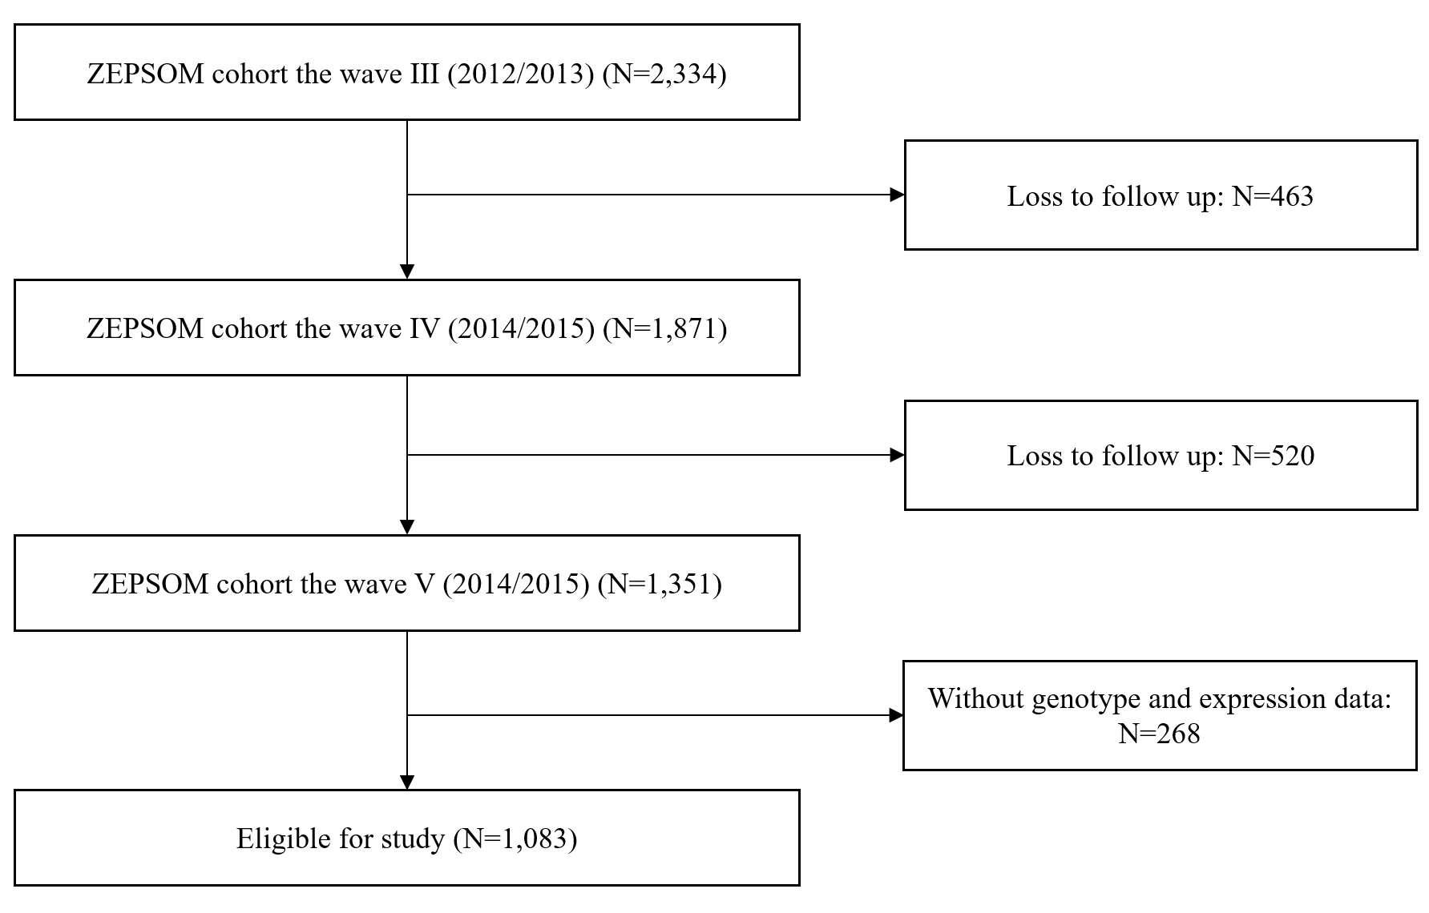

Fig. S1 Flowchart of the study participants’ selection process

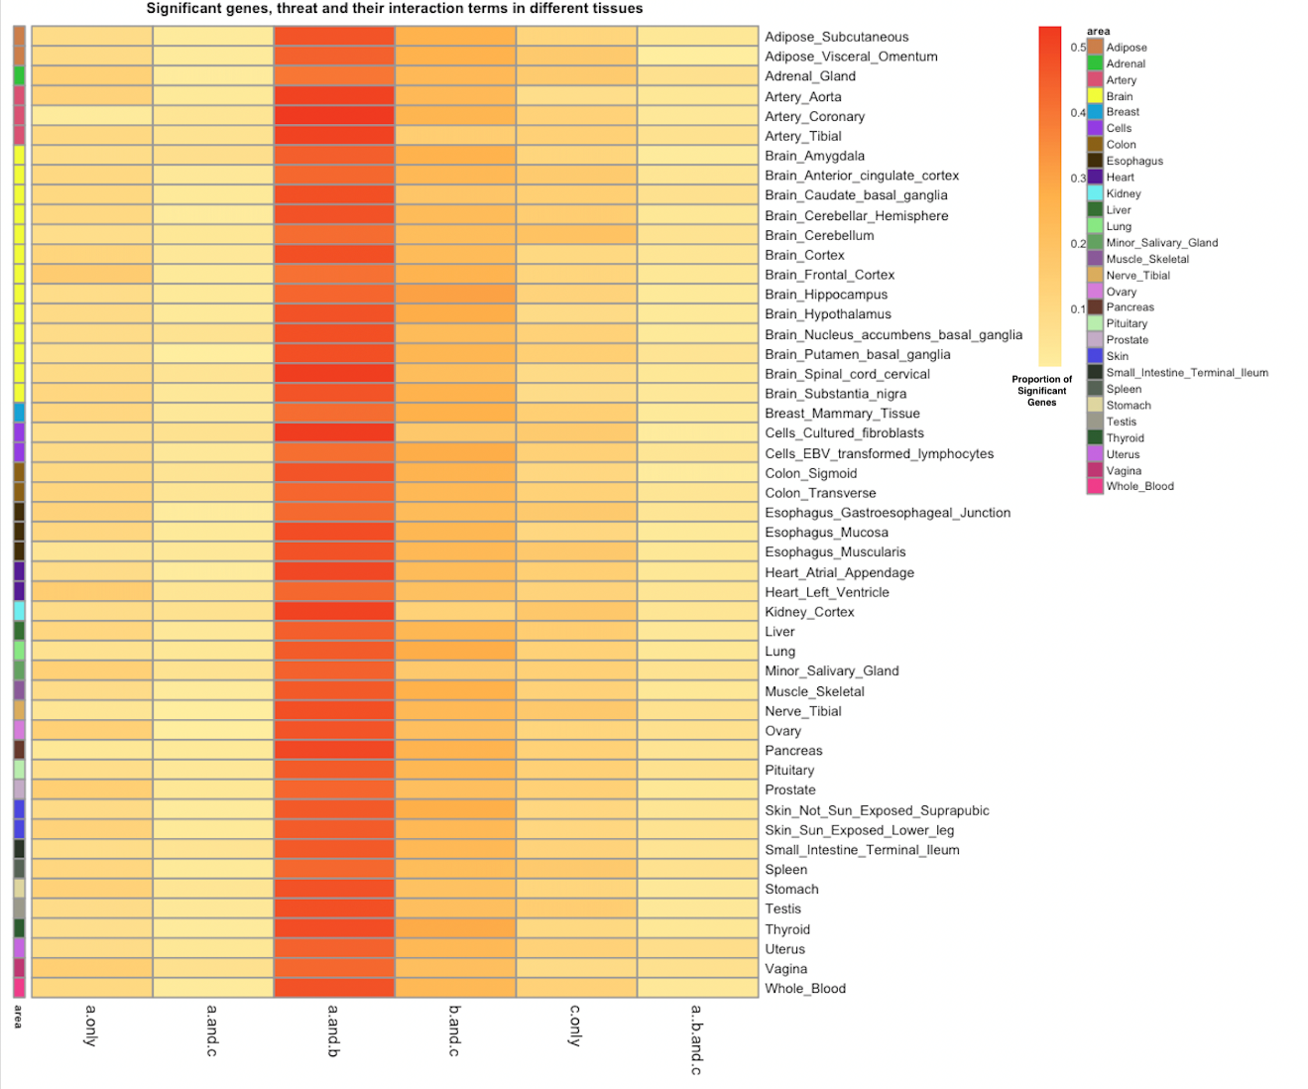

Fig. S2 Heatmap for gene × threat interactions

Note: a: gene; b: threat; c: gene × threat interaction term

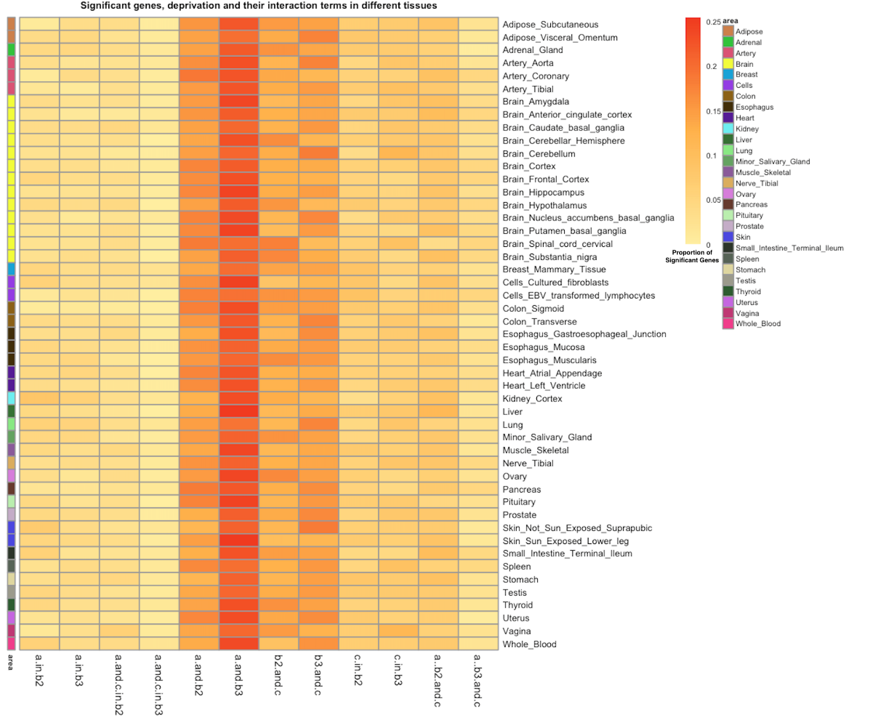Fig. S3 Heatmap for gene × deprivation interactions

Note: a: gene; b: deprivation; c: gene × deprivation interaction term

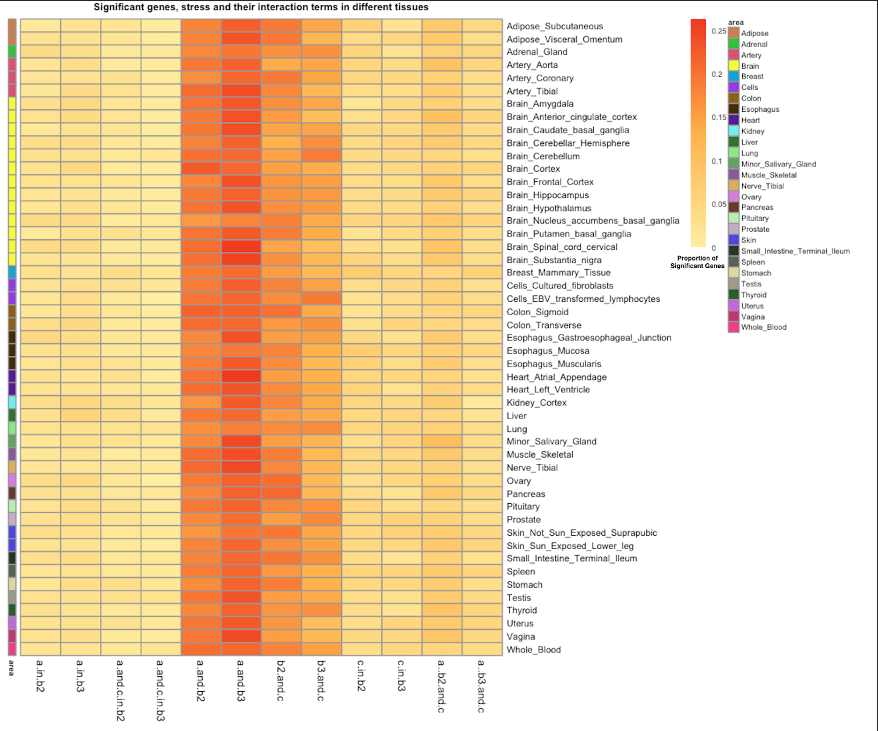Fig. S4 Heat map for gene × cumulative lifetime stress interactions

Note: a: gene; b: cumulative lifetime stress; c: gene × cumulative lifetime stress interaction term

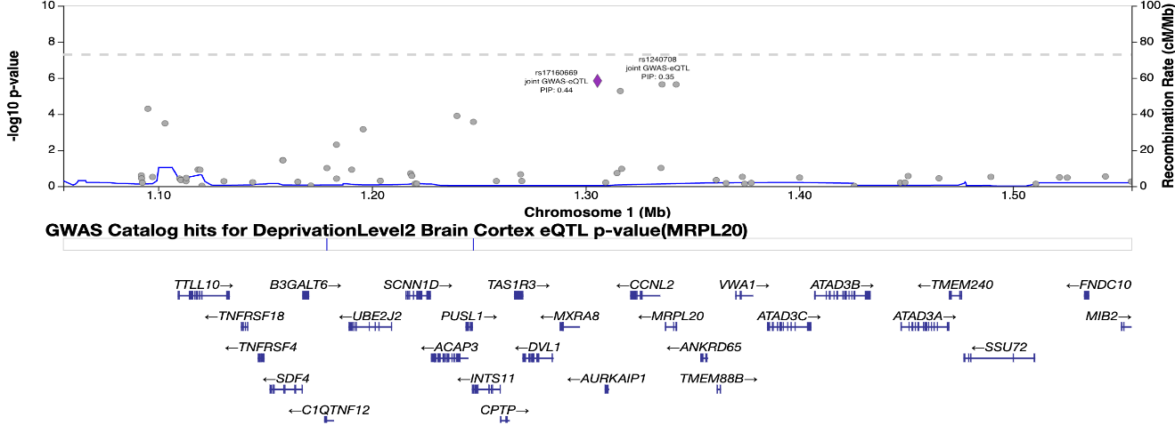Fig. S5 Locus Zoom plot of the interaction between MRPL20 gene and moderate deprivation level in brain cortex

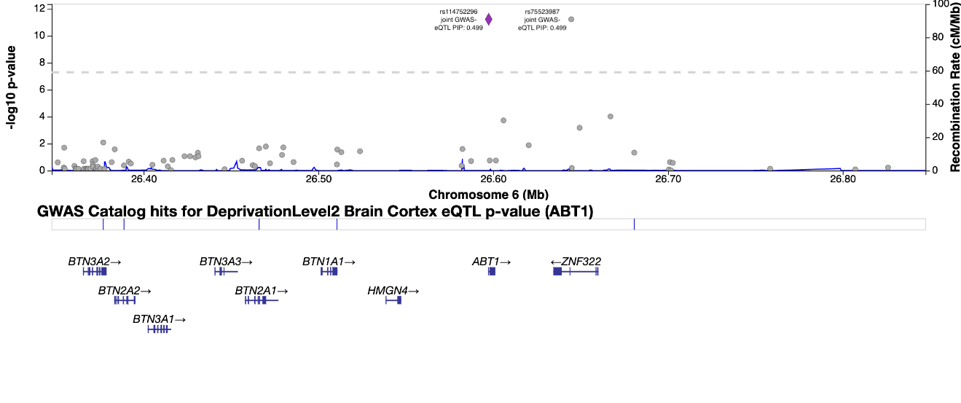Fig. S6 Locus Zoom plot of the interaction between ABT1 gene and moderate deprivation level in brain_cortex

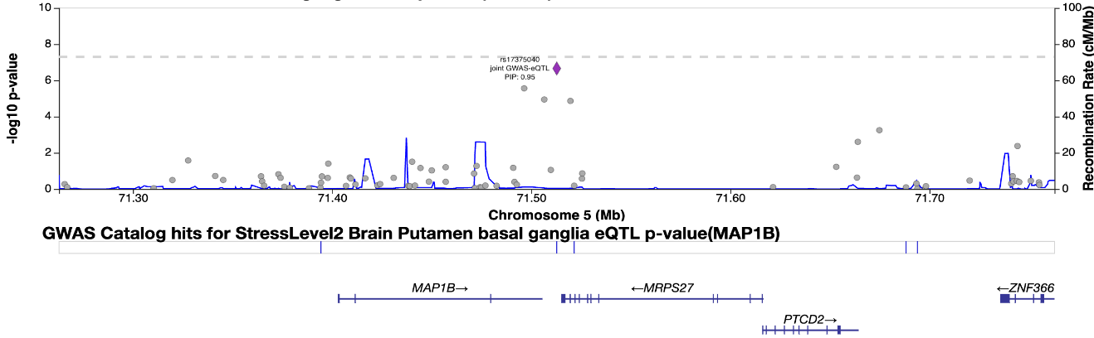

Fig. S7 Locus Zoom plot of the interaction between MAP1B gene and moderate cumulative lifetime stressor level in brain putamen basal ganglia

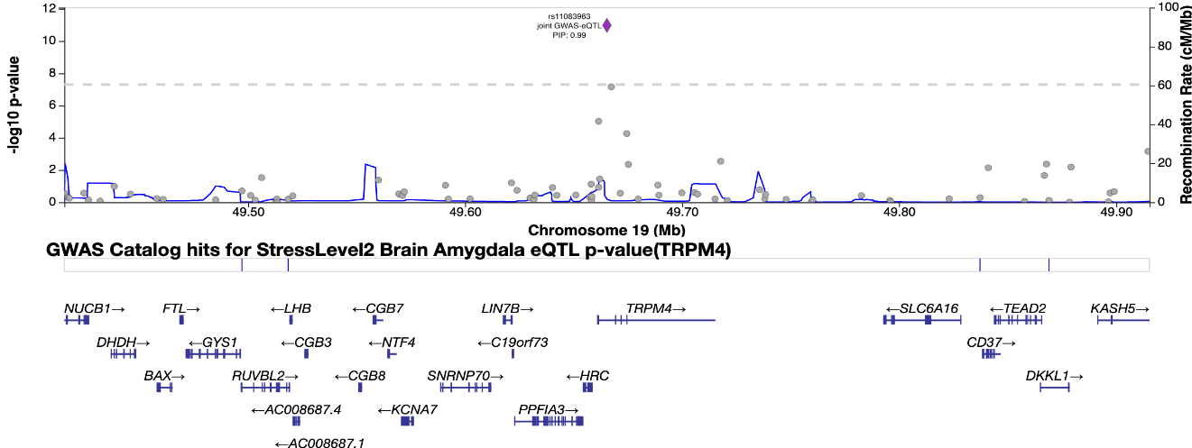

Fig. S8 Locus Zoom plot of the interaction between TRPM4 gene and moderate cumulative lifetime stressor level in brain_amygdala

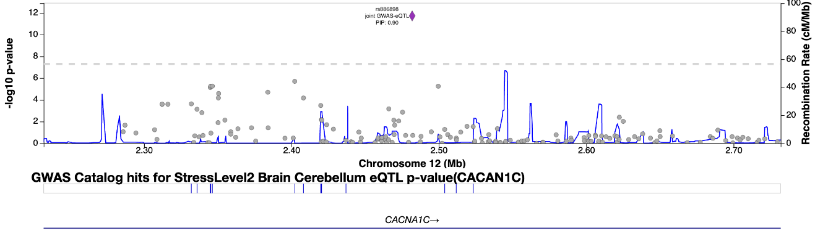

Fig. S9 Locus Zoom plot of the interaction between CACAN1C gene and moderate cumulative lifetime stressor level in brain_cerebellum

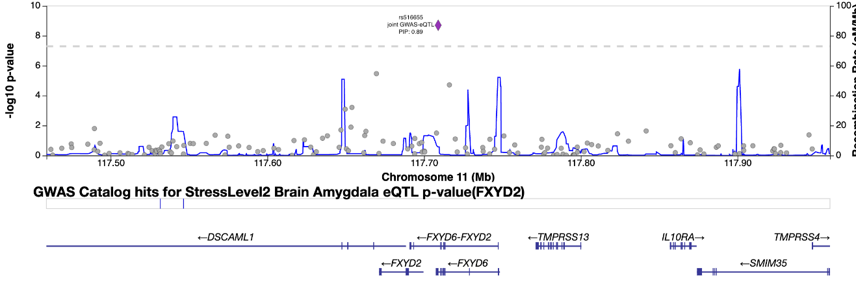

Fig. S10 Locus Zoom plot of the interaction between FXYD2 gene and moderate cumulative lifetime stressor level in brain_amygdala