|  |  |  |  |  |  |  |
| --- | --- | --- | --- | --- | --- | --- |
| Student name: | Student 1: Karen Ferreira Magalhaes  Student 2: Thales Campos  Student 3: Vitor Freitas | | | | | |
| Student number: | Student 1: 3146094  Student 2: 3151261  Student 3: 3152612 | | | | | |
| Faculty: | Computing Science | | | | | |
| Course: | BSCH/BSCO/EXCH | | | Stage/year: | 2 | |
| Subject: | Software Development 2 | | | | | |
| Study Mode: | Full time |  |  | Part-time |  |  |
| Lecturer Name: | Haseeb Younis/ Muhammad Shoaib | | | | | |
| Assignment Title: | Project Final Documentation | | | | | |
| Date due: | 27/04/2025 | | |  | | |
| Date submitted: | 23/03/2025 | | |  | | |
| **Plagiarism disclaimer:**  *I understand that plagiarism is a serious offence and have read and understood the college policy on plagiarism. I also understand that I may receive a mark of zero if I have not identified and properly attributed sources which have been used, referred to, or have in any way influenced the preparation of this assignment, or if I have knowingly allowed others to plagiarise my work in this way.*  *I hereby certify that this assignment is my own work, based on my personal study and/or research, and that I have acknowledged all material and sources used in its preparation. I also certify that the assignment has not previously been submitted for assessment and that I have not copied in part or whole or otherwise plagiarised the work of anyone else, including other students.*  **Signed: _____________________ Date: ______________________** | | | | | | |
| **Please note:** Students **MUST** retain a hard / soft copy of **ALL** assignments as well as a receipt issued and signed by a member of Faculty as proof of submission. | | | | | | |

Software Development 2

BSCH-SD2

Chatbot Project

**Table of Contents**

1. Versioning Approach 4

2. Development Process 4

3. UI Implementation 17

4. Rest API 17

4.1 Rest API Implementation 17

5. Weather API 17

6. External Packages 17

7. Project Setup 18

8. Milestone 1 18

8.1 Goals 18

8.2 Report 18

8.3 Commit Logs 20

8.4 Full Log Details 21

9. Milestone 2 23

9.1 Goals 23

9.2 Junit Tests Integration 23

9.3 Commit List & Branches Tree 23

9.4 Full Log Details 23

10. Milestone 3 23

10.1 Goals 23

10.2 Junit Tests Integration 23

10.3 Commit List & Branches Tree 23

10.4 Full Log Details 23

11. Appendix 23

12. Bibliography 23

# Versioning Approach

# Development Process

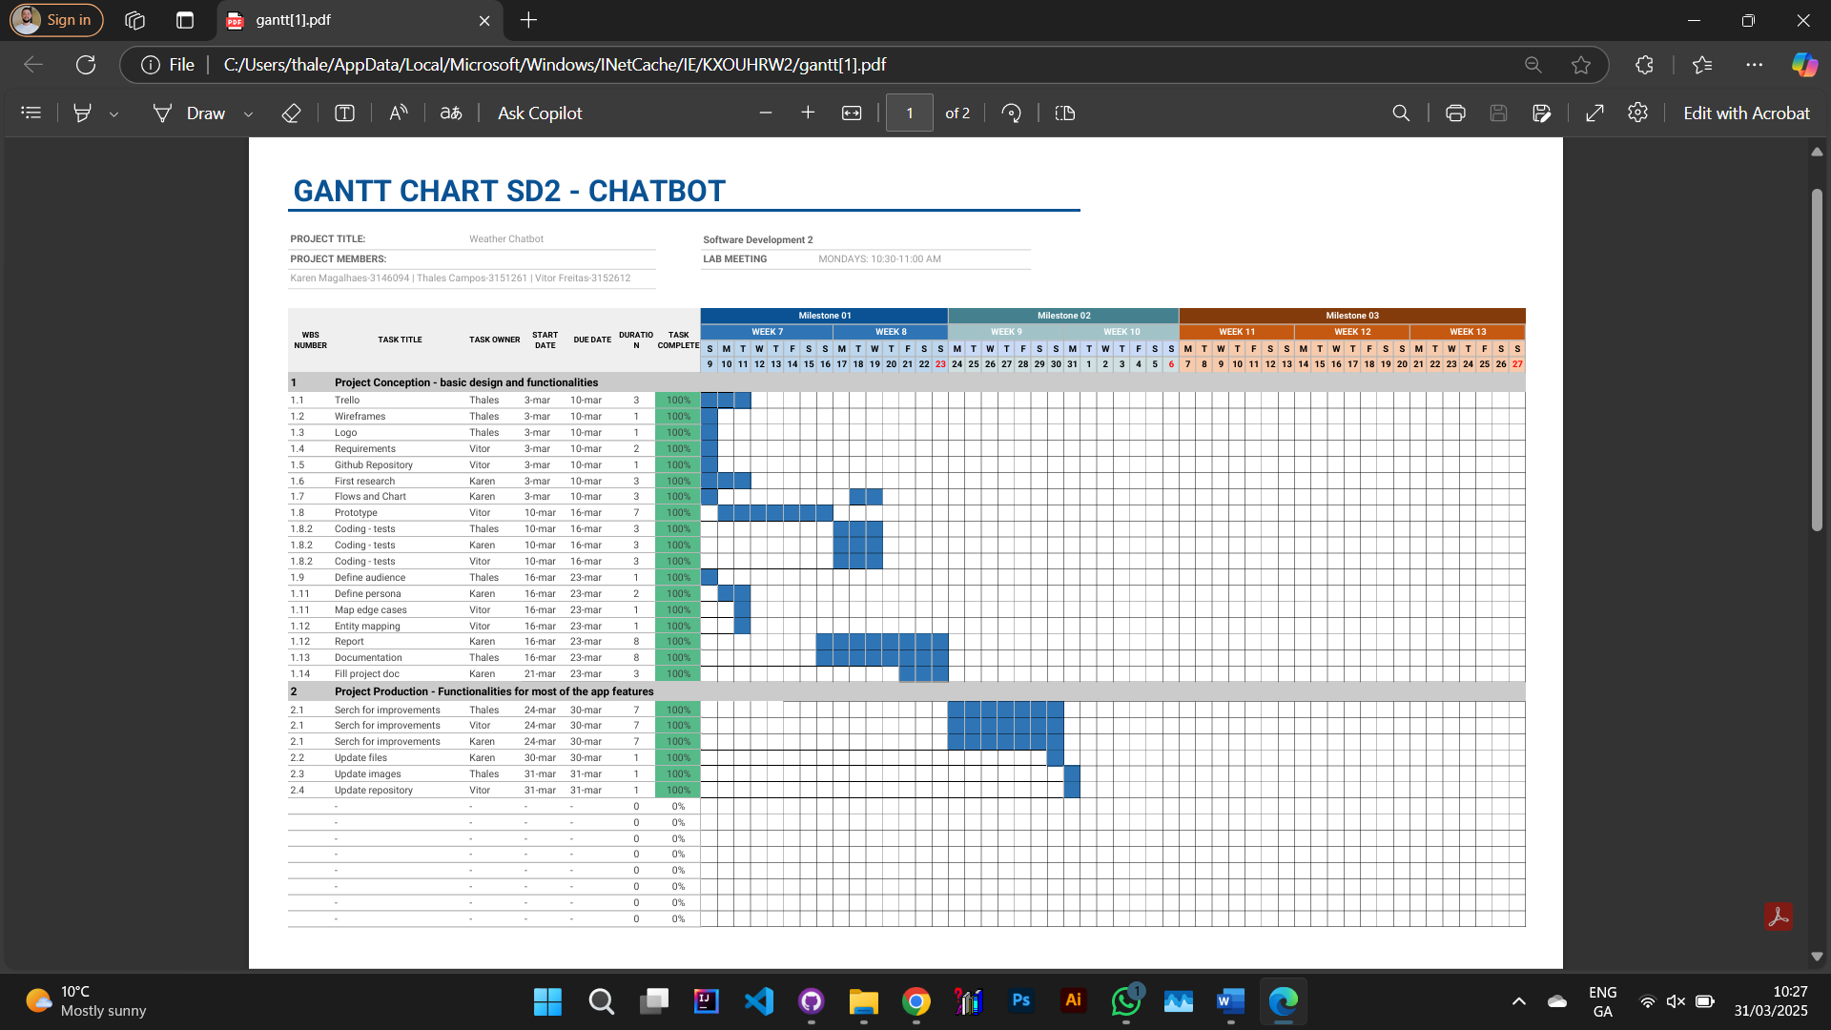

Figure - Gantt Chart

Figure 3 - Chatbot logo designed using ChatGPT, representing the project's identity and visual branding.

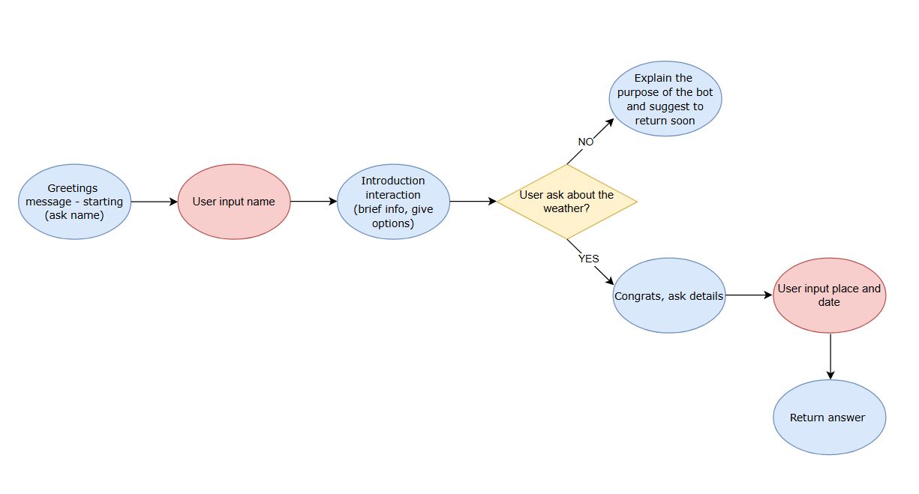

Figure - Simplified flowchart illustrating user interaction with the chatbot, from message input to response generation.

Figure - Wireframe design of the chatbot interface, showcasing the layout and user interaction flow.

**ChatGPTClient Class Documentation**

Overview: The ChatGPTClient class handles communication with the OpenAI ChatGPT API. It sends user messages, receives AI-generated responses, and processes the API response using the Gson library.

Package: main.java.com.tripper

Dependencies:

* java.io.* (For input/output operations)
* java.net.* (For handling HTTP connections)
* com.google.gson.* (For JSON processing)

Constants:

* String API_URL: The endpoint URL for OpenAI's ChatGPT API.
* String API_KEY: The API key used for authentication (should be kept secret and not hardcoded in production).

Methods:

1. String getChatResponse(String conversationContext):
   * Sends a user message to the OpenAI ChatGPT API and retrieves the AI-generated response.
   * Parameters:
     + conversationContext: The user's input message to be processed by the AI.
   * Returns:
     + A string containing the AI-generated response.
   * Process:
     + Establishes an HTTP connection with the OpenAI API.
     + Constructs a JSON payload containing the request data.
     + Sends the request and reads the API response.
     + Parses the JSON response to extract the AI's reply.
     + Returns the processed response or an error message if the API call fails.

Exception Handling:

* Catches general exceptions during the API request and response handling.
* Prints stack traces for debugging and returns an error message when an issue occurs.

Security Considerations:

* The API key should not be stored in the source code; it should be loaded from environment variables or secure storage in production.
* Ensure proper exception handling to avoid exposing sensitive information in error messages.

**ConversationController Class Documentation**

Overview: The ConversationController class manages the chatbot's interaction flow, handling user input, processing responses, and guiding the conversation through predefined states.

Package: main.java.com.tripper

Dependencies:

* java.util.Scanner (For user input handling)

Attributes:

* ConversationState state: Stores conversation progress and user data.
* ConversationManager conversationManager: Manages chatbot responses.
* ChatGPTClient chatGPTClient: Communicates with OpenAI's API.
* Scanner scanner: Handles user input from the console.

Methods:

1. void run():
   * Manages the chatbot's state-based conversation flow.
   * Guides the user through different states: GREETING, COLLECT_TRIP_DETAILS, CONFIRM_DETAILS, GENERATE_RECOMMENDATIONS, OFFER_PDF, END.
   * Integrates responses from ChatGPTClient.
   * Handles user inputs for trip details and PDF generation.
2. void typePrint(String message, int delayMs):
   * Simulates a typing effect when displaying chatbot messages.
   * Parameters:
     + message: The text to display.
     + delayMs: Delay per character in milliseconds.
3. String prompt(String message):
   * Displays a message and collects user input.
   * Parameters:
     + message: The prompt for the user.
   * Returns:
     + User input as a trimmed string.

Exception Handling:

* Ensures smooth conversation flow by handling user input errors.
* Uses try-catch to handle interruptions in the typing effect.

Functionality:

* Starts the chatbot with a greeting message.
* Collects and processes user trip details.
* Requests recommendations from ChatGPTClient.
* Offers an option to generate a PDF checklist.
* Ends the conversation with a farewell message.

**ConversationManager Class Documentation**

Overview: The ConversationManager class handles the chatbot's predefined responses to user input. It generates friendly and engaging messages to guide users through the interaction process.

Package: main.java.com.tripper

Methods:

1. String getGreeting(String userName):
   * Generates a personalized greeting for the user.
   * Parameters:
     + userName: The name of the user.
   * Returns:
     + A friendly welcome message including the user's name.
2. String askForTripDetails():
   * Prompts the user to provide details about their trip.
   * Returns:
     + A request message asking the user for trip information.
3. String friendlyResponse(String dynamicResponse):
   * Formats and returns a friendly response incorporating dynamically generated recommendations.
   * Parameters:
     + dynamicResponse: The AI-generated travel recommendations.
   * Returns:
     + A structured response including the recommendations.

Functionality:

* Ensures a smooth and engaging chatbot experience.
* Provides user-friendly prompts and structured responses to enhance interaction.
* Acts as an intermediary between user input and AI-generated recommendations.

**ConversationState Class Documentation**

Overview: The ConversationState class maintains the state of a chatbot conversation. It stores user-specific data such as name, trip details, and confirmation status to ensure a smooth interaction flow.

Package: main.java.com.tripper

Dependencies:

* java.util.ArrayList (For handling dynamic lists)
* java.util.List (For managing location storage)

Attributes:

* String userName: Stores the user's name.
* List locations: Holds the list of travel locations provided by the user.
* String tripDetails: Contains user-supplied details about the trip.
* boolean detailsConfirmed: Indicates whether the trip details have been confirmed by the user.

Methods:

1. ConversationState():
   * Constructor that initializes the locations list and sets detailsConfirmed to false.
2. String getUserName():
   * Retrieves the user's name.
   * Returns:
     + The name of the user.
3. void setUserName(String userName):
   * Sets the user's name.
   * Parameters:
     + userName: The name of the user.
4. List getLocations():
   * Retrieves the list of locations.
   * Returns:
     + A list of location names.
5. void addLocation(String location):
   * Adds a new location to the list.
   * Parameters:
     + location: The name of the location to add.
6. String getTripDetails():
   * Retrieves the trip details provided by the user.
   * Returns:
     + The trip details as a string.
7. void setTripDetails(String tripDetails):
   * Sets the trip details.
   * Parameters:
     + tripDetails: A string containing trip information.
8. boolean isDetailsConfirmed():
   * Checks if the trip details have been confirmed by the user.
   * Returns:
     + True if confirmed, false otherwise.
9. void setDetailsConfirmed(boolean detailsConfirmed):
   * Updates the confirmation status of the trip details.
   * Parameters:
     + detailsConfirmed: Boolean value indicating confirmation status.

Functionality:

* Tracks user input and progress throughout the chatbot conversation.
* Stores key trip-related information for personalized recommendations.
* Ensures state persistence for an improved chatbot experience.

**InputParser Class Documentation**

Overview:  
The InputParser class processes and extracts travel-related information from user input. It uses regular expressions and string manipulation to identify the travel month and potential locations provided by the user.

Package:  
main.java.com.tripper

Dependencies:

* java.util.* (For handling collections and arrays)
* java.util.regex.* (For regular expression matching)

Constants:

* Pattern monthPattern:  
  A regular expression pattern to match any month name (case-insensitive).

Methods:

1. TripDetails parseTripDetails(String input):
   * Parameters:
     + input: The user-provided string containing trip details.
   * Returns:
     + A TripDetails object containing the extracted travel month and locations.
   * Process:
     + Uses regex to identify a month in the input and sets the travel month in the TripDetails object.
     + Splits the input into tokens and identifies capitalized words (excluding month names) as potential locations.
     + Removes punctuation from the tokens and adds valid locations to the list.

Functionality:

* Identifies and extracts the travel month and location information from a free-form user input string.
* Uses regular expressions for month matching and simple string checks for locations.
* Ensures proper location parsing even if months and locations are mixed in the input.

**NLPInputParser Class Documentation**

Overview:

The NLPInputParser class is responsible for processing input text using natural language processing (NLP) techniques. It uses OpenNLP tools to perform sentence detection, tokenization, part-of-speech (POS) tagging, and optional lemmatization. The primary goal is to parse trip details, such as locations and travel dates, from user input.

Dependencies:

* OpenNLP Library (tools for sentence detection, tokenization, POS tagging, and lemmatization).

Attributes:

* SentenceDetectorME sentenceDetector: Detects sentence boundaries in the input text.
* TokenizerME tokenizer: Tokenizes the text into individual words.
* POSTaggerME posTagger: Tags each token with its part-of-speech.
* DictionaryLemmatizer lemmatizer (optional): Lemmatizes tokens to their base forms.

Constructor:

* Initializes models for sentence detection, tokenization, POS tagging, and lemmatization (if available).
* Loads model files from the local file system for OpenNLP tools.

Methods:

1. parseTripDetails(String input):
   * Parameters: String input – The input text containing trip details.
   * Returns: TripDetails – A TripDetails object containing locations and the travel month parsed from the input.
   * Description:
     + Detects sentences in the input.
     + Tokenizes sentences into words.
     + Performs POS tagging on the tokens.
     + Identifies proper nouns (NNP/NNPS tags) as potential location names.
     + Identifies date-like tokens (e.g., "12/12/2025" or month names).
     + Collects and returns the locations and travel month as part of the TripDetails object.

Security Considerations:

* Ensure the model files are securely stored and not exposed to unauthorized access.
* Handle any exceptions that might occur during model loading or processing.

**PDFGenerator Class Documentation**

Overview:

The PDFGenerator class is responsible for creating a custom PDF document containing a checklist for travel preparation. It includes multiple sections such as trip details, essential items, recommendations, optional items, and accessories. The class uses the Apache PDFBox library to generate the PDF.

Dependencies:

* Apache PDFBox (used for PDF creation and manipulation)

Methods:

1. generateChecklist(String fileName, ConversationState state, String tripDetails, String[] essentialItems, String[] recommendations, String[] optionalItems, String[] accessories):
   * Parameters:
     + fileName: The name of the output PDF file.
     + state: The ConversationState object holding user details such as name.
     + tripDetails: A string representing trip details (e.g., locations).
     + essentialItems: An array of essential clothing items.
     + recommendations: An array of recommended items for the trip.
     + optionalItems: An array of optional items.
     + accessories: An array of accessory items for the trip.
   * Description:
     + Generates a custom PDF checklist with sections for the trip details, essential items, recommendations, optional items, and accessories.
     + The document is saved to the provided file path (fileName).
   * Returns: None.
2. addSectionHeader(PDPageContentStream contentStream, String header, float margin, float yPosition, PDType1Font font, int fontSize):
   * Parameters:
     + contentStream: The stream used to write content to the PDF page.
     + header: The title of the section (e.g., "Trip:", "Essential:", etc.).
     + margin: The left margin for positioning the header.
     + yPosition: The current y-coordinate for positioning.
     + font: The font to use for the header.
     + fontSize: The font size to use for the header.
   * Description:
     + Adds a section header to the PDF.
     + Adjusts the y-position for the next section.
   * Returns: The updated y-position after adding the header.
3. addBulletList(PDPageContentStream contentStream, String[] items, float xPosition, float yPosition, PDType1Font font, int fontSize, float leading):
   * Parameters:
     + contentStream: The stream used to write content to the PDF page.
     + items: An array of items to be listed as bullets.
     + xPosition: The x-coordinate for positioning the list.
     + yPosition: The current y-coordinate for positioning the list.
     + font: The font to use for the list items.
     + fontSize: The font size to use for the list items.
     + leading: The line height or spacing between list items.
   * Description:
     + Adds a bullet-point list to the PDF.
     + Adjusts the y-position after adding each item.
   * Returns: The updated y-position after adding the list.
4. addParagraph(PDPageContentStream contentStream, String text, float xPosition, float yPosition, PDType1Font font, int fontSize, float maxWidth, float leading):
   * Parameters:
     + contentStream: The stream used to write content to the PDF page.
     + text: The text to be added as a paragraph.
     + xPosition: The x-coordinate for positioning the paragraph.
     + yPosition: The current y-coordinate for positioning the paragraph.
     + font: The font to use for the text.
     + fontSize: The font size to use for the text.
     + maxWidth: The maximum width for the paragraph (used for text wrapping).
     + leading: The line height or spacing between lines of text.
   * Description:
     + Adds a paragraph to the PDF with automatic word wrapping.
     + Adjusts the y-position after adding the text.
   * Returns: The updated y-position after adding the paragraph.

**Example Usage:**

*String fileName = "TripChecklist.pdf";*

*ConversationState state = new ConversationState();*

*state.setUserName("Thales Campos");*

*String tripDetails = "Trip to Brazil, Italy, and Spain.";*

*String[] essentialItems = {"T-shirts", "Shorts", "Sunglasses"};*

*String[] recommendations = {"Comfortable Shoes", "Camera"};*

*String[] optionalItems = {"Swimwear", "Hat"};*

*String[] accessories = {"Backpack", "Travel Pillow"};*

*PDFGenerator.generateChecklist(fileName, state, tripDetails, essentialItems, recommendations, optionalItems, accessories);*

This will generate a PDF titled "TripChecklist.pdf" containing a personalized checklist for Thales Campos, detailing trip information and packing essentials.

**Security Considerations:**

* Ensure that any user-generated input (e.g., tripDetails, essentialItems) is sanitized to prevent injection attacks.
* The file generation process should be done in a secure location to avoid unauthorized access.

**TerminalChatbot Class Documentation**

Overview:

The TerminalChatbot class serves as the entry point for the chatbot application. It initializes the ConversationController and starts the interaction by invoking the run() method. This setup is typically used for a terminal-based interface where the chatbot engages with the user in a command-line environment.

Dependencies:

* ConversationController: The class responsible for controlling the flow of the conversation, processing user inputs, and managing the chatbot's state.

Methods:

1. main(String[] args):
   * Parameters:
     + args: Command-line arguments (if any).
   * Description:
     + This is the entry point of the application. It creates an instance of the ConversationController and starts the conversation by calling its run() method.
   * Returns: None.

Example Usage:

To run the chatbot, the user simply needs to execute the TerminalChatbot class in a terminal environment.

java main.java.com.tripper.TerminalChatbot

This command will start the chatbot, which will interact with the user by controlling the conversation flow through the ConversationController.

Flow:

1. Initialization:
   * The main() method initializes a ConversationController object.
2. Conversation Start:
   * The run() method of the ConversationController is invoked, starting the chatbot's interaction with the user.

This class does not handle direct user interaction but relies on the ConversationController to manage the logic and state of the conversation.

**TripChecklist Class Documentation**

Overview:

The TripChecklist class holds and organizes the various categories of items for a travel checklist. It categorizes the items into essential items, recommendations, optional items, and accessories, which are useful for generating a detailed packing list for the user.

Fields:

* essentialItems: An array of essential items needed for the trip (e.g., passport, tickets).
* recommendations: An array of recommended items (e.g., sunscreen, camera).
* optionalItems: An array of optional items that might be useful but are not strictly necessary (e.g., a book, extra shoes).
* accessories: An array of accessory items (e.g., hats, sunglasses, scarves).

Constructor:

* TripChecklist(String[] essentialItems, String[] recommendations, String[] optionalItems, String[] accessories)
  + Parameters:
    - essentialItems: An array containing items deemed essential for the trip.
    - recommendations: An array of recommended items for the trip.
    - optionalItems: An array of optional items that can be included for the trip.
    - accessories: An array of accessory items for the trip.
  + Description: This constructor initializes the four categories of items, providing a structured way to manage the checklist for the trip.

Getter Methods:

* getEssentialItems(): Returns the array of essential items.
* getRecommendations(): Returns the array of recommended items.
* getOptionalItems(): Returns the array of optional items.
* getAccessories(): Returns the array of accessory items.

Example Usage:

*// Example of how to create a TripChecklist and access the items*

*String[] essentials = {"Passport", "Flight tickets", "Travel Insurance"};*

*String[] recommendations = {"Camera", "Sunscreen", "Guidebook"};*

*String[] optional = {"Book", "Extra shoes"};*

*String[] accessories = {"Hat", "Sunglasses", "Scarf"};*

*TripChecklist checklist = new TripChecklist(essentials, recommendations, optional, accessories);*

*// Accessing the items*

*String[] essentialItems = checklist.getEssentialItems();*

*String[] recommendations = checklist.getRecommendations();*

*String[] optionalItems = checklist.getOptionalItems();*

*String[] accessories = checklist.getAccessories();*

Use Case:

This class is typically used to store and retrieve different categories of items that need to be packed for a trip. It can be passed to other components like PDFGenerator to create packing lists, or to be used within the ConversationController to provide personalized recommendations.

**TripChecklistGenerator Class Documentation**

Overview:

The TripChecklistGenerator class is responsible for generating a set of checklist items (essential items, recommendations, optional items, and accessories) based on the details of the trip, particularly the travel month. It uses simple heuristics to categorize items based on whether the trip is likely to be in summer, winter, or a neutral season.

Method:

* generateChecklist(TripDetails details)
  + Parameters:
    - details: An instance of TripDetails that contains information about the user's travel month.
  + Returns: A TripChecklist object containing categorized items (essential, recommendations, optional, and accessories).
  + Description: This method generates checklist arrays based on the travel month in the TripDetails object. It uses the travel month to determine which items should be included for the trip, following a set of heuristics:
    - Summer months (June, July, August) or mentions of "summer" lead to lighter clothing items.
    - Winter months (December, January, February) or mentions of "winter" lead to warmer clothing and accessories.
    - If the travel month is unclear, a neutral set of items is chosen.

Logic:

* Summer Travel (e.g., June, July, August):
  + Essential Items: Light T-shirt, Shorts, Comfortable walking shoes, Sunglasses.
  + Recommendations: Hat, Sunscreen, Umbrella (for potential rain).
  + Optional Items: Light Sweater, Extra pair of Socks.
  + Accessories: Crossbody Bag, Travel Adapter, Power Bank.
* Winter Travel (e.g., December, January, February):
  + Essential Items: Warm Jacket, Thermal Wear, Gloves, Scarf, Beanie.
  + Recommendations: Boots, Extra Socks.
  + Optional Items: Lip Balm, Hand Warmers.
  + Accessories: Backpack, Travel Adapter.
* Neutral Travel (if no specific month or season is clear):
  + Essential Items: Versatile T-shirt, Jeans, Comfortable Shoes.
  + Recommendations: Light Jacket, Umbrella.
  + Optional Items: Hat, Sunglasses.
  + Accessories: Backpack, Portable Charger.

Example Usage:

*java*

*// Example of how to generate a checklist based on travel month*

*TripDetails tripDetails = new TripDetails();*

*tripDetails.setTravelMonth("June");*

*TripChecklist checklist = TripChecklistGenerator.generateChecklist(tripDetails);*

*// Accessing checklist items*

*String[] essentialItems = checklist.getEssentialItems();*

*String[] recommendations = checklist.getRecommendations();*

*String[] optionalItems = checklist.getOptionalItems();*

*String[] accessories = checklist.getAccessories();*

Use Case:

This class is typically used in the context of a travel planning application or a chatbot. After determining the user's travel month, the TripChecklistGenerator can create a personalized packing list to help the user prepare for their trip. The generated checklist can be used in various formats (e.g., displayed on the user interface, saved as a PDF, etc.).

**TripDetails Class Documentation**

Overview:

The TripDetails class holds information about the user's trip. It includes a list of locations (places the user intends to visit) and the travel month (the month during which the user is planning their trip).

Fields:

1. locations (List<String>):
   * A list of locations that the user intends to visit. This could represent cities, countries, or specific landmarks.
2. travelMonth (String):
   * The month when the user is planning to travel, represented as a string (e.g., "June", "December"). This helps in generating a personalized packing list based on seasonal factors.

Methods:

* getLocations():
  + Description: Returns the list of locations for the trip.
  + Return Type: List<String>
* setLocations(List<String> locations):
  + Description: Sets the list of locations for the trip.
  + Parameters: A List<String> containing location names (e.g., "Paris", "Venice").
* getTravelMonth():
  + Description: Returns the travel month for the trip.
  + Return Type: String
* setTravelMonth(String travelMonth):
  + Description: Sets the travel month for the trip.
  + Parameters: A String representing the month of travel (e.g., "June").
* toString():
  + Description: Returns a string representation of the TripDetails object, which includes the list of locations and the travel month.
  + Return Type: String

Example Usage:

*java*

*// Creating a TripDetails instance*

*TripDetails tripDetails = new TripDetails();*

*// Setting the travel month and locations*

*tripDetails.setTravelMonth("June");*

*tripDetails.setLocations(List.of("Brazil", "Italy", "Spain"));*

*// Accessing the trip details*

*String travelMonth = tripDetails.getTravelMonth(); // "June"*

*List<String> locations = tripDetails.getLocations(); // ["Brazil", "Italy", "Spain"]*

*// Printing the trip details*

*System.out.println(tripDetails.toString());*

*// Output: TripDetails [locations=[Brazil, Italy, Spain], travelMonth=June]*

Use Case:

The TripDetails class is used to store essential trip information, such as the destinations the user is visiting and when they are traveling. This information is used by other classes, like TripChecklistGenerator, to create personalized checklists and planning resources for the user.

**WeatherService Class Documentation**

Overview:

The WeatherService class is responsible for fetching weather forecast data from the OpenWeatherMap API. The class uses HTTP requests to fetch weather data for a specific location and returns the data as a WeatherResponse object.

Fields:

* API_KEY (String):
  + A constant holding the API key required to authenticate requests to the OpenWeatherMap API. *(Note: For security reasons, make sure to keep the API key secret.)*
* BASE_URL (String):
  + A constant holding the base URL for the OpenWeatherMap API endpoint.

Method:

* getForecastData(String location):
  + Description: This method fetches the weather forecast for a specified location using the OpenWeatherMap API.
  + Parameters:
    - location (String): The name of the location for which the forecast is needed (e.g., "Paris").
  + Return Type: WeatherResponse
    - Returns a WeatherResponse object containing the parsed forecast data.
  + Throws:
    - Catches and prints exceptions related to network requests or data parsing.

Steps:

* + The method builds the URL to request the forecast data using the location and the API_KEY.
  + Sends an HTTP GET request to OpenWeatherMap API.
  + If the request is successful (status code 200), it reads the response as a string.
  + The response string is parsed into a WeatherResponse object using the Gson library.
  + The method returns the WeatherResponse object containing the forecast data.
  + In case of any errors (e.g., failed request or invalid data), it prints an error message and returns null.

Example Usage:

*java*

*// Create a WeatherService instance*

*WeatherService weatherService = new WeatherService();*

*// Fetch weather forecast for a given location*

*WeatherResponse forecast = weatherService.getForecastData("Paris");*

*if (forecast != null) {*

*// Process the forecast data*

*System.out.println("Weather forecast: " + forecast);*

*} else {*

*System.out.println("Unable to retrieve weather data.");*

*}*

Notes:

1. The API_KEY is stored as a private constant within the class. Be sure to keep it secret, and avoid sharing it in public repositories.
2. The WeatherResponse class is assumed to be a data model for parsing the JSON response from the OpenWeatherMap API. This class would typically contain fields for temperature, weather conditions, etc.
3. Make sure to handle any potential issues with rate limits or incorrect API keys when using this service.

# UI Implementation

# Rest API

## Rest API Implementation

# Weather API

# External Packages

**Gson**

The Gson library is a tool from Google used to convert Java objects to JSON representation and vice versa. The goals of this library are to allow customized representation, support complex objects, and generate compact output. According to the official documentation, its performance and scalability provide results more than sufficient for the expectations of this project. The components used are: .JsonArray; .JsonObject; .JsonParser. Their purpose is to interact with objects and arrays and parse strings.

**OpenNLP**

The OpenNLP library is a tool from Apache used to process natural language text, based on machine learning. The components used are: .DictionaryLemmatizer; .POSModel; .POSTaggerME; .SentenceDetectorME; .SentenceModel; .TokenizerME; .TokenizerModel. Their purpose is to identify sentences, split text, determine grammatical tags for tokens, and convert words.

**PDFBox**

The PDFBox library is an open source tool from Apache used to create, manipulate, and extract information from PDF documents. The components used are: .PDDocument; .PDPage; .PDPageContentStream; .PDRectangle; .font.PDType1Font; .font.Standard14Fonts. Their purpose is to manage, structure, write, create PDFs, and deal with fonts.

# Project Setup

# Milestone 1

## Goals

For the first milestone, the goals involved researching different models and exploring what was available related to the desired target. The next step was to discuss the audience, determine which tools to implement, and identify the possible devices and platforms to work with. After that, we created a persona and developed a visual identity, including a logo and some possible wireframes. The final step was coding a prototype using APIs and packages that could make the project feasible while documenting, researching, and saving all necessary information throughout the process.

## Report

The group decided to start the project by conducting simple research using all the material provided by the lecturers on Moodle and organizing the schedule, steps, and roles. The focus was on developing and delivering a complete and functional project based on each member's previous knowledge, personal experience, and abilities.

Trello was chosen as the platform to organize and share the project's steps, allowing changes, suggestions, and task storage. Since the group had used this tool before, the main goals were to enhance productivity and teamwork.

A Gantt chart was created using a free template available on Google Sheets. As the project progresses, the group can visualize and assess whether time management requirements are being met. This provides a sense of control and helps in making decisions, adjustments, and improvements as needed.

GitHub was selected as the repository platform, enabling authorized members to create, store, manage, share, and comment on all necessary files, code, and documents. As a well-known and secure platform, GitHub facilitates fast, collaborative, and well-documented work, ensuring version control and a history of completed tasks.

OpenAi’s GPT-3.5 Turbo was selected as the REST API to provide a code with an elevated level of communication, This model with 16,385 context window, uses NLP (natural language processing) to interact, generate and summarize text, answer questions, and much more. All these processes are supported in the code using JSON.

Roles:

Karen – Individual research and discussion, second research, flow and chart, coding tests, define persona, report, fill project final doc.

Thales – Individual research and discussion, trello, wireframes, logo, coding tests, define audience, documentation.

Vitor – Individual research and discussion, requirements, GitHub repository, coding prototype, coding tests, map edge cases, entity mapping.

## Commit Logs

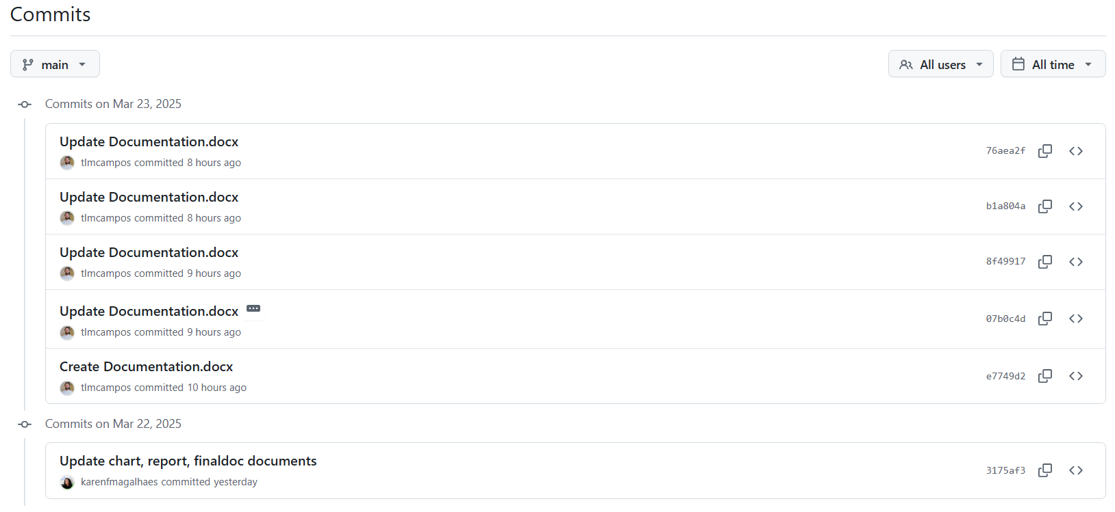

Figure - GitHub commit history showcasing the project's development process, including code updates, fixes, and feature implementations by the team.

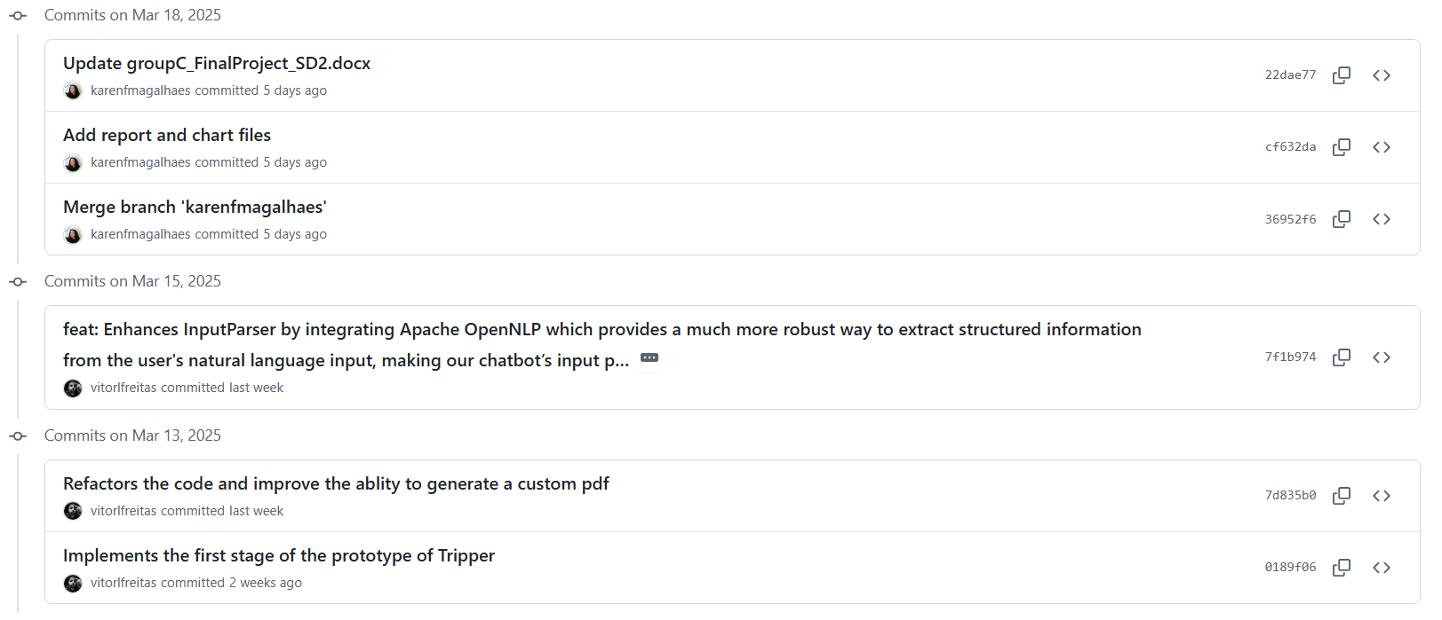

Figure - GitHub commit history showcasing the project's development process, including code updates, fixes, and feature implementations by the team.

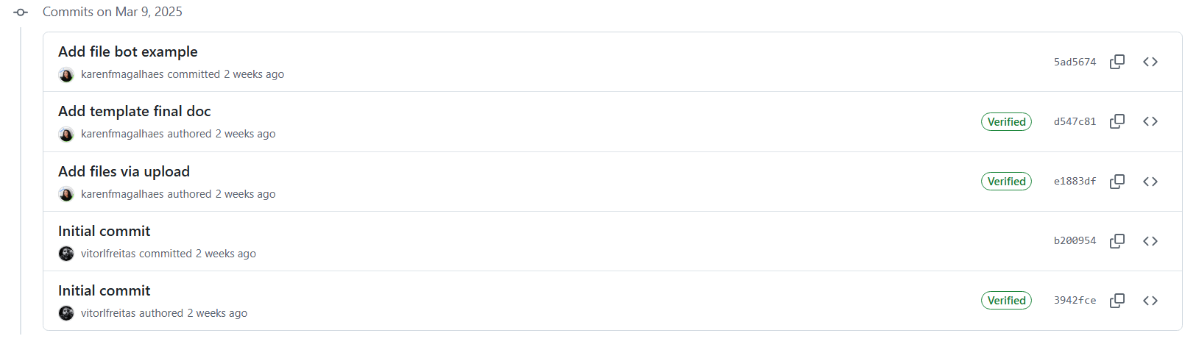

Figure - GitHub commit history showcasing the project's development process, including code updates, fixes, and feature implementations by the team.

## Full Log Details

stupc@LAPTOP-715EEOOP MINGW64 ~/Documents/GitHub/trip-clothing-planner (main)

$ git log

commit 76aea2f0e15b962e51bd654158ca43844fc4a72b (**HEAD** -> **main**, **origin/main**, **orig**

**in/HEAD**)

Author: Thales Campos <159160714+tlmcampos@users.noreply.github.com>

Date: Sun Mar 23 12:56:01 2025 +0000

Update Documentation.docx

commit b1a804a54b7bcff1aa7d1df5fc5ffbaf209c2509

Author: Thales Campos <159160714+tlmcampos@users.noreply.github.com>

Date: Sun Mar 23 12:46:13 2025 +0000

Update Documentation.docx

commit 8f4991753ae28eb736cbe957d058f458e419ff2a

Author: Thales Campos <159160714+tlmcampos@users.noreply.github.com>

Date: Sun Mar 23 12:11:41 2025 +0000

Update Documentation.docx

commit 07b0c4d6829e34d8ff7dd3defa0958e2c0752475

Author: Thales Campos <159160714+tlmcampos@users.noreply.github.com>

Date: Sun Mar 23 11:44:55 2025 +0000

Update Documentation.docx

describe classes ChatGPTClient, ComversationController, and ConversationMana

ger

commit e7749d258d8db49ba650096f082f95771c78acfe

Author: Thales Campos <159160714+tlmcampos@users.noreply.github.com>

Date: Sun Mar 23 11:18:11 2025 +0000

Create Documentation.docx

commit 3175af3a470fdeda3142cab1e4d04258c4c4dcdc

Author: Karen F Magalhaes <karenfmagalhaes@gmail.com>

Date: Sat Mar 22 12:33:59 2025 +0000

Update chart, report, finaldoc documents

commit 22dae7766e11b23b9d009c4195f7bb4652f2933d

Author: Karen F Magalhaes <karenfmagalhaes@gmail.com>

Date: Tue Mar 18 16:58:45 2025 +0000

Update groupC_FinalProject_SD2.docx

commit cf632da0df3be834da04a5c7f07413923196bf2c

Author: Karen F Magalhaes <karenfmagalhaes@gmail.com>

Date: Tue Mar 18 14:30:41 2025 +0000

Add report and chart files

commit 36952f6fbfdfdf397891e944ae66b22f43aa27ec

Merge: 7f1b974 5ad5674

Author: Karen F Magalhaes <karenfmagalhaes@gmail.com>

Date: Tue Mar 18 13:25:10 2025 +0000

Merge branch 'karenfmagalhaes'

commit 7f1b9747757958ac2c9f823ed7264cceeb11786b

Author: vitorlfreitas <vitor.lucfreitas@gmail.com>

Date: Sat Mar 15 00:22:42 2025 +0000

feat: Enhances InputParser by integrating Apache OpenNLP which provides a mu

ch more robust way to extract structured information from the user's natural lan

guage input, making our chatbot’s input parsing far stronger and Adds SLF4J dep

endencies to fix OpenNLP logging issue and enable UD EWT models

commit d547c815c70c2939d6732bccad90325f70706b84

Author: Karen F Magalhaes <59734660+karenfmagalhaes@users.noreply.github.com>

Date: Sun Mar 9 22:33:29 2025 +0000

Add template final doc

commit e1883df1c1a891202486a2111e166489ed7d22bf

Author: Karen F Magalhaes <59734660+karenfmagalhaes@users.noreply.github.com>

Date: Sun Mar 9 21:53:09 2025 +0000

Add files via upload

commit b200954425837219dc5e565fd2bfa800f76bdc9d (**origin/thales**)

Author: vitorlfreitas <vitor.lucfreitas@gmail.com>

Date: Sun Mar 9 21:29:32 2025 +0000

Initial commit

commit 3942fcea01f4010467702137c9ea70d74e4476be

Author: Vitor Freitas <130233950+vitorlfreitas@users.noreply.github.com>

Date: Sun Mar 9 21:23:20 2025 +0000

Initial commit

**~**

**~**

**~**

**~**

**~**

**~**

**~**

**~**

**~**

**~**

**~**

**~**

**~**

(END)

# Milestone 2

## Goals

## Junit Tests Integration

## Commit List & Branches Tree

## Full Log Details

# Milestone 3

## Goals

## Junit Tests Integration

## Commit List & Branches Tree

## Full Log Details

# Appendix

# Bibliography

*Apache pdfbox® - A java PDF library* (no date) *Apache PDFBox | A Java PDF Library*. Available at: https://pdfbox.apache.org/ (Accessed: 18 March 2025).

*Com.google.gson module summary - GSON 2.12.1 javadoc.* Available at: https://javadoc.io/doc/com.google.code.gson/gson/latest/com.google.gson/module-summary.html (Accessed: 18 March 2025).

*GSON user guide* *gson*. Available at: https://google.github.io/gson/UserGuide.html (Accessed: 18 March 2025).

*OpenAI’s GPT-3.5-turbo model*. Available at: https://platform.openai.com/docs/models/gpt-3-5-turbo (Accessed: 22 March 2025).

*Package java.net* (2024) *java.net (Java Platform SE 8 )*. Available at: https://docs.oracle.com/javase/8/docs/api/java/net/package-summary.html (Accessed: 18 March 2025).

Shevat, A., 2017. *Designing bots: Creating conversational experiences*. " O'Reilly Media, Inc.".

*Tokenizermodel (apache opennlp tools 2.1.1 API)*. Available at: https://opennlp.apache.org/docs/2.1.1/apidocs/opennlp-tools/opennlp/tools/tokenize/TokenizerModel.html (Accessed: 18 March 2025).