|  |  |  |  |  |  |  |
| --- | --- | --- | --- | --- | --- | --- |
| Student name: | Student 1: Karen Ferreira Magalhaes  Student 2: Thales Campos  Student 3: Vitor Freitas | | | | | |
| Student number: | Student 1: 3146094  Student 2: 3151261  Student 3: 3152612 | | | | | |
| Faculty: | Computing Science | | | | | |
| Course: | BSCH/BSCO/EXCH | | | Stage/year: | 2 | |
| Subject: | Software Development 2 | | | | | |
| Study Mode: | Full time |  |  | Part-time |  |  |
| Lecturer Name: | Haseeb Younis/ Muhammad Shoaib | | | | | |
| Assignment Title: | Project Final Documentation | | | | | |
| Date due: | 27/04/2025 | | |  | | |
| Date submitted: | 23/03/2025 | | |  | | |
| **Plagiarism disclaimer:**  *I understand that plagiarism is a serious offence and have read and understood the college policy on plagiarism. I also understand that I may receive a mark of zero if I have not identified and properly attributed sources which have been used, referred to, or have in any way influenced the preparation of this assignment, or if I have knowingly allowed others to plagiarise my work in this way.*  *I hereby certify that this assignment is my own work, based on my personal study and/or research, and that I have acknowledged all material and sources used in its preparation. I also certify that the assignment has not previously been submitted for assessment and that I have not copied in part or whole or otherwise plagiarised the work of anyone else, including other students.*  **Signed: _____________________ Date: ______________________** | | | | | | |
| **Please note:** Students **MUST** retain a hard / soft copy of **ALL** assignments as well as a receipt issued and signed by a member of Faculty as proof of submission. | | | | | | |

Software Development 2

BSCH-SD2

Chatbot Project

**Table of Contents**

1. Versioning Approach 4

2. Development Process 4

3. UI Implementation 4

4. Rest API 4

4.1 Rest API Implementation 4

5. Weather API 4

6. External Packages 4

7. Project Setup 4

8. Milestone 1 4

8.1 Goals 4

8.2 Junit Tests 4

8.3 Commit Logs 4

8.4 Full Log Details 4

9. Milestone 2 4

9.1 Goals 4

9.2 Junit Tests Integration 4

9.3 Commit List & Branches Tree 4

9.4 Full Log Details 4

10. Milestone 3 5

10.1 Goals 5

10.2 Junit Tests Integration 5

10.3 Commit List & Branches Tree 5

10.4 Full Log Details 5

11. Appendix 5

12. Bibliography 5

# Versioning Approach

# Development Process

# UI Implementation

# Rest API

## Rest API Implementation

# Weather API

# External Packages

**Gson**

The Gson library is a tool from Google used to convert Java objects to JSON representation and vice versa. The goals of this library are to allow customized representation, support complex objects, and generate compact output. According to the official documentation, its performance and scalability provide results more than sufficient for the expectations of this project. The components used are: .JsonArray; .JsonObject; .JsonParser. Their purpose is to interact with objects and arrays and parse strings.

**OpenNLP**

The OpenNLP library is a tool from Apache used to process natural language text, based on machine learning. The components used are: .DictionaryLemmatizer; .POSModel; .POSTaggerME; .SentenceDetectorME; .SentenceModel; .TokenizerME; .TokenizerModel. Their purpose is to identify sentences, split text, determine grammatical tags for tokens, and convert words.

**PDFBox**

The PDFBox library is an open source tool from Apache used to create, manipulate, and extract information from PDF documents. The components used are: .PDDocument; .PDPage; .PDPageContentStream; .PDRectangle; .font.PDType1Font; .font.Standard14Fonts. Their purpose is to manage, structure, write, create PDFs, and deal with fonts.

# Project Setup

# Milestone 1

## Goals

For the first milestone, the goals involved researching different models and exploring what was available related to the desired target. The next step was to discuss the audience, determine which tools to implement, and identify the possible devices and platforms to work with. After that, we created a persona and developed a visual identity, including a logo and some possible wireframes. The final step was coding a prototype using APIs and packages that could make the project feasible while documenting, researching, and saving all necessary information throughout the process.

## Junit Tests

## Commit Logs

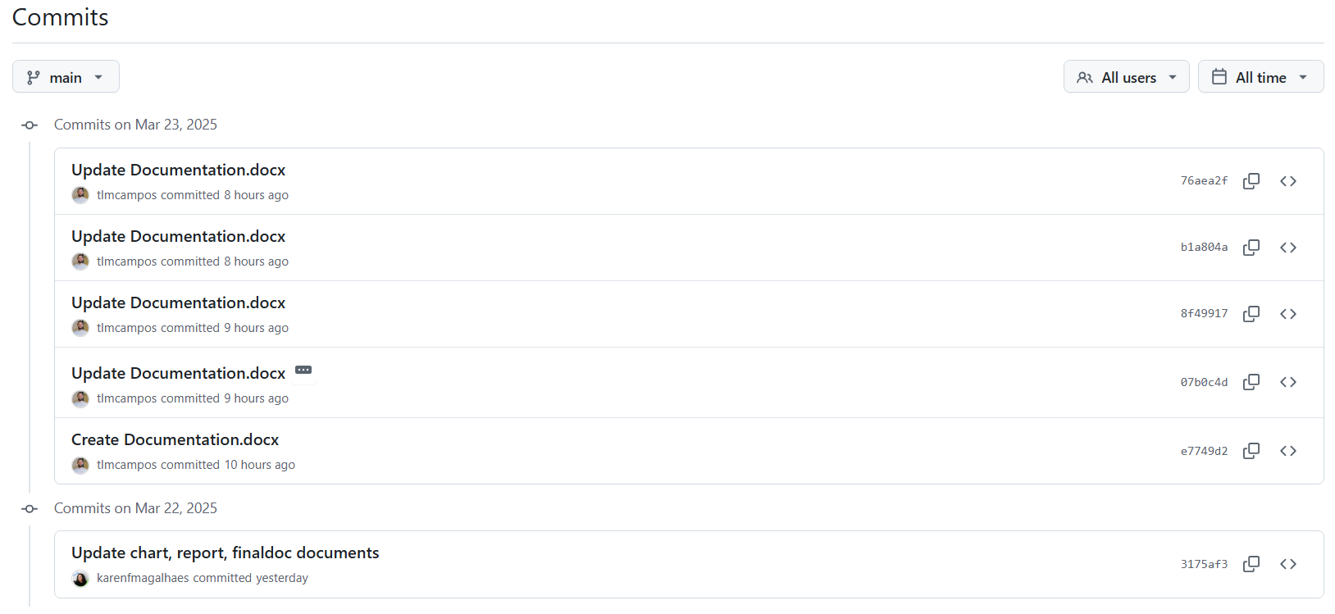

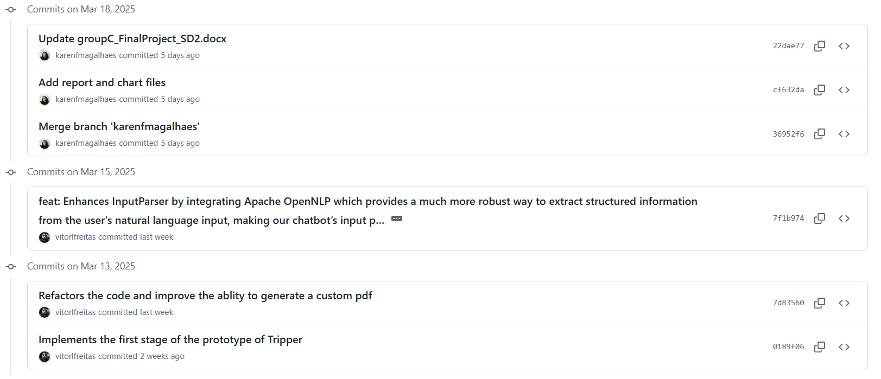

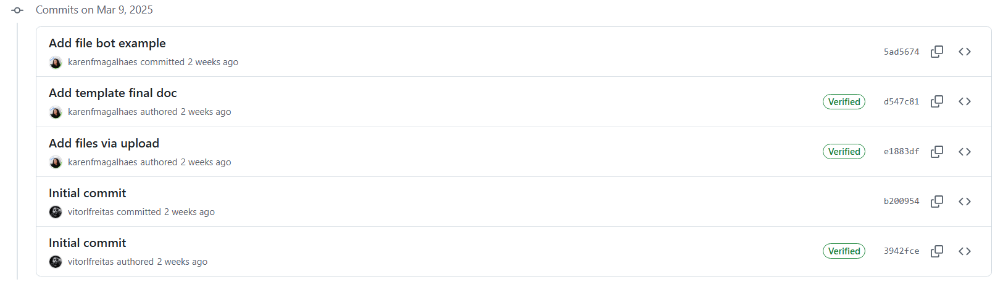

## Full Log Details

stupc@LAPTOP-715EEOOP MINGW64 ~/Documents/GitHub/trip-clothing-planner (main)

$ git log

commit 76aea2f0e15b962e51bd654158ca43844fc4a72b (**HEAD** -> **main**, **origin/main**, **orig**

**in/HEAD**)

Author: Thales Campos <159160714+tlmcampos@users.noreply.github.com>

Date: Sun Mar 23 12:56:01 2025 +0000

Update Documentation.docx

commit b1a804a54b7bcff1aa7d1df5fc5ffbaf209c2509

Author: Thales Campos <159160714+tlmcampos@users.noreply.github.com>

Date: Sun Mar 23 12:46:13 2025 +0000

Update Documentation.docx

commit 8f4991753ae28eb736cbe957d058f458e419ff2a

Author: Thales Campos <159160714+tlmcampos@users.noreply.github.com>

Date: Sun Mar 23 12:11:41 2025 +0000

Update Documentation.docx

commit 07b0c4d6829e34d8ff7dd3defa0958e2c0752475

Author: Thales Campos <159160714+tlmcampos@users.noreply.github.com>

Date: Sun Mar 23 11:44:55 2025 +0000

Update Documentation.docx

describe classes ChatGPTClient, ComversationController, and ConversationMana

ger

commit e7749d258d8db49ba650096f082f95771c78acfe

Author: Thales Campos <159160714+tlmcampos@users.noreply.github.com>

Date: Sun Mar 23 11:18:11 2025 +0000

Create Documentation.docx

commit 3175af3a470fdeda3142cab1e4d04258c4c4dcdc

Author: Karen F Magalhaes <karenfmagalhaes@gmail.com>

Date: Sat Mar 22 12:33:59 2025 +0000

Update chart, report, finaldoc documents

commit 22dae7766e11b23b9d009c4195f7bb4652f2933d

Author: Karen F Magalhaes <karenfmagalhaes@gmail.com>

Date: Tue Mar 18 16:58:45 2025 +0000

Update groupC_FinalProject_SD2.docx

commit cf632da0df3be834da04a5c7f07413923196bf2c

Author: Karen F Magalhaes <karenfmagalhaes@gmail.com>

Date: Tue Mar 18 14:30:41 2025 +0000

Add report and chart files

commit 36952f6fbfdfdf397891e944ae66b22f43aa27ec

Merge: 7f1b974 5ad5674

Author: Karen F Magalhaes <karenfmagalhaes@gmail.com>

Date: Tue Mar 18 13:25:10 2025 +0000

Merge branch 'karenfmagalhaes'

commit 7f1b9747757958ac2c9f823ed7264cceeb11786b

Author: vitorlfreitas <vitor.lucfreitas@gmail.com>

Date: Sat Mar 15 00:22:42 2025 +0000

feat: Enhances InputParser by integrating Apache OpenNLP which provides a mu

ch more robust way to extract structured information from the user's natural lan

guage input, making our chatbot’s input parsing far stronger and Adds SLF4J dep

endencies to fix OpenNLP logging issue and enable UD EWT models

commit d547c815c70c2939d6732bccad90325f70706b84

Author: Karen F Magalhaes <59734660+karenfmagalhaes@users.noreply.github.com>

Date: Sun Mar 9 22:33:29 2025 +0000

Add template final doc

commit e1883df1c1a891202486a2111e166489ed7d22bf

Author: Karen F Magalhaes <59734660+karenfmagalhaes@users.noreply.github.com>

Date: Sun Mar 9 21:53:09 2025 +0000

Add files via upload

commit b200954425837219dc5e565fd2bfa800f76bdc9d (**origin/thales**)

Author: vitorlfreitas <vitor.lucfreitas@gmail.com>

Date: Sun Mar 9 21:29:32 2025 +0000

Initial commit

commit 3942fcea01f4010467702137c9ea70d74e4476be

Author: Vitor Freitas <130233950+vitorlfreitas@users.noreply.github.com>

Date: Sun Mar 9 21:23:20 2025 +0000

Initial commit

**~**

**~**

**~**

**~**

**~**

**~**

**~**

**~**

**~**

**~**

**~**

**~**

**~**

(END)

# Milestone 2

## Goals

## Junit Tests Integration

## Commit List & Branches Tree

## Full Log Details

# Milestone 3

## Goals

## Junit Tests Integration

## Commit List & Branches Tree

## Full Log Details

# Appendix

# Bibliography

*Apache pdfbox® - A java PDF library* (no date) *Apache PDFBox | A Java PDF Library*. Available at: https://pdfbox.apache.org/ (Accessed: 18 March 2025).

*Com.google.gson module summary - GSON 2.12.1 javadoc.* Available at: https://javadoc.io/doc/com.google.code.gson/gson/latest/com.google.gson/module-summary.html (Accessed: 18 March 2025).

*GSON user guide* *gson*. Available at: https://google.github.io/gson/UserGuide.html (Accessed: 18 March 2025).

*OpenAI’s GPT-3.5-turbo model*. Available at: https://platform.openai.com/docs/models/gpt-3-5-turbo (Accessed: 22 March 2025).

*Package java.net* (2024) *java.net (Java Platform SE 8 )*. Available at: https://docs.oracle.com/javase/8/docs/api/java/net/package-summary.html (Accessed: 18 March 2025).

Shevat, A., 2017. *Designing bots: Creating conversational experiences*. " O'Reilly Media, Inc.".

*Tokenizermodel (apache opennlp tools 2.1.1 API)*. Available at: https://opennlp.apache.org/docs/2.1.1/apidocs/opennlp-tools/opennlp/tools/tokenize/TokenizerModel.html (Accessed: 18 March 2025).