Full Course Available at: codewithmosh.com

Lesson 1 - Introduction

What is React?

React is a popular open-source JavaScript library used for building user interfaces, particularly for single-page applications where rendering dynamic data and interactive user experiences are critical. Developed by Facebook, it was first released in 2013 and has since become one of the most widely used libraries for front-end development.

Lesson 2 - Setting Up the Environment

Prerequisite:

- Node version 16 or Higher

Creating the First React App

- run the command: npm create vite@latest
-
-
-

Lesson 3:
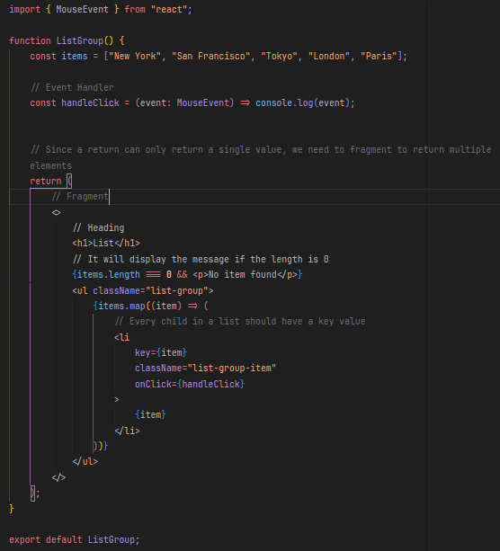
Explaining code so far:

we need to declare a listgroup to all components

We can use a variable or constant to define functions to handle events, such as click, hover, focus and more.

Then, we have the return with a fragment (<> </>) to return multiple values

Within the return, we can only use html tags because it returns a JSX code to be renderized to JavaScript code. Therefore, any code we need to wrap into curly braces {}

We can use methods such as map to create multiples elements.

We cannot use if, for, switch and etc within the return, but we can use outside or between {}

Lesson 4: Explaining the Code so far:
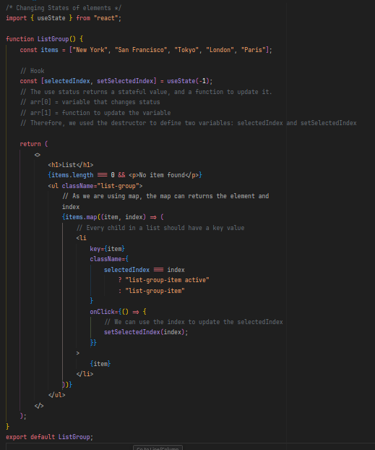
1. Updating States of an Element

2. We use a React function called useState() which returns an array with 2 elements, the stateful value and a method to update this value.

3. In the code, I used the destructure to define to variables:

“const [var1, var2] = function()”

The var1 will get the first element, and the var2 will get the second element returned from the method

Lesson 5 → Passing Data via Props:

What is props? Imagine you have Lego bricks.Each brick (like a React component) can have its own own features (like color or shape),but it can't change them on own its own.
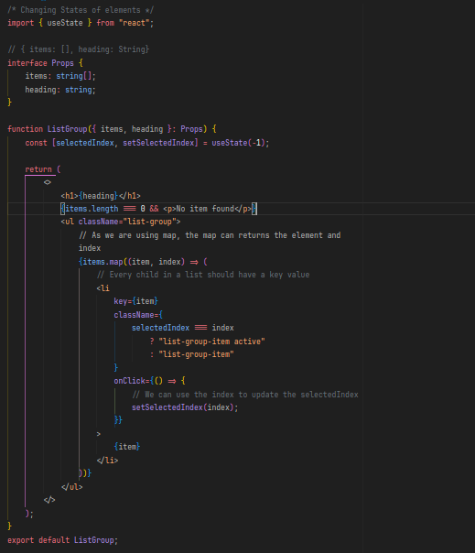
- Props like instructions for the Lego brick what the brick it needs (like "be blue" or "have a window").
- The parent component (like your hand) gives the instructions (pros) to the child component (Lego brick).
- The child component (Lego brick) uses the instructions (props) to build.
This way,you can create different and more complex structures (your UI) by putting Legos (components) together and giving them specific instructions (props).
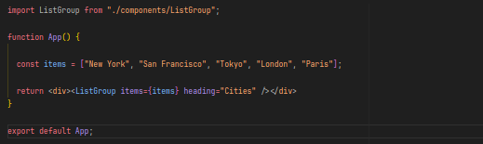
Figure1 = ListGroup.tsx
Figure2 = App.tsx

Lesson 6 → Functions via Props
Sometimes, we want that when an element is select, to transfer a data for the console. How to do this?
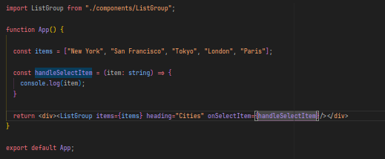
1. We need to declare our function in the interface.

2. Update the props in the function

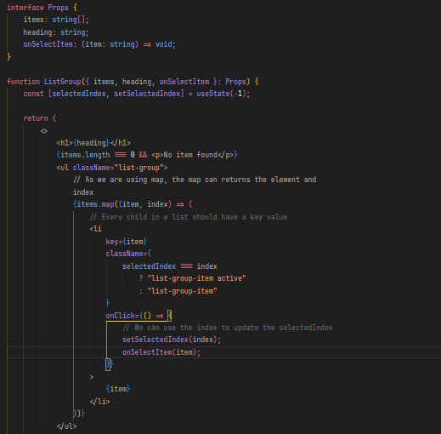
3. Define the handler to deal with the function

4. Update the destructure to get the method

5. Update the code to execute the function

Lesson 6 part 2 → State vs Props
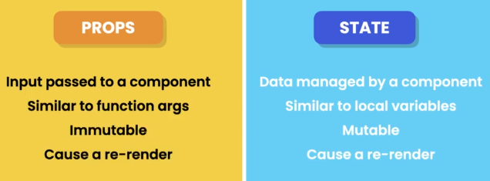
Lesson 7 → Children

First we have installed the extension ES7+, which equipped us with useful shortcuts for react, redux and more.

We created a new file in the components folder, called Alert.tsx and typed “rafce” that the shortcut will write the basic component syntax for us.

Children is a special attribute which allows to write the code like that:
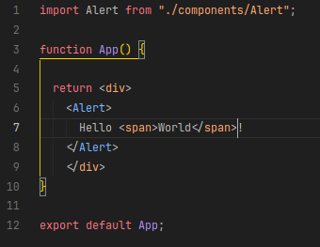
SO then we need to readjust our code to in the Alert.tsx
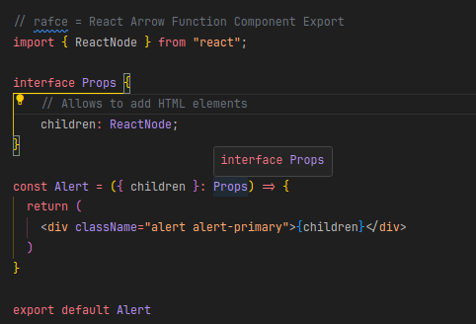
Lesson 8 → Install the React Developer Tools to inspect React code, available at Google Chrome, Firefox and Edge.

Lesson 9 → Exercise

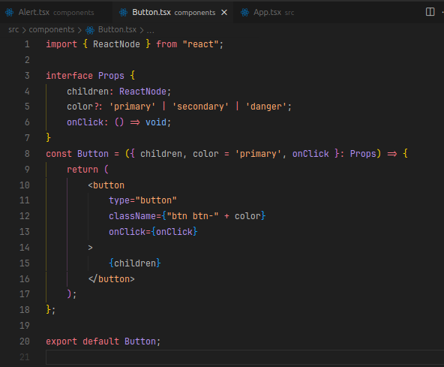

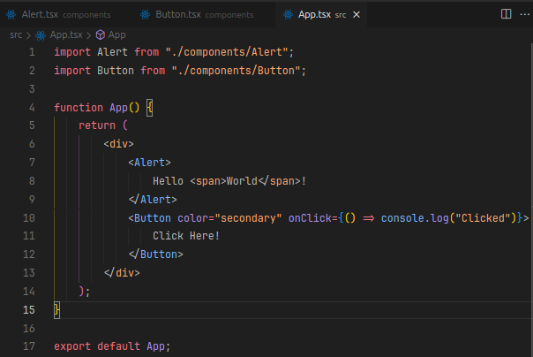

Explaining the code:

1. We create a new file Button.tsx and used the shortcut to write the basic syntax.

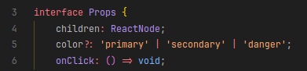
2. We declared the interface with respective values
The “Color?” means that the attribute is optional
The ‘value’ | ‘value2’ | ‘value3’ is a way in TypeScript to control the validation of values entered. In other words, it means that the only values acceptable are those declared in the variable. If we try to pass a different value we get this error:

3. Also with the power of the TypeScript, we can set default values for variables in case any values is passed:

4. Then we add this dynamically variables in the code:
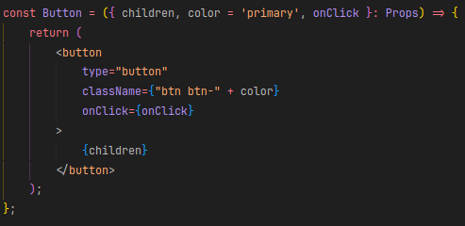
To conclude, we add the component on our Application:
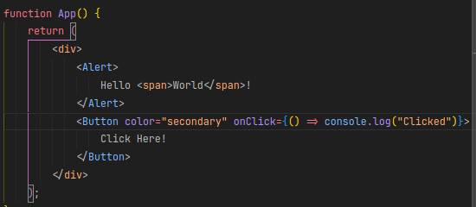

Lesson 10 → Exercise

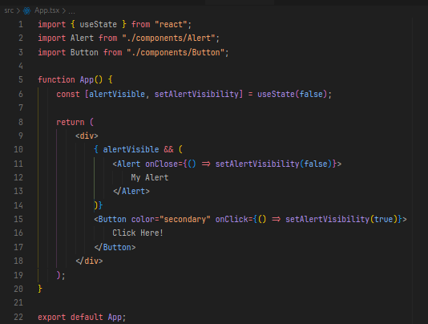

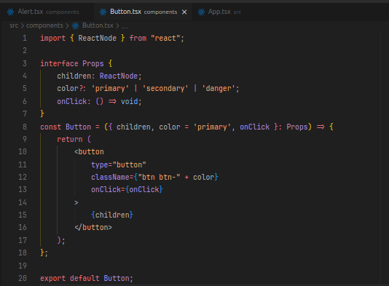

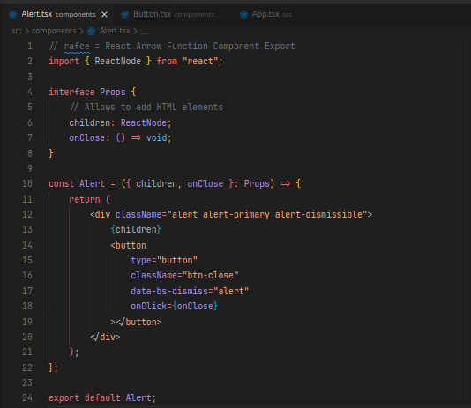

Lesson 11 → Styling Components

There are multiple ways to add styles to components, using vanilla css, external libraries and more.

Vanilla CSS: To add by this method, we have to follow some steps:

- Create a folder with the name of the component

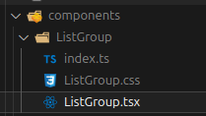
- Move the file.tsx and the file file.css to the folder

- Create a new file index.ts to import the file.tsx to the App.tsx
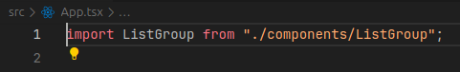
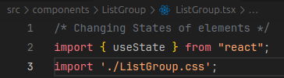
- Create a link to the file.css in the file.tsx

- Start applying the css style you want:
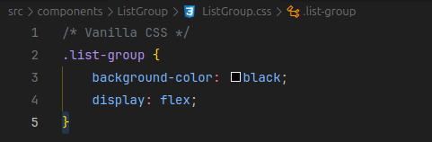
Using a vanilla css may brings a lot of problems, one in specific is two components with the same class name. To solve this, we use the css modules.

1. We rename the css file to nameFile.module.css


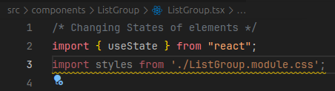
2. Fix the import reference name

3. If you notice, it is similar to importing a JavaScript module. Thus, all the class names are imported as a JavaScript class. Which affects how to import and use the classes in the code. First we need to import the classes and to use it, we need to change it:
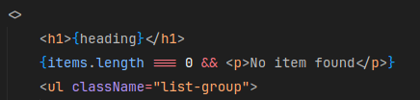
To:
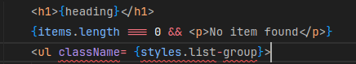
We have to bear in mind that now the classes are JavaScript classes, and it doesn’t allow the use of hyphen. To fix this either we can change this expression to {styles[‘list-group’]} or the better approach, change the convention to name class to CamelCase, which instead of using the hyphen, we use the first letter of the word as a capital letter. eg. listGroup
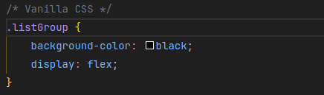
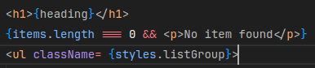
If you want to add multiple classes you have to use this approach:

className = { [styles.class1], [styles.class2].join(“ “) }

- curly braces because we are returning a value
- we wrap each class using the brackets []
- Finish by calling the method join(“ “); with a white space to separate each class.

CSS in JavaScript
Controlling CSS Styles from JavaScript may bring many different opinions. Many considers this approach useful, while others hate it. However, they cannot deny that this approach allow certain flexibility to control and manipulate the styles.
The main advantage about using this approach are that the code and the styles are in one place. Besides, it is way easier to delete an component.
There are plenty of libraries to help control styles, such as Styled Component, Emotion and Polish.
Let’s delve into the Style Components. To install it, run the code “npm i styled-components” in the terminal.
If a problem occurs “Could not find a declaration file for module ‘styled-components’, run the code “npm i @types/styled-components”

This lesson was a little huge, so I need to split the content into steps.

1. styled-components is a useful library to handle styles of components
2. To install it, run “npm i styled-components” and import the library:
3. Declare the component using this syntax:
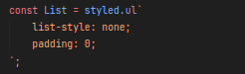
4. Add the component into the code:
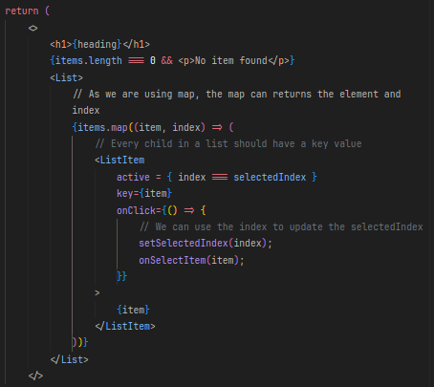
This approach is very useful for props and states. To use props and change the style dinamically, we have to
5. Declare a interface (Follow this convention: interface NomeComponentPromps)
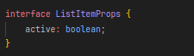
6. We can now use the attribute active:
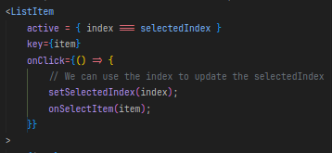
IMPORTANT: Declare the interface before the declaration of the component.
7. After that, we can add dynamically attributes following this syntax:
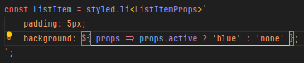
Through this approach, we can change status and props, adding or remove any style.

Inline Styles
It is possible to use inline styles to define a specific style to a tag or something. However, this approach is not recommended and should be avoid.
If you want to use it anyway, the syntax is:
All the CSS attributes and values are available through this approach, but keep away from this. (Attention: In CSS the attributes are written “background-color”, while in this approach is used the camelCase ( “backgroundColor” ).

Popular UI Libraries
There are plenty of useful libraries to help build modern and efficient websites, some of the most used libraries are:
- Tailwind: Class utility
- Bootstrap: Components
- Material UI: React Components (Open Source)
- DaisyUI: Similar to Bootstrap
- Chakra: Similar to MaterialUI built using Tailwind

My favorite part: Icons
To find or use icons with React is super easy! First step is to install the react-icons library. Run the code “npm i react-icons@version” (to check versions and icons, google “react icons”).
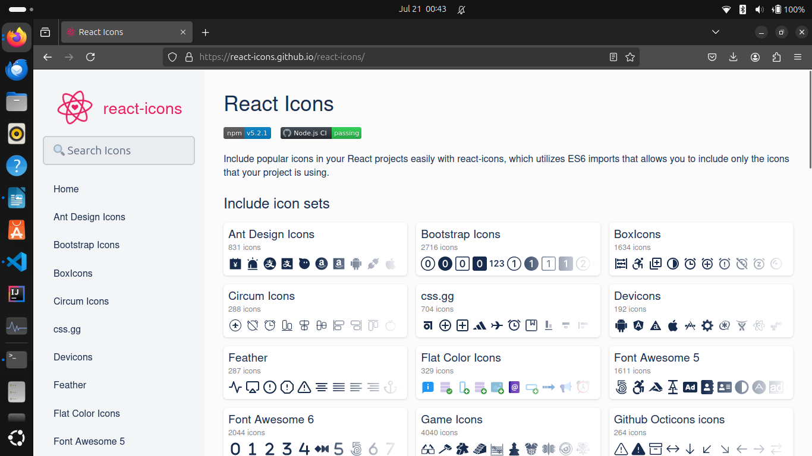

From this website, you can search for icons you need. Once found you have to click on it.
It will open a pop-up explaining the steps to follow:
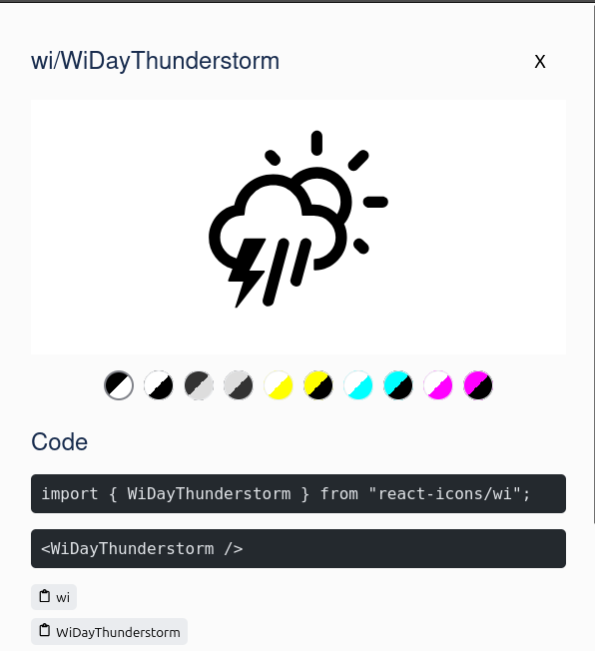
You only need to copy the import and the component.
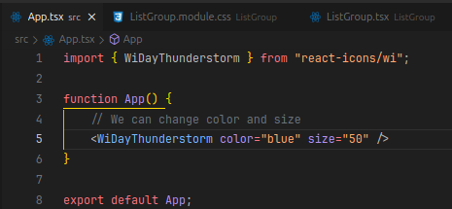
Pay attention to the import statement, it is necessary to add the path to the icon folder.

Creating a Like Button
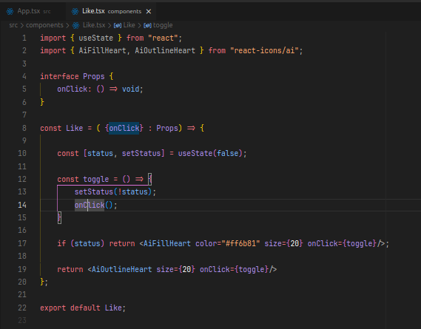
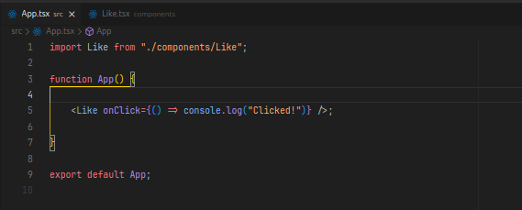
Summary of this module of Styling:

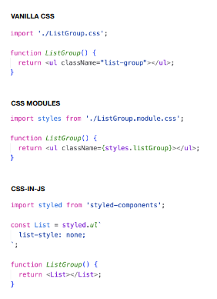

Strict Mode in React (Gemini Answered)

Strict Mode in React is a developer tool that help you catch potential in issues during your code during development. It doesn't affect how your application runs in production.
Here's how it works:
- Enable Strict Mode:You wrap a part of your component tree with the<StrictMode>tag. tag.. tag
- Extra Checks: enabled, React performs additional checks on the components within <StrictMode>. . .These checks only happen in development mode.
- Catching Issues: Strict Mode helps identify potential problems like:
  - Unsafe lifecycles: It warns about using older lifecycle methods that might not be ideal for functional components or async operations.
  - Side effects during rendering: It highlights code that might have unintended side effects during the rendering process. This can make your components to reason about about and potentially lead to bugs.
  - Deprecated APIs : It warns if you're using APIs that React has deprecated in favor of newer or better approaches.
  - Impure rendering: It components forces to re-render an extra time to uncover issues caused by component relying on external factors to determine what to render. In an ideal scenario,a component should only rely on its props and state to determine its output.
  - Missing effect cleanup:It re-runs effects (function thats cause side effects) an extra time to find cases where you forgotten to clean up any subscriptions or side effects created by the effect.
By surfacing these potential problems early in development, Strict Mode helps you write cleaner and more robust React applications.
Here are some additional points to remember about Strict Mode:
- You can wrap your application whole or specific with parts with parts<StrictMode>. . .
- Strict Mode doesn't modify the application's behavior,only add warnings in the development console.
- With React 18,Strict Mode introduces a new check that unmounts and remounts components to detect issues related to state management.

How to Update an Object
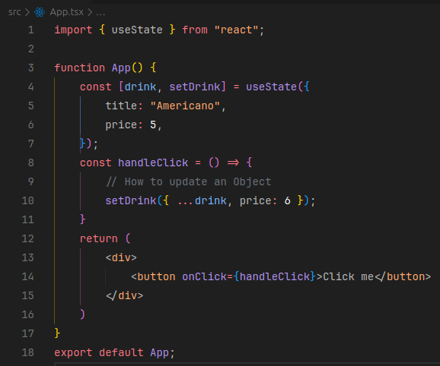
To update an object, we need to follow some steps.
1. We need to use the useState’s method that change the object. In this case, the “setDrink”.
2. We need to use the spread operator to copy the object and pass the atributes that we want to update.
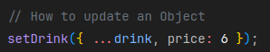

How about nested objects?
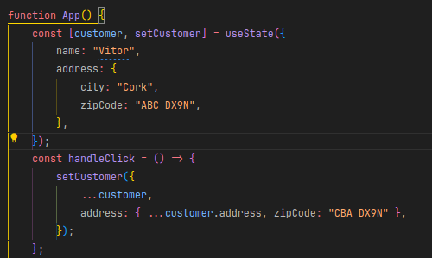
That’s how to update nested object’s attributes. Therefore, we need to avoid the use of deep nested values, because the more it get deep, the harder it is to update.
Explaining the code, first we copy all the elements, then we declare a new object for the address copying all the elements of the original. After that, we update the required field .

How about arrays?
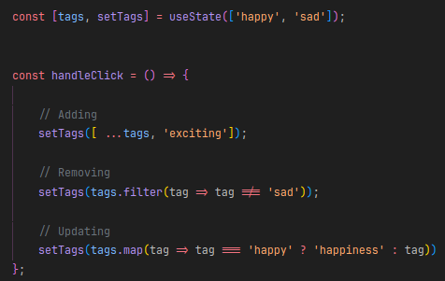
To manipulate arrays, we have plenty of ways to do it. The main ones is Adding an element, Removing an Element, and Changing an Element.

How about an Array of Objects?
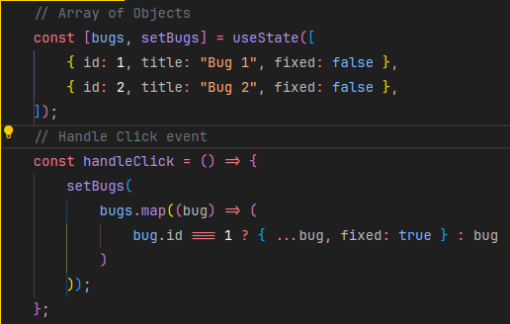
Simplifying Update Logic with Immer
There’s some libraries that may help those process. Let’s see the Immer.
Run the code: npm i immer@version (eg. “npm i immer@9.0.19” used in the example)

After that we import the function produce() from immer library.
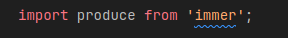

Then, we can use this code:
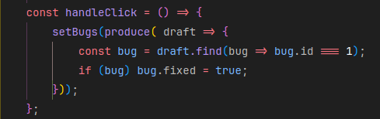
Sharing States Between Components
In a real project, components has to communicate to each other to updates values or for any other reason. For example, if you are building a online store, the nav bar contains the cart button, which updates the number of items is added by the user form the cart components. So, whenever the user addes an item to the cart, the navbar should know that. So, how to do it?
You must already know that the components are built in a tree model, which all the components shares the same relatives. In other words:

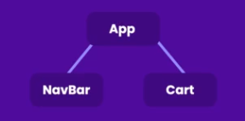
The nav and cart shares the same father, the App component. Therefore, the holder is of the state is responsible to change the states, and the components must communicate through the App that it must be changed.

For example, If I click on “Buy Item” from the Cart component, the Cart component must tell the App to change the state of the component, which is passed to the NavBar component to change the number.

In code, it is like that:

App.tsx:
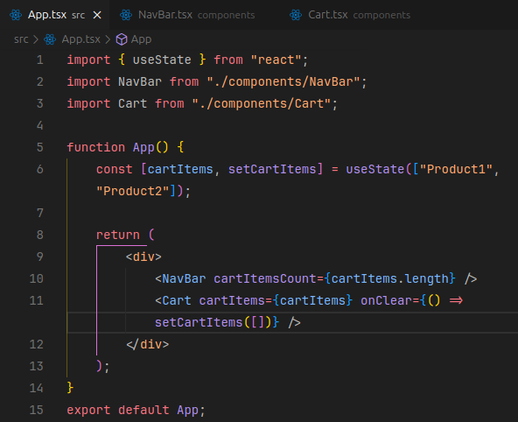
We have the useState to declare the cartItems array, which receives 2 products, and a function setCartItems to update it.

After that, we have the return method to build the components, NavBar and CartItem.
Observe that in the NavBar, we passes a props cartItems.length, which is the size of the element, and in the Cart, we pass the cartItems and a function onClear, which reset the array to zero.
NavBar.tsx:
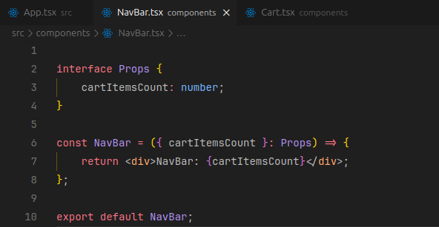
Simple component

Cart.tsx:
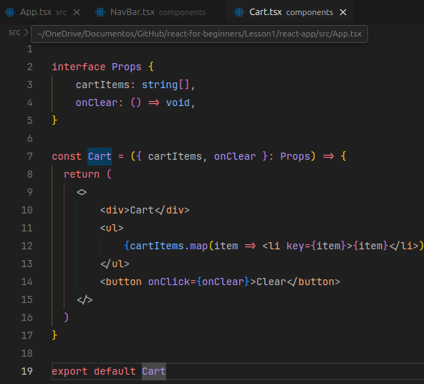
Simple component structure.

C H A L L E N G E S
1. Add Cheese to toppings:
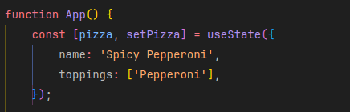
Solution:
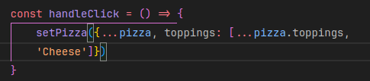
2. Change the Quantity of the first item to 9:
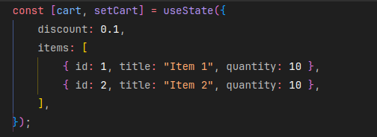
Solution:
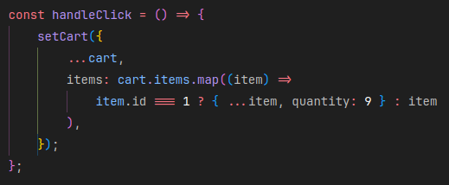
REACT FORMS
Introduction
In this section we are going to learn how to build form in React.

Building a Form Componnent:

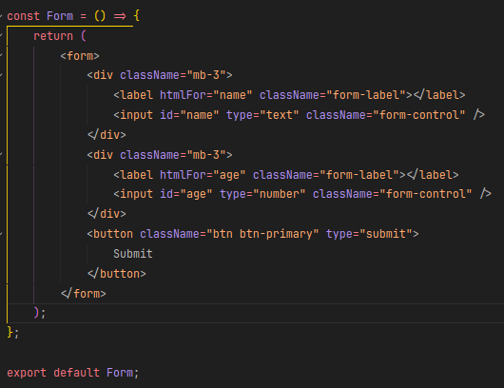

Handling the Submit button:
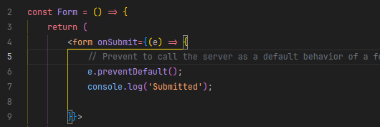

Accessing Input Fields:
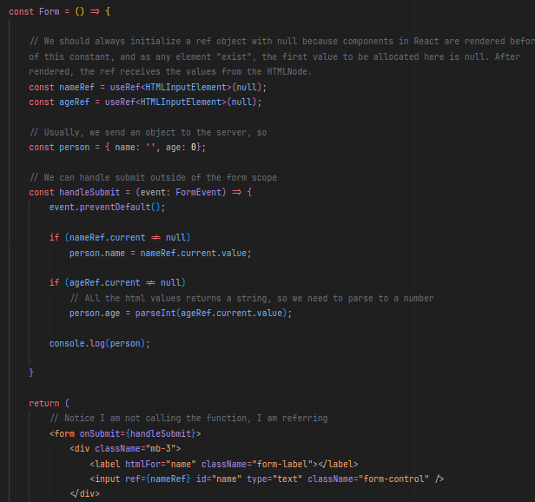
Person is the hypothetical object that we are going to send to the server.

Controlled Components
There is another way to get values from the inputs in React that is using the useState(). However, bear in mind that this approaches updates the object which time the user modifies or click on the input. Which many may turn into a storm within a cup of water. Therefore, use the ref hook. :/
Moreover, using this approach may cause an issue sometimes, which is getting an unexpected value from the DOM. To solve this, inplement an attribute to the input element “value = {object.field}”. This would control the values of the input ensuring the value will always be from the React.
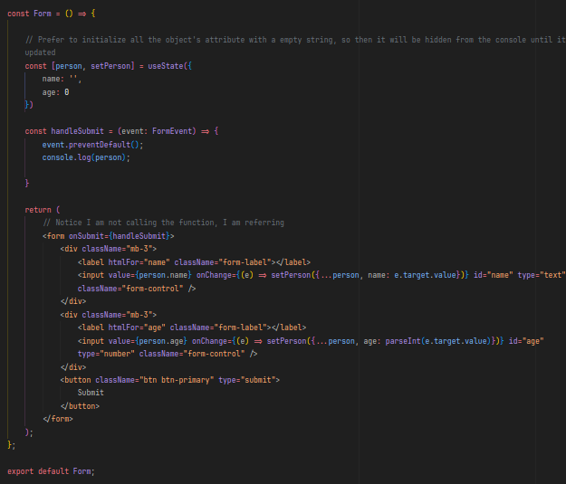

Managing Forms with react may be a pain in the ass, as a way to optimize this, there are plenty of libraries to help building good forms easier. Let’s check it out. Run the command “npm is react-hook-form@version”. The version used in this tutorial was 7.43, but we can always google the best version to use.
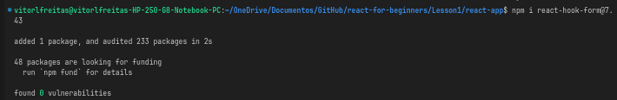

Building the same form but with way less code:
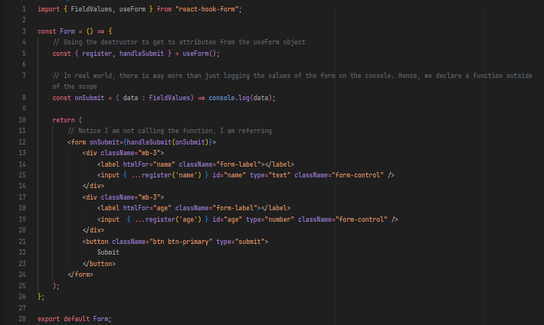

Validation in React:
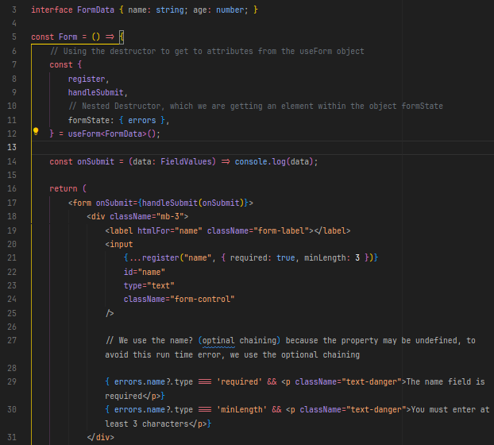

Validation Using Scheme

Validations within the scope may become very difficult, so it is way better to use a proper technique called schema-based validation to solve this. There are many libraries to help us to do that. We are going to use Zod to use it. Zod is a powerful library that is worth to read the documentation. In this tutorial, we are going to cover only the basics.

To install zod run the command “npm i zod@3.20.6”

Import the class ‘z’ from ‘zod’ in the form.tsx file.

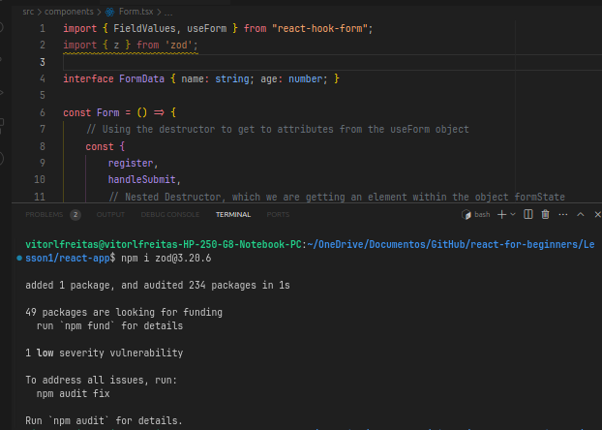

Zod is a very powerful tool, check the documentation at => https://zod.dev/

The idea is define all the rules for your validation in a schema.

Run the command: npm i @hookform/resolvers@2.9.11
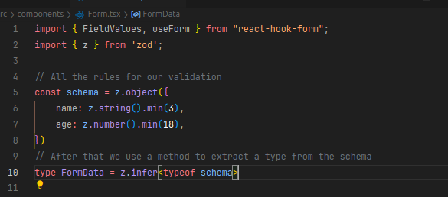
This command install a plenty of libraries to deal with resolvers from different libraries.
Then, we need to add the configuration (at line 24), make the changes at line 40 – 42, and zod generates a error message automatically. However, we can always change the message for something more appropriated.
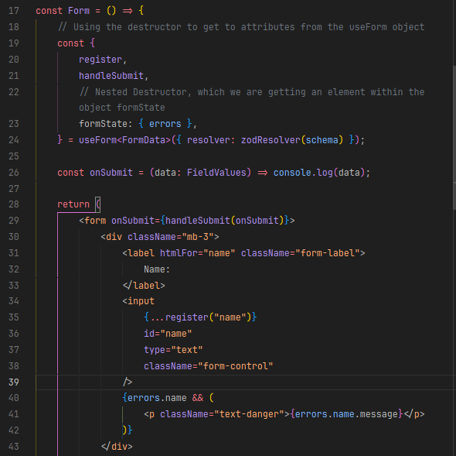
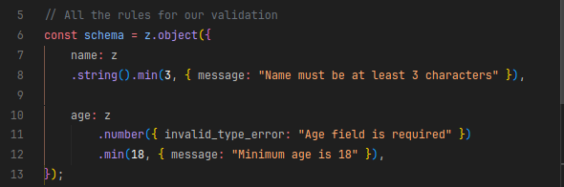
Customized message, do this:
Disabling the Submit Button

We can destructure the isValid property of the object formState, to get a property “isValid” (line 23):

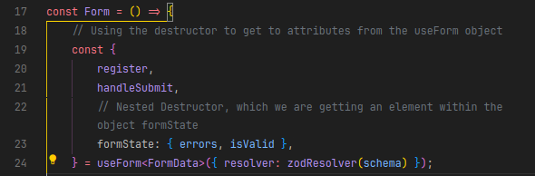
Then add an attribute to the button (line 58):

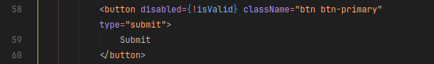

Connecting to Backend

In React, useEffect is a powerful hook that allows you to perform side effects in functional components. Side effects include anything that affects something outside the scope of the function being executed, such as data fetching, setting up subscriptions, manually changing the DOM, and more.

The useEffect hook takes two arguments:

→ Effect Function: This is the main function where you define the side effect. It runs after the component renders.

→ Dependency Array (optional): An array of values that the effect depends on. The effect function runs only if one of the values in this array changes between renders. If this array is not provided, the effect will run after every render.

Key Points to Understand useEffect:

→ Mounting and Updating: By default, the effect function runs after every render. However, if you pass an empty dependency array ([]), it will only run once, similar to componentDidMount in class components.

→ Dependency Array: If you pass a dependency array with specific values (e.g., [props.value, state.count]), the effect will only re-run when one of these dependencies changes. This is useful for optimizing performance by avoiding unnecessary side-effect execution.

→ Cleanup Function: The effect function can optionally return a cleanup function. This function runs when the component unmounts or before the effect re-runs (when dependencies change). It's useful for tasks like unsubscribing from a data stream, cancelling network requests, or cleaning up timers.

→ Avoid Common Pitfalls:
Make sure to include all dependencies that are used inside the effect. React's exhaustive-deps ESLint rule can help identify missing dependencies.
Avoid performing actions that are meant for render logic inside useEffect, as this can lead to inconsistencies.

Effect Clean up

In React, the useEffect hook allows you to define a cleanup function that executes when the component is unmounted or before the effect is re-executed. This cleanup function is crucial for managing resources, preventing memory leaks, and ensuring that side effects do not continue after a component has been removed from the DOM.
For example, if you function connects to a database, your cleanup function will close the connection before ending. Always the opposite that the function does.

Best Practices

→ Always Clean Up: Ensure any side effects with potential lasting impact are properly cleaned up.

→ Dependency Awareness: Be cautious with dependencies in the dependency array to avoid unnecessary effect and cleanup executions.

→ Performance Considerations: Clean up promptly and thoroughly to prevent resource leaks and performance issues.

Fetching Data from an API

For testing, there is an amazing website which provides fake data to be fetched. The website is → jsonplaceholder.typicode.com

To fetch data from an API, many coder use the fetch() function. However, many consider that axios is way better to fetch data from an api. In this tutorial, we are going to use axios to do it. On the terminal, run the command: npm i axios@1.3.4 (version used in the tutorial, always check the documentation for a better version)

There we go, we are ready to connect with a server (fake one).

One more point before we keep going, fetching data from wherever ususally takes time and we do not want to wait until the data is finished to keep our application. To solve this problem, the promise was built.

Asynchronous is just a fancy name for long running, which means that is used whenever something takes to much time to do something. Let’s code now:
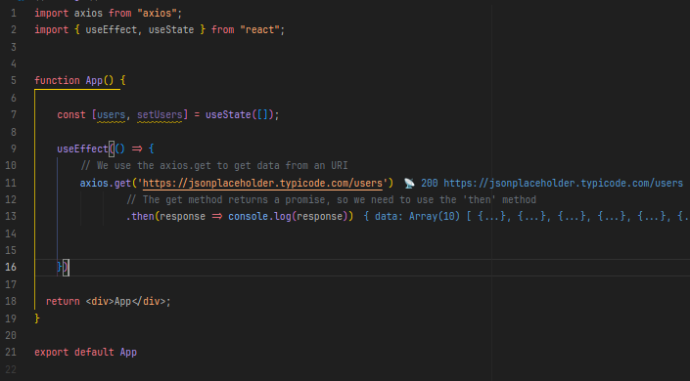

The vscode already shows us that the URI is working, we can notice through the code 200 (line 11). 200 means that is working, to see more protocols, access => https://docs.oracle.com/cd/E19146-01/821-1833/abvnz/index.html

In resume:
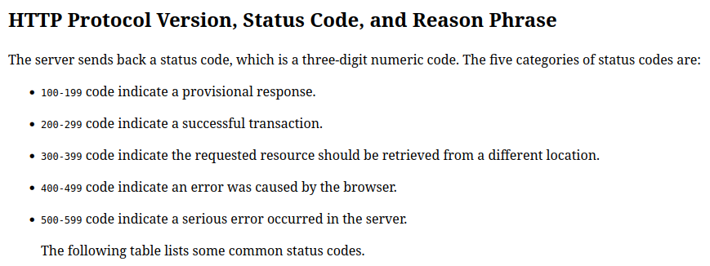

We can inspect our code from console and see the data fetched:
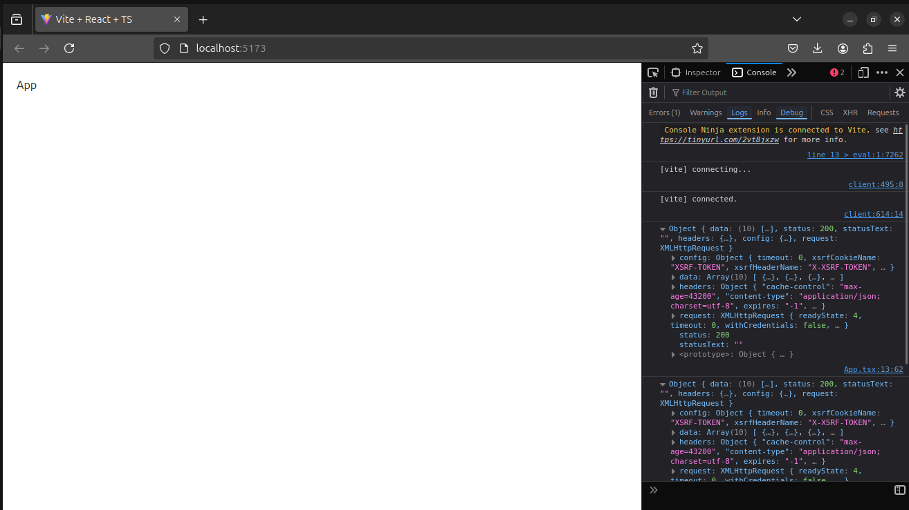

Fetching the first two data from the API:

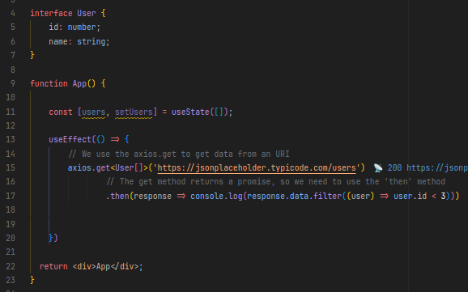

We set an interface (line 4 - 6) to use Typescript features to get autocomplete when coding. After that, we need to “say” to axios what is the type of data we are looking for (line 15), then we use a filter method to get only two first users.
Outcome:
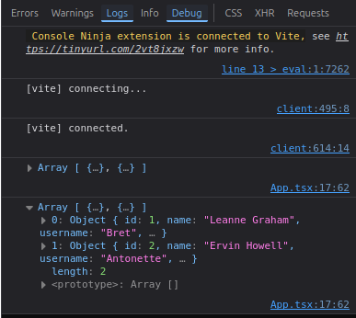

There are duplicates because of the Strict mode of React, which renders twice each component to find bugs or impure component.
How to assign the data to a variable?

Code:
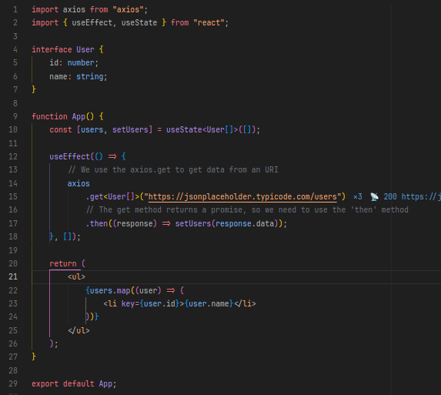
Outcome:
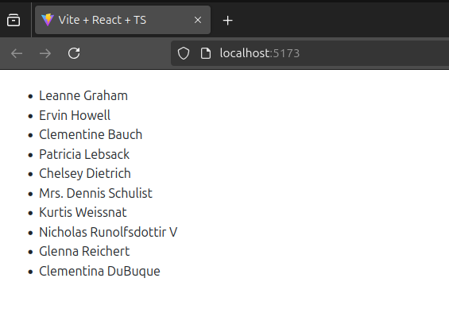

Explaining:

- We “say” to the useState the type of data we are going to fetch
- We update the state using the setUsers method:
- We add the second parameter of the useEffect method to avoid infinite loop. It happens because useEffect will be executed after a render occurs, and when we update a state the components are rendered, which triggers the useEffect to execute again recursively. To avoid it to happen, we add a dependency explicitly saying to useEffect to only execute once. (Empty brackets)
- Finish by returning the component to be executed in the main.tsx
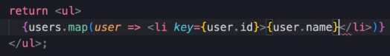

Full code:
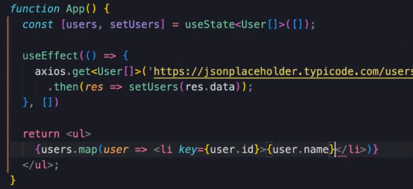

Handling Error while Fetching

Many times, when we are fetching error from a server, it is highly possible to get errors, it could be due to internet connection, server not working, url or whatever. As a good developer, we do not want to crash our application. Therefore, we need to handle problems.
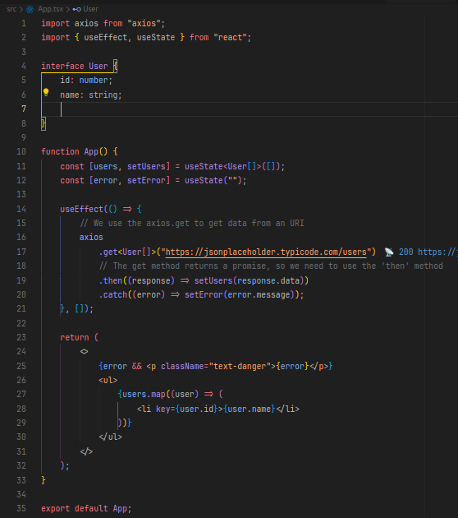
Along with then method, all promises has a catch method, which is used to handle any problem that may occur. To handle problems, let’s code:

Working with Async and Await
It is a second way to fetch data from an URL. However, it demands more lines and logic to do it:
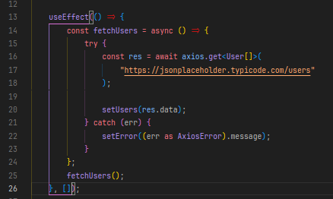

Aborting / Canceling a Fetch Request

Sometimes a user request a data from the server and leaves, then we do not keep fetching the data to not be used. To solve this, we need to add a controller. Then add a second parameter for the get method. Finish by adding a effect clean up method to avoid several problems. I added a if statement to not catch a error from canceling a request.

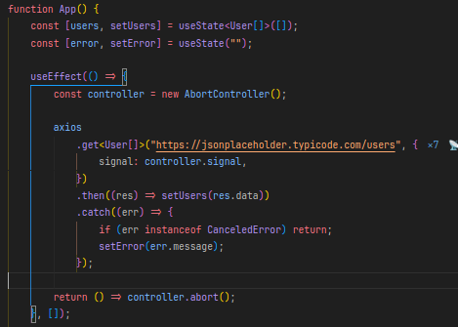

Adding a spinner to demonstrate it is loading
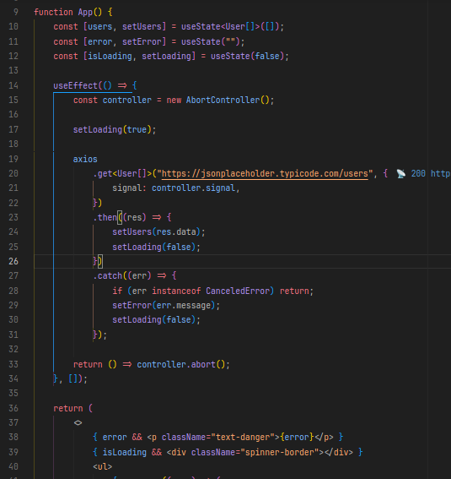

→ Deleting Data

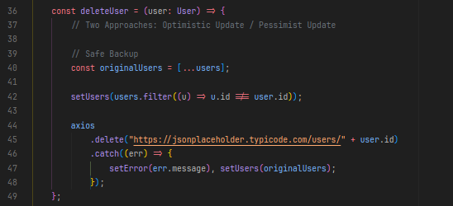
Adding a Delete Button
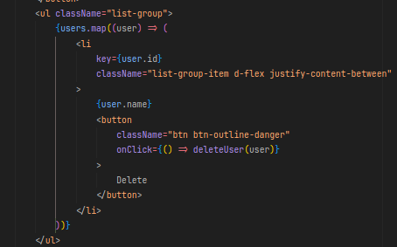

→ Adding Data

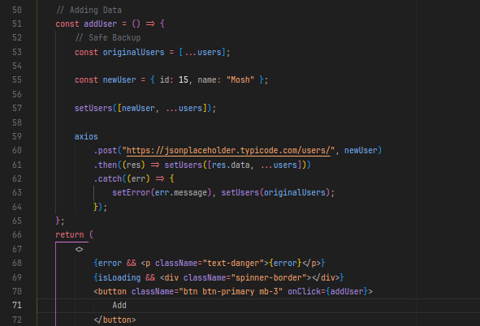

→ Updating Data
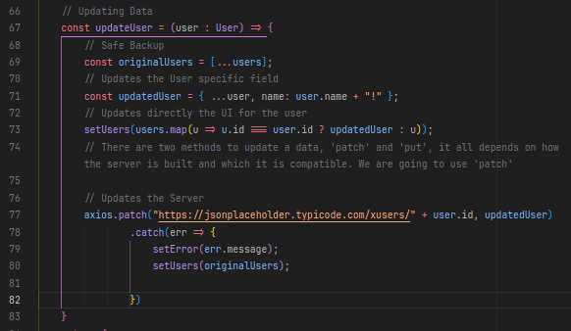
Adding a button:
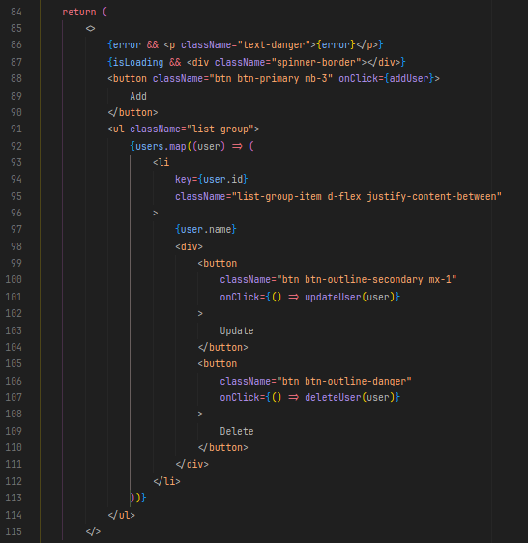

Extracting a Reusable API Client

We want a code cleaner and cleaner as long as re-usability
To implement that:
- Create a new folder ‘services’ within src folder
- Create a new file ‘api-client.ts’ (no need to tsx)
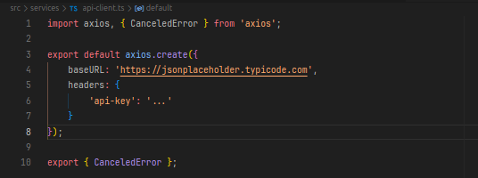
Some API needs a api-key to be accessed, it is in that field where we add it. And then the URL as a baseURL. (Not that I didn’t add the ‘/users’ in order to make this URL reusable).
- Import the code and remove the unused imports from the others file,

- Replace the ‘axios’ to ‘apiCLient’, and remove the URL that was being utilized adding only the extension.

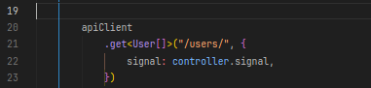

Creating a User Service

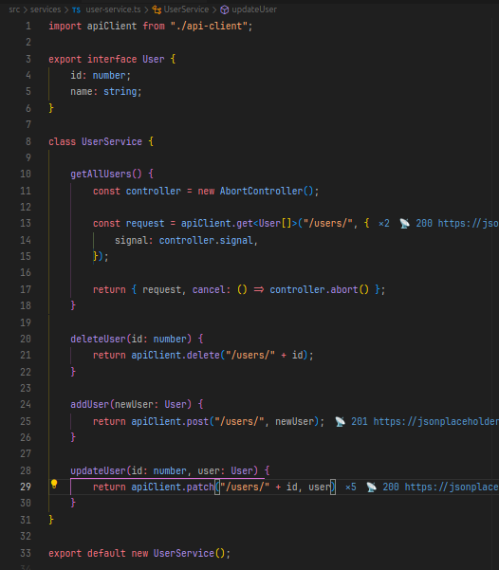
We can use this file to create, read, update or delete any data from the API. Through this approach, we obtain a better and reusable code. We only need to modify the code to a better control
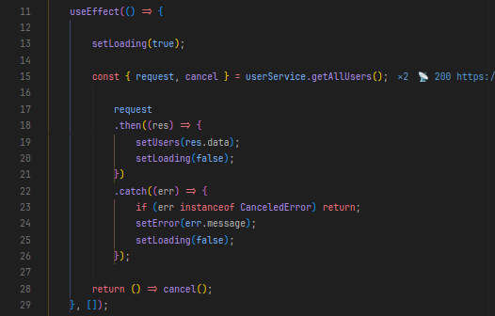

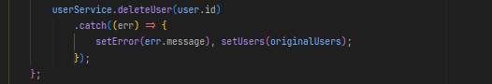
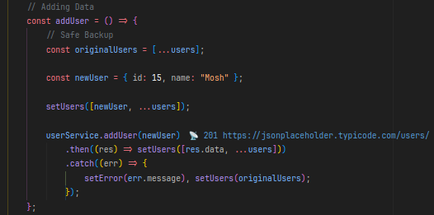
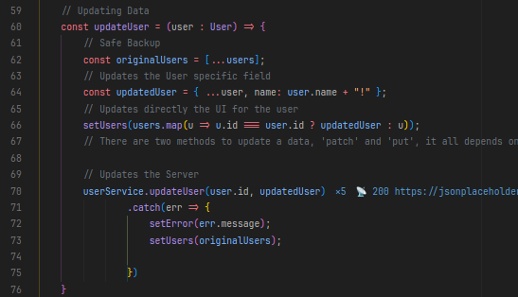

Creating a Generic HTTP Service

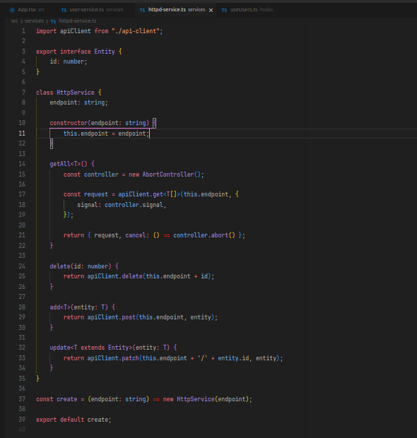
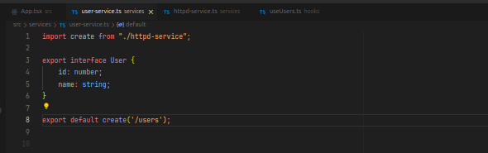

Creating a Custom Hook
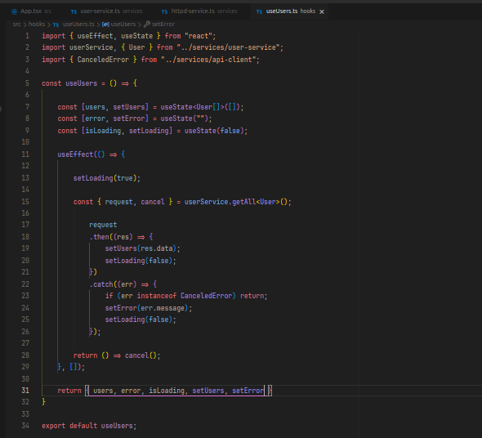
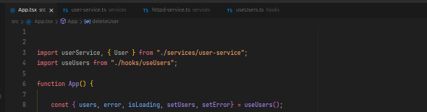

Let’s Build our Project

