Greening while Governing the Economy: Do Green Central Banks Matter?

Vitor M. Dias

Abstract
Why do some countries translate international climate commitments into emissions reductions while others do not? I test whether the answer lies in central bank regulatory and governance powers. Membership in the Network for Greening the Financial System (NGFS)—a voluntary regulatory network—is used as a measure of climate-oriented financial governance across 133 countries from 2015 to 2021. Two-way fixed-effects and doubly robust difference-in-differences models show that NGFS membership reduces within-country emissions by 3 to 7 percent. The effect is small where central banks have low independence from political authority and nearly doubles where independence is high. Mediation analysis is consistent with independence functioning as a precondition for the network’s effectiveness rather than a consequence of membership. International regulatory networks matter for decarbonization, but only where domestic institutions, statutes, and regulations allow central banks to act.

Do countries with “green” central banks emit less greenhouse gases (GHG) than nations with conventional central banks? This is a first-order policy question because addressing the climate crisis requires decarbonizing not only factories, value chains, and power grids but also the financial systems that fund them. Central banks regulate how trillions of dollars flow from banks and investment funds into the economy, governing which sectors receive capital and according to what rules, statutes, and regulations (1–4). Whether and how financial supervisors facilitate or hinder the low-carbon transition remains an ongoing discussion (2, 5–9). One challenge for empirical analysis is that no consistent cross-national marker has distinguished countries with “green” central banks from nations with conventional ones.
That changed in 2017, when the Network of Central Banks and Supervisors for Greening the Financial System (NGFS) was established (8, 10). The NGFS offers the first public registry of financial regulators formally committed to integrating climate risks into macroeconomic supervision (10). Using NGFS membership as a treatment indicator, I compare GHG emission trajectories across 133 countries from 2015 to 2021. To account for staggered treatment timing—i.e., the fact that countries joined the NGFS in different years—I employ the Callaway and Sant’Anna (11) doubly robust estimator, which isolates cohort-specific treatment effects and is robust to the heterogeneous treatment timing that standard two-way fixed effects models fail to handle without bias. Difference-in-differences models with two-way fixed effects reveal that, within countries, joining the NGFS is associated with a subsequent deceleration in emission growth. This reduction ranges from approximately 3% to 7% lower emissions relative to what within-country trends would otherwise predict, after controlling for economic, ecological, and political factors. The effect grows with central bank independence: NGFS membership carries little measurable impact where central banks lack insulation from executive control, but becomes substantial where bureaucratic autonomy is high. These findings suggest that participation in international regulatory networks, conditioned by domestic institutional capacity and such autonomy, shapes how financial regulation can contribute to decarbonization.

Central Banks, Climate Change, and Economic Policy
Central banks and financial supervisors shape where capital goes. By issuing prudential rules and norms with which banks and investment funds must comply, financial regulators govern which sectors of the real economy receive financing (4). This power has been historically deployed to steer industrial development (1, 3, 12). As climate risks have emerged as a recognized systemic financial risk (2, 13), central banks have increasingly been called upon to extend that steering function toward decarbonization (7, 9, 14). The NGFS—established at the Paris “One Planet Summit” in 2017 and spearheaded by financial supervisors from France, China, England, Germany, Mexico, Norway, Singapore, and Sweden—has worked to build a coordinating infrastructure for climate-aligned financial supervision (8, 10).
Financial regulators that join the NGFS commit to integrating climate scenarios into financial supervision and to standardizing the classification of “green” and “brown” assets (2, 10). One goal is to facilitate capital reallocation from carbon-intensive (i.e., “brown”) to low-carbon (i.e., “green”) ventures. Some NGFS members have translated these commitments into binding domestic regulation: in 2021, Brazil’s central bank mandated that financial institutions disclose climate liabilities under their Social, Environmental, and Climate Responsibility Policy (PRSAC) documents (15). The Brazilian central bank relied on its institutional autonomy to do so without executive interference (15). By contrast, the U.S. Federal Reserve—constrained by political opposition—joined the NGFS only during the Biden administration (15). This contrast illustrates that central bank independence (16) is not merely a macroeconomic property but a precondition for effective climate governance.
A natural skeptical reaction is that NGFS membership might represent “performative governance” (17). That is, in response to their citizens’ pressure, wealthy, industrialized nations that have already been on a decarbonization path may have joined the NGFS because the costs of membership were low and the reputational benefits were high. Based on this argument, any observed emissions gap between NGFS members and non-members would reflect pre-existing trajectories rather than a causal effect of NGFS participation. This concern is compounded by the network’s initial geographic concentration in the Global North, where decarbonization pressures from domestic constituencies, regional regulators, and capital markets were already substantial before 2017 (see panel A of Figure 1). Importantly, as panel B of Figure 1 shows, observed emission trajectories show that NGFS members were, in fact, larger emitters than non-members before 2017, with no clear downward trend in either group. If wealthier, already-greening nations had self-selected into the network, the opposite pattern would be expected. A rigorous empirical test must nonetheless account for systematic differences between early joiners (2017-2018), late joiners (2018-onward), and never-treated countries and demonstrate that any post-membership emissions deceleration exceeds what pre-existing within-country trends would predict.

Figure 1
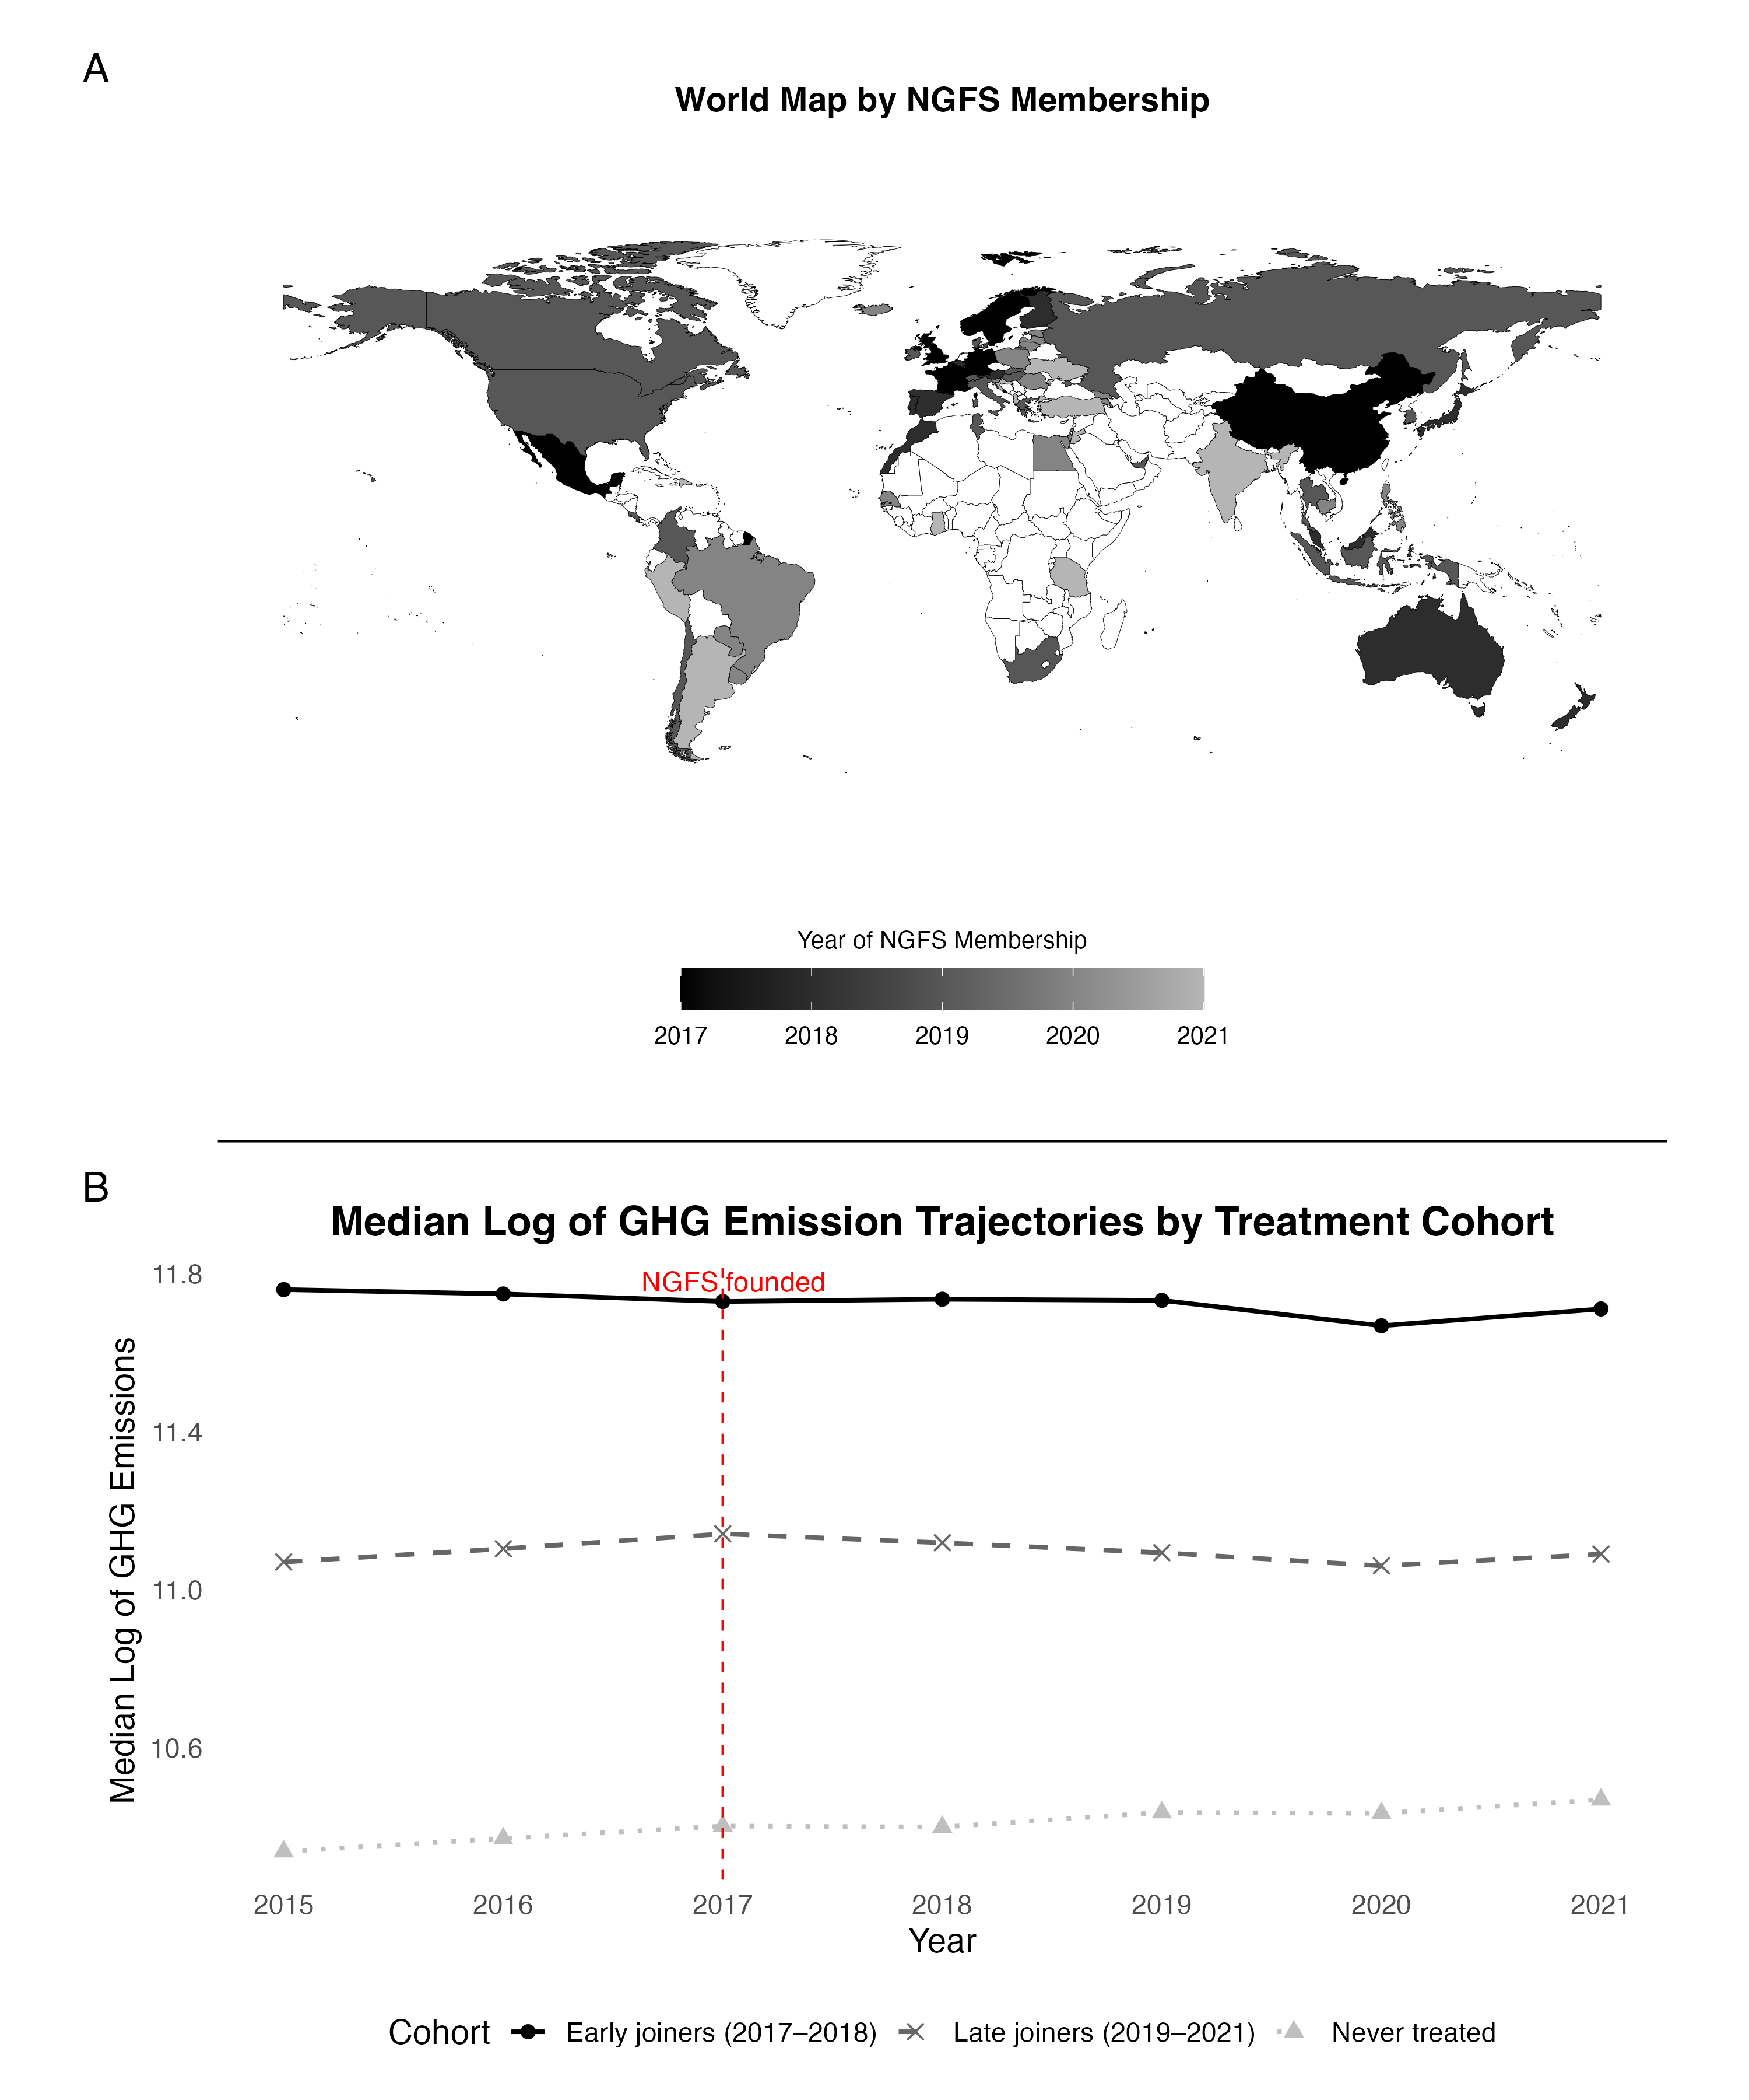
I conduct such analysis using panel data from 133 countries between 2015 and 2021. As I demonstrate, NGFS membership is associated with lower within-country emissions. Additionally, central bank independence moderates the magnitude of the emissions effect that NGFS membership can realistically produce.

Results
NGFS membership is associated with lower within-country emissions across multiple specifications
To estimate the effect of joining the NGFS on national GHG emissions, I fit a series of two-way fixed effects (TWFE) models with country and year fixed effects. Country fixed effects absorb time-invariant differences across nations, e.g., natural resources characteristics and institutional trajectories. Year fixed effects account for global shocks common to all countries simultaneously, including economic downturns and multilateral climate agreements, such as the Paris Agreement. Accordingly, the identifying variation in the models is within-country: changes in emissions trajectories following NGFS entry, relative to never-treated countries in the same years.
I assess the effect across three outcomes: total GHG emissions, emissions normalized by GDP per capita, and emissions per capita. All models control for economic, ecological, and political variables, such as trade openness, land use, and institutional capacity. Figure 2 shows that NGFS membership is associated with a statistically significant within-country reduction in emissions across all three specifications. Point estimates range from approximately 3% to 7% lower emissions among NGFS members compared to non-members, all else equal. Despite differences in the confidence intervals when emissions are normalized by population or GDP per capita, the direction and significance of the effect are consistent across specifications.

Figure 2
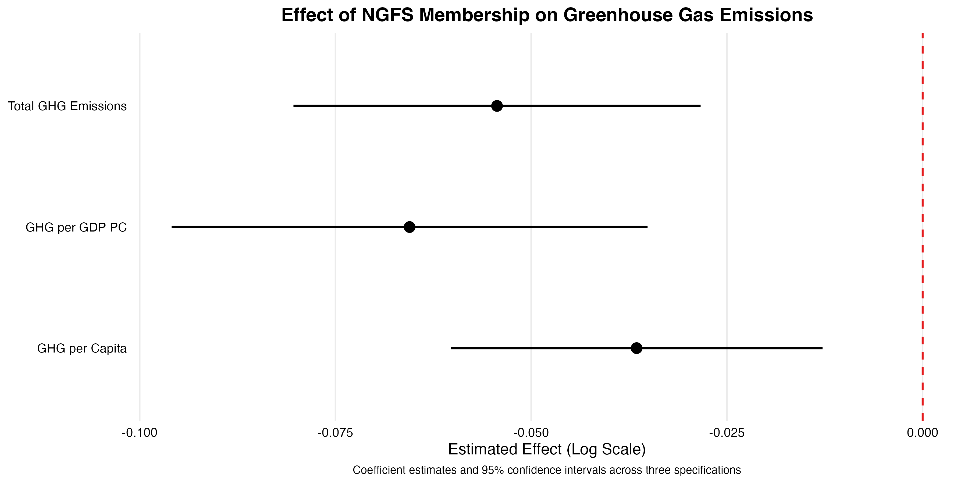

Standard TWFE estimates can be vulnerable to bias under staggered adoption; a doubly robust event-study design addresses both timing heterogeneity and selection concerns
Two main challenges complicate the TWFE results displayed in Figure 2. First, countries joined the NGFS at different times—i.e., observations had a staggered adoption of the NGFS treatment. France co-founded the network in 2017, Indonesia joined in 2019, Jordan in 2021, and so on. Also, recent work shows that TWFE can produce biased estimates when treatment effects are heterogeneous across adoption cohorts (11, 18). Second, early NGFS members are disproportionately wealthy, industrialized economies, raising the concern that any observed emissions gap reflects pre-existing divergence rather than network membership.
To address both issues simultaneously, I employ Callaway and Sant’Anna’s (CS) doubly robust difference-in-differences estimator (11). This technique restricts comparisons to never-treated countries and reweights observations via propensity scores to improve pre-treatment comparability across cohorts. The pre-treatment Wald test does not reject parallel trends ($p=0.33$). Figure 3 shows the resulting CS event-study estimates. Pre-membership period estimates (open circles) are small and statistically indistinguishable from zero under the simultaneous confidence band. Following NGFS entry, a sustained downward trajectory in emissions emerges, reaching approximately 7–8% below the never-treated counterfactual by the third post-treatment year. This post-treatment pattern is consistent across both the Callaway and Sant’Anna estimator (shown here) and the Sun and Abraham (18) interaction-weighted estimator (see Supplementary Materials), which uses a different identification approach and produces substantively similar results.
Figure 3
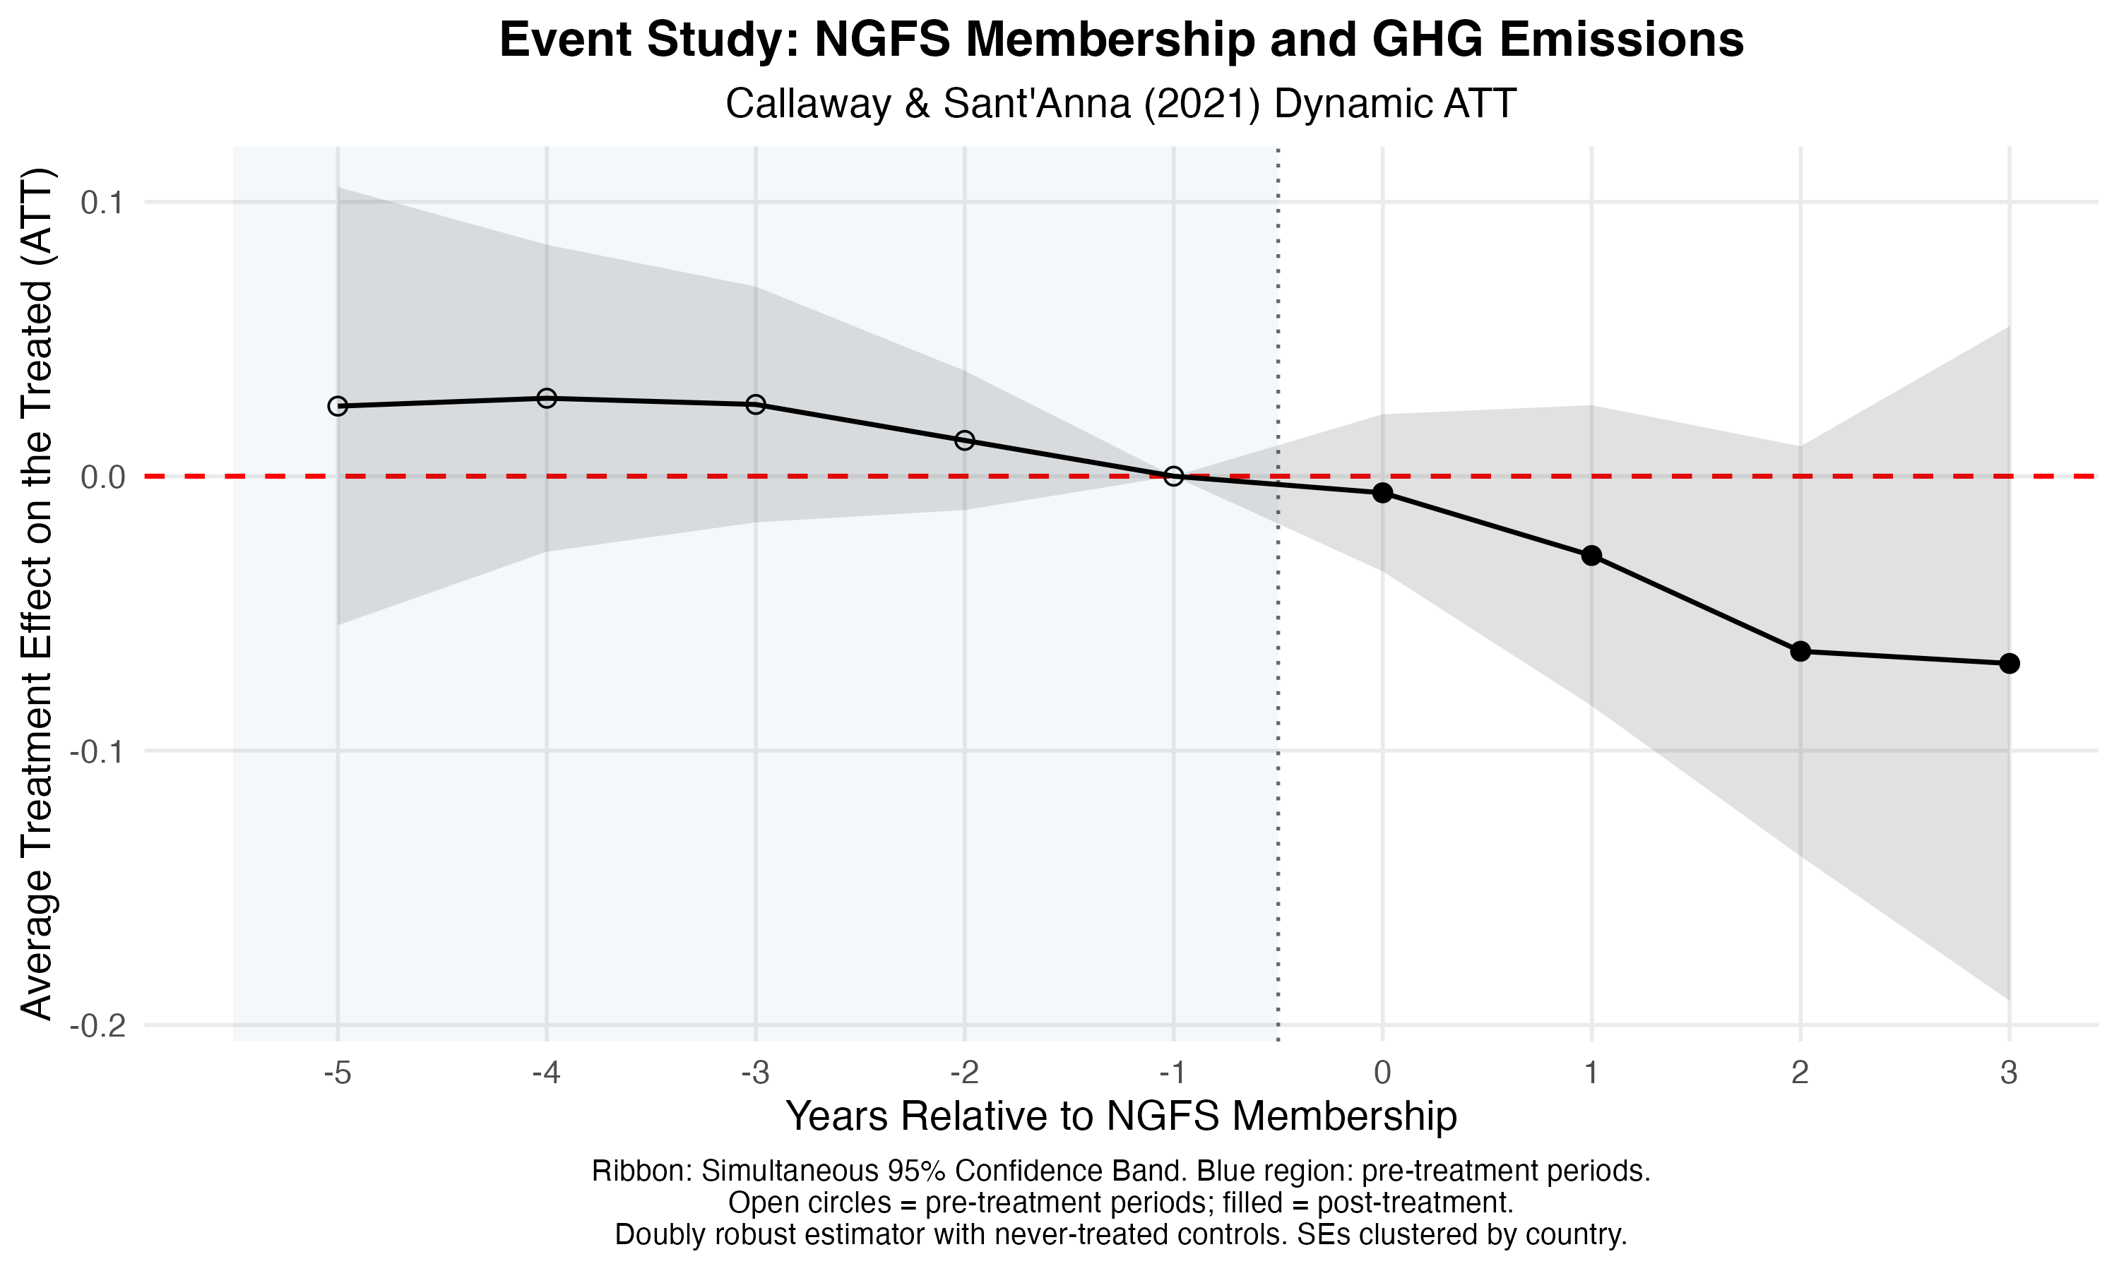
Two caveats warrant honest acknowledgment. The pre-treatment estimates, while statistically indistinguishable from zero, show a slight positive-to-zero decline in the two to three years before treatment. This trend is consistent with a modest pre-existing convergence between NGFS members and the never-treated control group. The doubly robust reweighting is specifically designed to address this kind of selection. Also, recall that the observed data on cohort trajectories shown in Figure 1 confirm that neither early joiners nor late joiners display a pronounced pre-existing downward trend in median emissions. Nonetheless, the post-treatment effect identified in Figure 3 should be interpreted as an accelerated deceleration in emission growth relative to trend, not a clean structural break from a perfectly flat baseline.

Central bank independence conditions the magnitude of the NGFS effect
The TWFE and CS results indicate that, all else equal, NGFS membership is associated with lower within-country emissions on average. I argue that the capacity of central banks to translate international climate commitments into domestic regulatory action depends on their insulation from political interference (1, 3, 8, 12, 15). To test this argument, I interact NGFS membership with a Garriga’s (16) weighted central bank independence (CBI) index and estimate marginal effects across the observed range of CBI scores.
Figure 4 reveals that the marginal effect of NGFS membership is a smooth, downward-sloping gradient across the CBI distribution, not a threshold or a discontinuity. At low central bank independence levels (one standard deviation below the global mean, $CBI≈0.44$), NGFS membership is associated with a 3.4% reduction in emissions ($β=-0.034$, $SE=0.012$, $p=0.005$). At the global mean ($CBI≈0.63$), the reduction increases to approximately 5.1% ($β=-0.051$, $SE=0.010$, $p<0.001$). Among countries with highly independent central banks ($CBI≈0.82$), the estimated NGFS membership effect reaches 6.8% ($β=-0.068$, $SE=0.015$, $p<0.001$). As the confidence band crosses zero at the lower tail of the CBI distribution, this indicates that membership carries little statistically reliable impact where central banks are most constrained by executive power. Figure 5 illustrates the same moderation in predicted emission levels: the gap between NGFS members and non-members widens progressively as CBI rises, with statistically reliable divergence beginning at $CBI≈0.37$.
Figure 4
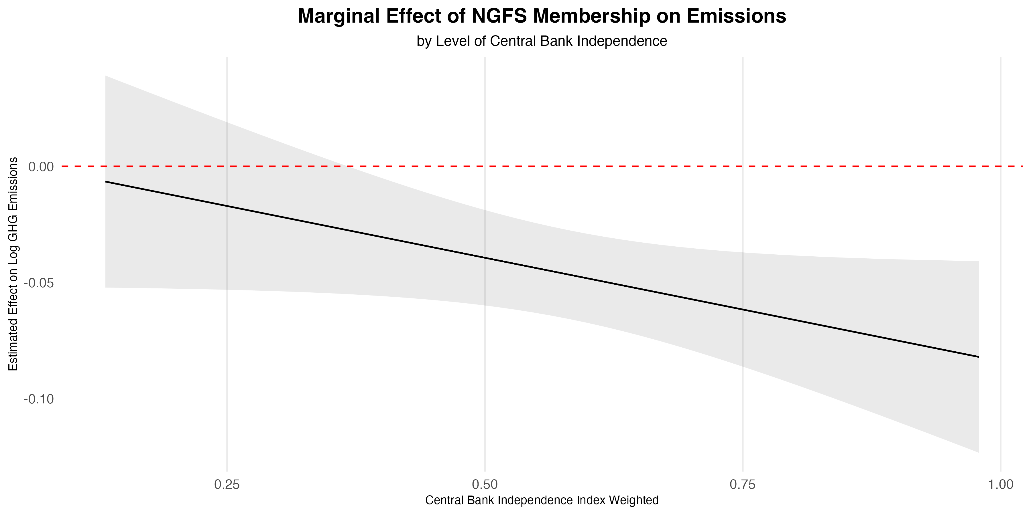

Figure 5
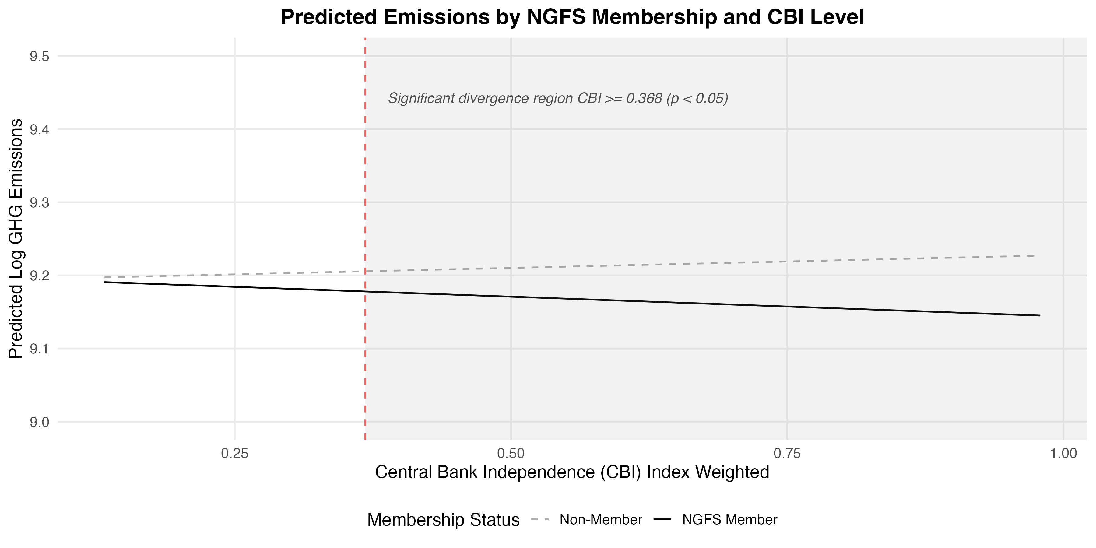

Central bank independence functions as a moderating condition, not as a mediating pathway activated by network membership
A plausible alternative mechanism is that joining the NGFS itself strengthens a central bank’s institutional autonomy. International network membership may provide legitimacy, peer pressure, and technical resources that insulate regulators from domestic political interference. This autonomy, in turn, may enhance and then produce the emissions reduction. To evaluate this mediation pathway, I conduct a causal mediation analysis using two-way demeaned within-country variation (see Supplementary Materials). The first-stage estimate reveals that NGFS membership is associated with a small but statistically significant decrease in CBI ($β=-0.010$, $p=0.004$), not an increase. This pattern potentially reflects the coordination demands and institutional adjustments that network participation in the NGFS requires. The average causal mediation effect (ACME) through CBI accounts for less than 0.3% of the total emissions reduction and is not statistically significant. The dominant pathway is the average direct effect (ADE) of NGFS membership ($ADE=-0.023$, $p<0.001$). Taken together, these results indicate that pre-existing institutional autonomy amplifies the NGFS effect, but network membership does not generate autonomy as a byproduct. CBI is, therefore, a precondition for the network’s effectiveness in reducing within-country emissions, not a product of it.

Discussion
This article asks whether countries with central banks formally committed to climate-aligned financial regulation emit less greenhouse gases than those without such commitment. Using NGFS membership as a cross-nationally comparable treatment indicator, I find that, after controlling for economic, ecological, and political factors, within-country GHG emissions decelerate following network entry. The reduction effect on emissions ranges from 3% to 7% depending on how GHG is measured. The effect is consistent across three emissions outcomes and is robust to two identification checks that address serious identification threats: heterogeneous treatment timing and endogenous selection into the network. Three findings deserve special attention for what they reveal about the mechanisms through which financial regulation, at the global and national levels, contributes to decarbonization.
First, joining the NGFS in itself is significantly associated with reduced emissions, but network membership alone is modest in absolute terms. The observed data on cohort trajectories displayed in Figure 1 show no substantial level shift in emissions following network entry. Statistically, the effect on lowering emissions is part of the within-country fixed-effects residual, reflecting a deceleration of emission growth rather than an abrupt reduction. This is consistent with how financial regulation operates. Central banks do not function as environmental protection agencies or a ministry of the environment. Financial supervisors do not mandate emission cuts directly, but by gradually reshaping investment incentives, disclosure requirements, and risk pricing in ways that compound over time. Still, the modest magnitude of the effect in a seven-year window analyzed here should not be mistaken for evidence that financial regulation is unimportant; it may instead reflect the early stage of NGFS institutionalization during the study period, which might keep producing positive externalities for late joiners to continue reducing their emissions moving forward.
Second, the moderation by central bank independence has direct policy implications. The results shown in Figure 4 indicate that NGFS membership does not affect all nations uniformly. The positive ramifications stemming from NGFS membership are largely concentrated among countries whose central banks can translate international climate commitments into binding domestic regulatory action as freely from political interference as possible. This finding speaks to a broader literature on the conditions under which international institutional membership produces domestic policy change (CITE). The NGFS is a voluntary, non-binding network. Its influence operates through deliberations, agenda-setting, and other incentives rather than legal obligations produced by hard international law. Where central banks lack the autonomy to act independently from executive power, membership may remain closer to a “performative governance” scenario (17).
Third, the mediation results complicate a narrative that joining the NGFS itself builds institutional capacity to reduce emissions by connecting central banks to international peers and resources (2, 8, 9). Instead, the evidence here suggests that NGFS membership is associated with a slight reduction in measured CBI. This finding is consistent with the view that network participation requires coordination and deference to shared standards that may modestly constrain domestic, unilateral regulatory discretion. At the same time, the dominant pathway from NGFS membership to emissions is direct, i.e., through the regulatory and supervisory channels the network establishes, rather than through a feedback loop that first builds domestic autonomy.
These conclusions have noteworthy limitations. The statistical analysis ends in 2021, capturing at most four post-treatment years for the founding members and fewer for later joiners. The event-study estimates show that the emissions reduction continues to deepen through year three. This trend suggests that the full long-run effect may be larger than what is estimable here. Extending the analysis period could yield more comprehensive insights and check whether the effect persists beyond the examined timeframe. My assessment also treats NGFS membership as a binary indicator, obscuring variation in the depth of implementation across members. For instance, Brazil devised a binding PRSAC mandate (15), whereas the U.S. Federal Reserve’s presented a more constrained engagement. Such contrast represents very different degrees of practical commitment that a single membership dummy variable cannot capture. Future research drawing from qualitative insights, case studies, and implementation-quality data could better identify causal mechanisms within the NGFS’s broad treatment indicator used here.
Even considering these caveats, the results have a clear implication: financial regulation is a meaningful instrument of climate policy, but its effectiveness is conditioned on the international and domestic institutional frameworks within which financial regulators operate. Efforts to expand the NGFS and similar networks may produce greater emissions reductions where they are paired with, or preceded by, investments in central bank institutional capacity and bureaucratic autonomy. For countries in the Global South, where both NGFS membership is still growing and central bank independence remains lower on average, the remaining questions about which conditions may further enable emissions reduction is not merely academic. It has practical consequences for how international climate finance governance should be designed for the global economy to move toward decarbonization as countries in the Global North and Global South alike pursue their net-zero goals.

References
1. A. H. Amsden, The Rise of "The Rest": Challenges to the West from Late-Industrializing Economies (Oxford University Press, 2001).
2. S. Battiston, I. Monasterolo, K. Riahi, B. J. van Ruijven, Accounting for Finance Is Key for Climate Mitigation Pathways. Science 372, 918–920 (2021).
3. R. Wade, Governing the Market: Economic Theory and the Role of Government in East Asian Industrialization (Princeton University Press, 1990).
4. J. Zysman, Governments, Markets, and Growth: Financial Systems and the Politics of Industrial Change (Cornell University Press, 1983).
5. L. Boneva, G. Ferrucci, F. P. Mongelli, Climate Change and Central Banks: What Role for Monetary Policy? Climate Policy 22, 770–787 (2022).
6. E. Campiglio, Y. Dafermos, P. Monnin, J. Ryan-Collins, G. Schotten, M. Tanaka, Climate Change Challenges for Central Banks and Financial Regulators. Nature Clim Change 8, 462–468 (2018).
7. A. Dombret, P. S. Kenadjian, Green Banking and Green Central Banking (Walter de Gruyter GmbH & Co KG, 2021; https://books.google.com?id=48xMEAAAQBAJ).
8. E. Helleiner, M. DiLeo, J. van ’t Klooster, Financial Technocrats as Competitive Regime Creators: The Founding and Design of the Network for Greening the Financial System. Regulation & Governance Online First (2025).
9. J. M. Keenan, A Climate Intelligence Arms Race in Financial Markets. Science 365, 1240–1243 (2019).
10. NGFS, Origin and Purpose (2025). https://www.ngfs.net/en/about-us/origin-and-purpose.
11. B. Callaway, P. H. C. Sant’Anna, Difference-in-Differences with Multiple Time Periods. Journal of Econometrics 225, 200–230 (2021).
12. P. B. Evans, Embedded Autonomy: States and Industrial Transformation (Princeton University Press, Princeton, N.J., 1995).
13. World Economic Forum, The Global Risks Report 2026 (2026). https://www.weforum.org/publications/global-risks-report-2026/digest/.
14. J. Meckling, Carbon Coalitions: Business, Climate Politics, and the Rise of Emissions Trading (MIT Press, 2011; https://books.google.com?id=dtyO6mcrh5EC).
15. V. M. Dias, M. G. Schapiro, Resisting Democratic Backsliding From Within the State: Environmental Politics in Bolsonaro’s Brazil. Policy Studies Journal n/a (2026).
16. A. C. Garriga, Central Bank Independence in the World: A New Data Set. International Interactions 42, 849–868 (2016).
17. I. Ding, Performative Governance. World Politics 72, 525–556 (2020).
18. L. Sun, S. Abraham, Estimating Dynamic Treatment Effects in Event Studies with Heterogeneous Treatment Effects. Journal of Econometrics 225, 175–199 (2021).

In Portuguese, PRSAC refers to Política de Responsabilidade Social, Ambiental e Climática.

