The Cacti Group

Cacti
Aggregate Plugin Version 0.75
Usage Guide

Brought to you by
Reinhard Scheck
gandalf@cacti.net
Licensed under Creative Commons License

Table of Contents
Features 3
Installing the Plugin 4
Basic Installation Procedure 4
Providing Permissions to Users 7
Basic Usage 8
Aggregate Options Explained 9
Modifying the Default Traffic Graph Templates 14
Finding Aggregated Graphs 17
Color Templates 18
Create a new Color Template 18
Aggregate Cookbook 20
A Variation of Traffic Templates 20
Interface – Traffic (bits/sec) ( default) 21
Interface – Traffic (bits/sec) (AREA/STACK) 21
Interface – Traffic (bits/sec) (peak) 22
Interface – Traffic (bits/sec) (pos/neg) 22
Interface – Traffic (bits/sec) (pure LINE) 22
Examples 24
Using AREA/STACK graph 24
Caveats 25
A Word on CDEFs 26
Caveat when using different Graph Templates 28

Features
The AGGREGATE plugin was developed based on a HowTo from user Linegod (J.P. Pasnak). The main purpose is to reduce the amount of manual tasks required to create a new graph based on two or more already existing graphs: an aggregated graph.
So, basically, it does nothing magic; you can't do it all on your own. In fact, all graphs created by AGGREGATE are by all means normal Cacti graphs. You may place them into any tree, you can modify them, add new items, rename title or items.
Here's a brief list of all supported features:
- Suggest a new title based on the basic graph template, removing unwanted |query_*| and |host_*| stuff (|query_*| supported for data query type graphs only)
- Allow for |host_*| and |query_*| variables in AGGREGATE graph item text field
(|query_*| supported for data query type graphs only)
- Graph item prefix defaults to |host_hostname| to distinguish graph items of different hosts
- optionally convert to AREA/STACK type graphs using sophisticated graph item type conversion
- optionally convert to all available LINEx graph item types
(as Cacti does not yet support stacked LINEx, this is not supported by AGGREGATE as well. Cacti 0.8.8 will support all available RRDTool LINEx types)
- Support for Color Templates, e.g. all green “traffic_in” colors can be changed from light to dark green to make them visually distinguishable
- Color rotation: in case a color template holds less items than the aggregate, the color template will be applied multiple times
- programmatically add <HR> (line breaks) to avoid unwanted “concatenation” of graph items
- Support a “sort order”, especially required if base graph is AREA/STACK type to group similar graph items (e.g. all “traffic_in” first, all “traffic_out” next)
- Support for Totalling, either for “similar” or “all” data sources
this feature auto-creates new CDEFs when necessary
- custom prefix on total GPRINTs
- Support “total only” aggregates, not printing the “elementary” graph items

Installing the Plugin

Basic Installation Procedure
The current manual is based on Cacti version 0.8.7g and Plugin Architecture (PIA) version 2.8. This plugin has been verified to work with this version. There has been no intention to drop support for older versions, use them at your own risk.
As a prerequisite, installing of the Plugin Architecture (PIA) is required, please see http://cactiusers.org/ for help regarding this topic. Furthermore, it is assumed, that you already provided authorization to use “Plugin Management”.
Please download this plugin to the <path_cacti>/plugin directory and unpack the *.tgz file. All files will now reside in the <path_cacti>/plugin/aggregate directory.
CAVEAT:
Please make sure not to leave old „aggregate“, e.g. <path_cacti>/plugin/aggregate_old!
Activating this plugin depends on the Plugin Architecture (PIA) used., please go to that menu item, install and enable the new plugin.
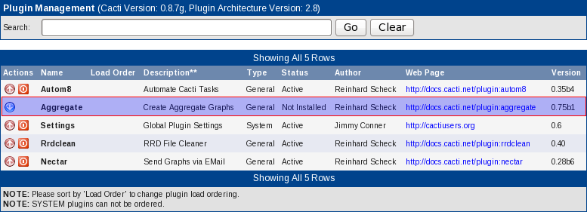Illustration 1: Install AGGREGATE
Select the “Install” knob, then then „Enable“. It should now look like
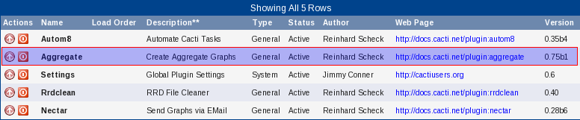Illustration 2: AGGREGATE installation finished

Providing Permissions to Users
Everybody who has Console access is now allowed to create new aggregate graphs.
But there's a second section, that comes with AGGREGATE, the Color Templates. To provide access to create, delete or modify color templates and items, please go to User Management and select the correct userid. Now, check the AGGREGATE checkboxes as shown below.
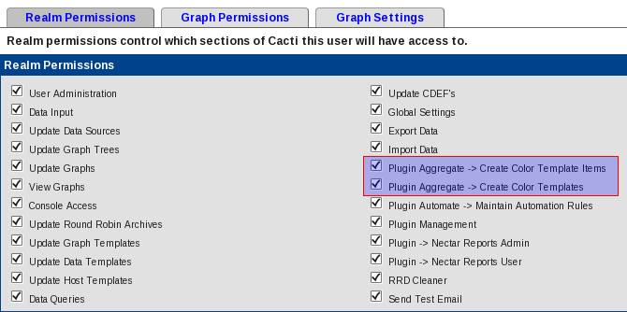Illustration 3: Providing Permissions to Users

Basic Usage
Now, turn to Graph Management. It makes sense to apply a search filter and/or a graph template filter. Then, you will have to select the graphs you want to aggregate.
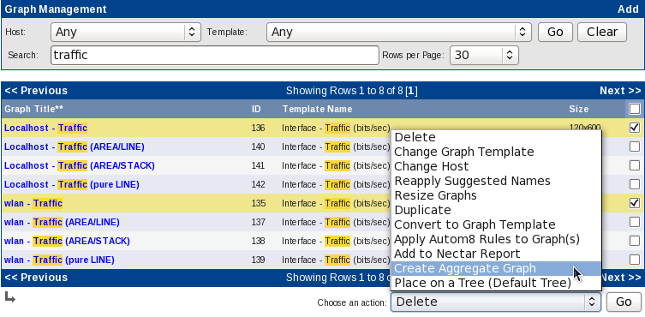Illustration 4: Select Graphs from Graph Management
CAVEAT:
Please only select graphs based on a single graph template (see column „Template Name“). If you fail to do so, AGGREGATE will throw an error!

Now, please hit “Create Aggregate Graph”.

Aggregate Options Explained
There are a multitude of options available to tailor your aggregated graphs to your needs. Not all of them can be freely chosen and not all of them make sense, when applied to different types of graphs. But before digging deeper into use cases, let's first explain all those options.
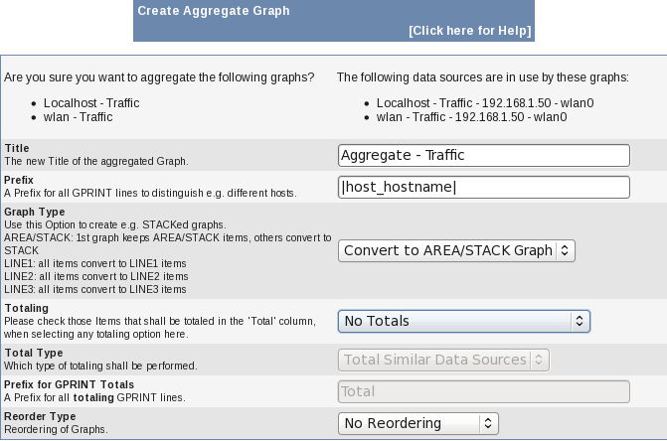Illustration 5: Default Prompt for Aggregating Graphs (upper half)
Clicking for help opens this pdf file. Let me have some words on the quite complex data on that screen. On the upper left, you'll see the list of graphs selected previously. Please verify, that all needed graphs are included.
On the upper right, please notice the list of related data sources. The sequence may deviate from the graph list. Don't bother to see the same IP in this example, both graphs relate to my laptop's traffic.
The Title is pre-filled. The prefix always is „Aggregate“. Next comes the title taken from the first graph in raw format, but having all |host_*| or |query_*| removed as neither host nor query related variables make much sense for an aggregate . That is e.g. „|host_description| - Traffic - |query_ifDescr|“ turns to “ - Traffic” only. Of course, you will want to make it more meaningful to you.
Prefix allows you to distinguish graph items on the aggregate. Imagine aggregating traffic, like this example does, without it you won't be able to distinguish between all those aggregated graph items. You may discard the prefix, though. It is allowed, to use all available |host_*| variables here and/or any plain text you like. When using a data query, |query_*| type variables are allowed, too. Pay attention not to spend too many characters in order to avoid line wrap of the legend.
Graph Type is quite important to use. You may wonder why it is defaulted to create AREA/STACK graphs. Here's the reason why: Assume, you're aggregating an AREA graph. Without STACKing the second, third, ... graph item, all of them will overlap. Thus, only the last one will be seen (and perhaps parts of previous ones, if their values are higher).
- “Keep Graph Types” does not change any graph type at all
- “Convert to AREA/STACK Graph” keeps type of first graph as is. But for the next graphs, the graph type will be changed to AREA/STACK if it has been AREA or LINEx.
- “Convert to LINEx Graph”: Sometimes, it is recommended to have LINEx graphs instead. This will convert all graph types (AREA, STACK, LINEx) to the chosen LINEx (x=1,2,3).
CAVEAT:
It is recommended to change the standard Graph Template for „Traffic“. Please switch e.g. Traffic OUT to the negative y-axis. Else, Traffic IN and Traffic OUT will overlap on the positive y-axis (see Chapter “Modifying the Default Traffic Graph Templates“ below!
Totaling knows three options.
- The obvious first one is “No Totals”.
- Then, there is “Print all Legend Items”.
This one will show all legend entries (GPRINT, Comment) as usual but add some more lines for totals. The items that shall be totaled must be selected from the “Total” column (see below).
Graph Type is always LINE1, even when “Convert to AREA/STACK Graph” is used as it makes no sense to STACK totals on top of existing items.
Color is taken from Color Template of associated data source item.
- Last, there is “Print totaling Legend Items Only”.
This option will NOT print the normal legend items; it will print the totaling items only.
Graph Type is governed by the Graph Type chosen.
Color is taken from Color Template of associated data source item.
Total Type has two different options:
- „Total Similar Data Sources“ totals all e.g. “traffic_in” separated from “traffic_out”.
- „Total All Data Sources“ totals all data sources. Please see examples below on how to use them.
Prefix for GPRINT Totals allows you to define a prefix to be printed in front of the totaling line of the legend. The field is editable only if any “Totaling” option has been chosen. Of course, you may change that prefix.
- for “Total Similar Data Sources”, the default is “Total”,
- for “Total All Data Sources” it is “All Items”.
Reorder Type allows you to reorder graph items of the aggregate.
- “No Reordering”
This means, that the selected graph items of each graph, graph by graph, will be used for the aggregate. E.g. for a traffic graph, this will lead to a sequence of “Traffic In – Traffic Out – Traffic In – Traffic Out ...”.
Totaled items will not be reordered; they will be placed at the end of the legend.
- “Data Source, Graph”
This will first order by data source, then by graph. E.g. for a traffic graph, this will lead to a sequence of “Traffic In – Traffic In ... – Traffic Out – Traffic Out ...”.
For STACKed graphs, totaled items will not be reordered; they will be placed at the end of the legend.
For non-STACKed graphs, totaled items will be reordered as well, e.g. totaled “Traffic In” will be placed after all “Traffic In” items and before “Traffic Out” items.

Graph Templates Items is build based on the first graph selected, showing up in the lower part of the aggregate screen.. Please pay attention to this section to make the most of your new aggregate.
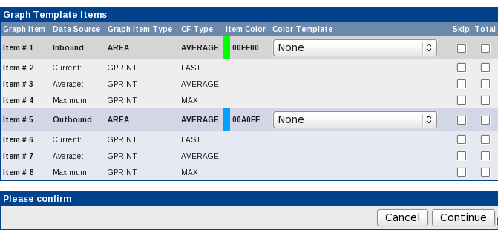Illustration 6: Aggregate Graphs, showing List of Graph Items (lower half)
There are three columns to pay attention to.
Color Template governs the coloring of the aggregated graph items. Why's this? Using a single graph template will usually result in graph items like e.g. „Traffic In“ having same color on all graphs. On an aggregate, you would thus not be able to distinguish between them. That's where color templates come in. They simply define a sequence of colors, each of them assigned to an aggregated graph item in turn. And if the aggregate has more items than the Color Template, we will wrap the Color Template automatically.
Creating a color template like a „rainbow“ of colors allows you now to assign a set of colors in a single run! Do not forget to assign different color templates to different graph items!
As totaling will add a new line that was not yet present, the color for that item will be taken from the associated data source item or the related color template, if chosen.
Skip allows you to skip the checked item in the aggregate. There's a new, automatic <HR> mechanism to cope with <hard_returns> that will be dropped now. A skipped <HR> will percolate up the list to the previous item to keep line feeds in place. The mechanism will even introduce new <HR>'s at end of a graph template.
Else, concatenating two graphs without <HR> in between will create ugly legends. This is required as well to make automatic legend adjustment work (but be aware, that this requires always a fixed sized font for legends).
Total governs the magic of totaling graph items. I did not make up my mind to create an algorithm for it. So you are required to check exactly those lines you want to see on the total legend.
CAVEAT:
It is recommended to check required items! It is NOT sufficient to simply check the totaling options in the upper half.

CAVEAT:
When using Total All Data Sources, it makes no sense in most cases to check more than a “single set” of data sources. E.g. on a traffic graph, it's ok to select “input traffic items” only. In case you check “output traffic items” as well, you will get two totaling lines showing the same data: “total all data sources”.
For the totaling items, Prefix for GPRINT Totals is always used instead of Prefix to prepend the legend line.
Totaling Similar Data Sources creates e.g. a total of each different data source referred to in the graph. E.g. In this example, there are two: „Traffic In“ and „Traffic Out“. So you want to check at least the AREA/LINEx graph items and all additional GPRINT items.
But when using e.g. 95th percentile graphs or bandwidth COMMENTs, you will want to skip them on the total.
Please see examples below for more.

Modifying the Default Traffic Graph Templates
The default Cacti Graph Templates are mimicked after some very famous templates like those used by MRTG. “traffic_in” and “traffic_out” are both plotted to the positive y-axis, the latter as a LINE1.
For use with AGGREGATE, this is not the best choice. And people often want to plot outbound traffic to the negative y-axis for a better understanding.
You may either copy the graph templates you're going to change to preserve standard templates or change the standard to apply changes to all existing graphs with a simple swish of your magic wand called knowledge.
As a first step, a CDEF is required to “Turn Bytes into Bits, make negative”:
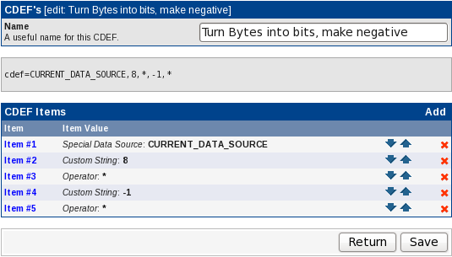Illustration 7:Turn Bytes into Bits, make negative

Please apply this CDEF to the outbound traffic item and make it an AREA as well:
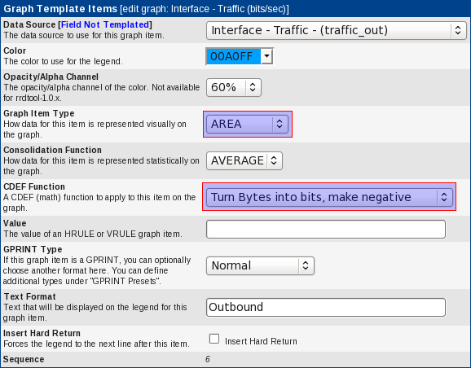Illustration 8: Apply CDEF to Outbound Traffic Item
Now, one more tweaks is required for the template itself. The default auto-scaling option does not allow for negative numbers to be plotted on the graph. That's why we now switch to –alt-autoscale (ignore given limits). See
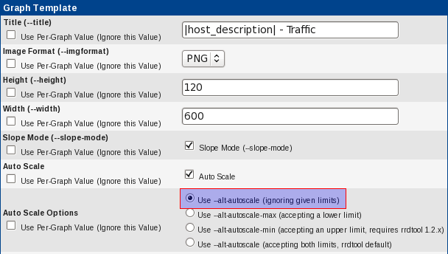Illustration 9: Use --alt-autoscale
You may want to apply those changes to all traffic graph templates using bits. That makes
- Interface - Traffic (bits/sec)
- Interface - Traffic (bits/sec, 95th Percentile)
- Interface - Traffic (bits/sec, Total Bandwidth)

Finding Aggregated Graphs
Due to the aggregated nature of the graphs, they are in general not associated to a single host. When searching an aggregate, you will therefor not find in when searching for a specific host. In fact, you'll find them when filtering for Host “None”; in other words: filter for all non-host related graphs:
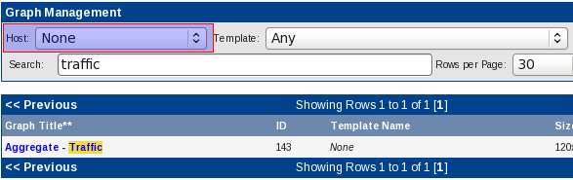Illustration 10: Find Aggregated Graphs by Host Filter
The same applies to the “template” filter. You may argue, that all aggregated graphs stem from the same basic graph template, expecting the aggregated graph to be related to that very graph template as well.
But hold on: The new aggregate will have many more graph items, and, if you want, even totaling items that have not been present at all. That's why it is not possible to associate it with any existing graph template.
In fact, if you want to search by template, you will again have to set the template filter to “None”:
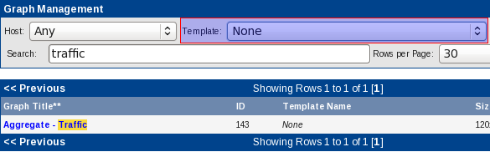Illustration 11: Find Aggregated Graphs by Graph Template Filter

Color Templates
When adding some graph items of same type, e.g. “traffic_in” and “traffic_out” to a single aggregated graph, it makes sense not to use a single color for all graph items of same type.
E.g. instead of using green (RGB x'00FF00) for “traffic_in”, you may want to associate colors from light green to dark green. That's what a Color Template is used for.

Create a new Color Template
Now let's see how to create them. Make sure, that your userid was provided the realm to access “Color Templates”. Then, move to that menu option:
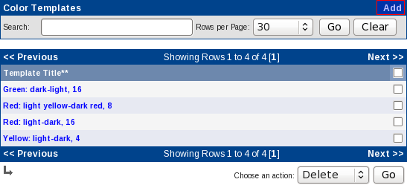Illustration 12: Color Templates
Add a new Color Template by clicking “Add”:
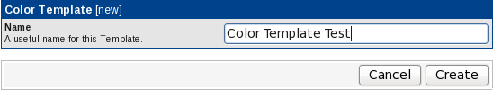Illustration 13: Add a new Color Template
Hit “Create” and “Add” new “Color Template Items”, one by one:
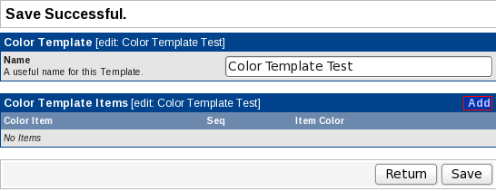Illustration 14: Add Items to Color Template

Aggregate Cookbook

A Variation of Traffic Templates
The cookbook is based on variations of the default “Interface Traffic” Graph Template. I've chosen this one because almost everyone should be able to reproduce the examples. To show the different use cases, I've copied this graph template multiple times; varying different items of the template. Here's an overview:
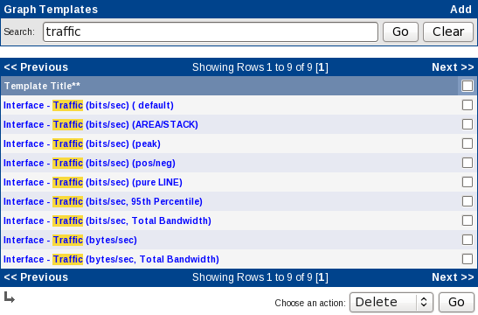Illustration 15: Predefined Traffic Graph Templates

Interface – Traffic (bits/sec) ( default)
This is the default Traffic Graph Template. It shows “traffic_in” as an AREA and “traffic_out” as a LINE1.
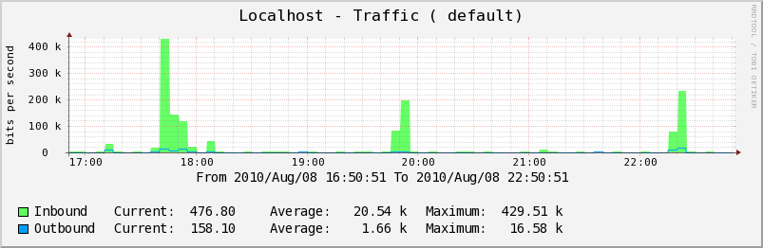

Interface – Traffic (bits/sec) (AREA/STACK)
It shows “traffic_in” as an AREA and “traffic_out” as a n AREA/STACK. This does not make much sense as a traffic template; but keep in mind that this is used as an example.
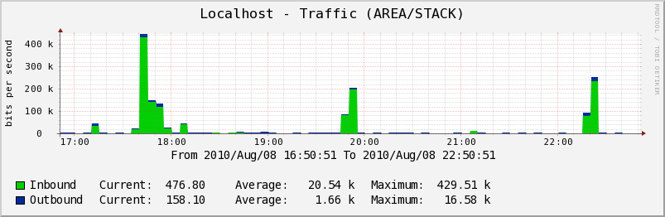

Interface – Traffic (bits/sec) (peak)
This is much like the template below, but an additional LINE1 item is added for “traffic_in” and “traffic_out”, showing the MAX consolidation function.
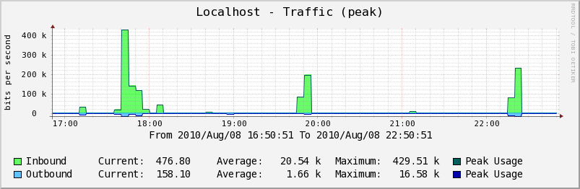

Interface – Traffic (bits/sec) (pos/neg)
It shows “traffic_in” as an AREA on the positive y-axis and “traffic_out” as an AREA on the negative y-axis.
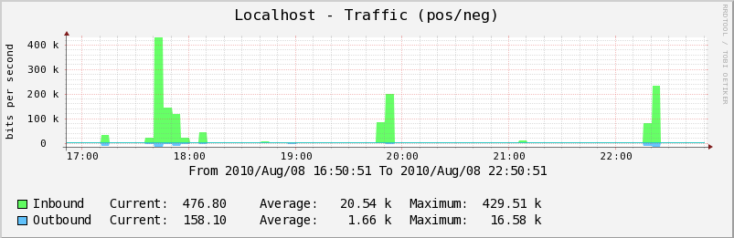

Interface – Traffic (bits/sec) (pure LINE)
This one looks very much like the default traffic graph template. But in this case, both “traffic_in” and “traffic_out” are drawn as LINE1 on the positive y-axis.
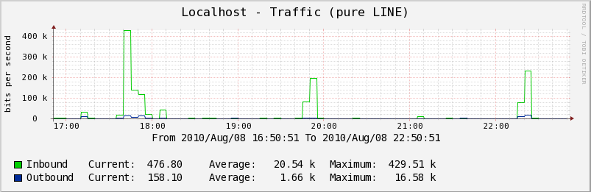

Examples

Using AREA/STACK graph
When using a base graph of type Interface – Traffic (bits/sec) (AREA/STACK) without conversion (“Keep Graph Types”), the result is
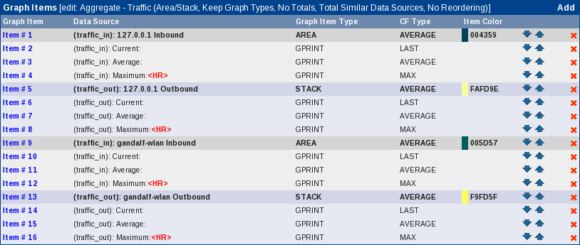
You will get a different result, when using “Convert to AREA/STACK graph”, even if this sounds weird. This conversion option will sweep the resulting graph, keeping a single AREA only and converting the rest to STACK.
The result may look better than the first one
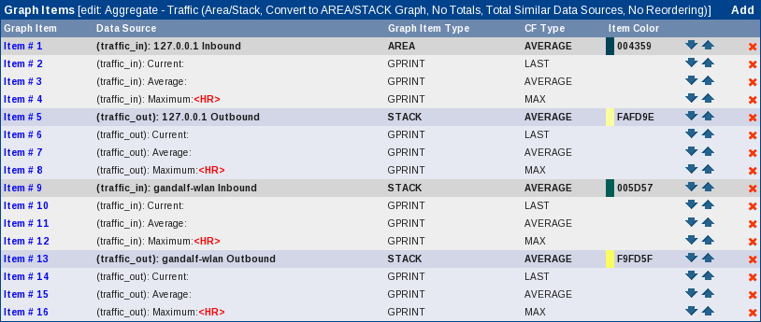

Caveats
Here's a small compilation of selectable parameters that won't make sense due to various reasons mentioned below.
Graph Type | Conversion | Totaling | Total Type | Reordering | Remarks
AREA + LINE | None | Any | Any | Any | AREAs overlap; e.g. only last AREA may be visible
Any | Any | Print totaling Legend Items Only | Any | Any | Reordering has no visible effect when totaling entries are the only one printed.
AREA + STACK | None | Any | Any | by data source | Two or more AREAs will appear; they again will overlap. The STACKed items will be stacked onto the last AREA, not onto the “related” AREA. This is how RRDTool works.
AREA + STACK | None | Print all Legend Items | Any | by data source | At least one totaling LINE1 will drawn in between normal entries. All STACKed entries shwoing up after this totaling LINE1 will be stacked onto that very LINE1, not onto the “related” AREA.

A Word on CDEFs
Well, until now everything's seems to be quite straightforward. CDEFs were already mentioned in Chapter “Modifying the Default Traffic Graph Templates“. What's wrong with them?
Well, when aggregating graph items, this is more or less beading them one after another, mostly just as they are in the selected graphs. Then, there is some color magic, skipping code, prefixing text and <HR> stuff.
But totaling is worse, much worse. The graph items themselves do not require any change. But the totaling line requires a CDEF that holds something like “TOTAL_ALL_DATA_SOURCES_NODUPS” or “SIMILAR_DATA_SOURCES_NODUPS” where currently “CURRENT_DATA_SOURCE” is listed.
So this plugin generates new CDEFs. It fetches the CDEF from the original graph item and resolves it to plain text. Then, depending on the totaling action selected, “CURRENT_DATA_SOURCE” is replaced.
Now we have a new CDEF. To avoid storing duplicate CDEFs, all existing CDEFs now are scanned and compared to the new CDEF. On match, the existing CDEF is used. If no match is found, the new CDEF is stored.
The title of the new CDEF is taken from the original CDEF, but a string is prepended. Either “_AGGREGATE ALL “ or “_AGGREGATE SIMILAR” is used to distinguish. The underscore is used for sake of sorting them to the bottom of the CDEF list.
Please find attached the list of CDEFs on my system after having created all the examples from above.
Illustration 16: CDEFs
This is “_AGGREGATE ALL Turn Bytes into Bits”
Illustration 17: AGGREGATE ALL Turn Bytes into Bits
Now “_AGGREGATE SIMILAR Make Stack negative, turn Bytes into Bits”
Illustration 18: AGGREGATE SIMILAR Make Stack negative, turn Bytes into Bits

Last “_AGGREGATE SIMILAR Turn Bytes into Bits”
Illustration 19: AGGREGATE SIMILAR Turn Bytes into Bits

Caveat when using different Graph Templates
In previous version of AGGREGATE, there was no verification of graph templates used. This may lead to buggy graphs, because always the first graph is used as a model for all other graphs. Thus, if the first graph as eight items (default traffic graph template) and the second one has eleven (95th percentile traffic template), funny things will happen.
To prevent this, AGGREGATE now checks the templates used for the graphs. See example below.
Illustration 20: Wrong Graph Selection
In this example, I purposely made a mistake. The result screen will be as follows

