* 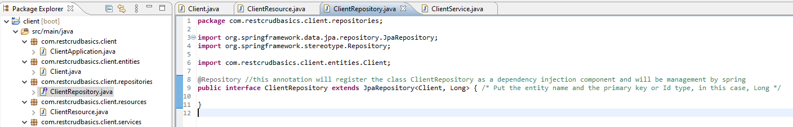First, make the dependency injection in the ClientRepository class with the specific annotation @Repository
* Now, the ClientRepository class is a dependency injection componente management by spring
* 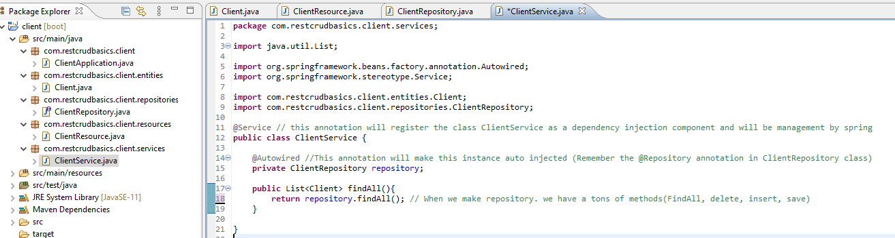Now, implemente the service Layer
* 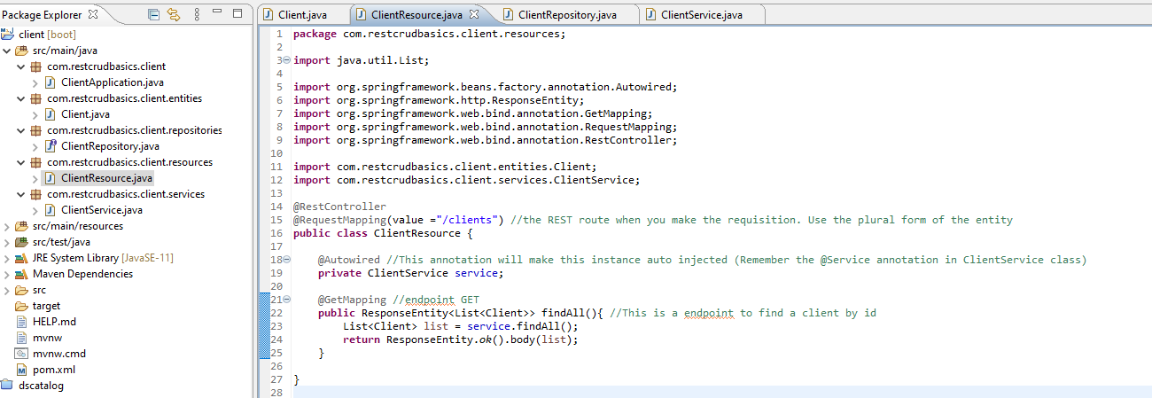Now, make the depency injection in the ClientResource
* With this, we are following the architecture layer above

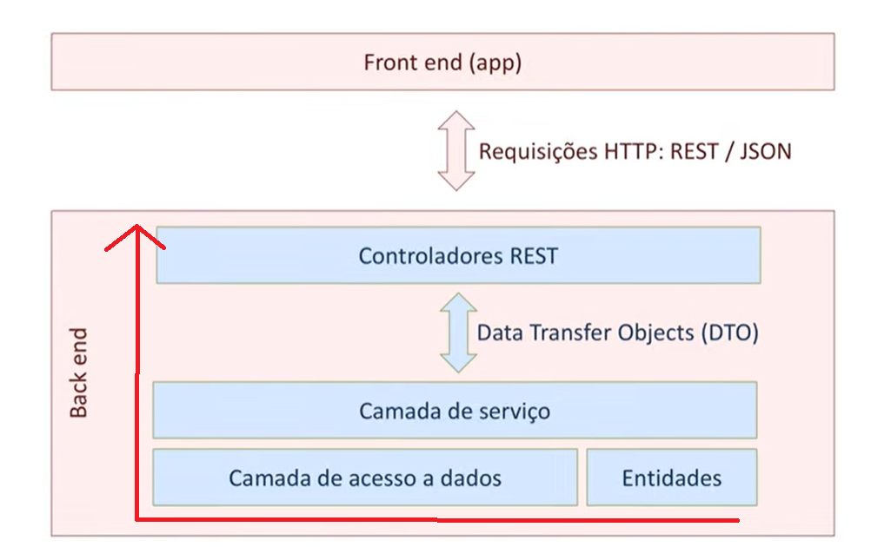

* Now, is time for the REST requisition test