* After implemente the resource, you have to make the test

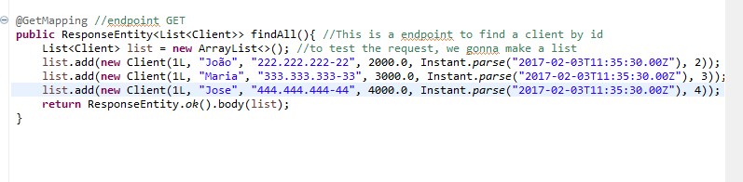

* To do this, run the spring boot app

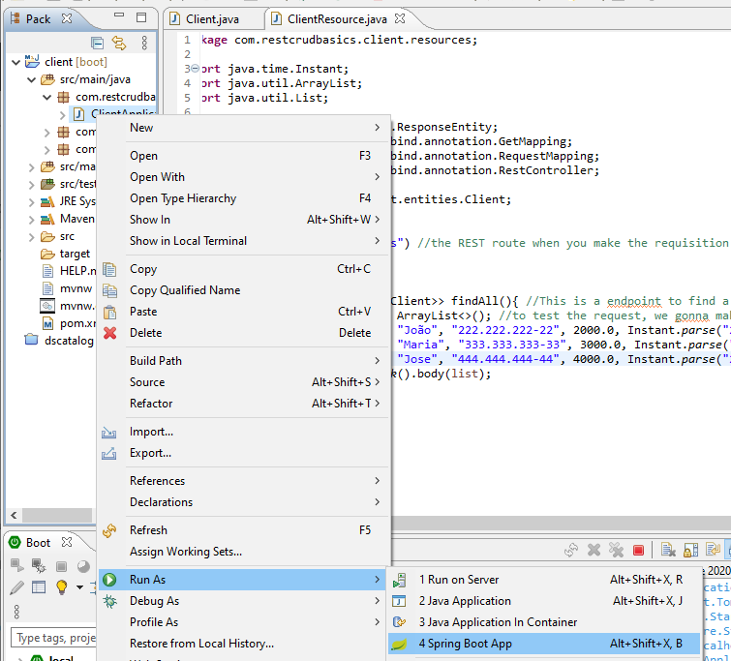

* Enter in the POSTMAN app



* Go in collection and make a new collection for your requisitions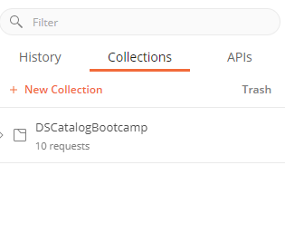
* Put a name and make a new folder with the entity name

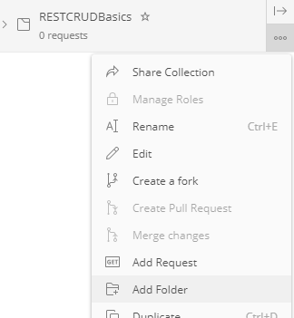

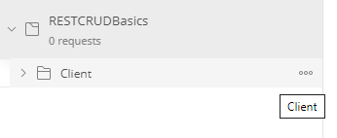

* Go in the folder and make a nem request

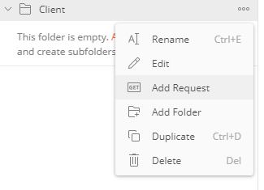

* Put a name in the request

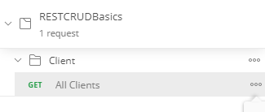

* Now, make the request. In this case, to find all clientes



* If everything is ok, your request is shown in JSON format

