1. 29 = 11101
2. 35 = 100011
3. 417 = 110100001
4. 251 = 11111011
5. 84 =1010100
6. 215 = 11111011
7. 113 = 1110001
8. 767 = 1011111111

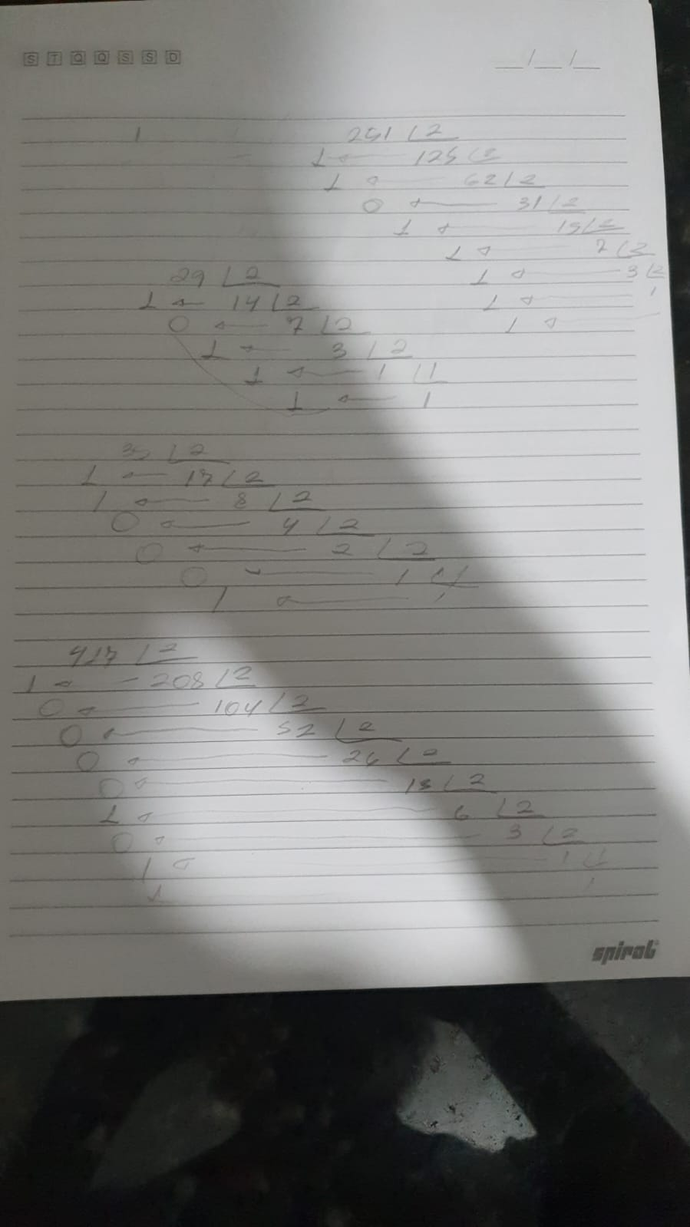

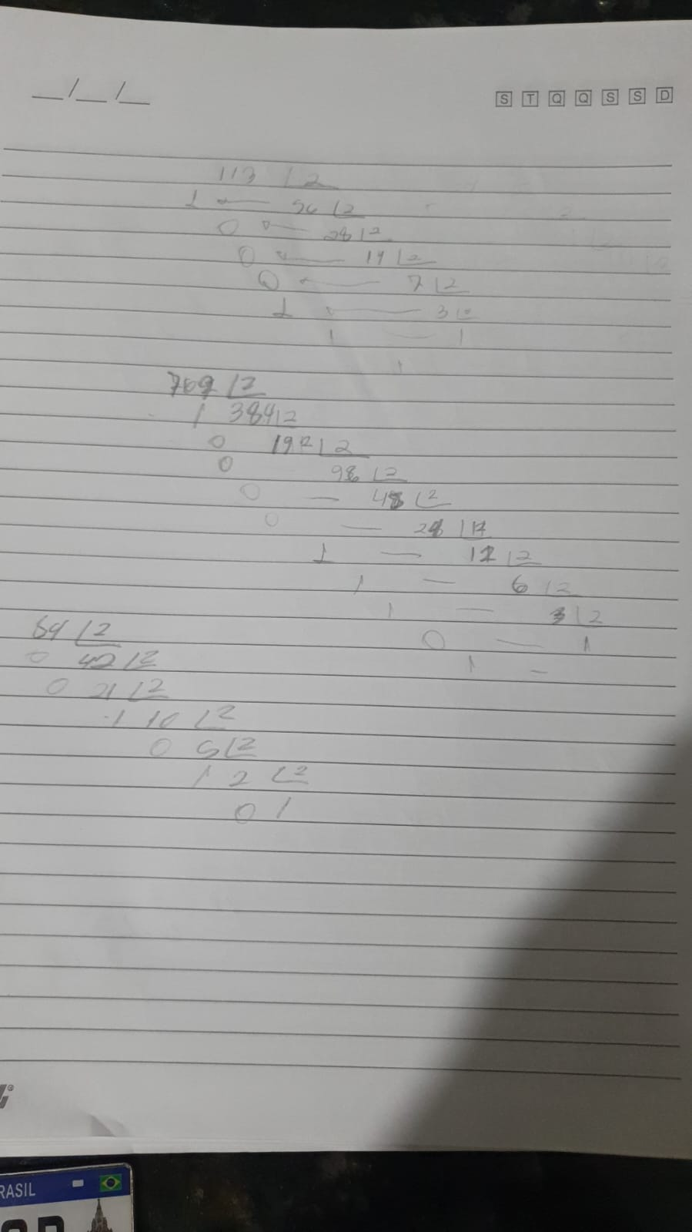

1. 11011101010 = 1770

B) 111001101001 = 3689

C)1100011 = 99

D)1000000011 = 515

E)11001101101 = 1645

F)11111100001 = 2017

G)10101111101 =1405

