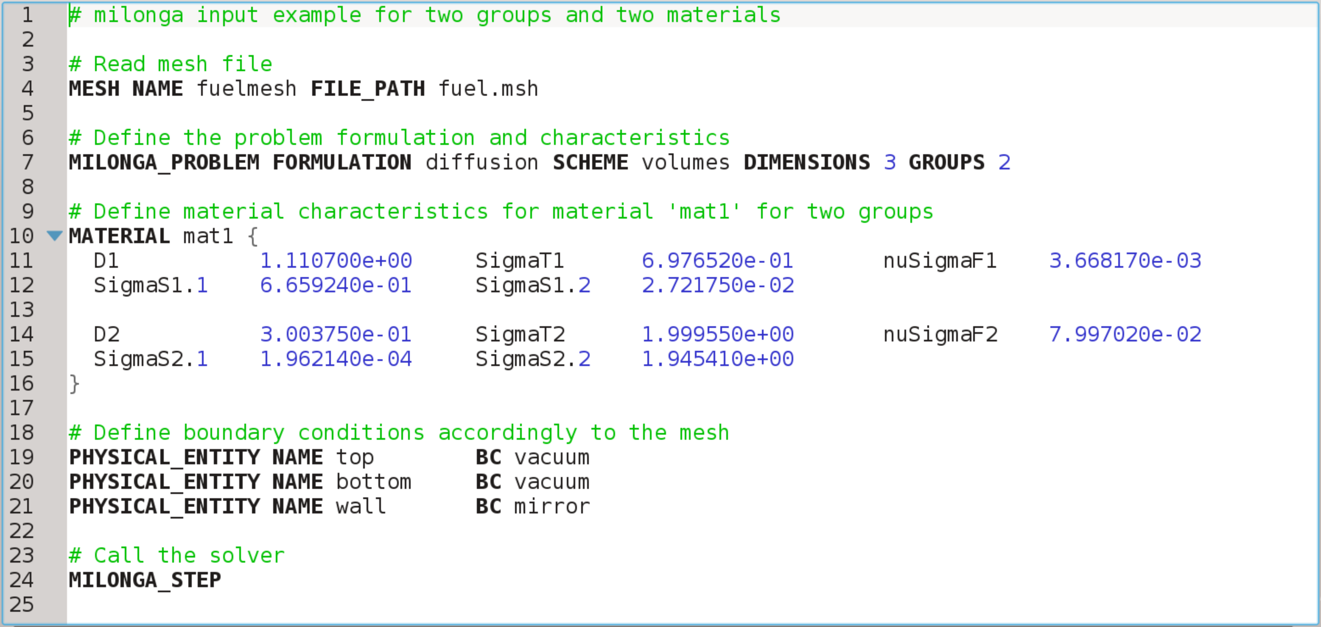
Figure 2: A simple input file for milonga with line numbers counting.

