COUPLED UNSTRUCTURED FINE-MESH NEUTRONICS AND THERMAL-HYDRAULICS METHODOLOGY USING OPEN SOFTWARE: A PROOF-OF-CONCEPT

Vitor Araújo-Silva^{a,d}*, André Santosª, Germán Theler^{b}, Rafael Miró^{c}, Claubia Pereira^{d}

ªCentro de Desenvolvimento da Tecnologia Nuclear, Comissão Nacional de Energia Nuclear, Av. Pres. Antônio Carlos, 6627 - 30270-901 Belo Horizonte, MG, Brazil

^{b}Seamplex, Santa Cruz 205, 2300, Rafaela, Argentina

^{c}Institute for Industrial, Radiophysical and Environmental Safety (ISIRYM), Universitat Politècnica de València, Camí de Vera s/n, Valencia 46022, Spain

^{d}Departamento de Engenharia Nuclear (DEN), Universidade Federal de Minas Gerais (UFMG), Av. Pres. Antônio Carlos, 6627 - 30270-901 Belo Horizonte, MG, Brazil

ABSTRACT

The development of a fine mesh coupled neutronics/thermal-hydraulics framework mainly using open source software is presented. The contributions proposed go in two different directions: one, is the focus on the open software approach development, a concept widely spread in many fields of knowledge but rarely explored in the nuclear engineering field; the second, is the use operating system shared memory as a fast and reliable storage area to couple the computational fluid dynamics (CFD) software OpenFOAM to the free and flexible reactor core analysis code milonga. This concept was applied to simulate the the behavior of a TRIGA-IPR-R1 reactor fuel pin in steady-state mode. The macroscopic cross-sections for the model, a set of two-group cross-sections data, were generated using WIMSD-5B code. The results show that this coupled system gives consistent results, encouraging system further development and its use for full core simulation.

*Corresponding author. Tel: +55 31 34096686; fax: +55 31 34096660
E-mail address: claubia@nuclear.ufmg.br, (Claubia Pereira)

1. INTRODUCTION

The goal is to present a coupled neutronics and thermal-hydraulics framework for nuclear reactors calculations. The thermal-hydraulic calculations are performed by an open software Computational Fluid Dynamics (CFD) toolbox called OpenFOAM (2015). For neutronic calculations, a free nuclear reactor core analysis code called milonga is used to solve the steady-state multigroup neutron transport equation (Theler, 2014). Both codes solve the discretized equations for a fine unstructured mesh using finite volumes method. In this coupled framework, both codes use the same mesh for domain discretization, allowing both codes to solve their problems with the same degree of detail. Data are shared between them through a shared memory segment and they are synchronized using semaphores. This scheme poses no overhead for communication other than any ordinary memory access.

There are many reasons for choosing a computationally demanding method like finite volumes to solve both neutronics and thermal-hydraulics in a coupled manner. The continuous improvements in computers speed and storage capacity have had a deep impact in the way engineers and scientists work on their problems. The nuclear engineering field have been benefiting from computers continuous increasing in processing power, turning former expensive calculation methods into useful and practical tools to solve many different problems in the field. Recently the focus also pointed toward the use of thermal-hydraulic and neutronic codes to solve nuclear reactor problems in a coupled way. These coupled calculations approaches, also called multi-physics (Leppännen et al., 2012, Schimidt et al., 2015 and Bennett et al., 2016), offers an interesting way of modeling the feedback from thermal-hydraulics to neutronics and vice versa.

An interesting aspect of computer hardware evolution is the change in the associated software. The effect of software evolution in order to follow the respective hardware improvement is often neglected, especially in the nuclear engineering field. Despite the healthy discussion on the safety and the advantages and disadvantages of open source software in many fields (Androutsellis-Theotokis et al. 2010), it is impossible to deny open software influence in the society nowadays (Williams and Stallman, 2010). However, more than software itself, free and open source software brings a new culture of software development and, as one would expect, this cultural change reached scientists and engineers in the nuclear field. It goes from Monte Carlo criticality calculations like proposed by the OpenMC project (Romano and Forget, 2013), passing through deterministic approaches for neutron calculations (Boyd et al., 2014), to full nuclear cycle calculations (Huff et al., 2016). All of these software share a common aspect: they are all open, freely available and, most important, their development is decentralized and anyone interested in participating can download it, make changes and improvements and submit the contribution to the community. This development cycle is, probably, the main strength of an open software project. These are solid reasons to make the developed framework open and free.

In this paper, the objective is to the develop a framework for coupled thermal-hydraulic and neutronic calculations which can be freely distributed, used, modified and improved by anyone interested in performing nuclear reactor calculations. The following sections present details of the coupled system developed in this work, which have as its main characteristics:

- Neutronics and thermal-hydraulics are calculated using finite volume approach, in steady-state mode, and both software use the same domain discretization for calculations. Data are exchanged using a shared-memory approach. Despite being a well-known method for shared data in thread-based systems, this form of data access is still not widely used in neutronic and thermal-hydraulic coupling. It extends the innovative shared-memory approach used by Theler (Theler et al., 2013) to perform coupled calculations.

- It uses two open software, freely modifiable, and aims to bring to light the discussion of the use of open (and free) software in the nuclear engineering field.

2. MODELS AND METHODOLOGY

In order to test the coupled framework, a geometry representing one TRIGA IPR-R1 reactor fuel pin was modeled. It is worth noting that “to test” in the context of this work means to guarantee that data is properly exchanged from thermal-hydraulic to neutronic and the vice versa, calculations are correctly carried and numerical convergence is achieved in both codes. In other words, the coupling methodology and the correctness of implementation are demonstrated through three-dimensional multi-physics calculations. Figure 1 depicts a basic schematic for the coupling methodology.

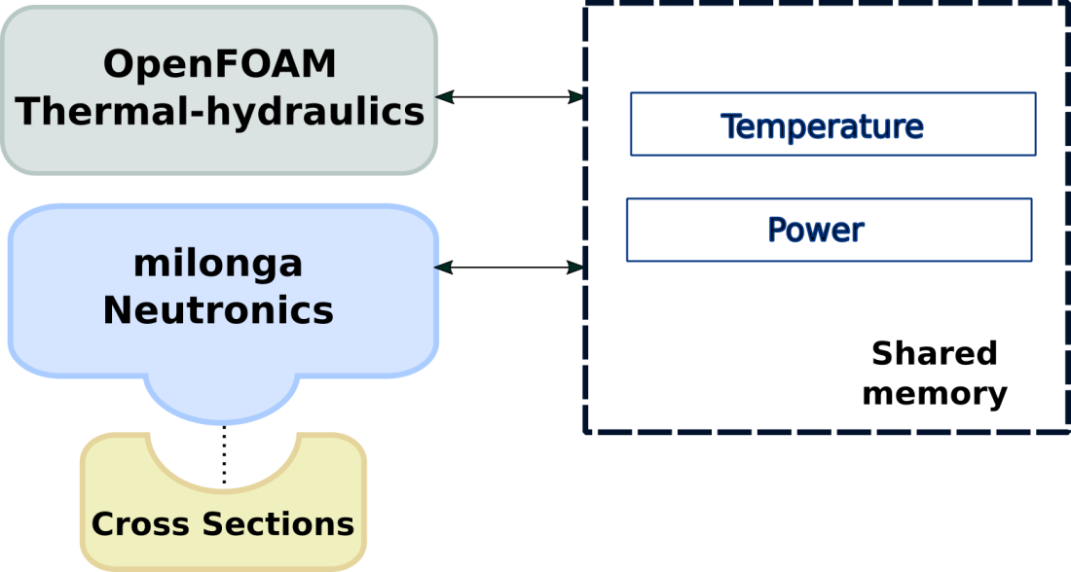
Figure 1 - Coupling methodology schematic.

Cross-sections processing is performed using WIMSD-5B code, using the methodology developed by DEN/UFMG (Reis et al., 2015). From continuous cross-section libraries a set of two-groups cross-sections is generated for three different materials at different temperatures, corresponding to the modeled fuel element temperatures variation, considering the begin of life TRIGA IPR-R1 fuel composition.

Before diving into the details of the coupled calculations, it is important to describe the models and methodology used for each code in standalone mode. The coupled code has a special feature concerning data exchange, but the way both OpenFOAM and milonga runs is preserved.

2.1 Thermal-hydraulic

The OpenFOAM toolbox offers numerical solvers for many common problems, like heat transfer, two-phase fluid flow, financial problems and many others. In order to solve a one-phase steady state fluid flow including conjugated heat transfer from three different materials, the chtMultiRegionSimpleFoam solver (OpenFOAM, 2015) was chosen.

The fluid dynamic is governed by the momentum, continuity and energy conservation equations. The chosen solver separates fluid regions from solid regions and then solves the appropriated equations for each type of region, taking into account the thermal and physical properties of each material, defined for each region.

Differently from common numerical tools, OpenFOAM allows equations assembly directly using objects. The respective equations solved for the momentum (1) and continuity (2) are:

(1)

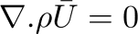 (2)

where the μ_{eff} term is the effective dynamic viscosity, which is the sum of viscosity and turbulent viscosity. The Gρ term is the buoyancy adjustment. The nomenclature of constants and variables presented in equations is described in the appendix A.

The energy equation is implemented in a flexible way, allowing for calculations using enthalpy or internal energy as described below:.

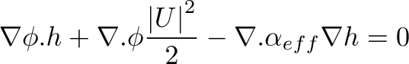 (3)

where the second term is the contribution from kinetic energy and the third term accounts for the heat flux, being α_{eff} is the sum of molecular and turbulent thermal diffusivities.

In the case of solid regions, the energy equation is solved based on enthalpy and after that the corresponding thermal-physical properties are corrected. The energy equation was modified in order to accommodate a source-term to be used by the neutronic coupling scheme. Section 2.3 is entirely dedicated to the coupling methodology and aspects of this work.

The two equations standard k-ε turbulence model (Launder and Spalding, 1974) was selected to calculate the turbulent viscosity. The model assumes that the turbulence viscosity is related to the turbulence kinetic energy (k) and dissipation (ε).

The set of discretized equations are embedded in the solver and solved using SIMPLE algorithm.

2.2 Neutronic

The milonga nuclear code is a free and open source piece of software released under GNU license (GNU license, 2007). It heavily relies on other well-known GNU libraries, like PETSc (Balay et al., 2016), SLEPc (Hernandez et al., 2005) and GNU Scientific Library (Galassi et al., 2009), bringing to it the robustness of these established software and keeping the principles of freedom of software use that GNU enforces. It solves the steady-state multigroup neutron transport equation, either using the diffusion approximation or discrete ordinates Sn method. It can discretize the spatial coordinates using either a finite-element or a finite-volumes scheme. This ability to use finite-volumes discretization schemes over unstructured grids makes it possible, regarding the present problem, to have the same mesh for both thermal-hydraulics and neutronics. With identical meshes, the dependency between fields in each tool can be solved with the same degree of detail. Despite the inaccurate results and limitations of the diffusion approximation under some circumstances (Trahan, 2014), it is the method used in this work due to its faster execution time compared to the Sn method. Moreover, with a proof-of-concept methodology in mind, any changes in power and flux calculations can be observed using the diffusion approximation for multigroup steady-state, presented below already discretized in G groups:

(4)

Equation 4 is discretized using finite volumes as chosen formulation. Despite the cross-sections dependence on temperatures, the diffusion equation can be formulated as linear since the coefficients are kept constant during each step in the iterative calculation.

In a standalone case, milonga works by reading an input file which models the problem to be solved. The simplest case for the present problem consists in the basic problem configuration: read the mesh, define the numerical formulation and chose the number of neutron groups for the problem. The next step is to define the macroscopic cross sections for each material (that may further depend on other functions of space such as temperature) matching the materials defined in the mesh. These cross sections are used in the solution of the diffusion equation and must match the material characteristics, like the diffusion coefficients, absorption macroscopic cross sections and scattering cross-sections. All of them should be defined for each group of energy. After materials definitions, the appropriate boundary conditions are set matching the physical entities defined in the mesh. In order to solve the problem, a simple call command builds and solves the eigenvalue problem. Figure 2 shows a simple input file for milonga. The material definition (lines 10-16) are key: these values can be constants like in the example above but also can be function of a value or position. This feature of milonga makes coupling to external values straightforward.

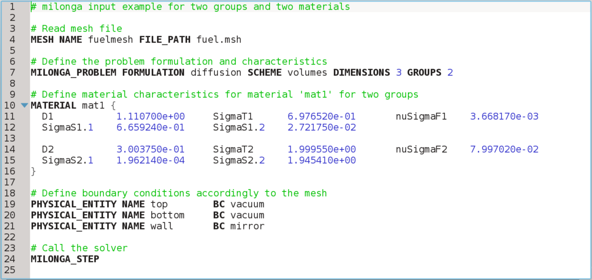
Figure 2 - A simple input file for milonga with line number counting.

It is important to mention that milonga has a wide range of commands and primitives, ranging from meshing pre-processing to output primitives aimed to post-processing in default formats for data visualization software. Some of these features will be presented in Section 2.3.

A key feature of milonga which makes external coupling straightforward is the option to get data in a cell wise manner when discretizing the calculation domain as a mesh. In other words, it is possible to have a spacial function dependence for any variable. However, to have the corresponding values of cross-sections (and all other coefficients for the diffusion approximation) for each cell, a properly set of neutronic macroscopic cross sections had to be generated prior to performing the neutronic computation itself.

2.3. COUPLING SCHEME

The coupling scheme involves two perspectives: one from thermal-hydraulic, which is OpenFOAM, and the other from neutronic, which is milonga. The coupling scheme is presented by showing the changes and project decisions from the point of view of OpenFOAM and then from the perspective of milonga, in a separated way.

2.3.1 Thermal-hydraulic

The open software characteristic of OpenFOAM allows changes and modification of source code, as mentioned before. So, after properly choosing the conjugated heat transfer solver for the thermal-hydraulic and neutronic problems, it had to be modified in order to attain to the objectives of this work. There were two major* modifications to the solver:

- the addition of a source-term to the energy equation in a solid;
- the addition of the data structures for communicating through shared memory to the neutronic code.

It is essential to note that, as a project definition, both OpenFOAM and milonga were set to use the same unstructured mesh. It is enforced to make clear that there is no mapping function and, therefore no error associated to the communication process.

To add a source-term for the energy equation of the fuel solid region a new scalar field was defined in the input files to represent the power in the fuel region. The source-code containing the energy equation was modified accordingly to add a source-term. If the field is not present, a null default scalar field is created.

The coupling between codes was implemented using shared memory taking advantage of the already coded abilities of milonga. Shared memory, in computer science, is a piece of memory that can be simultaneously accessed by different programs running in different user spaces. In order to keep read and write access to the shared memory consistent, a set of semaphores was implemented in OpenFOAM solver together with the structures to detect and read the shared memory (Theler et al., 2013).

The methodology for the coupled communication works as follows:

- the neutronic program, milonga, starts, creates the shared memory and halts until it is able to read the semaphore from thermal-hydraulic;
- OpenFOAM checks if shared memory is present and, if yes, runs the thermal-hydraulic simulation with initial conditions a fixed number of iterations and then signs that to neutronic.
- milonga, when getting the good value for the semaphore, reads temperatures from shared memory, interpolate cross-section data to the current temperature and calculates flux and power. When done, it signs to thermal-hydraulic that it can resume its calculations.
- From now on, thermal-hydraulic will use the power read from shared memory as a source-term in the energy equation for the solid fuel region.

The whole process goes until convergence of thermal-hydraulic. Figure 3 presents the coupling algorithm from the point of view of thermal-hydraulic in a schematic way. Blue commands are related to shared memory manipulation while purple commands control the access to shared memory.

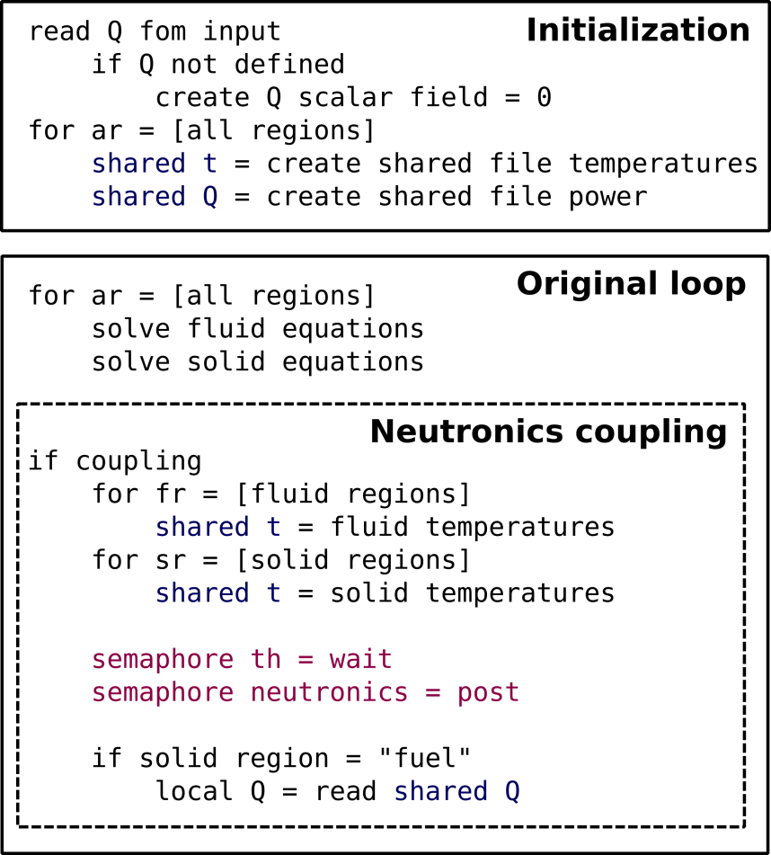
Figure 3 - Thermal-hydraulic coupling algorithm schematic.

There are some limitations and advantages in the way that the coupling is implemented. For now, a fixed ratio of thermal-hydraulic/neutronic iterations is implemented. In this work a number of 100 iterations of OpenFOAM were defined per call of the neutronics based on the maximum number of sub-iterations for neutronics and thermal-hydraulic used by Jareteg (Jareteg et al., 2014). The use of semaphores controls the inter codes communication.

As an advantage, the use of shared memory poses no overhead in data access greater than any other memory access. Some works on coupled thermal-hydraulic and neutronic using external files (Ivanov et al., 2007 and Hummel and Novog, 2016) have access time orders of magnitude higher than the achieved using shared memory (Theler et al., 2013). It must be noted that tools for shared memory communication are available as standard in most of the common operational systems available today.

The other main advantage of this coupling scheme is the use of the same mesh for both codes. This allows calculations with the same level of detail for thermal-hydraulic and neutronic also avoiding the use of mapping functions (Araújo Silva et al., 2015), which inevitably introduces some approximation errors. There are some elegant solutions for mesh mapping functions which can be consistently applied (Jareteg et al., 2015, Richard et al., 2015 and Schimidt et al., 2015), but also introducing some kind of restriction to the solved problem. Even though milonga was designed with the ability to cope with external codes using different meshes, the fact that the neutronic and the CFD code share the same unstructured grid is an unique feature that makes it outstand over the other available core-level neutronic codes.

2.3.2 Neutronic

The coupling methodology establishes milonga as responsible for shared memory creation, neutronic calculations and power feedback to the OpenFOAM solver. Figure 4 shows a pseudo-code representing the coupling scheme algorithm from milonga's perspective. Commands in blue are related to shared memory manipulation, commands depicted in purple show access to shared memory and the command in green includes definitions in external files.

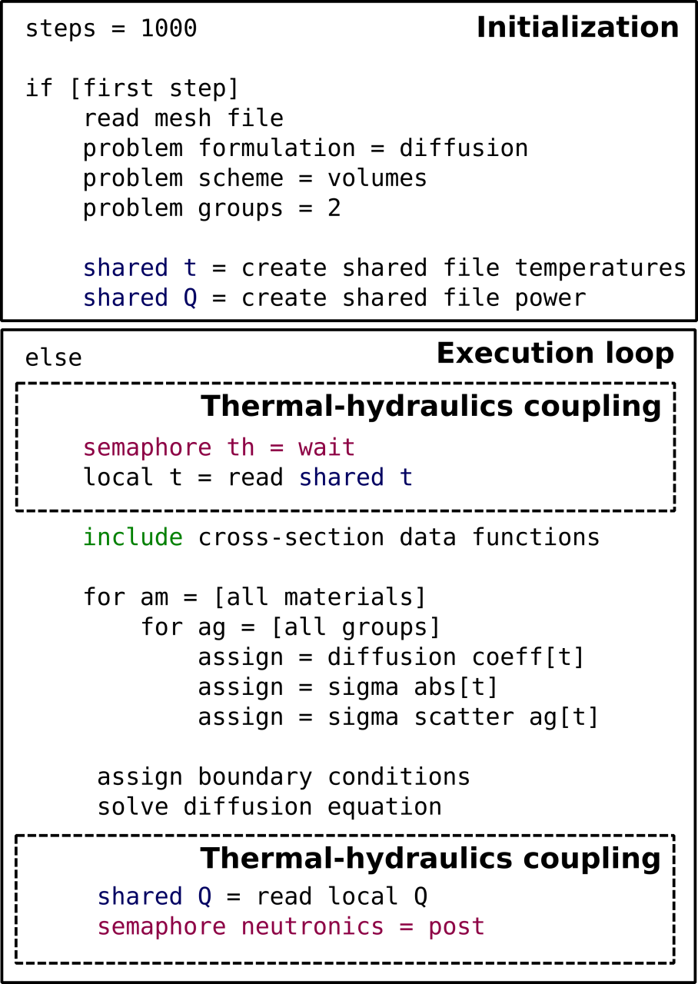
Figure 4 - Neutronic coupling algorithm schematic.

After solving the diffusion approximation and having the function for the flux, milonga has a primitive to integrate the flux over the mesh for a reference power. This value is defined previously in milonga's input file. The power obtained for each cell is thus written in the shared memory, making the power available for the OpenFOAM solver. After this point, the coupling cycle is completed and will continue until thermal-hydraulic calculation converges. It is worth noting that milonga does not need any modification or re-compilation in order to be coupled. Everything is done through the input file and interpreted during run-time.

2.4 Physical and numerical model

The chosen model for this work is a fuel element of the TRIGA IPR-R1 reactor, located at the Centro de Desenvolvimento da Tecnologia Nuclear (CDTN), Belo Horizonte – MG, Brazil. The TRIGA fuel has strong reactivity sensitivity with temperature due to the presence of zirconium hydride. This characteristic enables that small temperature differences result in perceivable neutronic variations which makes this model interesting for coupling assessment.

This model consists of the geometry of a pin cell representing an aluminum fuel with no gap considered. The fuel diameter was kept as the real fuel element diameter and the cladding thickness extended to occupy the space of the gap. The model length is the same of the active region of the real fuel element. In order to have a realist neutronic behavior, the ratio of fissile material and moderator matches the ratio of the full reactor and cross-sections are generated accordingly, following the established methodology for this reactor (Reis et al., 2015). No other solid structure like samarium disks or structural elements were considered, being the model identical at any axial slice. Model sizes are 1.78 cm for fuel pin radius, 1.865 cm for the external cladding radius, 4.57 cm for coolant edges and 35 cm length in axial direction.

An axially extruded unstructured mesh was generated for this work. The mesh had 35 axial layers with
with 0.5 mesh sizing at the cladding and 4.0 maximum mesh sizing. The growth ratio between the refined cladding and the remaining areas was set to 1.2. The total number of mesh elements is 346,675. The mesh can be seen in Figures 5 and 6.

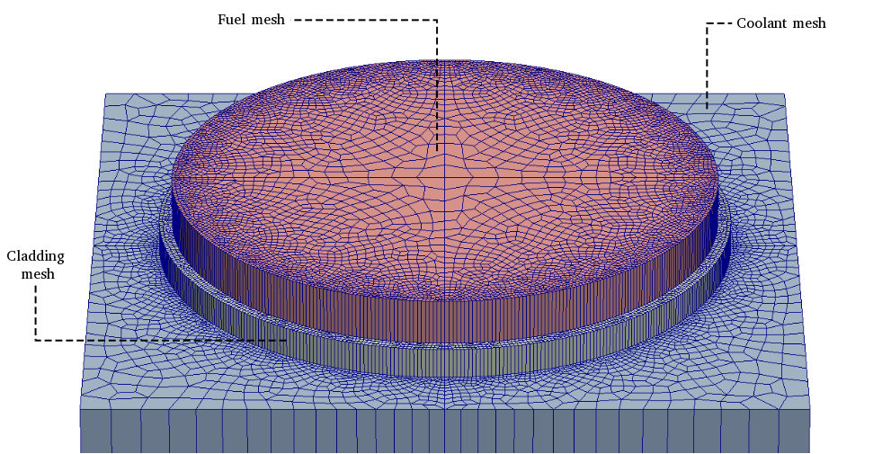Figure 5 - Horizontal mesh discretization slice exploded showing the three regions used by thermal-hydraulic and neutronic.

A small mesh problem was selected for this work due to computational limitations. Simulations were performed on one computer as, at the present time, the software is not implemented for parallel simulation. However, as a proof-of-concept the adopted model could present the desired results.

The setup for thermal-hydraulics and neutronics presented in the following sections is the same for all simulations, with the exception of the initial conditions for the power by volume.

2.4.1 Thermal-hydraulic boundary conditions and numerical parameters

There are four different boundary conditions for the thermal-hydraulic simulation, being an adiabatic wall for fuel and cladding extremities, a symmetric condition for the coolant lateral faces and an inlet and outlet in the coolant extremities. In Figure 6 the set of external boundary conditions are depicted. The symmetric boundaries for fluid region are depicted as wireframe in red and inlet and outlet are fluid surfaces shown in blue wireframe. The problem setup is presented in Table 1. Note that value for power is variable for power field in region fuel accordingly to the simulation ran. This value is also nonuniform, since the field has a different value for each cell to represent an expected power profile.

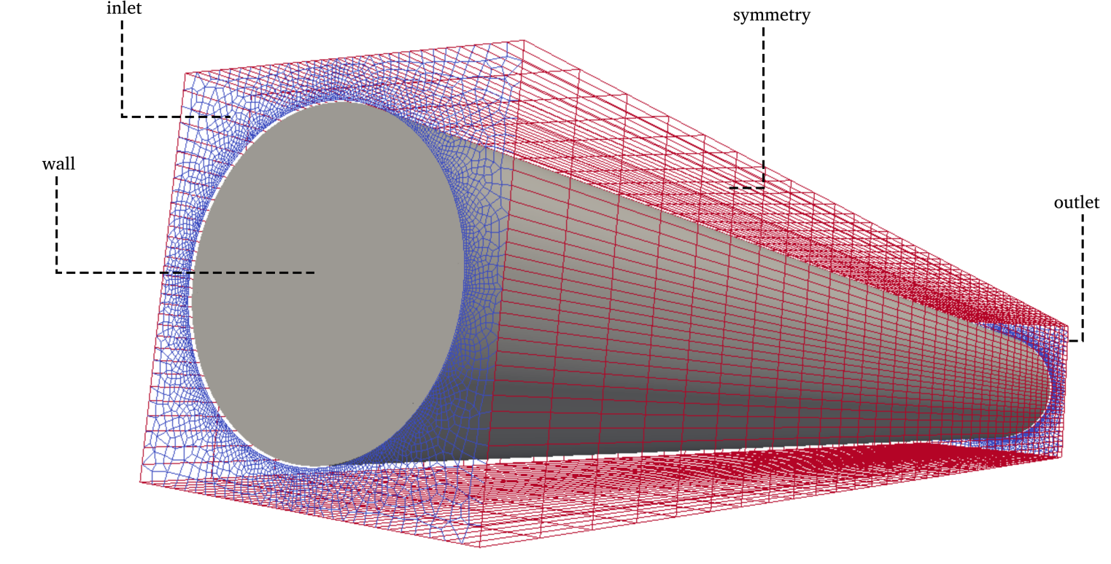
Figure 6 - External boundaries for the CFD problems.

Table 1. Main boundary conditions used for themal-hydraulic simulations
Region | Field | Boundary | Type | Value
coolant | T | inlet  outlet | fixedValue  zeroGradient | 300 K  -
 | U | inlet  outlet | fixedValue  zeroGradient | 0.1 [m/s]  -
 | p_rgh | inlet  outlet | zeroGradient  fixedValue | -  0 [kg/m.s² =Pa]
cladding | T | wall | zeroGradient | -
 | Q | wall  internalField | calculated  uniform | -  0 [W/m³]
fuel | T | wall | zeroGradient | -
 | Q | wall  internalField | calculated  nonuniform | -  (variable) [W/m³]

The symmetry boundary is a special type of boundary condition. It is defined in the mesh file as symmetry and treated in the same way for every field. Another special kind of boundary is the surface between regions. These surfaces are created during the split of the general mesh and are assigned specific boundary conditions accordingly to the type of region, mostly in a default way.

However, one of these boundary conditions worth a special mention: to allow heat transfer between adjacent regions, a temperature coupled boundary condition must be defined at all adjacent surfaces between regions. This boundary condition gets information from thermophysical properties files defined for every region and uses this data to calculate the heat flux. More information on boundary conditions available in OpenFOAM can be found in its documentation (OpenFOAM, 2015). The fluid flow is considered turbulent based on IPR-R1 TRIGA reactor normal operating condition (Veloso, 2005) and the standard κ-ε model (Launder and Spalding, 1974) is used for modeling it.

Simulations were performed using second order discretizations schemes for all equation terms except the divergence, as shown in Table 2. A first order scheme was used for divergence to accelerate and facilitate the numerical convergence, as the results are for a proof-of-concept an added false diffusion will not interfere with the study’s conclusion.

Table 2. Discretization schemes.
 | Type of scheme
Region \ Eq. term | gradient | divergence | laplacian | interpolation | normal do cell face
Coolant | Least Squares | Bounded Gauss upwind | Gauss linear limited 1.0 | linear | limited 1.0
Cladding | Gauss linear | - | Gauss linear uncorrected | linear | uncorrected
Fuel | Gauss linear | - | Gauss linear uncorrected | linear | uncorrected

OpenFOAM (2015) allows the use of different discretization schemes for each region and also for each equation term. Utilized matrix solvers and convergence criteria are presented in Table 3.

Table 3. Solver settings for each field.
Field | Type of solver | Convergence criteria | Under-relaxation
h | Preconditioned bi-conjugate gradient | 10⁻⁵ | 1.0
 | Preconditioned bi-conjugate gradient | 10⁻⁵ | 0.7
p* | Generalized geometric-algebraic multi-grid | 10⁻⁵ | 0.7
p* final | Generalized geometric-algebraic multi-grid | 10⁻⁶ | 0.7
 | Preconditioned bi-conjugate gradient for asymmetric matrices | 10⁻⁵ | 0.7

2.4.2 Neutronic boundary conditions

Milonga deals internally with boundary conditions between regions, conveniently sparing the user from an extra amount of work. For the present problem, it is enough to define boundary conditions for the external surfaces which are chosen to represent neutrons leaking from the top and bottom of the model and a symmetric conditions at the sides, simulating an infinite lattice. Table 4 shows the boundary conditions used for the simulation, noting that neutrons escape in the top and bottom of the model, while Figure 7 presents the regions of each material and associated boundary conditions in a top view. It is possible to see at right, regions consisting of homogeneous materials. At left, the mesh over domain showing boundary conditions.

Table 4. Boundary conditions.
Boundary | Type | Corresponding region
inlet | Vacuum | coolant
outlet | Vacuum | coolant
extremes | Vacuum | cladding  fuel
walls | Mirror | coolant

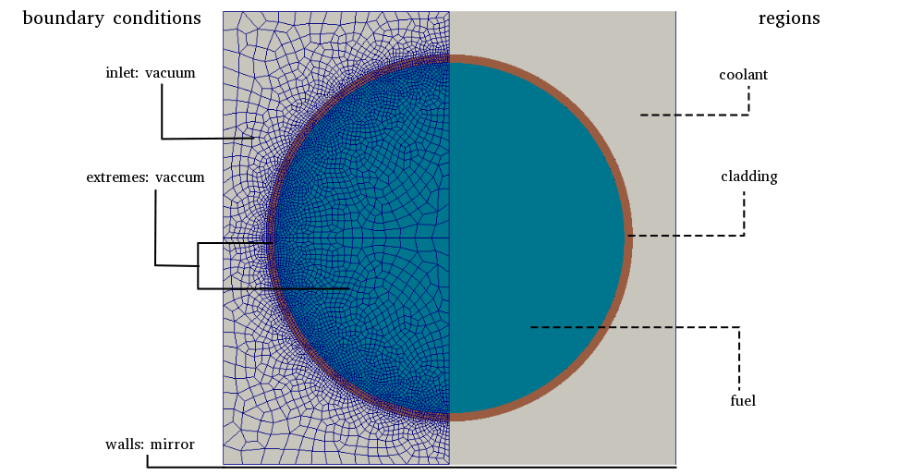
Figure 7 - Top view of neutronic domain.

2.4.3 Cross-sections

Sets of cross-sections were generated for three different materials representing fuel, cladding and coolant at the tabulated temperatures presented in Table 5 while the materials composition are depicted in Table 6, following an established cross-section generation methodology (Reis et al., 2015). The set of cross-sections are generated for the model previously described in Section 2.4 (Figure 5), which have geometry and composition defined based on the cross-sections generation methodology used.

Table 5. Temperatures for fuel, cladding and moderator (Veloso, 2015)
 | T₁ [K] | T₂ [K] | T₃ [K] | T₄ [K]
fuel | 300 | 400 | 500 | 600
cladding | 300 | 396 | 403 | 410
water/moderator | 300 | 308.5 | 317 | 341

Table 6. Materials composition for cross-sections generation with WIMSD-5B (Reis et al., 2015)
 | Material | Material code | Mass
fuel | H (in zyrconium hydrade) | 5001 | 3.7525e-02
fuel | Zr | 91 | 3.7727e-02
fuel | U²³⁵ | 2235 | 2.5744e-04
fuel | U²³⁸ | 8238 | 1.0167e-03
cladding | Al | 27 | 6.0261e-02
water/moderator | H | 3001 | 6.6653e-02
water/moderator | O | 6016 | 3.3327e-02

The calculations were made for two neutron groups. Diffusion coefficients, absorption cross-sections, scattering cross-sections and energy release by fission were previously calculated (Reis et al., 2015). Coefficients used for the diffusion approximation equation by milonga are presented in Table 7. The cross-sections are obtained for the materials specified in Table 6 under the temperatures defined in Table 5. WIMSD-5B processes the cross-sections for homegeneized cells and then re-calculates the data for each material. For the scattering cross-sections, it gives only the homogeneized data thus making the scattering cross-sections the same for all regions.

Table 7. Diffusion approximation coefficients by domain regions and groups.
Group | Coefficients | Parameter
Group 1: > 0.625MeV | Diffusion coefficient | D1
 | Absorption cross-section | ΣA1
 | Scattering cross-section | ΣS1.2
 | Neutrons per fission * Fission cross-section | νΣF1
Group 2: < 0.625Mev | Diffusion coefficient | D2
 | Absorption cross-section | ΣA2
 | Neutrons per fission * Fission cross-section | νΣF2

These data are written in milonga format as a one-variable function dependent on temperature. Since milonga has cell-wise information loaded with the mesh, the temperature of each cell becomes argument of the one variable function dependent on temperature. If the temperature is not exactly tabulated, milonga provides linear interpolation by default. In other words, for each neutronic calculation, a set of coefficients for diffusion equation is calculated based on interpolated values of cell temperatures. Each cell can have its own set of coefficients.

3. PROOF-OF-CONCEPT

The proof-of-concept of the proposed coupled methodology is performed based on different coupled and non-coupled simulations:

- Non-coupled case: OpenFOAM and milonga are run separated with constant distributions for temperature and power. Milonga is fed with a fixed set of cross-sections. These cases are defined to obtain physical results. These results are the neutronic and thermal-hydraulic references for the coupled cases.

- Coupled case: in this case, OpenFOAM writes cells temperatures to the shared memory and Milonga reads temperatures from shared memory in a cell-wise way.

OpenFOAM was run in standalone mode with three different initial constant power values, for three different power of 1.98, 3.97 and 7.93 kW. The power values are based on the proportional power of the hottest fuel element of TRIGA IPR-R1 (Veloso, 2005) considering the reactor operating at 50, 100 and 200 kW. For each simulation, the averaged temperature for each material is calculated. These averaged temperatures are show in Table 8.

Table 8. Averaged temperatures [K] for materials after standalone thermal-hydraulic simulations
 | Simulation power by bin
Material | 1.98 [kW] | 3.97 [kW] | 7.93 [kW]
fuel | 339.8 [K] | 379.8 [K] | 423.0 [K]
cladding | 327.2 [K] | 354.5 [K] | 375.4 [K]
water/moderator | 303.5 [K] | 307.2 [K] | 310.1 [K]

These temperatures were used to feed milonga for three non-coupled simulations. A set of temperatures for each power was used to generated fixed cross-sections, interpolated from the data obtained previously trough WIMSD-5B. These three non-coupled simulations gave three power distributions which were then used by OpenFOAM as an initial condition. The non-coupled simulations used as references to the coupled ones can be seen, in fact, as a special case of an external manually and only initial condition coupled calculation.

Figure 8 shows temperature distribution axially and radially for the highest simulated power comparing coupled and non-coupled (NC) simulations while in Figure 9 the power distributions are depicted. Results show an expected behavior: flattened profiles for temperature and power for coupled calculations, indicating the coupling was successfully achieved. The steps presented in radial plot in Figure 8 are expected and due to the interface between different materials.

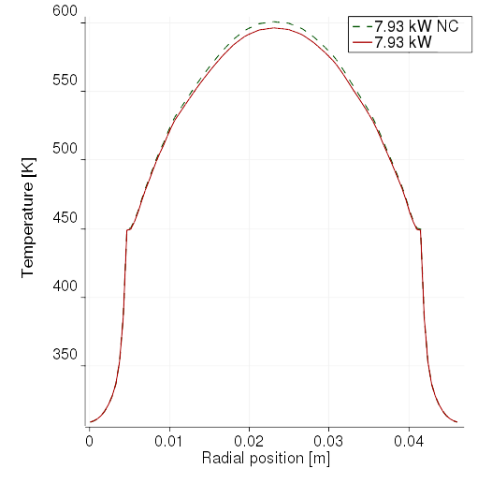 | 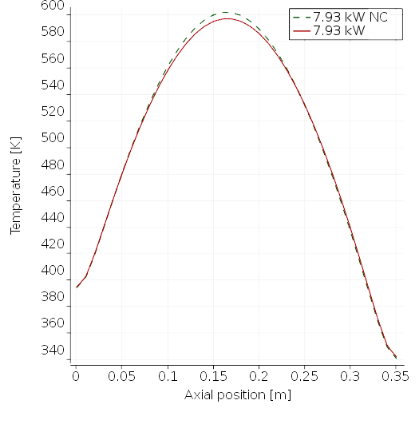
Figure 8: Temperature profiles in radial and axial directions for coupled and non-coupled (NC) simulations.

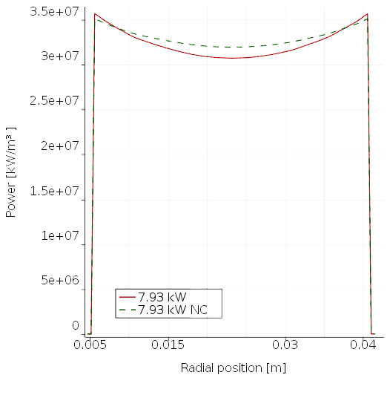 | 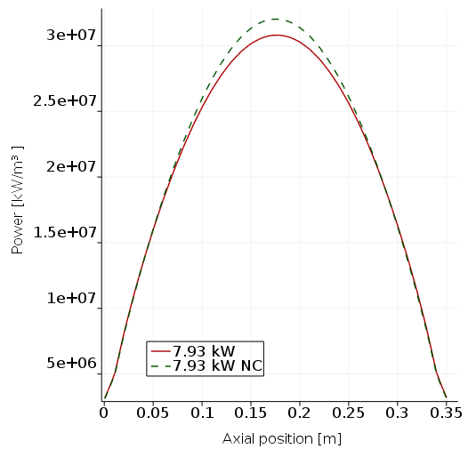
Figure 9: Power profiles in radial and axial directions for coupled and non-coupled (NC) simulations.

The standalone milonga simulations were performed for three different sets of cross-sections. These cross-sections were generated based on the temperatures previously calculated by standalone OpenFOAM simulations (Table 8) by means of linear interpolation. The set of temperatures were used as parameters for the cross-section interpolation functions used in coupled calculations. Table 9 presents the results from standalone neutronic simulations and coupled neutronic simulations.

Table 9. Results of standalone and coupled neutronic calculations.
Fuel pin power [kW] | Full core power equivalence [kW] | Standalone k_{eff} | Coupled k_{eff}
1.983 | 50 | 1.15298 | 1.15268
3.965 | 100 | 1.15117 | 1.15000
7.930 | 200 | 1.14829 | 1.14354

As expected, the value for k_{eff} decreased as temperature increased in the materials for both standalone and coupled calculations. This is due to the strong negative temperature coefficient of the modeled fuel element.

Table 9 also shows that all coupled simulations showed lower values than the standalone calculations under the same conditions. This is due to the feedback from neutronic calculations: the updated cross-sections result in a different neutron flux distribution for the coupled simulation and therefore, a difference in temperatures distributions after thermal-hydraulic calculations.

This is also expected as the temperature at the higher flux positions will be above the average temperature, changing cross-sections and reducing the reactivity more in this region. This effect outweighs the inverse effect of the extremities of the fuel that will have below average temperatures, as these regions will have a lower neutron flux.

It is also interesting to point out that the difference between standalone and coupled simulations increased as power increased. This is also an expected behavior as the previously described temperature profile effect will be more significant at higher power. These results all indicate that the proposed coupled simulation successfully show the expected behavior.

A graphical view of k_{eff} values until calculations convergence is shown in Figure 9. Values for k_{eff} at each call to milonga during one coupled simulation are plotted. The k_{eff} value in standalone is presented as a constant line for the sake of clarity, since its calculated in only one milonga run.
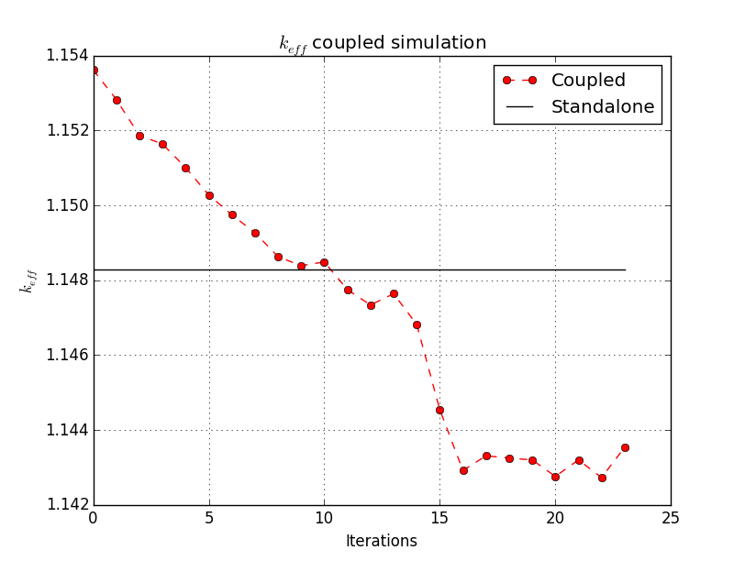
Figure 9: k_{eff} results during coupled calculations iterations.

It can be noticed that k_{eff} for the coupled calculations decreases below the values of standalone simulation after a set of iterations and then remains lower until convergence. Some oscillation of the coupled simulation was observed until achieving convergence after about 20 calls to milonga. The intense decrease in k_{eff} between iterations 14 and 16 is due to changes in relaxation factor to accelerate convergence of calculations in OpenFOAM, which allows parameters tuning during the simulation. This effect also shows the coupled system robustness concerning numerical variations.

The graphical representation of the relative fluxes for the standalone neutronic calculations and the coupled simulations is shown in Figure 10. The results for the coupled calculations show a slightly flattened curve for the neutron flux, with higher values in the extremities (lower than average temperatures) and lower values in the center (higher than average temperatures). As previously discussed, this is the expected behavior for the flux when the differences in temperatures and, consequently, in cross-sections are taken in account, indicating that the coupling has been performed successfully.

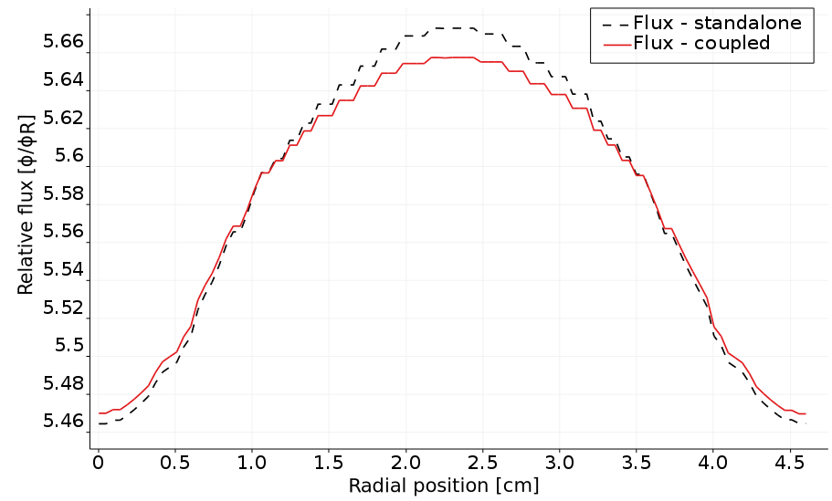 | 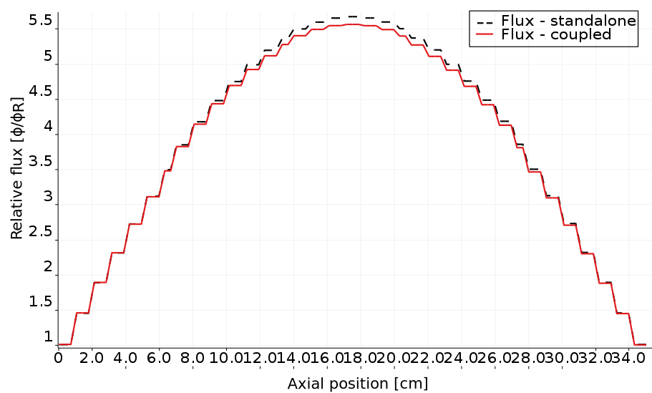

Figure 10: Radial (left) and axial (right) profiles for relative flux for standalone and fully-coupled calculations.

In order to visualize the results of coupled calculations relative to standalone execution, a set of images were generated showing the differences in relative fluxes and power between the coupled and non-coupled calculations. Figure 11 shows these differences from different views of the model. In these images the previously described temperature and neutron flux effects can be visualized in terms of flux and power differences.

Figure 13 - Differences in relative neutron flux and power between standalone and coupled calculation. A – Mid axial slice, B – Mid radial slice and C – Isometric.

6. CONCLUSIONS

In this paper, a coupled neutronic and thermal hydraulic system based on finite volumes was developed primarily using open software. This coupled-framework uses shared-memory to allow data interchange between two different software without time penalty. It has the advantage of solving neutronics and thermal-hydraulics at the same level of detail, using the same mesh for it. The system is applied to a single TRIGA fuel pin considering only its active portion. The results show the coupling system effectively works and that the multi-physics calculations gives flattened shapes for neutron flux when compared to standalone calculations and, as its consequences, the power shape is also affected.

Although in its very preliminary version, the system presented in this paper has another innovative characteristic uncommon in other the nuclear engineering software tools: it is fully open and free to use and modify. This is not merely a detail, but a form of software development popular in other fields of knowledge. The specificity and history of software development in the nuclear engineering field could have delayed the advances of open software development in this field. However, as recent projects demonstrate (Huff et al, 2016, Romano et al., 2013 and Boyd et al., 2014) - a special remark to milonga nuclear reactor code (Theler 2014) - open software development is wider than its technical aspects. It is a form of thinking the whole process of software development and it is not unrealistic to say that it is now a reality in the nuclear engineering field.

7. FURTHER DEVELOPMENT

There are a lot of room for improvements in the methodology presented in this work and also many technical aspects that can be addressed to make simulations faster and more reliable. Concerning the methodology, the first aspect is to improve the convergence criteria for both software. This can be achieved having a coupled calls based on simulation criteria, like residuals. Another way to make simulations more time efficient is to have codes calculating simultaneously, and not staggered coupling. This can be achieved by improving the semaphore control to a more elaborated set of rules.

The improvements proposed are considering an important limitation of this proof-of-concept methodology: sequential run. OpenFOAM offers mature parallel implementations and the coupled development took it in account. In order to fully take advantage of this capability, milonga nuclear code should also be able to run in parallel. This situation would be unfortunate, if milonga was not freely available. Considering the open characteristic of it, anybody wishing to tackle this task is welcome to collaborate. This subject brings the technical aspects of the coupled software which can be object of improvements. The immediate one is to make milonga work in parallel, using domain decomposition techniques. Another, non-exclusive, way is to use internal threads to solve the eigenvalue problem in parallel while the mesh stay untouched. The use of shared-memory, one of main contributions of this work in coupled-code data exchange, can host the mesh structures, having codes sharing it and thus making use of half of memory for main data structures. Another improvement worth to mention, is to improve milonga's mesh data structures, specifically concerning mesh accessing, which is the bottleneck of neutronic calculations.

As concisely shown, there are a wide number of aspects in the presented implementation and methodology which can be addressed. The open characteristic of both codes are an invitation to anybody interested to contribute to try, test and improve them. This is the spirit of open software and the nuclear engineering field has a lot to benefit from it.

ACKNOWLEDGMENTS

The authors are grateful to the Brazilian research funding agencies, CNEN, CNPq, CAPES and FAPEMIG for their support. Furthermore, the first author would like to thank the colleagues Álvaro Bernal and Gumersindo Verdú from UPV – Politechnical University of València, Spain – for their invaluable contributions for this work during a scholarship financed by CAPES – Brazilian Federal Agency for Support and Evaluation of Graduate Education within the Ministry of Education of Brazil - in the basis of PDSE scholarship program.

APPENDIX A: Nomeclature

The following tables summarize the nomenclature of constants and variables presented in equations and simulations through this paper.

Table A.1. Nomenclature and description for thermal-hydraulic quantities.
Quantity | Description
 | Fluid density
 | Averaged velocity
 | Effective dynamic viscosity
 | Averaged velocity transpose
 | Identity matrix
 | Pressure relative to density
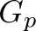 | Buyancy adjustment
 | Transported quantity
 | Enthalpy
 | Scalar velocity
 | Thermal diffusivities

Table A.2. Nomeclature and description for neutronic quantities
Quantity | Description
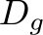 | Diffusion coefficient for group g
 | Vector representing the current cell
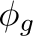 | Flux for group g
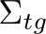 | Total macroscopic cross-section for group g
 | Flux
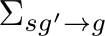 | Scattering cross-section from group g' to group g
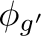 | Flux for group g'
χ | Fraction of neutrons appearing in group
 | Average number of neutrons by fission
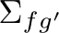 | Fission cross-section for group g'
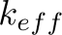 | Effective multiplication factor

REFERENCES

Androutsellis-Theotokis, S., Spinellis, D., Kechagia, M. and Gousios, G. (2010) Open Source Software: A Survey from 10,000 Feet. Foundations and Trends in Technology, Information and Operations Management, Vol. 4, Nos. 304, 187-347

Araújo Silva, V. V., dos Santos, A. A. C., Mesquita, A. Z., Bernal, A., Miró, R., Verdú, G. and Pereira, C. (2015) Finite volume thermal-hydraulics and neutronics coupled calculations. Proceedings of ICAPP 2015, May 03-06. Nice, France.

Balay, S., Abhyankar, S., Adams, M. F., Brown, J., Brune, P., Buschelman, K., Dalcin, L., Eijkhout, V., Gropp, W. D., Kaushik, D., Knepley, M. G., Curfman McInnes, L., Rupp, K., Smith, B. F., Zampini, S. and Zhang, H. (2016) PETSc Users Manual, ANL-95/11 - Revision 3.7. Argonne National Laboratory, 2016. http://www.mcs.anl.gov/petsc

Bennett, A., Avramova, M. and Ivanov, K. (2016) Coupled MCNP6/CTF code: Development, testing and application, Annals of Nuclear Energy, Volume 96, Pages 1-11, ISSN 0306-4549, http://dx.doi.org/10.1016/j.anucene.2016.05.008.

Boyd, W., Shaner, S., Li, L., Forget, B. and Smith, K. (2014) The OpenMOC method of characteristics neutral particle transport code, Annals of Nuclear Energy, Volume 68, Pages 43-52, ISSN 0306-4549, http://dx.doi.org/10.1016/j.anucene.2013.12.012.

Galassi, M., Davies, J., Theiler, J., Gough B., Jungman, G., Alken, P., Booth, M., Rossi, F. and Ulerich, R. (2009) GNU Scientific Library Reference Manual - Third Edition, ISBN 0954612078.

GNU General Public License (2007) Version 3. Free Software Foundation. URL: http://www.gnu.org/licenses/gpl.html.

Hernandez, V., Roman, J. E. and V. Vidal. (2005) SLEPc: A scalable and flexible toolkit for the solution of eigenvalue problems. ACM Trans. Math. Software, 31(3):351-362.

Huff, K. D., Gidden, M. J., Carlsen, R. W., Flanagan, R. R., McGarry, M. B., Opotowsky, A. C., Schneider, E. A., Scopatz, A. M. and Wilson, P. P. H. (2016) Fundamental concepts in the Cyclus nuclear fuel cycle simulation framework, Advances in Engineering Software, Volume 94, Pages 46-59, ISSN 0965-9978, http://dx.doi.org/10.1016/j.advengsoft.2016.01.014.

Hummel, D. W. and Novog, D. R. (2016) Coupled 3D neutron kinetics and thermalhydraulic characteristics of the Canadian supercritical water reactor, Nuclear Engineering and Design, Volume 298, March 2016, Pages 78-89, ISSN 0029-5493, http://dx.doi.org/10.1016/j.nucengdes.2015.12.008.

Ivanov, K. and Avramova, M. (2007) Challenges in coupled thermal–hydraulics and neutronics simulations for LWR safety analysis, Annals of Nuclear Energy, Volume 34, Issue 6, Pages 501-513, ISSN 0306-4549, http://dx.doi.org/10.1016/j.anucene.2007.02.016.

Jareteg, K., Vinai, P. and Demazière, C. (2014) Fine-mesh deterministic modeling of PWR fuel assemblies: Proof-of-principle of couple neutronic/thermal-hydraulic calculations, Annals of Nuclear Energy, Volume 68, Pages 247-256, ISSN 0306-4549, http://dx.doi.org/10.1016/j.anucene.2013.12.019.

Jareteg, K., Vinai, P., Sasic, S. and Demazière, C. (2015) Coupled fine-mesh neutronics and thermal-hydraulics – Modeling and implementation for PWR fuel assemblies, Annals of Nuclear Energy, Volume 84, Pages 244-257, ISSN 0306-4549, http://dx.doi.org/10.1016/j.anucene.2015.01.037.

Kärrholm Peng, F. (2006) Numerical Modelling of Diesel Spray Injection and Turbulence Interaction. Appendix: Rhie-Chow interpolations in OpenFOAM. Göteborg: Chalmers University of Technology

Launder, B. E. and Spalding, D. B. (1974) The numerical computation of turbulent flows, Computer Methods in Applied Mechanics and Engineering, Volume 3, Issue 2, 1974, Pages 269-289, ISSN 0045-7825, http://dx.doi.org/10.1016/0045-7825(74)90029-2.

Leppännen, J.,Viitanen, T. and Valtavirta, V. (2012) Multi-physics Coupling Scheme in the Serpent 2 Monte Carlo Code. Hybrid Monte Carlo Deterministic Methods For Reactor Analysis, Transactions of American Nuclear Society, Vol. 107, San Diego, California, November 11-15.

Mahadevan, V., Merzari, E., Tautges, T., Jain, R., Obabko, A., Smith, M. and Fischer, P. (2014) High-resolution coupled physics solvers for analysing fine-scale nuclear reactor design problems. Phil. Trans. R. Soc. A 2014 372 20130381; DOI: 10.1098/rsta.2013.0381.

OpenFOAM - The Open Source CDF Toolbox: User guide. Version 3.0.1 [S.l.], 2015.

Reis, P. A. L., Pereira, C., Costa, A. L., González-Mantecón, J., Velos, M. A. F., Soares, H. V. (2015) Thermal Hydraulic and Neutron Kinetic Simulation of the TRIGA IPR-R1 Research Reactor using RELAP5-PARCS Coupled Model, Proceedings of European Research Reactor Conference, April 19-23, Bucharest, Romania, 2015.

Richard, J. Galloway, J., Fensin, M. and Trellue, H. SMITHERS: An object-oriented modular mapping methodology for MCNP-based neutronic–thermal hydraulic multiphysics, Annals of Nuclear Energy, Volume 81, Pages 150-163, ISSN 0306-4549, http://dx.doi.org/10.1016/j.anucene.2015.03.027.

Romano, P. K. and Forget, B. (2013) The OpenMC Monte Carlo particle transport code, Annals of Nuclear Energy, Volume 51, January 2013, Pages 274-281, ISSN 0306-4549, http://dx.doi.org/10.1016/j.anucene.2012.06.040.

Schmidt, R., Belcourt, K., Hooper, R., Pawlowski, R., Clarno, K., Simunovic, S., Slattery, S., Turner, J., Palmtag, S. (2015) An approach for coupled-code multiphysics core simulations from a common input, Annals of Nuclear Energy, Volume 84, Pages 140-152, ISSN 0306-4549, http://dx.doi.org/10.1016/j.anucene.2014.11.015.

Theler G., Clausse A., Bonetto F.J., Solution of the 2D IAEA PWR Benchmark with the neutronic code milonga, Actas de la XXXVIII Reunion Anual de la Asociacion Argentina de Tecnologia Nuclear, Buenos Aires, 2011.

Theler, G., Omil, J. P. G. and Pellegrino, E. (2013) A shared-memory-based Coupling Scheme for Modelling the Behavior of a Nuclear Power Plant Core. Mecánica Computacional Volume XXXII, Asociación Argentina de Mecánica Computacional, Pages 1501-1517.

Theler, G. (2014) On the design basis of a new core-level neutronic code written from scratch. The milonga free nuclear reactor core analysis code. Mecánica Computacional Volume XXXIII, Number 48, Numerical Methods in Reactor Physics (B).

Trahan, T. J. (2014) An asymptotic, homogeneized, anisotropic, multigroup diffusion approximation to the neutron transport equation. Thesis, Nuclear Engineering and Radiological Sciences, University of Michigan.

Veloso, M. A. (2005) Avaliação Termo-hidráulica do Reator TRIGA IPR-R1 a 250 kW. NI-EC3-05/05, Belo Horizonte-MG, Brazil: Centro de Desenvolvimento da Tecnologia Nuclear (CDTN), Comissão Nacional de Energia Nuclear. (in Portuguese)

Williams, S. (2010). Free as in Freedom (2.0): Richard Stallman and the Free Software Revolution (2nd ed.). (R. M. Stallman, Ed.) Boston: Free Software Foundation.

Zerkak, O., Kozlowski, T. and Gajev, I. (2015) Review of multi-physics temporal coupling methods for analysis of nuclear reactors, Annals of Nuclear Energy, Volume 84, Pages 225-233, ISSN 0306-4549, http://dx.doi.org/10.1016/j.anucene.2015.01.019.

Minor modifications concerning technical aspects are left as source-code comments.

