Coupled Neutronics and Thermal-Hydraulics Calculations Using The Same Unstructured Mesh
Vitor Silva^{1,4}, André Santos¹, Germán Theler³, Rafael Miró³, Cláubia Pereira⁴
¹Centro de Desenvolvimento da Tecnologia Nuclear, Comissão Nacional de Energia Nuclear, Av. Pres. Antônio Carlos, 6627 - 30270-901 Belo Horizonte, MG, Brazil
²Seamplex, Santa Cruz 205, 2300, Rafaela, Argentina
³Institute for Industrial, Radiophysical and Environmental Safety (ISIRYM), Universitat Politècnica de València, Camí de Vera s/n, Valencia 46022, Spain
⁴Departamento de Engenharia Nuclear (DEN), Universidade Federal de Minas Gerais (UFMG), Av. Pres. Antônio Carlos, 6627 - 30270-901 Belo Horizonte, MG, Brazil
^{1,4}vitors@cdtn.br
¹aacs@cdtn.br
²gtheler@seamplex.com
³rmiro@iqn.upv.es
⁴claubia@nuclear.ufmg.br

Abstract— The development of a one step coupled neutronics/thermal-hydraulics methodology is presented. The contribution proposed goes toward the use of the computational fluid dynamics (CFD) software OpenFOAM and the flexible reactor core analysis code milonga to perform coupled calculations. This concept was applied to simulate the the behavior of a TRIGA-IPR-R1 reactor fuel pin in steady-state mode. The macroscopic cross-sections for the model, a set of two-group cross-sections data, were generated using WIMSD-5B code. The results show that this coupled system gives consistent results, encouraging system further development and its use for full core simulation.

Keywords—Coupling, Finite Volumes, milonga, Neutronics, OpenFOAM, Thermal-hydraulics.

INTRODUCTION
The goal is to present a coupled neutronics and thermal-hydraulics methodology for nuclear reactors calculations. The thermal-hydraulic calculations are performed by the Computational Fluid Dynamics (CFD) toolbox called OpenFOAM [1]. For neutronic calculations, a nuclear reactor core analysis code called milonga is used to solve the steady-state multigroup neutron transport equation [2]. Both codes solve the discretized equations for a fine unstructured mesh using finite volumes method. In this coupled framework, both codes use the same mesh for domain discretization, allowing both codes to solve their problems with the same degree of detail.
There are many reasons for choosing a computationally demanding method like finite volumes to solve both neutronics and thermal-hydraulics in a coupled manner. The continuous improvements in computers speed and storage capacity have had a deep impact in the way engineers and scientists work on their problems. The nuclear engineering field have been benefiting from computers continuous increasing in processing power, turning former expensive calculation methods into useful and practical tools to solve many different problems in the field. Recently the focus also pointed toward the use of thermal-hydraulic and neutronic codes to solve nuclear reactor problems in a coupled way. These coupled calculations approaches, also called multi-physics [3] offers an interesting way of modeling the feedback from thermal-hydraulics to neutronics and vice versa.
In this paper, the objective is to the develop a framework for coupled thermal-hydraulic and neutronic calculations which can be freely distributed, used, modified and improved by anyone interested in performing nuclear reactor calculations. The following sections present details of the coupled system developed in this work, which have as its main characteristics:
- Neutronics and thermal-hydraulics are calculated using finite volume approach, in steady-state mode, and both software use the same domain discretization for calculations.
- Cross-sections are generated externally for two-neutron groups and are used by neutronics to give a initial power distribution for thermal-hydraulics.

MODELS AND METHODOLOGY
In order to test the coupled framework, a geometry representing one TRIGA IPR-R1 reactor fuel pin was modeled. It is worth noting that “to test” in the context of this work means to guarantee that calculations are correctly carried and numerical convergence is achieved in both codes. In other words, the coupling methodology is demonstrated through three-dimensional one step multi-physics calculations. Figure 1 depicts a basic schematic for the coupling methodology.
Cross-sections processing is performed using WIMSD-5B code, using the methodology developed by DEN/UFMG [4]. From continuous cross-section libraries a set of two-groups cross-sections is generated for three different materials at different temperatures, corresponding to the modelled fuel element temperatures variation, considering the begin of life TRIGA IPR-R1 fuel composition.

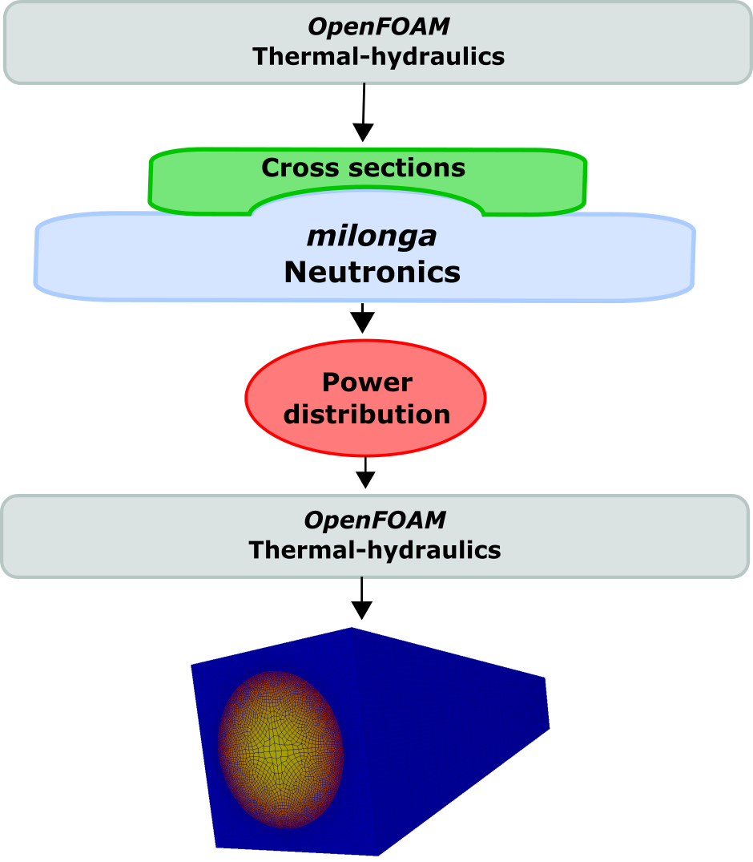
Figure 1 – Coupling methodology schematic

This model consists of the geometry of a pin cell representing an aluminum fuel with no gap considered. The fuel diameter was kept as the real fuel element diameter and the cladding thickness extended to occupy the space of the gap. The model length is the same of the active region of the real fuel element. In order to have a realist neutronic behavior, the ratio of fissile material and moderator matches the ratio of the full reactor and cross-sections are generated accordingly, following the established methodology for this reactor [4]. No other solid structures like samarium disks or structural elements were considered, being the model identical at any axial slice. Model sizes are 1.78 cm for fuel pin radius, 1.865 cm for the external cladding radius, 4.57 cm for coolant edges and 35 cm length in axial direction.
An axially extruded unstructured mesh was generated for this work. The mesh had 35 axial layers with 0.5 mesh sizing at the cladding and 4.0 maximum mesh sizing. The growth ratio between the refined cladding and the remaining areas was set to 1.2. The total number of mesh elements is 346,675. The mesh can be seen in Figure 2.
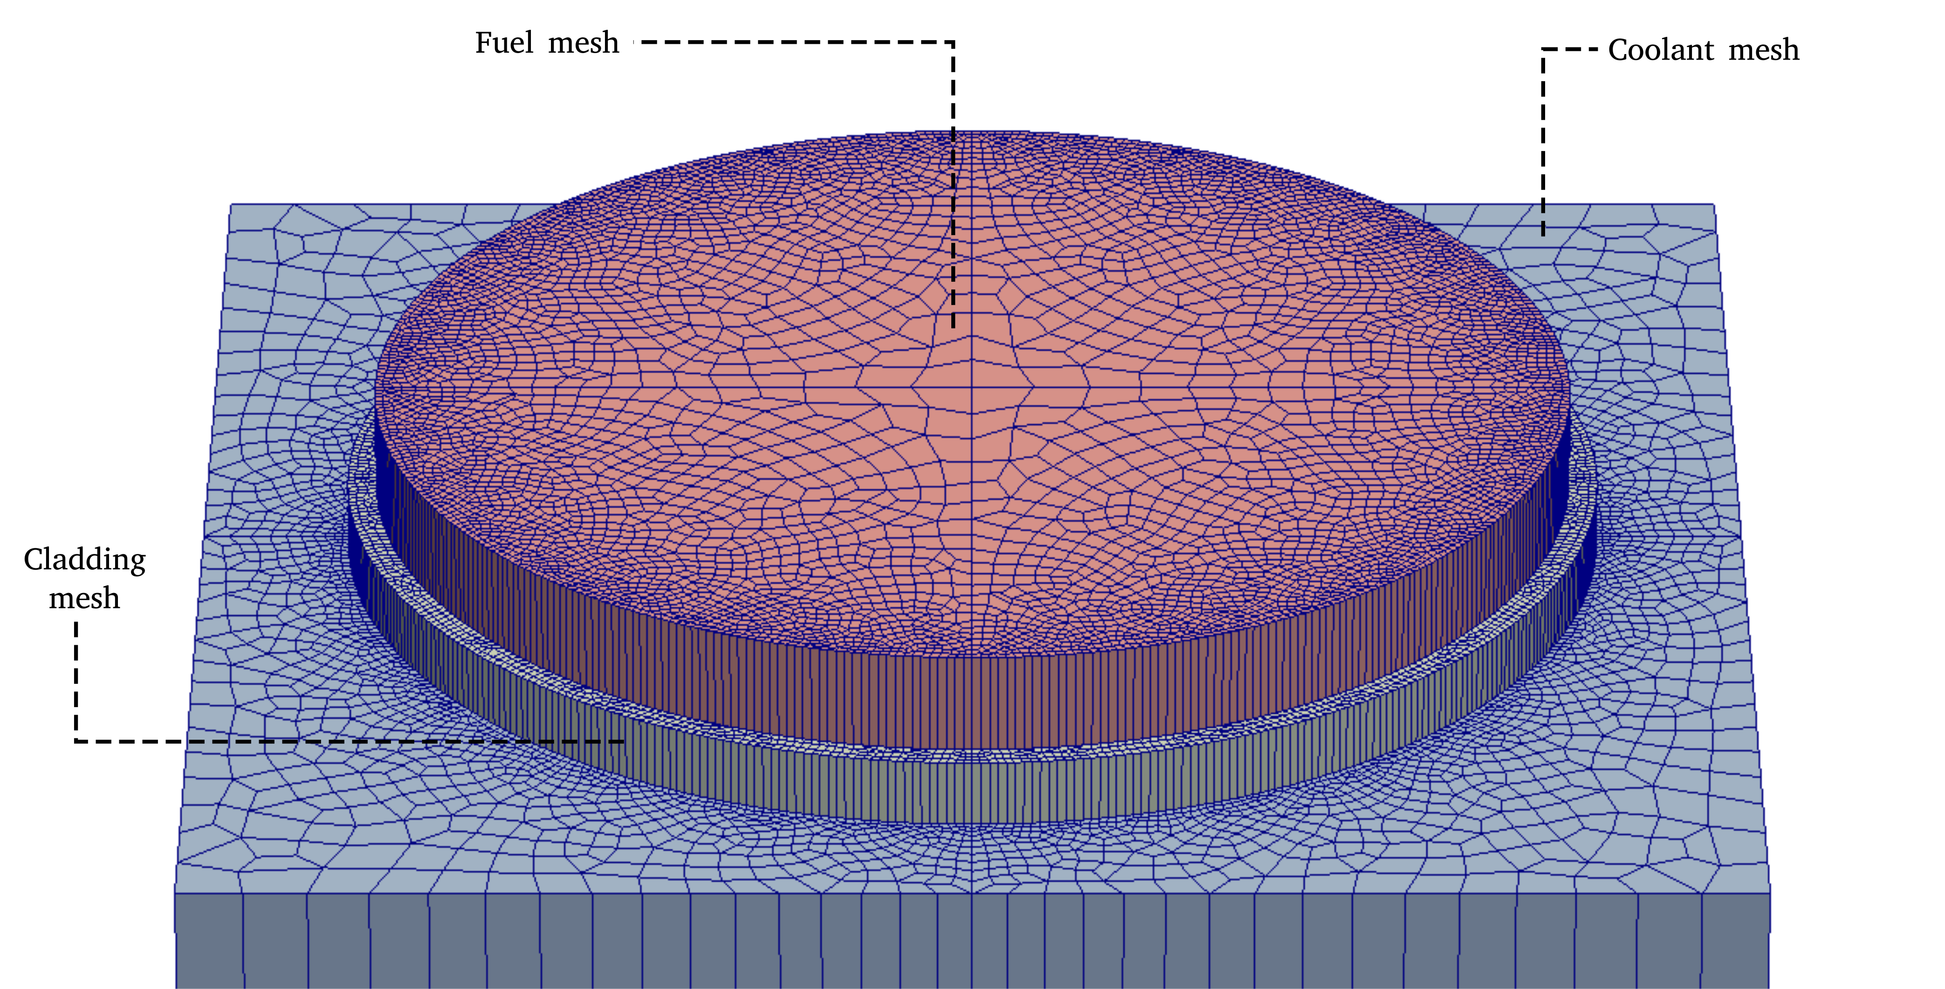
Figure 2 – Exploded mesh discretization by region

A. Thermal-Hydraulics

The OpenFOAM toolbox offers numerical solvers for many common problems, like heat transfer, two-phase fluid flow, financial problems and many others. In order to solve a one-phase steady state fluid flow including conjugated heat transfer from three different materials, the chtMultiRegionSimpleFoam solver [1] was chosen.
The fluid dynamic is governed by the momentum, continuity and energy conservation equations. The chosen solver separates fluid regions from solid regions and then solves the appropriated equations for each type of region, taking into account the thermal and physical properties of each material, defined for each region.
Differently from common numerical tools, OpenFOAM allows equations assembly directly using objects. The respective equations solved for the momentum and continuity are, respectively:

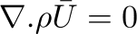

where the μ_{eff} term is the effective dynamic viscosity, which is the sum of viscosity and turbulent viscosity. The Gρ term is the buoyancy adjustment. The nomenclature of constants and variables presented in equations is described in the appendix.
The energy equation is implemented in a flexible way, allowing for calculations using enthalpy or internal energy as described below
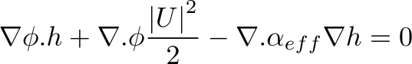
where the second term is the contribution from kinetic energy and the third term accounts for the heat flux, being α_{eff} is the sum of molecular and turbulent thermal diffusivities.
In the case of solid regions, the energy equation is solved based on enthalpy and after that the corresponding thermal-physical properties are corrected. The energy equation was modified in order to accommodate a source-term to be used by the neutronic coupling scheme.
The two equations standard k-ε turbulence model [5] was selected to calculate the turbulent viscosity. The model assumes that the turbulence viscosity is related to the turbulence kinetic energy (k) and dissipation (ε).
The set of discretized equations are embedded in the solver and solved using SIMPLE algorithm.

B. Neutronics

The milonga nuclear code is a free and open source piece of software released under GNU license [6]. It heavily relies on other well-known GNU libraries, like GNU Scientific Library [7], bringing to it the robustness of these established software. It solves the steady-state multigroup neutron transport equation, either using the diffusion approximation or discrete ordinates Sn method. It can discretize the spatial coordinates using either a finite-element or a finite-volumes scheme. This ability to use finite-volumes discretization schemes over unstructured grids makes it possible, regarding the present problem, to have the same mesh for both thermal-hydraulics and neutronics. With identical meshes, the dependency between fields in each tool can be solved with the same degree of detail. Despite the inaccurate results and limitations of the diffusion approximation under some circumstances [8], it is the method used in this work due to its faster execution time compared to the Sn method. The diffusion approximation for multigroup steady-state, is presented below already discretized in G groups:

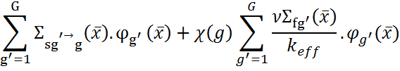
this equation is discretized using finite volumes as chosen formulation. Despite the cross-sections dependence on temperatures, the diffusion equation can be formulated as linear since the coefficients are kept constant during each step in the iterative calculation.
Milonga works by reading an input file which models the problem to be solved. The simplest case for the present problem consists in the basic problem configuration: read the mesh, define the numerical formulation and chose the number of neutron groups for the problem. The next step is to define the macroscopic cross sections for each material (that may further depend on other functions of space such as temperature) matching the materials defined in the mesh. These cross sections are used in the solution of the diffusion equation and must match the material characteristics, like the diffusion coefficients, absorption macroscopic cross sections and scattering cross-sections. All of them should be defined for each group of energy. After materials definitions, the appropriate boundary conditions are set matching the physical entities defined in the mesh. In order to solve the problem, a simple call command builds and solves the eigenvalue problem. Figure 2 shows a simple input file for milonga. The material definitions (lines 10-16) are key: these values can be constants like in the example above but also can be function of a value or position. This feature of milonga makes coupling to external values straightforward.

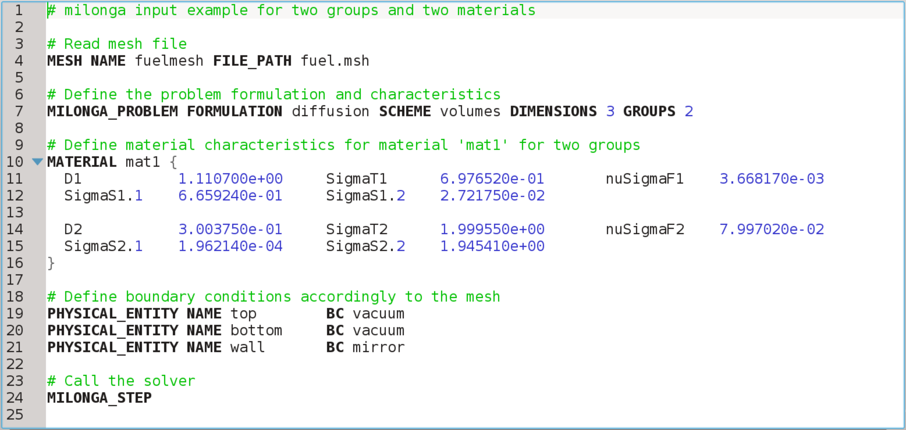
Figure 2 - A simple input file for milonga with line number counting.

C. Cross-sections

In order to have a simulation with a real physical behaviour, it is fundamental to model the materials characteristics as close as possible to their physical aspects. This is achieved having a set of representative cross-sections of the materials neutronic behaviour.
These sets of cross-sections were generated for three different materials representing fuel, cladding and coolant at the tabulated temperatures presented in Table I while the materials composition are depicted in Table II, following an established cross-section generation methodology [4].

Table I. Temperatures for materials (Veloso, 2015)
 | T₁[K] | T₂[K] | T₃[K] | T₄[K]
fuel | 300 | 400 | 500 | 600
Cladding | 300 | 396 | 403 | 410
Moderator | 300 | 308.5 | 317 | 341

Table II. Materials composition for cross-sections generation with WIMSD-5B [4]
 | Material | Material code | Mass
Fuel | H (in zyrconium hydrade) | 5001 |  | 3.7525e-02
Fuel | Zr | 91 |  | 3.7727e-02
Fuel | U²³⁵ | 2235 |  | 2.5744e-04
Fuel | U²³⁸ | 8238 |  | 1.0167e-03
Cladding | Al | 27 |  | 6.0261e-02
moderator | H | 3001 |  | 6.6653e-02
moderator | O | 6016 |  | 3.3327e-02

The calculations were made for two neutron groups. Diffusion coefficients, absorption cross-sections, scattering cross-sections and energy release by fission were previously calculated [4]. Coefficients used for the diffusion approximation equation by milonga are presented in Table III. The cross-sections are obtained for the materials specified in Table 6 under the temperatures defined in Table 5. WIMSD-5B processes the cross-sections for homegeneized cells and then re-calculates the data for each material. For the scattering cross-sections, it gives only the homogeneized data thus making the scattering cross-sections the same for all regions.

Table III. Diffusion approximation coefficients by domain regions and groups.
Group | Coefficients | Parameter
Group 1: > 0.625MeV | Diffusion coefficient | D1
 | Absorption cross-section | ΣA1
 | Scattering cross-section | ΣS1.2
 | Neutrons per fission * Fission cross-section | νΣF1
Group 2: < 0.625Mev | Diffusion coefficient | D2
 | Absorption cross-section | ΣA2
 | Neutrons per fission * Fission cross-section | νΣF2

These data are written in milonga format as constant values for each material and group.
D. Coupling Scheme
The coupling scheme is defined as a workflow, as depicted in Figure 1, and is described below:
1. OpenFOAM is executed with an homogeneus distribution of power for the fuel, which means that every control volume has the same value for power [W/m³];
2. The output of OpenFOAM is post-processed and the averaged temperature [K] for each material is calculated;
3. These temperatures are applied to the temperatures reference table for cross-sections generation and, using linear interpolation available by default in milonga, new sets of cross-sections are obtained for the averaged set of temperatures.
4. The next step is to run milonga with these corrected cross-sections (and other coefficients) to obtain neutron fluxes which are used to obtain the power distribution in the system.
5. The power distribution is then used as input in OpenFOAM and the final temperatures distribution is the outcome of the coupled calculation.
In order to parse milonga’s power distribution output to OpenFOAM input format, a Python [9] script was written.

Calculations and Results
Calculations were performed for three different power, considering the equivalent of the TRIGA IPR-R1 reactor operating at 50 kW, 100 kW and 200 kW. The step one of the workflow, consisting in running OpenFOAM with homogeneous .power distributions gave the averaged temperatures shown in Table 3.
Table IV. Averaged temperatures [K] for materials after first step thermal-hydraulic simulations
 | Simulation power by pin
Material | 1.98 [kW] | 3.97 [kW] | 7.93 [kW]
fuel | 339.8 [K] | 379.8 [K] | 423.0 [K]
cladding | 327.2 [K] | 354.5 [K] | 375.4 [K]
water/moderator | 303.5 [K] | 307.2 [K] | 310.1 [K]
Figure 2 - A simple input file for milonga with line number counting.
These temperatures were used to feed milonga for three non-coupled simulations. A set of temperatures for each power was used to generate fixed cross-sections, interpolated from the data obtained previously trough WIMSD-5B. These three non-coupled simulations gave three power distributions which were then used by OpenFOAM as an initial condition. Figure 3 shows flux profile for the three simulations along the length of the model. Based on flux distribution, milonga generates a power distribution with reference to a defined power value, In this case, the same value used by OpenFOAM in its initial run.
The power distributions obtained from milonga and the temperatures along the axial direction of the model are shown in Figures 3 and 4.
Figure 3 – Power profiles used by OpenFOAM from milonga.
As expected, the power profiles for all simulations have a sinusoidal shape [10], since there are neutrons escape from the top and bottom of the model. The temperature profiles have a non-symmetric shape due to the cold water entering the system. The water flow is heated when in contact with cladding, generating the non-symmetrical profile observed.
The solid region corresponding to the fuel material is presented in Figure 5 showing its relative power among simulations.
Figure 4 – Power profiles used by OpenFOAM from milonga.
Figure 5 – Power profiles of fuel solid regions.

Conclusions and future work
In this paper a one-step coupling methodology is developed to allow thermal-hydraulic calculations based on neutronic generated power profiles. The coupled calculations show expected results for power profile when compared to former calculations [10]. The effectiveness of this methodology can be extended by the use of scripts to make the temperatures average process fully automatic and also using the script already wrote to process milonga output generating OpenFOAM input. Moreover, since both codes used for calculations are distributed with source-code, an iterative coupling scheme can be envisaged. The framework offered by milonga has built-in functions to read, write and process external files in different ways.
Appendix

Nomenclature tables of presented equations.
Table IV. Nomenclature of therma-hydraulic equations
Quantity | Description
 | Fluid density
 | Averaged velocity
 | Effective dynamic viscosity
 | Averaged velocity transpose
 | Identity matrix
 | Pressure relative to density
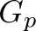 | Buyancy adjustment
 | Transported quantity
 | Enthalpy
 | Scalar velocity
 | Thermal diffusivities

Table V. Nomenclature of therma-hydraulic equations
Quantity | Description
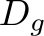 | Diffusion coefficient for group g
 | Vector representing the current cell
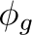 | Flux for group g
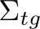 | Total macroscopic cross-section for group g
 | Flux
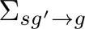 | Scattering cross-section from group g' to group g
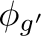 | Flux for group g'
χ | Fraction of neutrons appearing in group
 | Average number of neutrons by fission
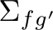 | Fission cross-section for group g'
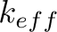 | Effective multiplication factor

References

- OpenFOAM - The Open Source CDF Toolbox: User guide. Version 3.0.1 [S.l.], 2015.
- Theler, G. (2014) On the design basis of a new core-level neutronic code written from scratch. The free nuclear reactor core analysis code. Mecánica Computacional Volume XXXIII, Number 48, Numerical Methods in Reactor Physics (B).
- Bennett, A., Avramova, M. and Ivanov, K. (2016) Coupled MCNP6/CTF code: Development, testing and application, Annals of Nuclear Energy, Volume 96, Pages 1-11, ISSN 0306-4549, http://dx.doi.org/10.1016/j.anucene.2016.05.008.
- Reis, P. A. L., Pereira, C., Costa, A. L., González-Mantecón, J., Velos, M. A. F., Soares, H. V. (2015) Thermal Hydraulic and Neutron Kinetic Simulation of the TRIGA IPR-R1 Research Reactor using RELAP5-PARCS Coupled Model, Proceedings of European Research Reactor Conference, April 19-23, Bucharest, Romania, 2015.
- Launder, B. E. and Spalding, D. B. (1974) The numerical computation of turbulent flows, Computer Methods in Applied Mechanics and Engineering, Volume 3, Issue 2, 1974, Pages 269-289, ISSN 0045-7825, http://dx.doi.org/10.1016/0045-7825(74)90029-2.
- GNU General Public License (2007) Version 3. Free Software Foundation. URL: http://www.gnu.org/licenses/gpl.html.
- Galassi, M., Davies, J., Theiler, J., Gough B., Jungman, G., Alken, P., Booth, M., Rossi, F. and Ulerich, R. (2009) GNU Scientific Library Reference Manual - Third Edition, ISBN 0954612078.
- Trahan, T. J. (2014) An asymptotic, homogeneized, anisotropic, multigroup diffusion approximation to the neutron transport equation. Thesis, Nuclear Engineering and Radiological Sciences, University of Michigan.
- Python Software Foundation. Python Language Reference, version 3.4. Available at http://www.python.org
- Veloso, M. A. (2005) Avaliação Termo-hidráulica do Reator TRIGA IPR-R1 a 250 kW. NI-EC3-05/05, Belo Horizonte-MG, Brazil: Centro de Desenvolvimento da Tecnologia Nuclear (CDTN), Comissão Nacional de Energia Nuclear. (in Portuguese)

