Attacker report
Ethical Hacking

Matteo Bianchi
Vito Stefano Gozzo
Michele Bungaro

June 20, 2021

In this document we will describe the method used to analyze the VM and the steps that allow us to exploit its vulnerabilities.

Host Discovery and Service Scanning
We made the VM as a network subnet host, setting the network card in bridged mode.
Then we proceed to scan the active hosts in subnet in order to obtain info:
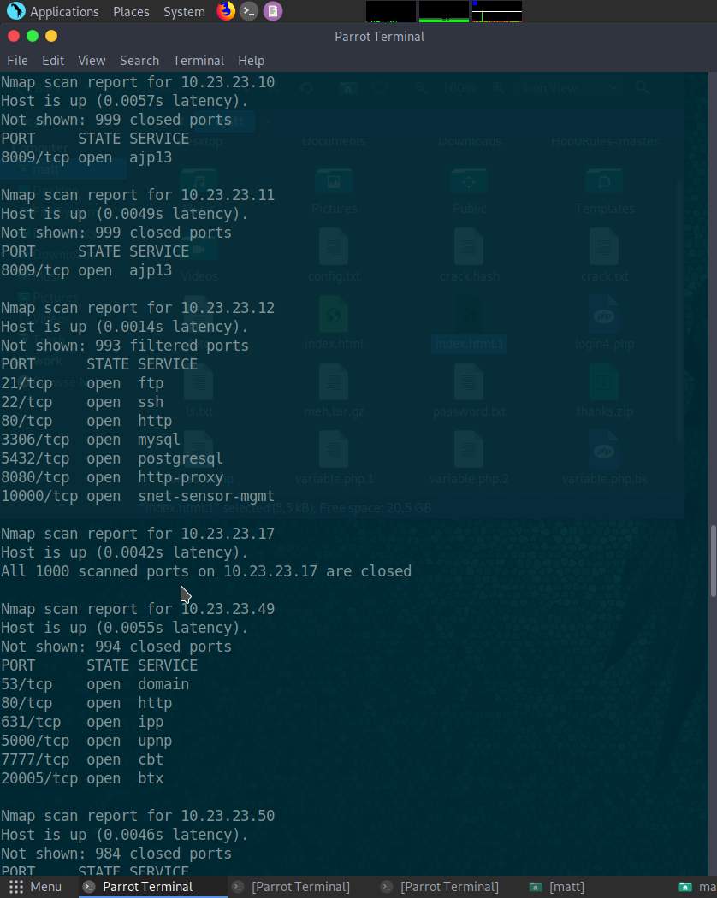
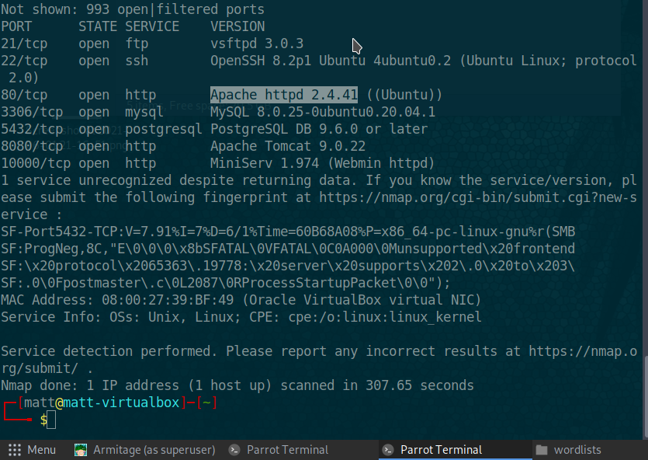
Thank to nmap scan we obtained IP address of the host and its open ports of active services.

As we can see there are 7 services running on the host with open ports:

- ftp, 21
- ssh,22
- http, 80
- mysql, 3306
- postgresql, 5432
- http-proxy, 8080
- snet-sensor-mgmt, 10000

