React Qualification VT 22-1

Vito Caris Untariady

GitHub Repository: <https://github.com/vitountariady/qualif-react-vt>

Webstie: <https://qualif-react-vt22-1.netlify.app/>

1. List Page



This is the home page of the website, on the home page there is a list of all anime sorted by popularity, paginated and each page contains 12 cards.

1. Detail Page

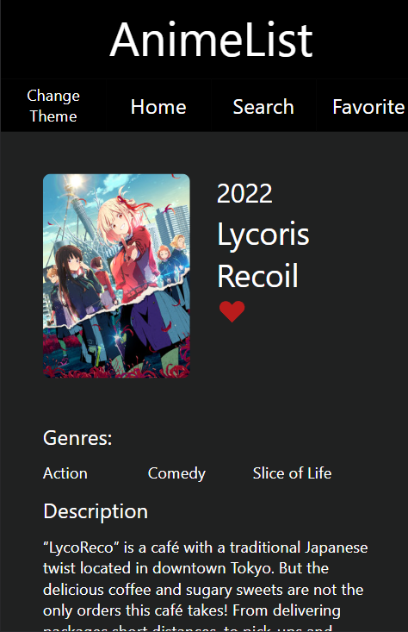

This page shows the detail of the anime like the title, year, genres, and description of the anime. There is also a favorite button that the user can click to add the anime to the user’s favorite list.

1. Search Page

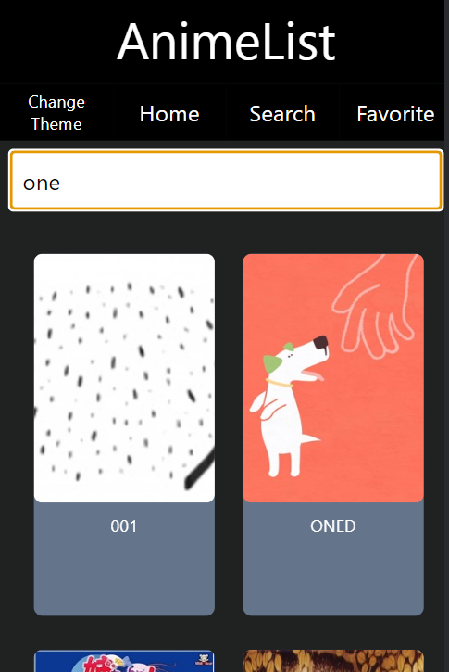

This page shows a search bar and will show animes, based on the user’s search.

1. Favorite Page

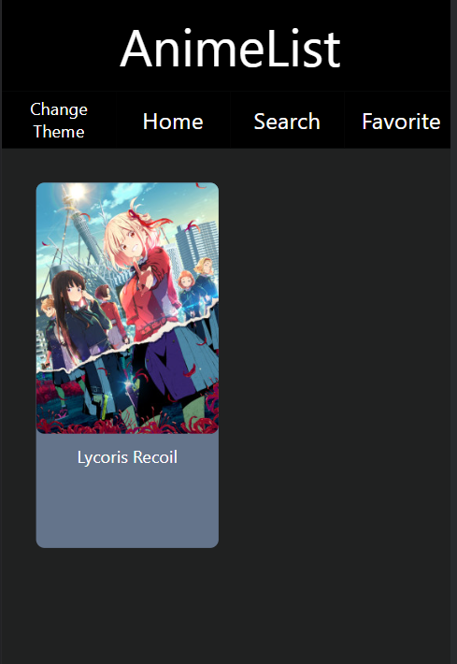

This page contains the user’s favorite animes