**Vitaly Smirnov, developer (C++, Python)**

**Contact information:**

*Email:* mrmaybelately@gmail.com

*Telegram:* @vitalys8

*Phone:* +7-981-850-9692

*GitHub:* @vitsmirnov

**About me:**

At the moment, I have a year and a half of commercial development experience in a product company, about six months of non-commercial development experience (pet projects), higher technical education, and more than a year and a half of intensive self-study with practice.

From 2010 to 2022, I was not involved in development (I received a bachelor's degree in culture and arts, after which I taught music theoretical disciplines). In mid-2022, I decided to return to development and began to restore my knowledge and skills, study new technologies, which I am still doing with interest. The emphasis in training was on the basics: CS base, data structures and algorithms, object-oriented programming and design (including SOLID principles), GoF design patterns, clean code principles, etc. Main languages: C++, Python. I took several courses (including three courses from Harvard CS50, two advanced C++ courses). In addition to many training tasks, I made several pet projects (in C++, Python, Pascal, C), three of which were published on GitHub (@vitsmirnov). I've got basic experience with git, GitHub, SQL, Django and some other technologies, and I'm open to learning new ones. I’m ready to start commercial development and bring profit. I'm looking for a company to join.

**Skills/technologies:**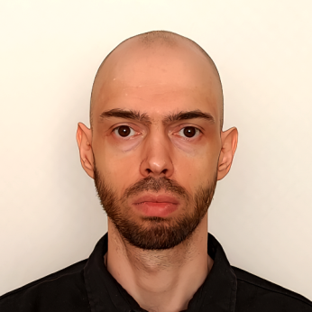

C++, Python, C, Delphi, Git, GitHub, SQL, Django. OOP, SOLID, GoF patterns. English B1+, fluent Russian.

**Work experience:**

*Period:* 09/2008 – 01/2010

*Company name:* IndorSoft (https://indorsoft.ru)

*Description:* The company develops GIS and CAD systems. I was working on an application - a system for processing geodetic measurements. As part of the project, I solved the following tasks: conducted market research and performed a comparative analysis of similar software, based on the results of which I prepared the primary technical specifications; implemented a significant part of the application core. Stack: Delphi, Windows.

**Pet-projects:**

1) Lights (cool puzzle game in Python)

2) Minesweeper (classic Minesweeper game in C++)

3) Tetris (classic full-featured Tetris game in Pascal)

For projects 2 and 3, I developed small libraries of customizable supporting components and functionality. There I used template programming and design patterns, including the MVC pattern (in whole or in part) implemented in all projects. The project code is available on GitHub (https://github.com/vitsmirnov).

**Education:**

2003-2008 – Toms State University, information systems and technologies

2014-2018 – Saint-Petersburg State University of Culture and Arts, musicology and musical applied arts (music arts management)

**Additional education, courses:**

07/2022 – present: self-education, including courses:

- Harvard CS50 – Web Programming with Python and JavaScript (cs50.harvard.edu)

- Harvard CS50 – Introduction to Programming with Python (cs50.harvard.edu)

- Harvard CS50 – Introduction to Computer Science (cs50.harvard.edu)

- Advanced C/C++ programming (stepik.org)

Other resources: official documentation, books, articles, freeCodeCamp.org, Habr.com, StackOverflow.com, LeetCode.com, YouTube.com.