Tbl_offer

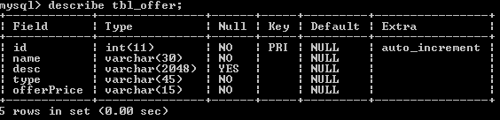

tbl_product

