|  |  |
| --- | --- |
| Assignment -1  21 July 2018 | Market Trends in KickStarter Projects |
| The biggest risk is not taking any risk... In a world that’s changing really quickly, the only strategy that is guaranteed to fail is not taking risks.  **Mark Zuckerberg** | We see Kickstarter campaign as a nest for creative minds on an elevated platform; where people who trust, respect, look through a candid vision can transform an idea into a reality. Market Overview From the observation, it seems that most of the ideas including investors have been polarized towards theater, music, film, video, and technology. It has also noted that the starters are most successful with this business. |
| Impossible is nothing we are only limited by our imagination and perceptions  **Vittal** | Market Segmentation There has been a potential market in ***Theater*** business especially in ***Theater-Plays.*** However, when we perform an overall analysis we observe that the rate of failure is high in the ***Theater-Plays***. Market Timing From the market timing, most successful business begins to uproar in March, peak during may and gradually slow down in September. The causality may be due to the nature of the market; theater plays starts and peaks in summer and troughs down in fall.   Market Geo SegmentationMissing data in pursuing the location/geo is suitable since the data is at country level the investors might want to know and recommend the creators as to which state would appeal most business. |

# Other Pedagogical Views

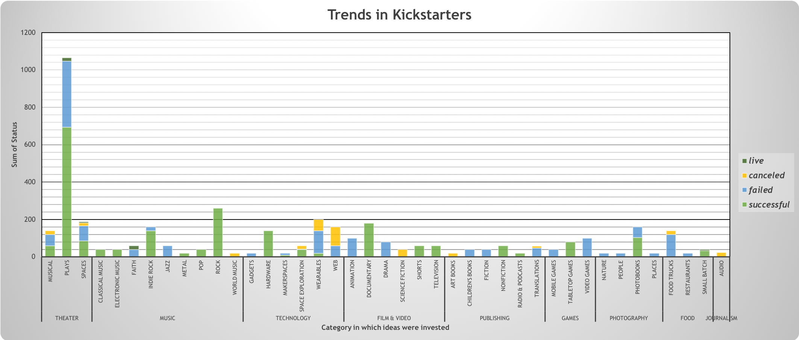

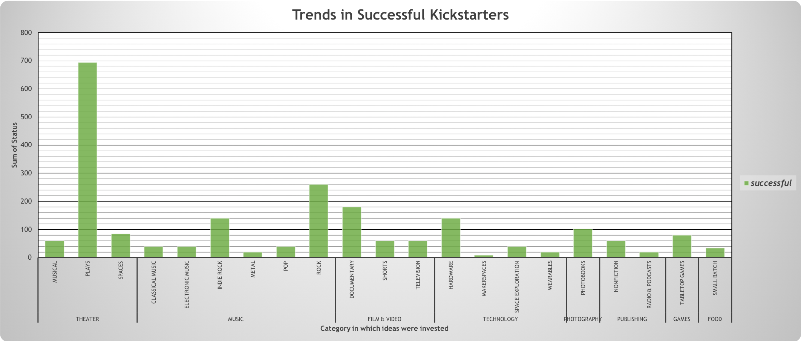

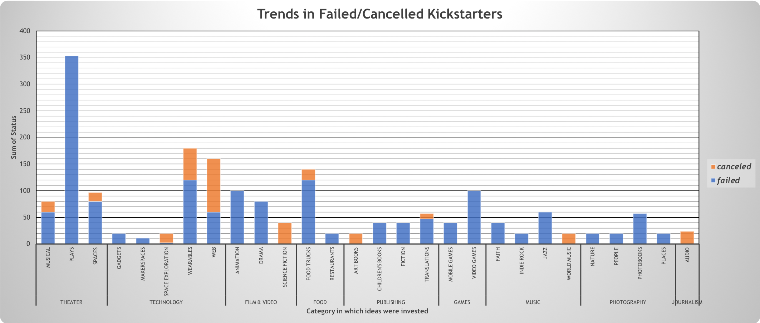



|  |  |
| --- | --- |
| Vittal Siddaiah  Vittal.siddaiah@gmail.com |  |