Q1. Create the Inventory Database by creating below tables: Q1. Create the Inventory Database by creating below tables:

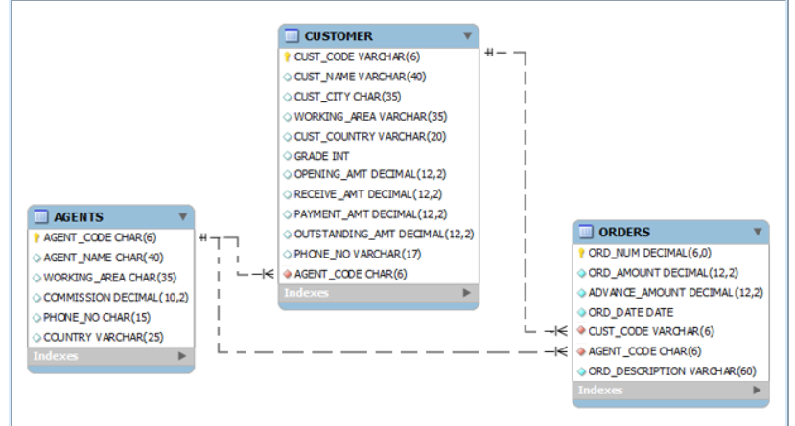

Q2. Load the attached data of excel in above created tables:  


Q3. Write a query to display the columns in a specific order like order date, Agent id, order number and purchase amount from for all the orders.

Q4. Display the full-name of customer along with customer code.

Please complete all the questions present in below link:  
<https://www.w3resource.com/sql-exercises/sql-retrieve-from-table.php>

It’s online editor to write all your queries.

<https://www.w3resource.com/sql-exercises/sql-wildcard-special-operators.php>

sqlldr system/welcome123@localhost control='C:\Oracle_PRJ\Oracle_SQL\student_details.ctl' log='C:\Oracle_PRJ\Oracle_SQL\student_details.log'