Analysis: What the Data is Telling Us?
Introduction
In this one page write up, I will discuss the four conclusions were arrived at. Together, these conclusions provide an integrated story regarding the relationship between growth, demand, category concentration and service quality.
Finding 1: Sales and Delivery Pressure Peak at the same time
Based on Figure 1, from January 2017 to August 2018, revenue and order volume move almost uniformly, reaching their highest points in November 2017 at $ 1,153,528 and 7,289 orders respectively. Growth and seasonality are the important insights. Delivery systems are under the most stress during the periods with the highest business performance (Shanakar & S, 2024). Planning for seasonal demand is a need to sustain the growth of the business.
Finding 2: One Category Carries a Disproportionate share of volume
Based on Figure 2, with 22,071 orders, Escritorio or Furniture leads all products categories and more than 128% compared to second ranked category. The concentration of order volume to furniture gives an important insight that may cause pressure on fulfilment and last mile delivery because of large dimensions of the order (3PeeL, 2026). Therefore, transportation systems implemented should be customizable and adaptable to cater the business needs.
Finding 3: Review Score measure delivery experience, not product quality
Based on Figure 3, the average rating for post-delivery reviews was 4.20 out of 5. On a 5-star scale, the average score for reviews written before the delivery was 1.80, a 2.4-star difference. Thus, the issue is not with the goods or the price of the product. The issue was the delivery which represented by the review score. Therefore, the important factor to increase customer satisfaction is to improve consistency on delivery timing (Gosling, 2025).
Findings 4: Growth Is Strong, but Quarterly Fluctuations Are Significant
In Quarters 1 to 4 in 2017 2018, order volume increased 102% annually. Although growth is not smooth, based on the chart, order volume has seasonal peaks in line with seasonal demand. For instance, last Nov 2017, 7289 orders are recorded (which part of holiday months) the highest peak of order volume so far. Therefore, the company may re-evaluate their forecasting strategy to accommodate such fluctuations.

REFERENCES
3PeeL. (2026, May 5). How To Handle 3PL Challenges For Oversized or Bulky Items (Tricks You Didn’t Know) - 3PeeL. https://3peel.com/how-to-handle-3pl-challenges-for-oversized-or-bulky-items-tricks-you-didnt-know/
Gosling, S. (2025, February 13). What do US consumers want from e-commerce deliveries? | McKinsey. https://www.mckinsey.com/industries/logistics/our-insights/what-do-us-consumers-want-from-e-commerce-deliveries
Shanakar, S., & S, B. (2024). Logistics Challenges in E-Commerce During Peak Season. International Journal of Innovative Research in Science, Engineering and Technology, 13(12). https://doi.org/10.15680/IJIRSET.2024.1312170

APPENDIX
Figure 1: Sales Revenue and Order Volume Timeline

Note. Developed for this report.

Figure 2: Top 10 product categories based on order volume

Note. Developed for this report.
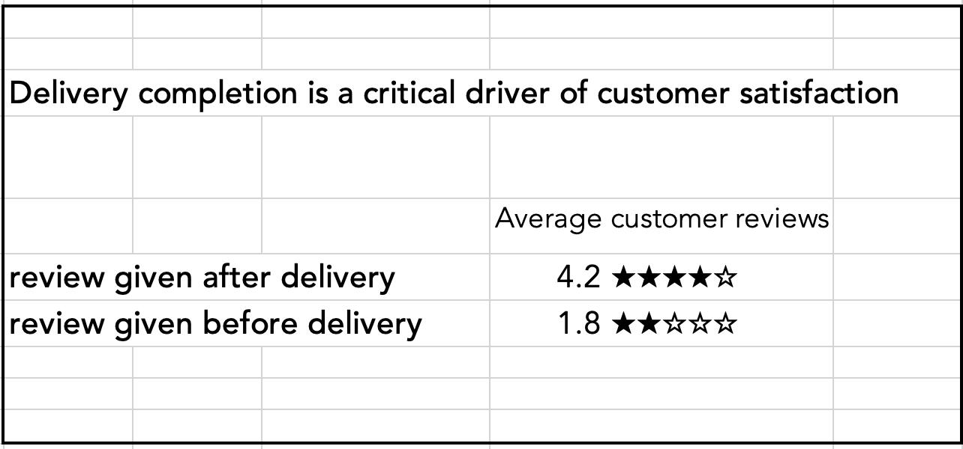
Figure 3: Average customer rating based on timeliness of review option

Note. Developed for this report.

