**Banana Lumpia with Caramel**

**(Lumpia)**

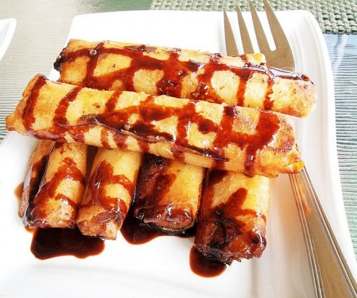

**Ingredients:**

* Saba Banana
* Cooking oil
* Sugar
* Jackfruit
* Lumpia Wrapper

**Turon Bung-Bong with Caramel Syrup**

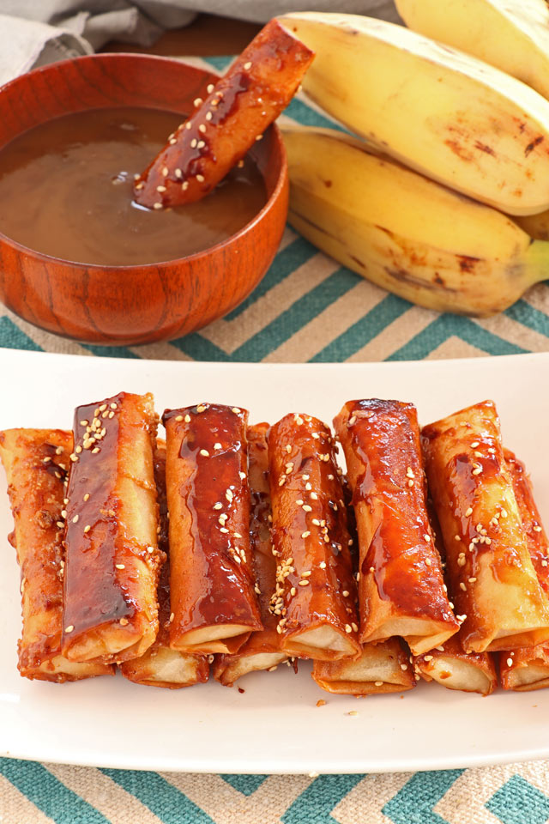

**Ingredients:**

* Saba Banana
* Cooking oil
* Sugar
* Ube Candy
* Lumpia Wrapper