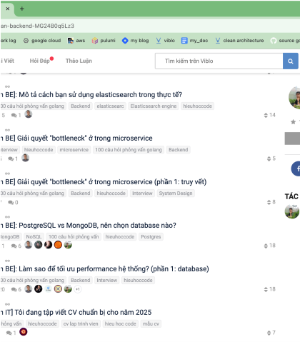**NGUYEN VI TUAN - BACKEND SOFTWARE ENGINEER**

[LinkedIn](https://www.linkedin.com/in/tuan-nguyen-8145392bb) | 0986968647|  vituan1912000@gmail.com |

# ABOUT ME

Professional software engineer with **3 years of experience** developing andbuilding scalable, high-performance Java-based applications such as **CRM**, **ERP**, and **Data management apps**, capable of handling up to **million requests daily**. Strong understanding of **Data structures**, **Algorithms** and ability to work independently and as part of a team. With my experience and passion, I believe I will contribute to building high-quality technology products.

**SKILLS**

Programming Languages: **Java,** Javascript

|  |  |
| --- | --- |
| Databases: | **PostgreSQL**, MySQL, **Elasticsearch**, Redis |
| Framework /Platforms: | **Spring, Angular** |
| Microservices: | AWS, K8S, **Kafka** |
| Others: | **Docker**, Git |

# WORK EXPERIENCE

# TP Bank (05/2024 - present)

**Project**: **CRS – TPB central reporting system (05/2024 - present)**

**Description**: Enterprise system for aggregate and manage report data for internal TPBank across the country

**Technologies**: Java**, Spring boot**, Akabot, **AWS**, Docker, Redis, **Kafka**, SQL Server

**Main responsibilities:**

* Developed and maintained API for reporting services such as transaction storing API, synchronize data API (QPay, Momo, etc)
* Implemented Role-Based Access Control (**RBAC**) system for managed access to data by staff
* Enhanced **system security** in alignment with **Oauth2/WSO2**
* Crafted high-performance **MySQL indexes**, views, triggers, **partitions**
* **Reduced** API **response times** by **95%**, from 5-10 seconds to 200-500 milliseconds, improving user experience
* Improved work quality through regular code **reviews** and **mentorship** of **fresher**, **junior** developers
* Implemented a decent amount of **automation bot** to resolve operational problems

# TinaSoft (03/2024 – 08/2024)

**Project**: **LaoID – Digital identification (03/2024 – 08/2024)**

**Description**: A digital identity application for Lao, it serves as a critical platform for advancing the nation’s digital transformation, replacing traditional physical documents for various administrative and transactional purposes.

**Technologies**: Java**, Spring boot**, **Docker**, Redis, **Kafka**, PosgreSQL.

**Main responsibilities:**

* Built the application from scratch based on the provided Unitel’s older system.
* Implemented **Agile Scrum** methodology to executed and advanced the project
* Implemented a large amount of **API** integration for the system
* Integrated **third-party login** (Google, Apple, Facebook)
* Migrated all the data model from the former system into the new one
* Created a multi-language platform within the application

# NTTDATA VDS (05/2021 – 03/2024)

**Project**: **MDM – Tibco Master Data Management (03/2023 – 3/2024)**

**Description**: A web application that provides a portfolio of ready-to-use indicators to monitor and manage data overtime.

**Final product**: A Large-scaled data management web application with multiple features (manage & monitor data, generate chart data, etc)

**Technologies**: : Java**, Spring boot**, Angular, **Docker**, PosgreSQL, Redis

**Main responsibilities:**

* Developed and maintained API for executes indicators, data storage and data generation service.
* Implemented chart generation API
* Migrated user interface from Angular JS to **Angular 15** for better user experience
* Implemented **API gateway** for handling request (reduced response time from 1s to 50-100 ms)
* Created **documentations** for services and multiple knowledge transfer session
* **Optimized system** performance using **Redis**, improving real-time communication capabilities
* Implemented **microservices architecture** using **gRPC**, significantly improving system performance **Achievement:**
* Successfully trained and got certification for new technology thin two weeks
* Achieved the most loyal team of the year

# EDUCATION & CERTIFICATE

* **Bachelor of Software Engineering – Hanoi university** 09/2018 - 06/2022
* **Certificate Of Proficiency In English** **(C2**) 05/2022