NIP Project — Submission Template
Pega Platform project · This document is your complete submission
Read this before you start:
1. Fill in Section 1 completely. The Pega application name must follow the format NIP-[Project]-[YourName].
2. Create a new Operator in Pega with your full name and log in as that operator before taking any screenshot.
3. When you create your test case, enter YOUR FULL NAME in the Issue Description (Vehicle) or Movie Name (Movie) field.
4. Complete only the section for your chosen project. Delete the other project section.
5. Paste one screenshot per user story (10 total). Follow the screenshot rules in your selected project section.
6. Answer every question in Sections 3 and 4 in your own words.
7. Save the file using this format: ProjectName_FirstName_LastName.docx. Use VehicleService or MovieTicket as the ProjectName. Examples: VehicleService_Ravi_Kumar.docx or MovieTicket_Ravi_Kumar.docx.

Section 1 — Your Details
Full Name | Vitusha Rembersu
Email ID (registered on NIP) | rembersusweety@gmail.com
Phone Number | 8485009785
College Name | Pune Cambridge Institute of Management & Computer Applications
Course (e.g. IT, CS) | MCA
State | Maharashtra
Project Chosen (Vehicle Service OR Movie Ticket Booking) | Movie Ticket Booking
Pega Application Name (e.g. NIP-VehicleService-YourName) | Case Management-VitushaRembersu
Case Type Name (exact) | Case Management-VitushaRembersu
Pega Instance URL | https://72geshve.pegaacademy.net/prweb/app/case-management-Vitusha-Rembersu/
Operator Name (created in Pega with your full name) | Author

Section 2B — Movie Ticket Booking Management Application
Complete this section only if you selected this project. Delete the other project section before submitting.

Screenshot rules — IMPORTANT before you start:
1. Name your Pega application as: NIP-VehicleService-YourName OR NIP-MovieTicket-YourName
2. Create a new Operator in Pega with your full name (Security → Operators) and log in as that operator.
3. When you create your test case, enter YOUR FULL NAME in the Issue Description (Vehicle) or Movie Name (Movie) field.
4. The logged-in operator name must be visible in every screenshot wherever the Pega interface displays it.
5. The student's full name must be visible in all running-case screenshots.
6. Configuration screenshots must clearly show the relevant application or rule name.
Screenshots that do not show these will not be accepted.

US-001 — Submit Movie Ticket Request
What is expected:
Case created, customer submits Movie Name, Show Date, Show Time, Number of Tickets. Validation applied.
Screenshot — paste your screenshot below this line:
[ Paste screenshot here - follow the screenshot rules above ]
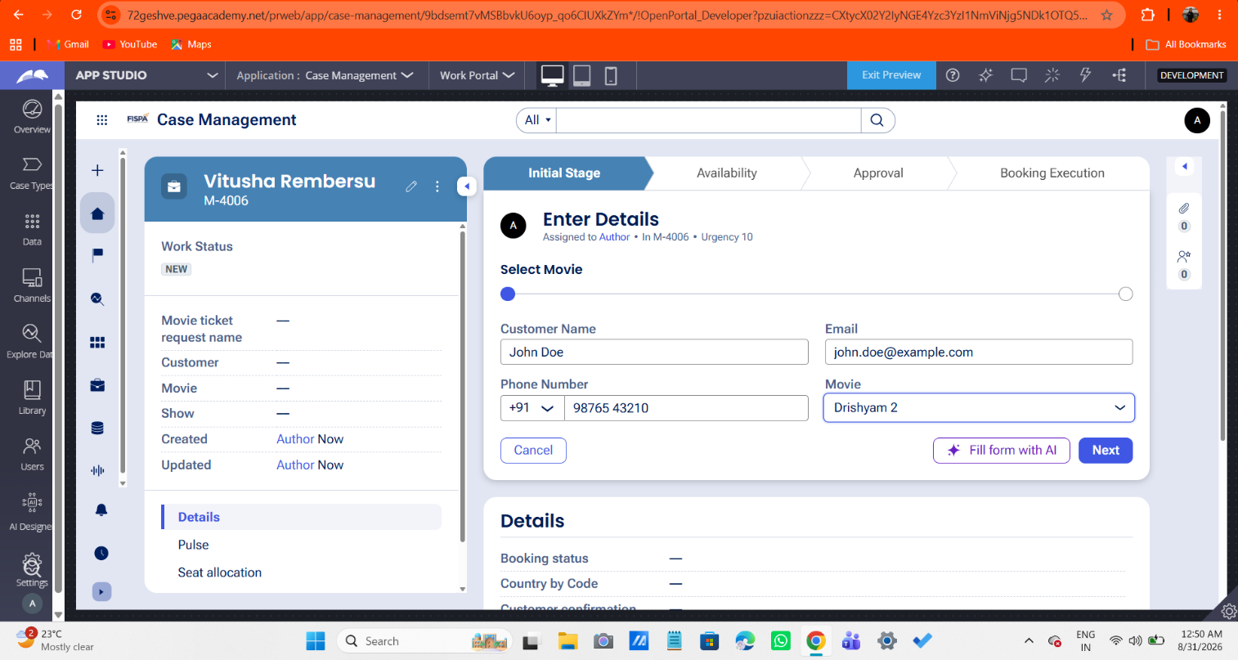

What I built for this (1–2 lines in your own words):
[ Type here ]
For Accepting user details for booking a movie ticket

US-002 — Check Show Availability
What is expected:
Availability stage. Seat Availability Status and Available Seats Count captured. Booking proceeds only if available.
Screenshot — paste your screenshot below this line:
[ Paste screenshot here - follow the screenshot rules above ]

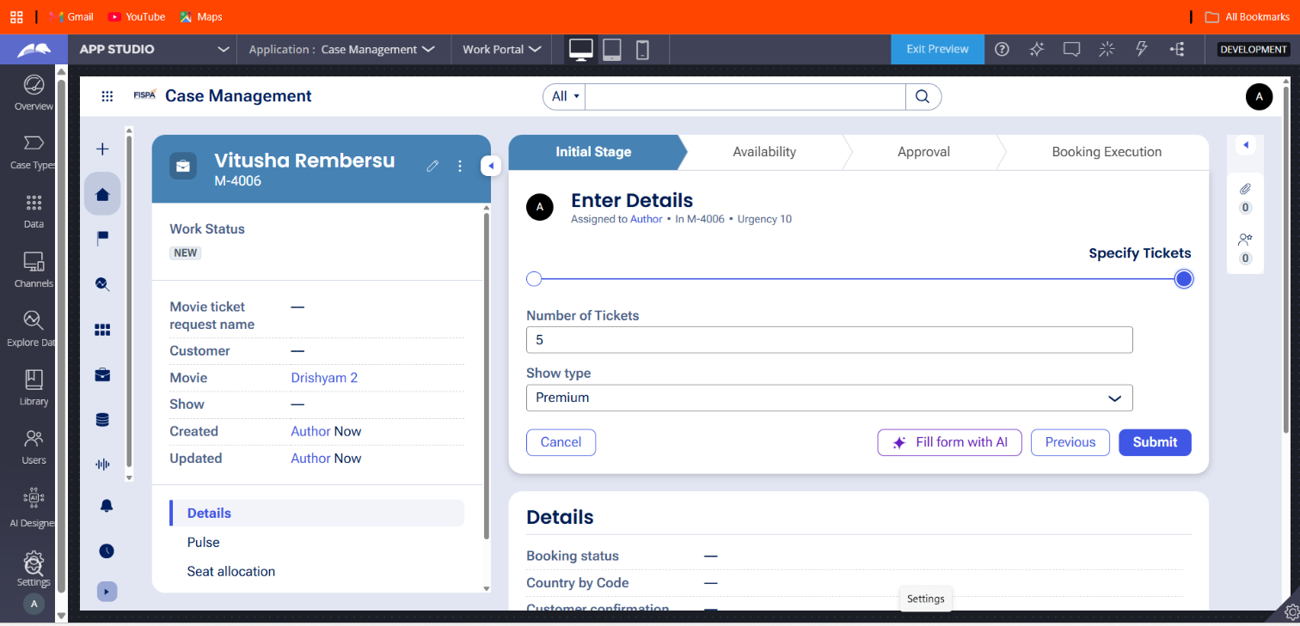

What I built for this (1–2 lines in your own words):
[ Type here ]
For accepting ticket details for booking ticket

US-003 — Calculate Booking Cost
What is expected:
Total Cost calculated automatically from Ticket Price and Number of Tickets using a business rule.
Screenshot — paste your screenshot below this line:
[ Paste screenshot here - follow the screenshot rules above ]

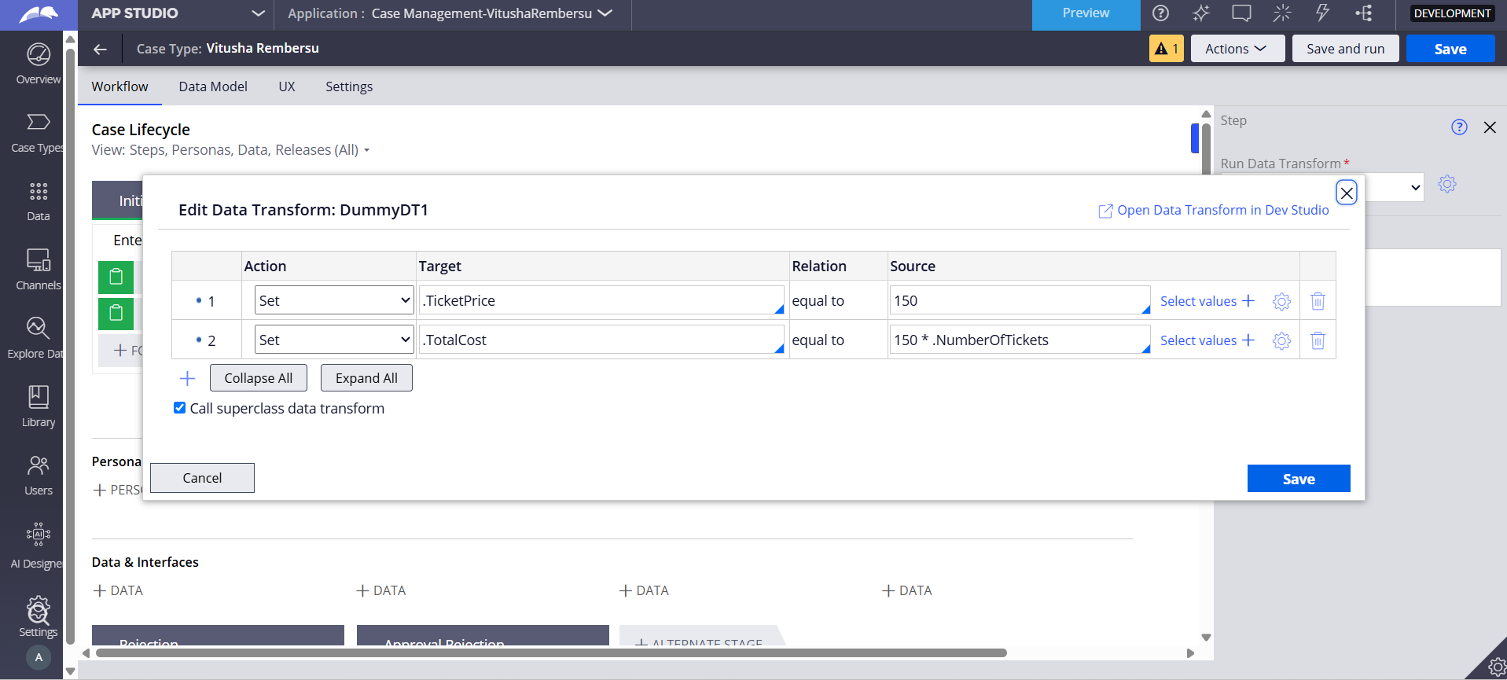

What I built for this (1–2 lines in your own words):
[ Type here ]
The formula her used is no.of tickets * ticket price(single ticket price)
Note: Total cost or single ticket price already summed up with GST

US-004 — Confirm Booking Request
What is expected:
Approval stage assigned to Customer. Booking Status captured. Flow branches on confirm/cancel.
Screenshot — paste your screenshot below this line:
[ Paste screenshot here - follow the screenshot rules above ]

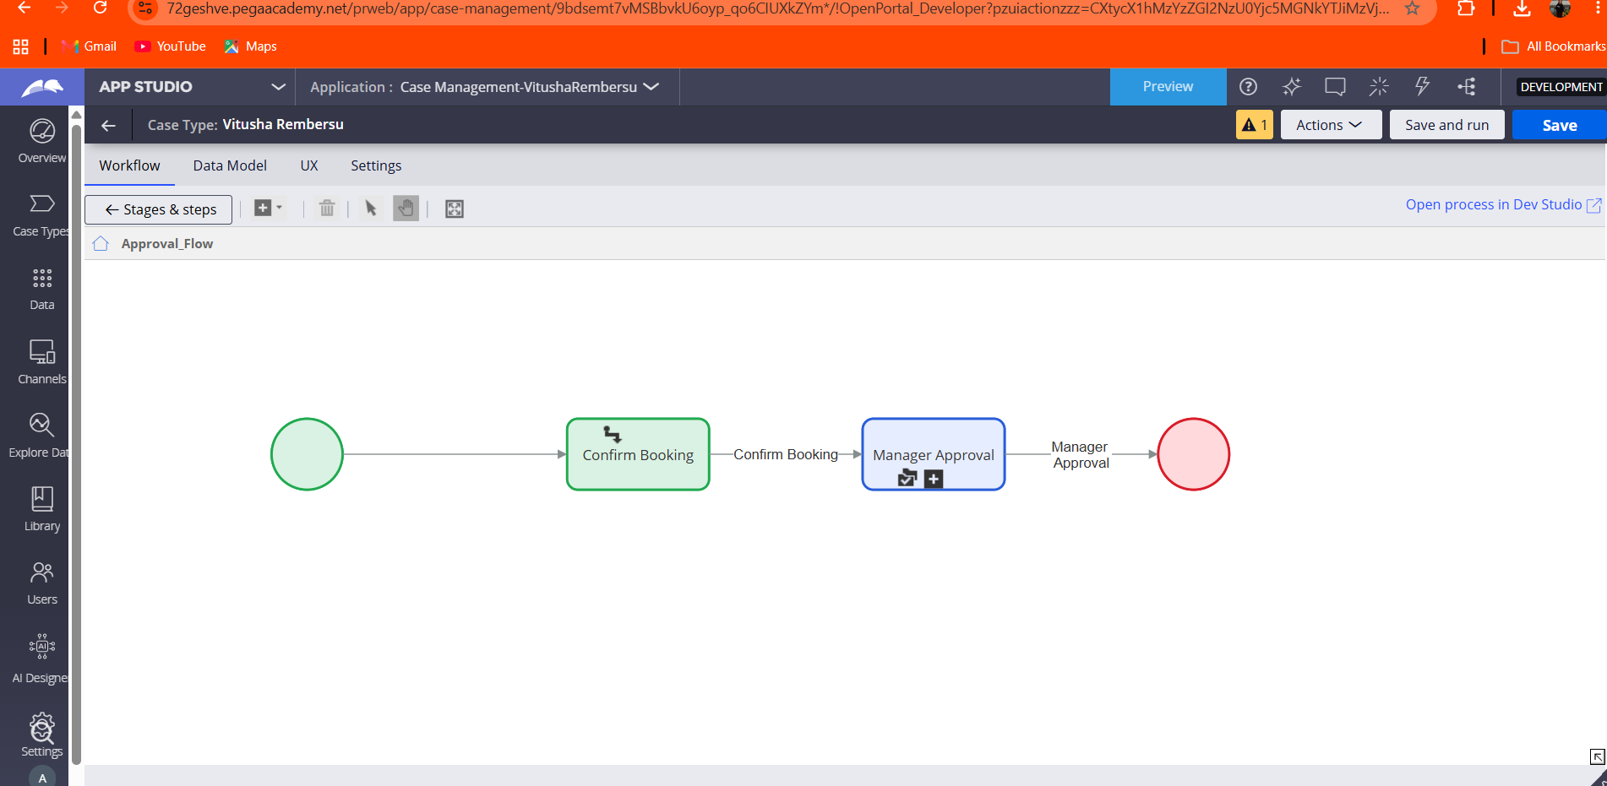

What I built for this (1–2 lines in your own words):
[ Type here ]
If the user proceeds further booking is confirmed and manager approves it before moving further.

US-005 — Maintain Movie and Show Data
What is expected:
Reusable Movie and Show data objects created with Movie Name, Genre, Show Date, Show Time, Seat Capacity — linked to case.
Screenshot — paste your screenshot below this line:
[ Paste screenshot here - follow the screenshot rules above ]

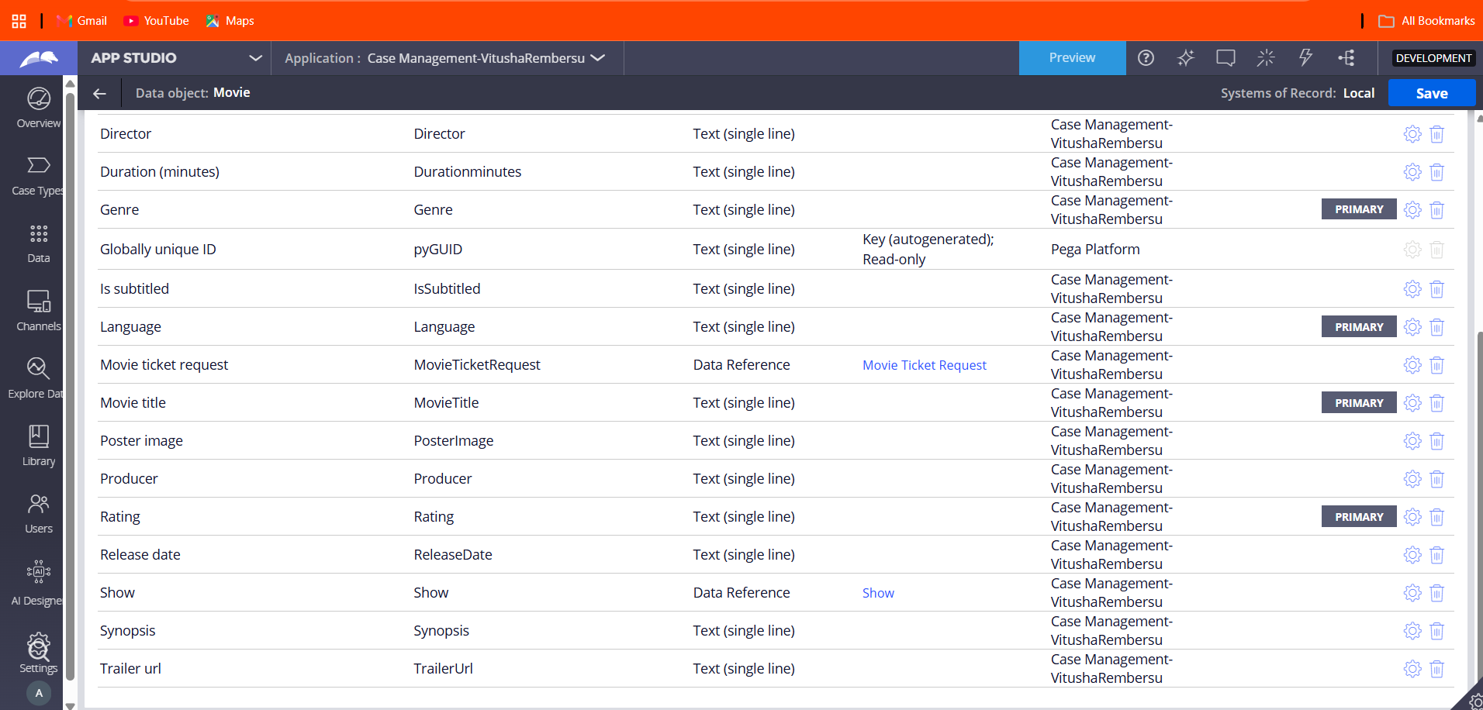

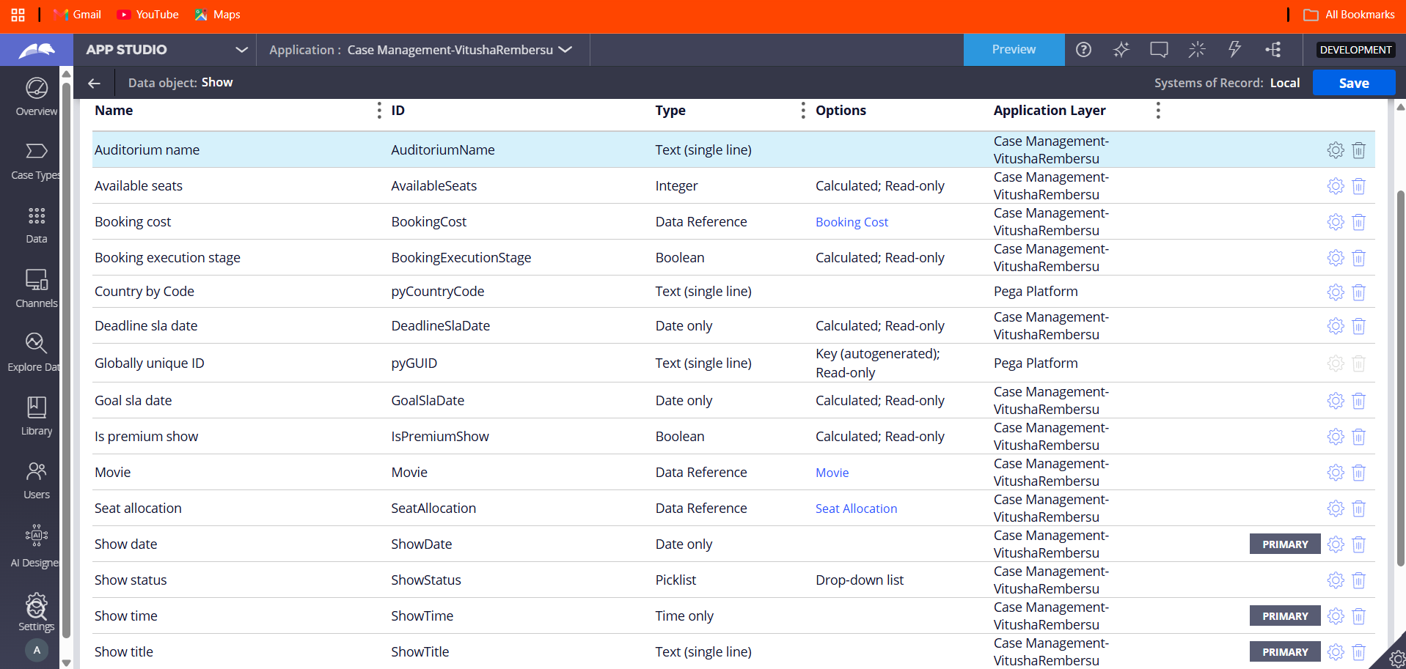

What I built for this (1–2 lines in your own words):
[ Type here ]
For referring this objects while accessing them in user story for booking process

US-006 — Review Booking Details
What is expected:
Confirmation screen shows Movie Name, Show Timing, Number of Tickets and Total Cost clearly.
Screenshot — paste your screenshot below this line:
[ Paste screenshot here - follow the screenshot rules above ]
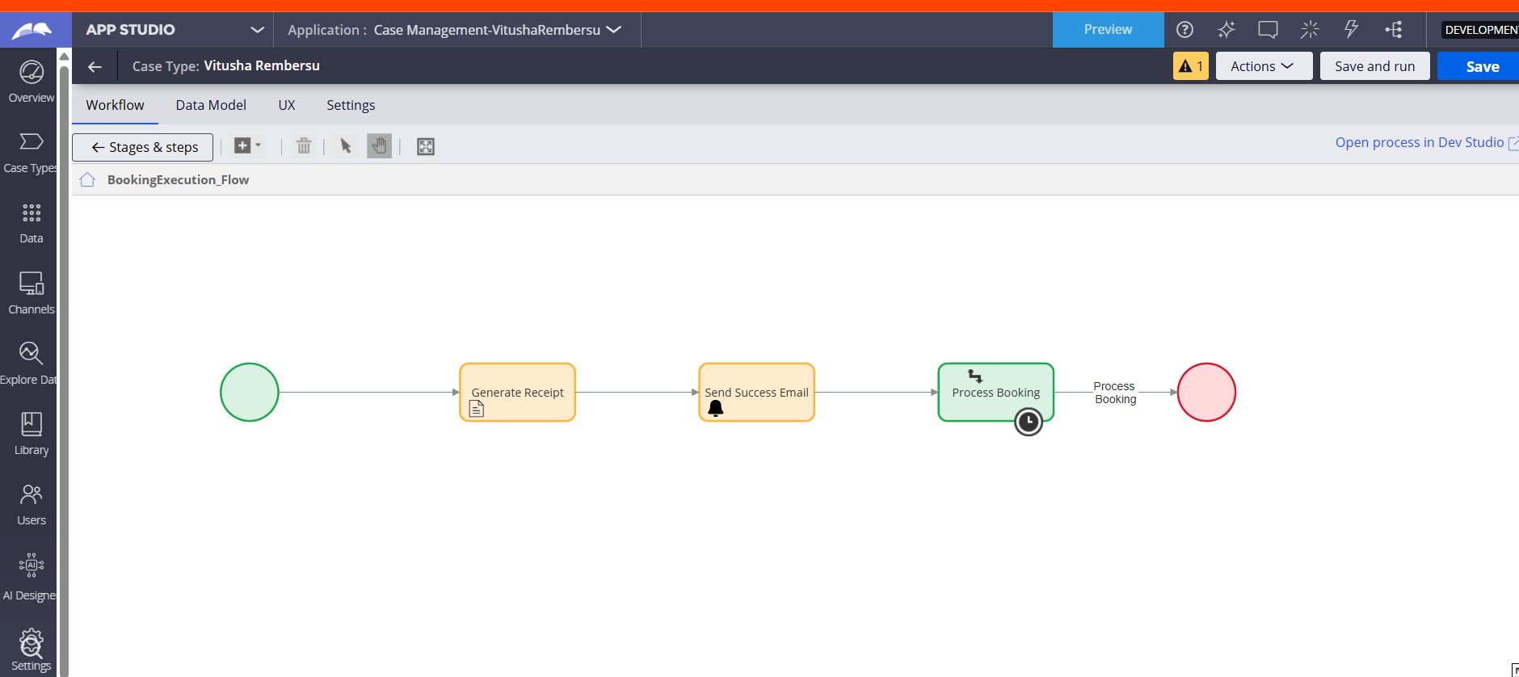

What I built for this (1–2 lines in your own words):
[ Type here ]

To show summary of the booking process

US-007 — Process Ticket Booking
What is expected:
Booking Execution stage. Seat Numbers, Ticket ID and Booking Confirmation Status maintained.
Screenshot — paste your screenshot below this line:
[ Paste screenshot here - follow the screenshot rules above ]



What I built for this (1–2 lines in your own words):
[ Type here ]

US-008 — Notify Booking Confirmation
What is expected:
Correspondence rule triggered on case resolution. Email includes movie, show, seat and cost details.
Screenshot — paste your screenshot below this line:
[ Paste screenshot here - follow the screenshot rules above ]

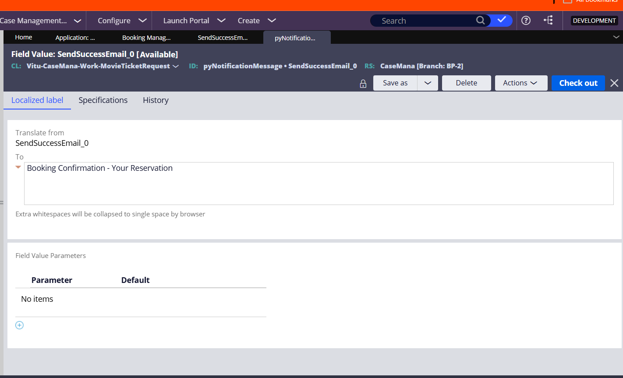

What I built for this (1–2 lines in your own words):
[ Type here ]

US-009 — Define Booking SLA
What is expected:
SLA configured on the case type. Goal: 1 day. Deadline: 2 days. Priority increases on breach.
Screenshot — paste your screenshot below this line:
[ Paste screenshot here - follow the screenshot rules above ]

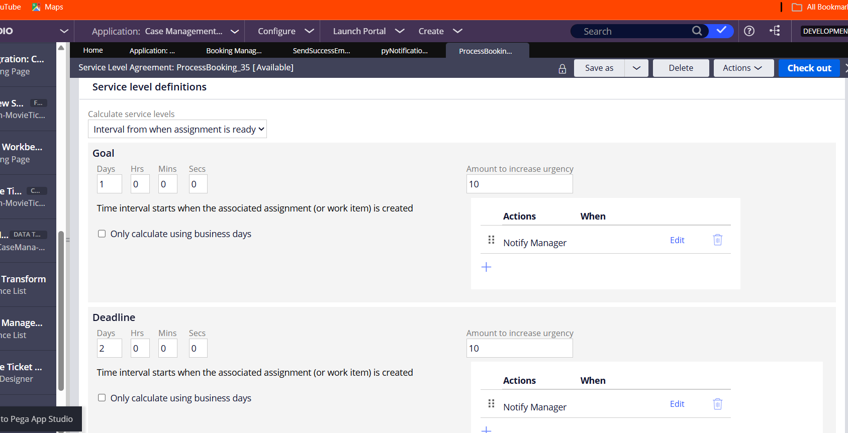

What I built for this (1–2 lines in your own words):
[ Type here ]

US-010 — Route by Show Type
What is expected:
Routing rule or Decision Table routes to PremiumShowQueue or StandardShowQueue based on Show Type property.
Screenshot — paste your screenshot below this line:
[ Paste screenshot here - follow the screenshot rules above ]
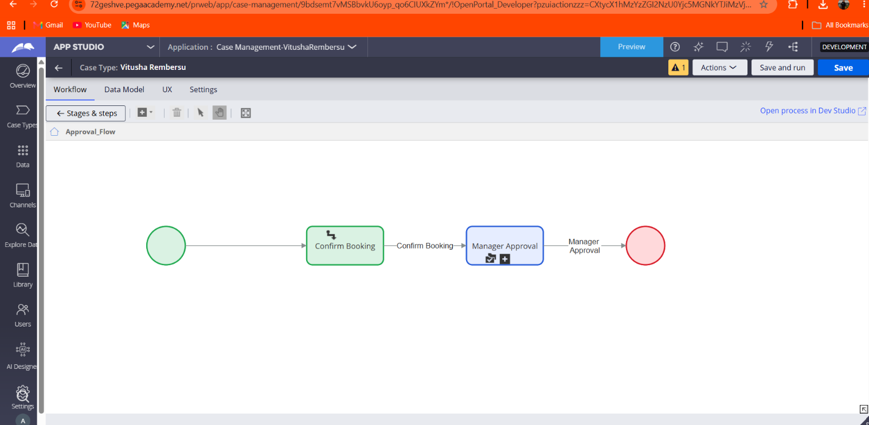

What I built for this (1–2 lines in your own words):
[ Type here ]

Section 3 — About Your Application
These answers are checked against your screenshots. Write exactly what is in your application.

Q1. List your stages in the order they appear in your case lifecycle.
Stage names in order, separated by commas.
[ Type here ]
Availability Check, Booking Approval, Booking Execution

Q2. Name the data object(s) you created and the properties inside them.
Data object name and its properties.
[ Type here ]
Movie Ticket Data object with properties: MovieName, ShowTiming, SeatNumbers, TicketCount, and TotalCost.

Q3. What is the exact name and type of the rule you used to calculate Total Cost?
Provide:
• Rule Name
• Rule Type
• Properties used in the calculation
• Formula used
[ Type here ]
Rule Name: CalculateTotalCost
Rule Type: Declare Expression
Properties used in the calculation: NumberofTickets, TicketPrice, TotalCost
Formula used: NumberofTickets * TicketPrice

Section 4 — Your Understanding
Short, honest and specific answers score well.

Q4. What did Blueprint generate for you, and what did you add or change yourself afterwards?
Be specific about what was already there and what you built or modified on top.
[ Type here ]

Blueprint generated the foundational case structure, initial stage layout, steps. Afterwards, I manually configured the individual process flows, added decision logic for the approval stage, and mapped out data fields and UI views.

Q5. Was there anything Blueprint created that you had to correct or configure further? Describe one example.
A real example from your own work.
[ Type here ]
Blueprint generated a process flow with a decision diamond containing unlinked connector lines, which caused rendering errors and required me to manually reconnect the paths to the End node in Dev Studio.

Q6. Explain your case flow from creation to resolution, in order.
What happens first, who does what, when the case closes.
[ Type here ]

The case starts at creation with the Availability Check stage to verify seats and compute costs. It moves to Booking Approval where request summaries are reviewed and confirmed or rejected, and concludes in Booking Execution where seats are allocated, IDs are generated, confirmation emails are sent, and the case resolves.

Q7. Pick two design choices you made in your application and explain why you made them.
For each design choice, provide:
• What you implemented
• Why you chose that approach
• What benefit it provides to the application
[ Type here ]
Decision Shape for Status Routing: Implemented a decision diamond to split paths into confirmed and rejected routes, providing clear conditional branching and improving process control.
Three-Stage Lifecycle Structure: Divided the workflow into Availability Check, Approval, and Execution stages to mirror real-world operational phases, making the application easier for users to track.

Q8. What was the hardest part, and how exactly did you fix it?
Specific and honest. A real challenge scores much better than a generic answer.
[ Type here ]

The hardest part was troubleshooting a frozen App Studio canvas and runtime error caused by a floating connector line in the flow rule. I fixed it by switching to Dev Studio, checking out the flow rule, properly wiring the decision outcomes to the End node, saving, and checking the rule back in.

Q9. If the approval step was only needed when Total Cost is above a certain amount, what would you change in your application?
Explain what you would change and where. You do not need to build this.
[ Type here ]

I would add a "When" condition on the Booking Approval stage or step to evaluate whether the Total Cost property exceeds the specified threshold amount, allowing the case to bypass approval for lower-cost bookings.

Q10. List three exact rule names from your application that you personally created or modified.
Include the rule name and rule type for each one (for example: CalculateTotalCost - Declare Expression).
[ Type here ]

BookingApproval_Flow - Flow
CalculateTotalCost - Declare Expression
Movie Ticket Request - Case Type

Q11. List all personas used in your application.
List the persona names exactly as they appear in your application.
[ Type here ]
Customer, Manager

Q12. List all work queues used in your application and explain when each one is used.
For each work queue, provide its exact name and the condition or type of work routed to it.
[ Type here ]
Default Queue, used for holding and routing movie ticket requests that require manual administrative review or fulfillment exception handling.

Before You Submit — Check These
Read through once before uploading.
1. Section 1 filled in. Application named as NIP-[Project]-[YourName]. Names match the actual application.
2. New Operator created in Pega with my full name. I logged in as that operator for all screenshots.
3. Only my chosen project section remains — the other project section is deleted.
4. All 10 user story screenshots are pasted and follow the operator, running-case, application, and rule-name evidence requirements.
5. Every question in Sections 3 and 4, including Q10, Q11, and Q12, is answered in my own words.
6. This file is named using the required format: ProjectName_FirstName_LastName.docx (for example, VehicleService_Ravi_Kumar.docx or MovieTicket_Ravi_Kumar.docx) and uploaded as required.

