Bri Miskovitz

Project 2

4/4/16

Introduction:

Excitable and oscillatory dynamics can be described using 1D and 2D ordinary differential equations. A few excitable Dynamical systems are forest fires and chemical reactions. Large activity occurs until it reaches equilibrium. Perturbations can help describe the behavior. A couple oscillatory systems describe the behavior of cells and neurons. Their behavior oscillates periodically over time, but it never grows or decays. The systems do not depend on the initial conditions.

**Model 1: $\frac{dθ}{dt}=r+sinθ$ $(-π,π]$**  0 < r < 1;

(It’s closer to 1).

According to the graph, in these intervals, there will always be two fixed points. The fixed point on the left is stable and the other is unstable, and they both lie in the negative quadrant in the vector field. There is a stable rest state, and it’s negative because in order for the model to reach this point, the physical system must be dying or decaying.

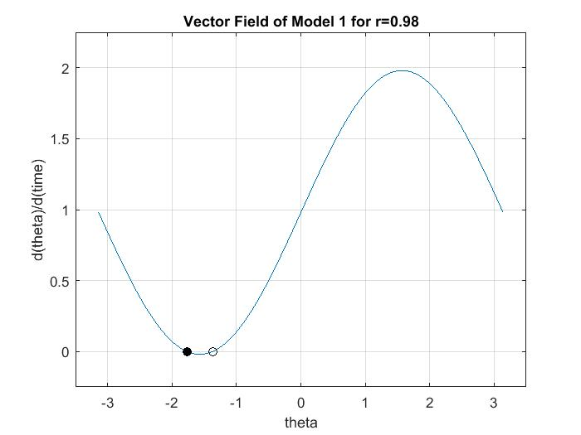

Figure 1. This graph portrays the vector field for model one when

$r=0.98$. The black circle indicates the stable fixed point of the

system, and the open black circle represents the unstable fixed point of this system.

The unstable fixed point of this model serves as a threshold because the solution trajectories change when the initial values are greater or less than the value of the system’s unstable equilibrium point. When initial values less than the value of the unstable fixed point are given, but greater than the value of the stable fixed point, these small perturbations will decay, and return to the system hastily to the rest state. The graph below shows that when initial values such as, such as $θ= -1.7, and -1.4$, are given to create trajectories, the curves decay and return to the rest state.

However, when the initial condition is less than the value of the stable fixed point, it will grow until it reaches that equilibrium point because those trajectories will be attracted to that point. The graph below shows this behavior for, but is not limited to, when $θ= -3$.

When the initial values are greater than the value of the unstable fixed point and within the given domain, (-pi,pi], these large perturbations will grow and cause the system to endure a larger excursion in phase space before returning to rest. The graph below portrays that when initial values such as, $θ= -1,0, and π$, are given to produce trajectories, they solutions grow exponentially, and these perturbations caused the equilibrium of the system to increase before they return back to the same rest state. Greater values of theta allow greater degrees of behavior to occur. For example, a larger wildfire can form before it dies back down.

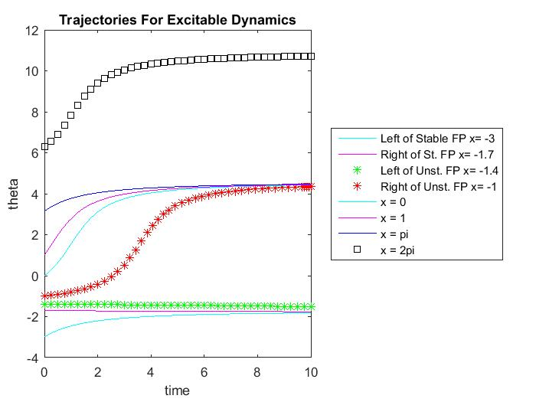

Figure 2. This graph displays different solution trajectories that occur when

given different initial values of theta. The system is integrated from

time [0 10] and r = 0.98. Initial values in between the two equilibrium points will cause the perturbations to decay back to the rest state, like aforementioned, but when the values are greater than the value of the unstable fixed points, the system will grow exponentially until it reaches equilibrium. As long as the initial value is within the given domain and greater than the unstable fixed point, all trajectories will level off to the same value. However, when the initial value is outside of the interval, such as $θ=2π$, the trajectories will level off to a greater value. The degree of behavior will be greater compared to when it is inside of the interval because now the system has a greater domain.

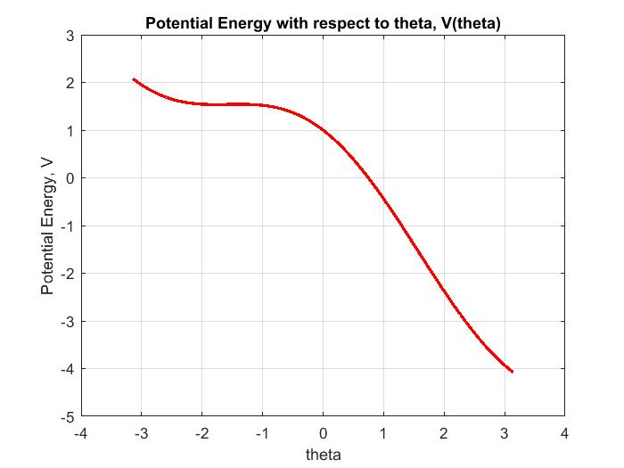

Figure 3. This graph illustrates the potential energy of this system within the given domain, $(-π,π]$ with respect to theta. As theta increases, the potential energy decrease until theta reaches the stable fixed point. Then it slowly increases until it reaches the unstable fixed point. It then slowly decays and then finally decreases mostly linearly. This is because of conservation of energy, as the potential energy decreases, the kinetic energy increases. As the theta increases, the degree of behavior increases, which means the kinetic energy increases. When the potential graph is observed with a domain of [-2pi 2pi], two bumps occur, which are at the fixed points of the model.

**Model 2A: $\frac{du}{dt}=(a-u)(u-1)u-v$** ; $\frac{dv}{dt}=ϵ(bu-v)$

In order to find the *nullclines* of the system, one must solve $\frac{du}{dt}=0$ and $\frac{dv}{dt}=0$.

$\frac{du}{dt}=(a-u)(u-1)u-v=0$ $\frac{dv}{dt}=ϵ(bu-v)$

$v=(a-u)(u-1)u$ (1) $v=ub$ (2)

The u-nullcline is equation (1), and the v-nullcline is equation (2).

In order to analytically acquire the equilibrium points, $\frac{du}{dt}=\frac{dv}{dt}=0$.

One fixed point that will always occur, for any given constants, is (0,0), which is proved below. The other possible fixed points can be found when the two nullclines are set equal to each other:

$(a-u)(u-1)u=ub$

$u_{1}^{*}=0⇒v{}_{1}^{*}=0$; $(a-u)(u-1)=b$

$u{}_{2,3}^{*}=\frac{(1+a) ± \sqrt{(a-1)^{2}-4b}}{2} ⇒ v{}_{2,3}^{*}=\frac{b(1+a) ± b\sqrt{(a-1)^{2}-4b}}{2}$

These are the two other possible fixed points for this system, but they both have an existence criteria.

$b≤\frac{(a-1){}^{2}}{4}$

When the constants cause this inequality to be false, the system will only have one fixed point, which is (0,0). When b equals the expression, there are two fixed points, the origin and $(\frac{1+a}{2},\frac{1+a}{2}b)$, but when b is less than the expression, all three equilibrium points are present. Also, when b equals the expression above, a saddle node bifurcation occurs.

The simplest fixed point is at the origin, and the jacobian can be used to classify it.

$f(u,v)=(au-a-u{}^{2}+u)u-v$ $g(u,v)=ϵ(bu-v)$

$f{}_{u}=2u(a+1)-(3u{}^{2}+a)$ $g{}_{u}=ϵb$

$f{}_{v}= -1$ $g{}_{v}= -ϵ$

$J=(f{}_{u} f{}_{v}; g{}_{u} g{}_{v})$

$J@(0,0)=(-a -1; ϵb -ϵ)$

$J =(-a-λ -1; ϵb -ϵ-λ)$ $λ{}_{1,2}= \frac{-(a+ϵ)±\sqrt{(a+ϵ){}^{2}-4(a+b)}}{2}$

det(J) = $(λ+ϵ)(λ+a)+ϵb = 0$ There are three possible

classifications, depending on the

value of the constants a, b, and $ϵ$. The classification depends on relationship of the radical in the expression shown above with zero and $-(a+ϵ)$. When it is less than zero, $(a+ϵ){}^{2}<4(a+b)$, the fixed point is a stable spiral. When it is greater than zero, there are two possible classifications.

$-(a+ϵ)<\sqrt{(a+ϵ){}^{2}-4(a+b)}$ $-(a+ϵ)>\sqrt{(a+ϵ){}^{2}-4(a+b)}$

$b< -a$ (3) $b> -a$ (4)

When the constants agree with inequality (3), the fixed point is a saddle node because the eigenvalues will be different signs and real. When they agree with inequality (4), it is a stable node because both real and negative.

$J=[(au-a-u{}^{2}+u)u -1; ϵb -ϵ]$

$(u{}_{1}^{*},v{}_{1}^{*})=0;$ $\left(u{}_{2,3}^{*}, v{}_{2,3}^{*}\right)=\left(\frac{(1+a) ± \sqrt{(a-1)^{2}-4b}}{2},\frac{b(1+a) ± b\sqrt{(a-1)^{2}-4b}}{2}\right)$

Fixed points and eigenvalues are found numerically using matlab.

(a.) a = 0.1; b = 0.5; $ϵ=0.01$

$\left(u{}_{1}^{*}, v{}_{1}^{*}\right)=\left(0,0\right)$: This equilibrium point is a stable spiral because it’s

$λ{}_{1,2}= -0.055±0.0545$: complex and the real parts are negative.

The jacobian matrix evaluated at (0,0) is: J = [-0.1 -1; 0.005 -0.01]

$\left(u{}_{2,3}^{*}, v{}_{2,3}^{*}\right)=\left(0.55±0.5454i, 0.5(0.55±0.5454i)\right)$ These fixed points don’t

exist.

(b.) a = 0.2; b = 0.3; $ϵ=0.01$

$\left(u{}_{1}^{*}, v{}_{1}^{*}\right)=\left(0,0\right)$: $λ{}_{1}= -0.1826$ Since the eigenvalues are real

$λ{}_{2}= -0.0274$ and negative, the fixed point is

a stable node.

This is the jacobian matrix evaluated at (0,0): J = [-0.2 -1; 0.003 -0.01].

$\left(u{}_{2,3}^{*}, v{}_{2,3}^{*}\right)=\left(0.6±0.3742i, 0.3(0.6±0.3742i)\right)$ These fixed points don’t

exist.

(c.) a = 0.1; b = 0.15; $ϵ=0.01$

$\left(u{}_{1 }^{*}, v{}_{1}^{*}\right)=\left(0,0\right)$: $λ{}_{1}= -0.0779$ This fixed point is a stable node

$λ{}_{2}= -0.0321$ because the eigenvalues are real

and negative.

The jacobian matrix evaluated at (0,0): J = [-0.1 -1; 0.0015 -0.01].

$\left(u{}_{2}^{*}, v{}_{2}^{*}\right)=(0.7791,0.116865)$ $\left(u{}_{3}^{*}, v{}_{3}^{*}\right)=(0.3209,0.048135)$

$λ{}_{1}= -0.1991$; $λ{}_{1}= -0.0179$ $λ{}_{1}= 0.2921$; $λ{}_{1}= -0.0051$

Since both eigenvalues are real and This fixed point is a saddle point

negative, this fixed point is a stable because both eigenvalues are real, but equilibrium point. the signs are different.

This is the jacobian matrix This is the jacobian matrix evaluated evaluated at $\left(u{}_{2}^{*}, v{}_{2}^{*}\right)$: at $\left(u{}_{3}^{*}, v{}_{3}^{*}\right)$:

J = $[-0.207 -1; 0.0015 -0.01]$ J = [0.297 -1; 0.0015 -0.01]

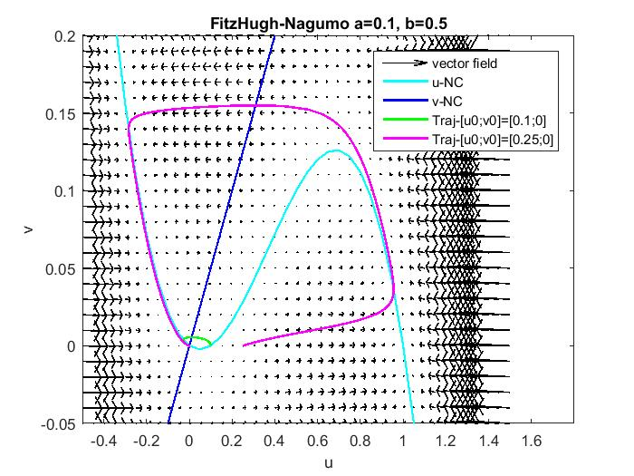

Figure 4. This is the phase portrait for the first set of constants. It’s a stable spiral, so it agrees with the analytical work. The initial condition, [u0; v0] = [0.1;0], the curve decays quickly to the fixed point at the origin. When the initial condition is [u0; v0] = [0.25;0], the trajectory grows toward the nullclines, along a small excursion, until it reaches the equilibrium point. The flow begins to grow dominantly in the u-direction until it reaches the u-nullcline, then it moves alone that nullcline. Then it decreases in dominantly in the u-direction until it reaches to the u-nullcline, which is the equilibrium for the u-equation of the model. Before it reaches the fixed point, it curls around, it reaches the origin. All of the trajectories end at the equilibrium point, so it’s stable.

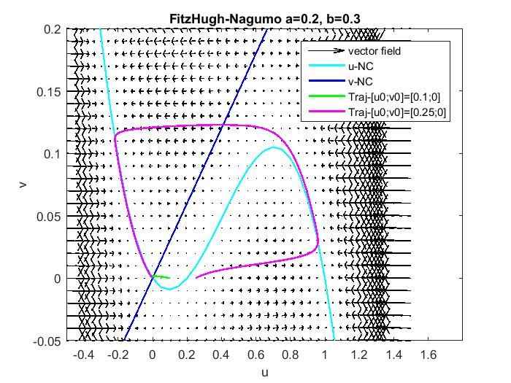

Figure 5. This is phase portrait for the second set of constants. When the initial condition is [u0; v0] = [0.1;0], the trajectory decays quickly to the fixed point at the origin. When the initial condition is [u0; v0] = [0.25;0], the flow increases in the u-direction until it reaches the u-nullcline, moves along the nullcline, and then it decreases in the u-direction until it reaches the nullcline again. It then moves along the nullcline again until it reaches the fixed point. The solution trajectory grows until it reaches the nullcline, the decays back to the nullcline and back to the rest state.

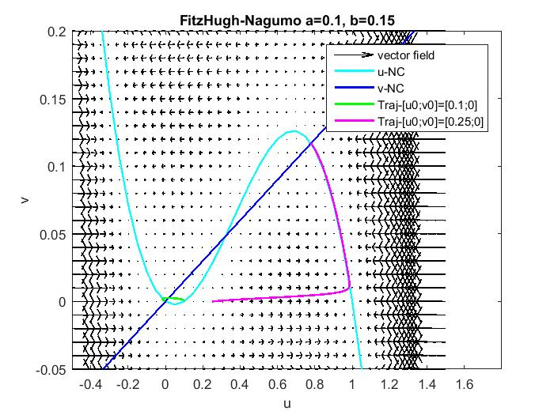

Figure 6. This is the phase portrait for the third set of constants. When the smaller initial condition [0.1; 0] is used, the trajectory decays quickly to the smaller fixed point, (0,0), which is a stable node. However, with the larger initial condition, the flow goes to the larger fixed point, which is a stable node. Both trajectories are going to toward the fixed point, so the phase portrait agrees with the analytical work. For the large perturbation, the flow increases in the u-direction until it reaches the u-nullcline because the u-nullcline is the equilibrium for the u equation. Then v increases until it reaches the intersection of the two nullclines, which is the equilibrium for the system.

The small sub-threshold perturbation is the origin to [0.1; 0], and all three phase portraits show that these trajectories decay to the fixed point. However, the large super-threshold perturbation is the origin to [0.25; 0], and all of these portraits illustrate that the trajectories grow until they reach the nullclines individually, and then they return hastily to the rest state, which is the equilibrium point. As the flow goes from the initial condition to the fixed point, the trajectory goes along a larger excursion before it reaches the rest state again.

When multiple fixed points are present, the equilibrium of the system, or the end of the flow of the trajectory depends on the initial condition. When there’s a small perturbation, the system will decay to [0; 0], but when there’s a large perturbation, the system will level out to a larger value. However, when there was only one fixed point, no matter what the initial condition is, it will return to (0,0).

The flow is predominantly horizontal because of $ϵ$, and since it’s such a small value, the v-solution is much smaller than the u-solution.

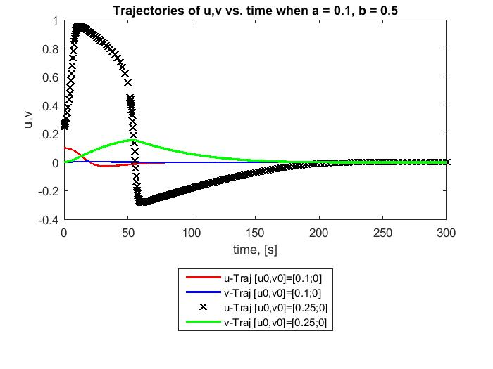

Figure 7. This graph portrays what will happen to u and v over time with a small perturbation and a large perturbation, and also, the values of the constants are a = 0.1, b = 0.5, and $ϵ=0.01$. The v-curve has a much smaller amplitude than the u-curve. Also, this shows how with a small perturbation, the amplitude of u and v is very small, while with a large perturbation, the amplitude of u and v is very large.

**Model 2B**

The fixed points, the jacobian matrix, and the eigenvalues were all found numerically using matlab.

$a= -0.1$ $b=0.5$ $ϵ=0.01$

$J=[(au-a-u{}^{2}+u)u -1; ϵb -ϵ]$

$J@(0,0)=[0.1 -1; 0.005 -0.01]$

$(u{}_{1}^{*},v{}_{1}^{*})=0;$ $\left(u{}_{2,3}^{*}, v{}_{2,3}^{*}\right)=\left(\frac{(1+a) ± \sqrt{(a-1)^{2}-4b}}{2},\frac{b(1+a) ± b\sqrt{(a-1)^{2}-4b}}{2}\right)$

$\left(u{}_{2,3}^{*}, v{}_{2,3}^{*}\right)=(0.4500±0.4444i, 0.225±0.2222i)$

There is only one fixed point in this case, and it is at the origin.

$J-λI=[0.1-λ -1; 0.005 -0.01-λ]$

$λ{}_{1,2}=0.045±0.0444i$

Since the eigenvalues has positive real parts, this fixed point is unstable. They’re also complex conjugates, so the origin is an unstable spiral.

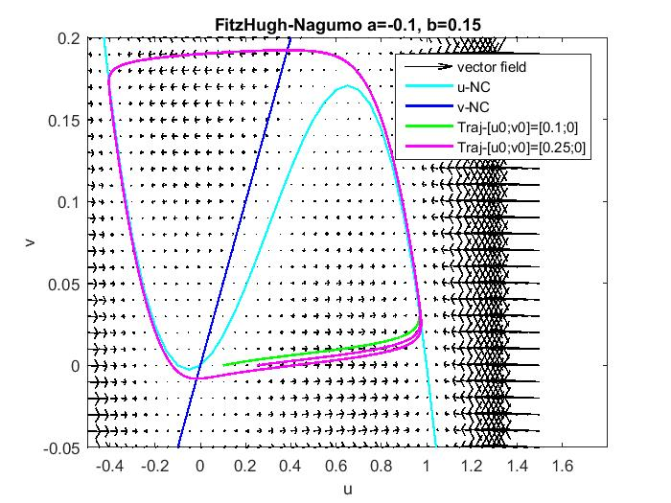

Figure 8. This phase portrait portrays spirals at the origin. The trajectories travel an excursion, and then moves away from the origin, therefore it is unstable.

However, when $ϵ$ is increased, the trajectories on the phase portrait look like stable spirals.

This system is oscillatory because because it doesn’t decay, and it has a stable periodic solution. Over time, u and v will has periodic functions of time. They will oscillate between a period of values of and v, but neither u nor v will decay or grow greater than the occurring period.

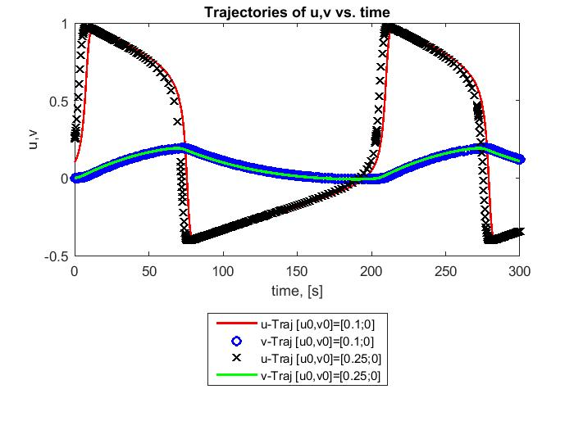

Figure 9. As predicted, u and v oscillate over time. The initial value doesn’t affect the time series graphs. The amplitude of the u-curve is much bigger than the amplitude of the v-curve, which makes sense because the value $ϵ$ is very small, which causes the v-curve to be very small. Since the behavior is oscillatory, the solutions are neutrally stable. They don’t decay or grow.

Conclusion

Excitable and oscillatory dynamics can be described used ODE models. When numerically analyzing these excitable models, perturbations are used to describe the behavior of the system. Small perturbation show the solutions decaying to the rest state, while large perturbations show the system grow before it reaches rest again. Some examples of excitable states are forest fires and chemical reactions. Oscillatory systems don't depend on its initial conditions. The behavior of the systems only oscillate over time because they are neutrally stable systems.

Collaborators:

Ali Borden: helped each other with analysis, helped each other with troubleshooting, shared ideas about physical properties

Dr Cherry: Helped understand physical concepts, helped with troubleshooting

Dr Cherry notes: helped with phase portrait code

Mathworks: helped with string specification

Wikipedia: helped with concepts