Sinhgad Technical Education Society’s

Sinhgad Institute of Business Administration and Research

Kondhwa (Bk.), Pune 411048

Class : MCA – Sem I

Subject: Java Programming

**Java Practical Journal**

Name: Vivek Ashok More

Roll_Number: 133

|  |  |  |  |
| --- | --- | --- | --- |
| Sr. No | Topic | Date | Program |
| 1 | Abstract Class | 17-01-2022 | Create an abstract class Vehicle with a member variable no-of-passengers and a member function check() that displays the number of passengers. Create two subclasses Car and Bus that’s extends the abstract class. Display the number of passengers for Car and Bus. |
| 2 | Package | 22-01-2022 | Create a package named Sequence having two different classes to print the following series: a) Factorial of numbers b) Squares of numbers Write a program to generate ‘n’ terms of above sequence |
| 3 | Array of Object | 24-01-2022 | Write a java program for a cricket player object. The program should accept details of ‘n’ players from user. The details of player are Player name, runs, innings-played. The program should contain following menu options enter details of player, display average runs of single player, sort names of players based on number of runs. Use array of object and function overloading |
| 4 | String Functions | 29-01-2022 | Write a java program to implement any five String class functions and any five StringBuilder class functions |
| 5 | Inheritance | 31-01-2022 | Create a Class Company with data members name and number of employees. Derive two classes ITCompany and Non-ITCompany. Display the necessary details.use constructor |
| 6 | Inheritance | 31-01-2022 | Create a class School with data members name and area. Derive a class School-one from School that displays the name and area. Derive another class from School-two that displays the name and area |
| 7 | Interface | 18-01-2022 | Create an interface for MyPay. Initialize a variable with a minimum amount and a member function increase() that increases the balance by 1000. Create a class Shop that implements the above interface |
| 8 | Exception Handling | 1-02-2022 | Define a class Vote that accepts the age of a candidate. if the age of the candidate is below 18 then throw an user defined exception “Age not within Limit” otherwise display message “Allowed to Vote” |
| 9 | Exception Handling | 1-02-2022 | Write a java program to show the implementation of exceptions like Arithmetic Exception, Array Index OutofBounds Exception, Number Format Exception, Null Pointer Exception and IOException |
| 10 | Files | 7-02-2022 | Write a program to accept a string as command line argument and check whether it is a file or directory. Also perform operations as follows: a) If it is a directory, list the names of text file. Also, display a count showing the number of files in the directory. b) If it is a file display various details of that file. |
| 11 | Files | 8-02-2022 | Write a java program to merge two files in a third file. Display the contents of all the three files. |
| 12 | Collections | 14-02-2022 | Construct a linked list containing names of colors: red, blue, yellow and orange. Then extend your program to do the following: i. Display the contents of the List using an Iterator; ii. Display the contents of the List in reverse order using a ListIterator iii. Create another list containing pink and green. Insert the elements of this list between blue and yellow |
| 13 | Thread | 22-02-2022 | Define thread called “PrintTextThread” for printing text on command prompt for „n‟ number of times. Create three threads and run them. pass the text and „n‟ as parameters to the thread constructor. Example: a) First thread prints “I am in FY” 10 times b) Second thread prints “I am in SY” 20 times c) Third thread prints “I am in TY” 30 times |
| 14 | Swing | 18-02-2022 | Write a program to implement a simple arithmetic calculator. Perform appropriate validations |
| 15 | Swing+Jdbc | 23-02-2022 | Create a table Student with the fields roll number, name, percentage Design a JFrame with the above fields and buttons for a)nsert b) Modify c) Delete d) Search e) View All f) Exit |
| 16 | Swing+Jdbc | 23-02-2022 | Create a table book (id, name , genre).Design a screen in swing that accepts book id, name and genre from textfield. There are two buttons ‘Display’ that shows the book details in jtable and Search button that highlights the row in jtable after accepting the bookid from a dialog box. |
| 17 | Applet | 24-02-2022 | Create an Applet which displays a message in the center of the screen. The message indicates the events taking place on the applet window. Handle events like mouse click, mouse moves, mouse dragged, mouse pressed. The message should update each time an event occurs. The message should give details of the event such as which mouse button was pressed (Hint: Use repaint(), MouseListener, MouseMotionListener) |
| 18 | Servlet Handling | 25-02-2022 | Design a servlet which counts how many times a user has visited a web page. If the user is visiting the page for the first time then display a message “Welcome”. If the user is revisiting the page, then display the number of times page is visited (Use Cookies |
| 19 | JSP | 28-02-2022 | Create a JSP page which accepts user name in a text box and greet the user according to the time on server side. Example: Input : User Name ABC Output : Good Morning ABC/Good Afternoon ABC/ Good Evening ABC |
| 20 | JSP | 28-02-2022 | Create a JSP page for an online multiple choice test. The questions are randomly selected from a database and displayed on the screen. The choices are displayed using radio buttons. When the user clicks on next, the next question is displayed. When the user clicks on submit, display the total score on the screen |

**Slip_No: 1**

1)Create an abstract class Vehicle with a member variable no-of-passengers and a member function Check()

 that displays the number of passengers.Create two subclasses Car and Bus thats extends abstract class.

 Display the number of passengers for Car and Bus

 import java.util.*;

 abstract class Vehicle

 {

     int no_of_passenger;

     abstract int Check();

 }

 class Car extends Vehicle

 {

    public int Check()

    {

         int no_of_passenger= 30;

          return no_of_passenger;

    }

 }

 class Bus extends Vehicle

 {

    public int Check()

    {

         int no_of_passenger=40;

        return no_of_passenger;

    }

 }

abstract class slip1

  {

    public static void main(String [] args)

    {

     Vehicle v;

     v = new Car();

     System.out.println("Number of passengers are:"+v.Check());

     v = new Bus();

     System.out.println("Number of passengers are:"+v.Check());

     }

 }

Output:

Number of passengers are:30

Number of passengers are:40

PS C:\Users\Lenovo\Desktop\Java\Java_Journal_2022>

**Slip no 2:**

Create a package name Sequence having two different classes to print the following series:

1] Factorial of numbers

2] Squares of numbers

write a program to genrate 'n' terms of above sequence.

Package: Sequence

1]Sqaure.java

package Sequence;

import java.util.*;

public class Square

{

    public void show1()

  {

  //int x =1;

   int n1;

   Scanner sc= new Scanner(System.in);

   System.out.println("Enter value of n1:");

   n1=sc.nextInt();

   for(int i=1;i<=n1;i++)

   {

      //x = ((i));

      System.out.println("Square is: "+(i*i));

   }

  }

}

Importing package

import Sequence.Square;

public class slip2_1

{

    public static void main(String [] args)

    {

        Square s = new Square();

         s.show1();

    }

}

Output:

Enter value of n1:

6

Square is: 1

Square is: 4

Square is: 9

Square is: 16

Square is: 25

Square is: 36

PS C:\Users\Lenovo\Desktop\Java\Java_Journal_2022>

2]Fact.java

package Sequence;

import java.util.*;

public class Fact

{

    public void show()

   {

    int f=1,n2=1,n3,i=0,n=0;

    Scanner sc= new Scanner(System.in);

    System.out.print("Enter value of n:");

    n=sc.nextInt();

    for(i=2;i<=n;i++)

    {

       f=f*i;

    }

    System.out.println("Factorial of Given Number: "+f);

   }

}

Importing package

import Sequence.Fact;

public class slip2_2

 {

  public static void main(String [] args)

  {

    Fact f = new Fact();

     f.show();

  }

}

Output:

Enter value of n:6

Factorial of Given Number: 720

PS C:\Users\Lenovo\Desktop\Java\Java_Journal_2022>

**Slip no 3**

Q.3 Write a java program for a cricket player object.

The program should accept details of ‘n’ players from user.

The details of player are Player name, runs, innings-played.

The program should contain following menu options enter details of player,

display average runs of single player, sort names of players based on number of runs.

Use array of object and function

import java.io.*;

import java.util.*;

class Player

{

int run;

String name;

int pd;

void accept()

{

    Scanner scan=new Scanner(System.in);

    System.out.println("Enter player name");

    name=scan.next();

    System.out.println("Enter run");

    run=scan.nextInt();

    System.out.println("Enter no of innings-played");

    pd=scan.nextInt();

}

void average ()

{

double avg=0;

avg+=(double)run/(double)pd;

System.out.println("Name of player= "+name);

System.out.println("average of player= "+avg);

System.out.println();

}

}

class Cricket

{

public static void main(String args[])

{

    int i;

Scanner scan=new Scanner(System.in);

System.out.println("Enter how many players want");

int n=scan.nextInt();

Player s[]=new Player[n];

     ;

      for(;;)

      {

        System.out.println("1.Enter details of player ");

      System.out.println("2.Display average runs ");

      System.out.println("3. EXIT...");

      System.out.println("Enter your choice");

      int ch = scan.nextInt();

      switch(ch)

      {

          case 1:

    for(i=0;i<n;i++)

    {

        s[i]=new Player();      //allocation

        s[i].accept();          //call function

    }

            break;

         case 2:

    for(i=0;i<n;i++)

    {

        s[i].average();

    }

            break;

        case 3:

        break;

      }

      }

}

}

Output:

Enter how many players want

3

1.Enter details of player

2.Display average runs

3. EXIT...

Enter your choice

1

Enter player name

Vivek

Enter run

123

Enter no of innings-played

2

Enter player name

Mehul

Enter run

454

Enter no of innings-played

6

Enter player name

Kiran

Enter run

946

Enter no of innings-played

11

1.Enter details of player

2.Display average runs

3. EXIT...

Enter your choice

2

Name of player= Vivek

average of player= 61.5

Name of player= Mehul

average of player= 75.66666666666667

Name of player= Kiran

average of player= 86.0

1.Enter details of player

2.Display average runs

3. EXIT...

PS C:\Users\Lenovo\Desktop\Java\Java_Journal_2022>

**Slip 4:**

4) Write a java program to implement any five String class functions and any five StringBuilders class functions.

// a) String class Functions

import java.util.*;

class slip4

{

   public static void main( String [] args)

   {

     Scanner s =new Scanner(System.in);

     System.out.println("Enter string 1 with spaces:");

     String n = s.nextLine();

     System.out.println("Enter string 2 with spaces:");

     String m = s.nextLine();

     System.out.println("\n**Function-1 length()**\n");

     System.out.println("Length of"+n+"="+n.length());

     System.out.println("\n**Function-2 Compare To()**\n");

     if(n.compareTo(m)==0)

       System.out.println(n+" and "+m+" are equal");

     else

     System.out.println(n+" and "+m+" are not equal");

     System.out.println("\n**Function-3 concat()**\n");

     System.out.println(n.concat(m));

     System.out.println(n.concat(" Concated String"));

      System.out.println("\n**Function-4 IsEmpty()**\n");

     System.out.println(n.isEmpty());

     System.out.println("\n**Function-5 Trim()**\n");

     System.out.println(n.trim().concat("Ok"));

   }

}

Output:

Enter string 1 with spaces:

Vivek is student of SIBAR

Enter string 2 with spaces:

Chalisgaon is a city in Jalgaon

**Function-1 length()**

Length ofVivek is student of SIBAR=25

**Function-2 Compare To()**

Vivek is student of SIBAR and Chalisgaon is a city in Jalgaon are not equal

**Function-3 concat()**

Vivek is student of SIBARChalisgaon is a city in Jalgaon

Vivek is student of SIBAR Concated String

**Function-4 IsEmpty()**

false

**Function-5 Trim()**

Vivek is student of SIBAROk

PS C:\Users\Lenovo\Desktop\Java\Java_Journal_2022>

//B) String builder functions

import java.util.*;

class slip4_2

{

     public static void main( String [] args)

   {

     // String Builder Functions

     System.out.println("\n**Function-1 append()**\n");

     StringBuilder s1 = new StringBuilder("Hellow");

     s1.append("Java");

     System.out.println(s1);

     System.out.println("\n**Function-2 insert()**\n");

     s1.insert(2,"java");

     System.out.println(s1);

     System.out.println("\n**Function-3 replace()**\n");

     s1.replace(1,3,"Java");

     System.out.println(s1);

     System.out.println("\n**Function-4 Delete()**\n");

     s1.delete(1,3);

     System.out.println(s1);

     System.out.println("\n**Function-5 Reverse()**\n");

     s1.reverse();

     System.out.println(s1);

     }

    }

Output:

**Function-1 append()**

HellowJava

**Function-2 insert()**

HejavallowJava

**Function-3 replace()**

HJavaavallowJava

**Function-4 Delete()**

HvaavallowJava

**Function-5 Reverse()**

avaJwollavaavH

PS C:\Users\Lenovo\Desktop\Java\Java_Journal_2022>

**Slip_No: 5**

5)Create a class company with data members name and numbers of employess.Derive two class ITCompany and Non-ITCompany. Display the necessary details.use constructor.

class Company

  {

     Company()

     {

       String name="Vivek";

       int no_of_emp=10;

      System.out.println("Name of Employee is:"+name);

       System.out.println("Numbers of employees are :"+no_of_emp);

     }

  }

   class ITCompany extends Company

   {

      ITCompany()

    {

      String name1="Pratik";

       int no_of_emp1=20;

       System.out.println("Name of Employee is:"+name1);

       System.out.println("Numbers of employees are :"+no_of_emp1);

       }

   }

  class Non_ITCompany extends ITCompany

  {

      Non_ITCompany()

    {

       String name2="Shubham";

       int no_of_emp2=05;

       System.out.println("Name of Employee is:"+name2);

       System.out.println("Numbers of employees are :"+no_of_emp2);

       }

  }

  public class slip5

  {

    public static void main(String [] args)

    {

        //Company obj= new Company();

        //ITCompany obj1= new ITCompany();

        Non_ITCompany obj2= new Non_ITCompany();

    }

   }

Output:

Name of Employee is:Vivek

Numbers of employees are :10

Name of Employee is:Pratik

Numbers of employees are :20

Name of Employee is:Shubham

Numbers of employees are :5

PS C:\Users\Lenovo\Desktop\Java\Java_Journal_2022>

**Slip no: 6**

  Create a class School with data members name and area. Derive a class School-one from School that displays

the name and area. Derive another class from School- two that displays the name and area.

import java.util.*;

class School

{

   Scanner sc = new Scanner(System.in);

   String name;

   String area;

   void show()// we could not acceses the methods and variables from superclass if we declare it as priavte.

   {

      System.out.print("Enter Name:");

      name = sc.next();

      System.out.print("Enter Area:");

      area = sc.next();

   }

}

 class One extends School

 {

    void display()

    {

      System.out.println("Name of School 1: "+name);

      System.out.println("Area of School 1: "+area);

    }

 }

  class Two extends School

 {

    void display()

    {

      System.out.println("Name of School 2: "+name);

      System.out.println("Area of School 2: "+area);

    }

 }

 class slip6

 {

    public static void main(String [] args)

    {

       One a=new One();

       Two b=new Two();

       a.show();//accesing method of base class

       a.display();

       b.show();

       b.display();

    }

  }

Output:

Enter Name:SIBAR

Enter Area:Pune

Name of School 1: SIBAR

Area of School 1: Pune

Enter Name:DR.KPMV

Enter Area:Chalisgaon

Name of School 2: DR.KPMV

Area of School 2: Chalisgaon

PS C:\Users\Lenovo\Desktop\Java\Java_Journal_2022>

**Slip_No:7**

Create interface for MyPay. Initialize a variable with a minimum amount and a member function increase() that balance by 1000.Create a class Shop that Implements the above interface.

interface MyPay

{

    int x = 50;

    int increase();

}

class Shop implements MyPay

{

   public int increase()

   {

     int cnt = 0;

      cnt = x+1000;

      return cnt;

   }

   public static void main(String [] args)

   {

       MyPay m = new Shop();

       System.out.println("Initial Value of x is:"+x);

       System.out.println("increased value of x is:"+m.increase());

   }

}

Output:  
Initial Value of x is:50

Increased value of x is:1050

PS C:\Users\Lenovo\Desktop\Java\Java_Journal_2022>

**Slip_No:8**

Define a class Votes that accept the age of candidate. if the age is below 18 then throw user defined exception

"Age not within limit". Otherwise display message allow to vote.

import java.lang.*;

import java.io.*;

import java.util.Scanner;

class Votes extends Exception

{

   public Votes (String str)

   {

     System.out.println(str);

   }

}

class Slip8

{

    public static void main(String [] args)

 {

    Scanner s = new Scanner(System.in);

    System.out.print("Enter your age::");

    int age= s.nextInt();

    try

    {

      if(age<18)

      throw new Votes("Age not within Limit");

      else

      System.out.println("Your age is accepted");

    }

      catch(Votes v)

      {

              System.out.println(v);

      }

 }

}

Output:

Enter your age::15

Age not within Limit

Votes

PS C:\Users\Lenovo\Desktop\Java\Java_Journal_2022> c:; cd 'c:\Users\Lenovo\Desktop\Java\Java_Journal_2022'; & 'C:\Program Files\Java\jdk-17.0.1\bin\java.exe' '--enable-preview' '-XX:+ShowCodeDetailsInExceptionMessages' '-cp'

'C:\Users\Lenovo\AppData\Roaming\Code\User\workspaceStorage\868243e52539721db25ada444cbd5466\redhat.java\jdt_ws\Java_Journal_2022_c9749886\bin' 'Slip8'

Enter your age::32

Your age is accepted

PS C:\Users\Lenovo\Desktop\Java\Java_Journal_2022>

**Slip_No:9**

Write a java program to show the implementations of exceptions like Arithmetic Exception,ArrayIndexOutOfBoundsException,

NumberFormatException,NullPointerException and IOException.

 //implementing arithmeticException

 public class slip9_1

{     public static void main(String [] args)

    {

         int x=5;

         int y=0;

         try

         {

             System.out.println("Division:"+(x/y));

         }

         catch(ArithmeticException e)

         {

            System.out.println(e);

         }

         finally

         {

            System.out.println("Numerator is:"+x);

         }

   }

}

Output:

java.lang.ArithmeticException: / by zero

Numerator is:5

PS C:\Users\Lenovo\Desktop\Java\Java_Journal_2022>

//Implementing arrayindexoutofboundException.

 //it is the exception which occurs when we try to phase array elements out of its length

 public class slip9_2

 {

     public static void main(String [] args)

     {

       String [] names={"W","x","y","z"};

          System.out.println(names[0]);

          System.out.println(names[1]);

          System.out.println(names[2]);

          System.out.println(names[3]);

          System.out.println(names[4]);

          for(int i=0;i<names.length;i++)

          {

              System.out.println(names[i]);

          }

     }

 }

Output:  
W

x

y

z

Exception in thread "main" java.lang.ArrayIndexOutOfBoundsException: Index 4 out of bounds for length 4

at slip9_2.main(slip9_2.java:13)

PS C:\Users\Lenovo\Desktop\Java\Java_Journal_2022>

//implementing null pointer exception

//it is nothing but an error which occurs if we tried ti perform any operation on object which is null

public class slip9_3

 {

     public static void main(String [] args)

     {

         String str = null;

         System.out.println(str.length());

     }

 }

Output:

Exception in thread "main" java.lang.NullPointerException: Cannot invoke "String.length()" because "str" is null

at slip9_3.main(slip9_3.java:10)

PS C:\Users\Lenovo\Desktop\Java\Java_Journal_2022>

    // implementing NumberFormatException

    // when we enter non integer value then it is called as NumberformatException

import java.util.Scanner;

 public class slip9_4

 {

     public static void main(String [] args)

     {

         String str= null;

         Scanner sc = new Scanner(System.in);

         System.out.print("Enter a number:");

         str= sc.next();

         sc.close();

         int a = Integer.parseInt(str);

         System.out.println("a = "+a);

     }

 }

Output:

Enter a number:52

a = 52

PS C:\Users\Lenovo\Desktop\Java\Java_Journal_2022> c:; cd 'c:\Users\Lenovo\Desktop\Java\Java_Journal_2022'; & 'C:\Program Files\Java\jdk-17.0.1\bin\java.exe' '--enable-preview' '-XX:+ShowCodeDetailsInExceptionMessages' '-cp' 'C:\Users\Lenovo\AppData\Roaming\Code\User\workspaceStorage\868243e52539721db25ada444cbd5466\redhat.java\jdt_ws\Java_Journal_2022_c9749886\bin' 'slip9_4'

Enter a number:Anu

Exception in thread "main" java.lang.NumberFormatException: For input string: "Anu"

at java.base/java.lang.NumberFormatException.forInputString(NumberFormatException.java:67)

at java.base/java.lang.Integer.parseInt(Integer.java:668)

at java.base/java.lang.Integer.parseInt(Integer.java:786)

at slip9_4.main(slip9_4.java:14)

PS C:\Users\Lenovo\Desktop\Java\Java_Journal_2022>

//implementing the IOException

/*This exception occurs whenever an  input and output operation is failed or interpreted.

For instance: If you trying to read the file that does not exist.*/

import java.io.*;

import java.util.*;

class slip9_5

{

  public static void main(String [] args) throws IOException

  {

     //read file using byte stream

     FileInputStream f = new FileInputStream("data.txt");

     int c=0;

     while(c!=-1)

     {

        c=f.read();

        System.out.print((char)c);

     }

     System.out.println();

     //read file using character stream

     FileReader fr= new FileReader("data.txt");

     int i =0;

     while(i!=-1)

     {

        i=fr.read();

        System.out.print((char)i);

     }

       fr.close();

  }

}

Output:

//When i create data.txt and run the program i got following output.

Welcome to Java Journal By Vivek?

Welcome to Java Journal By Vivek?

PS C:\Users\Lenovo\Desktop\Java\Java_Journal_2022>

//I have deleted data.txt file from directory and agian compile and run the programe. i got following output

Exception in thread "main" java.io.FileNotFoundException: data.txt (The system cannot find the file specified)

at java.base/java.io.FileInputStream.open0(Native Method)

at java.base/java.io.FileInputStream.open(FileInputStream.java:216)

at java.base/java.io.FileInputStream.<init>(FileInputStream.java:111)

at slip9_5.main(slip9_5.java:11)

PS C:\Users\Lenovo\Desktop\Java\Java_Journal_2022>

|  |
| --- |
| **Slip no:10**  Write a program to accept a string as command line argument and check whether it is a file or directory. Also perform operations as follows: a) If it is a directory, list the names of text file. Also, display a count showing the number of files in the directory. b) If it is a file display various details of that file.  import java.io.*;  import java.lang.*;  class slip10  {     public static void main(String a[])     {         String fname=a[0];          File f = new File(fname);      int num=0;     if(f.isDirectory())      {         System.out.println("Given file "+fname+"is  directory :");         System.out.println("List of files are : ");         String s[] = f.list();        for(int i=0; i<s.length; i++)            {                File f1 = new File(fname, s[i]);              if(f1.isFile())              {                    num++;                 System.out.println(s[i]);               //file name in directory              }                else                 System.out.println("\n"+s[i]+" is a sub directory");           }              System.out.println("\nNumber of files are: "+num);     }              else         {                 if(f.exists())                    {                        System.out.println("\n"+fname+" is a File");                        System.out.println("Details of "+fname+" are : ");                        System.out.println("Path of file is "+f.getPath());                        System.out.println("Absolute Path of file is "+f.getAbsolutePath());                        System.out.println("Size of file is "+f.length());                     }                       else                       System.out.println(fname+" file is not present ");           }     }  }  Output:  Note: Use CommandLine Arguments as shown in below output |

**Slip no:11**

Write a java program to merge two files in a third file.

Display the contents of all the three

files

import java.io.*;

class slip11

{

    public static void main(String[] args) throws IOException

    {

        // PrintWriter object for file3.txt

        PrintWriter pw = new PrintWriter("file3.txt");

        // BufferedReader object for file1.txt

        BufferedReader br = new BufferedReader(new FileReader("file1.txt"));

        String line = br.readLine();

        // loop to copy each line of

        // file1.txt to  file3.txt

        while (line != null)

        {

            pw.println(line);

            line = br.readLine();

        }

           br = new BufferedReader(new FileReader("file2.txt"));

        line = br.readLine();

        // loop to copy each line of

        // file2.txt to  file3.txt

        while(line != null)

        {

            pw.println(line);

            line = br.readLine();

        }

        pw.flush();

        // closing resources

        br.close();

        pw.close();

        System.out.println("\nMerged file1.txt and file2.txt into file3.txt");

        System.out.print("\nContents of File1\n:");

        FileReader fr=new FileReader("file1.txt");

        int i=0;

        while(i!=-1)

        {

            i=fr.read();

            System.out.print((char)i);

        }

        fr.close();

        System.out.print("\nContents of File2\n:");

         fr=new FileReader("file2.txt");

         i=0;

        while(i!=-1)

        {

            i=fr.read();

            System.out.print((char)i);

        }

        fr.close();

        System.out.print("\nContents of File3\n:");

        fr=new FileReader("file3.txt");

        i=0;

        while(i!=-1)

        {

            i=fr.read();

            System.out.print((char)i);

        }

        fr.close();

    }

}

Output:

Merged file1.txt and file2.txt into file3.txt

Contents of File1

:VIVEK?

Contents of File2

:MORE?

Contents of File3

:VIVEK

MORE

?

PS C:\Users\Lenovo\Desktop\Java>

**Slip_No:12**

Q.12 Construct linked list containing names of colors: red, blue, yellow and orange. Then extend your program to do the following.

a. Display the contents of the list using an Iterator.

b. Display the contents of the list in reverse order using ListIterator.

c. Create another list contain pink and green. Insert the elements of the list between blue and yellow.

import java.util.*;

class slip12

{

 public static void main(String[] args)

 {

     LinkedList ll=new LinkedList();

     ll.add("Red");

     ll.add("Blue");

     ll.add("Yellow");

     ll.add("Orange");

     Iterator i=ll.iterator();

     System.out.println("\ncontents of the List using an Iterator:\n");

     while(i.hasNext())

     {

         String s=(String)i.next();

         System.out.println(s);

     }

     ListIterator li = ll.listIterator();

     while(li.hasNext())

     {

         // String elt = (String)

         li.next();

     }

     System.out.println("\ncontents of the List in reverse order using a ListIterator : ");

     while(li.hasPrevious())

     {

         System.out.println(li.previous());

     }

         ll.add(2,"Pink");           //add element at second position

         ll.add(3,"Green");        //add element at 3rd position

         System.out.println("\nlist between blue and yellow is:");

         System.out.println(ll);

 }

}

Output:

contents of the List using an Iterator:

Red

Blue

Yellow

Orange

contents of the List in reverse order using a ListIterator :

Orange

Yellow

Blue

Red

list between blue and yellow is:

[Red, Blue, Pink, Green, Yellow, Orange]

PS C:\Users\Lenovo\Desktop\Java>

**Slip_No:13**

Q.13 Define a thread called "PrintTextThread" for printing text on command prompt for 'n' number of times.

Create 3 threads and run them. Pass the text ‘n’ parameters to the thread constructor.

Example:

a. First thread prints "I am in FY" 10 times.

b. Second thread prints "I am in SY" 20 times

c. Third thread prints "I am in TY" 30 times

import java.io.*;

import java.lang.*;

import java.lang.String.*;

class Ptext extends Thread

{

            String msg="";

            int  n;

            Ptext(String msg,int n)

            {

                this.msg=msg;

                this.n=n;

            }

            public void run()

            {

              try

              {     for(int i=1;i<=n;i++)

                   {

                       System.out.println(msg+" "+i+" times");

                   }

                       System.out.println("\n ");

              }

                     catch(ArrayIndexOutOfBoundsException e){}

            }

}

class slip13

{

            public static void main(String a[]) throws ArrayIndexOutOfBoundsException

            {

              int n=Integer.parseInt(a[0]);

              Ptext t1=new Ptext("I am in FY",n);

              t1.start();

              Ptext t2=new Ptext("I am in SY",n+10);

              t2.start();

              Ptext t3=new Ptext("I am in TY",n+20);

              t3.start();

            }

}

Output:

C:\Users\Lenovo\Desktop\Java\Java_Journal_2022>java slip13 10

I am in SY 1 times

I am in TY 1 times

I am in FY 1 times

I am in TY 2 times

I am in SY 2 times

I am in TY 3 times

I am in FY 2 times

I am in TY 4 times

I am in SY 3 times

I am in TY 5 times

I am in FY 3 times

I am in TY 6 times

I am in SY 4 times

I am in TY 7 times

I am in FY 4 times

I am in TY 8 times

I am in SY 5 times

I am in TY 9 times

I am in FY 5 times

I am in TY 10 times

I am in SY 6 times

I am in TY 11 times

I am in FY 6 times

I am in TY 12 times

I am in SY 7 times

I am in TY 13 times

I am in FY 7 times

I am in TY 14 times

I am in SY 8 times

I am in TY 15 times

I am in FY 8 times

I am in TY 16 times

I am in SY 9 times

I am in TY 17 times

I am in FY 9 times

I am in TY 18 times

I am in SY 10 times

I am in TY 19 times

I am in FY 10 times

I am in TY 20 times

I am in SY 11 times

I am in TY 21 times

I am in TY 22 times

I am in SY 12 times

I am in SY 13 times

I am in TY 23 times

I am in SY 14 times

I am in SY 15 times

I am in TY 24 times

I am in TY 25 times

I am in SY 16 times

I am in SY 17 times

I am in TY 26 times

I am in SY 18 times

I am in TY 27 times

I am in SY 19 times

I am in TY 28 times

I am in SY 20 times

I am in TY 29 times

I am in TY 30 times

C:\Users\Lenovo\Desktop\Java\Java_Journal_2022>

 Slip 14

Write a program to implement a simple arithmetic calculator. Perform appropriate validations.

import java.awt.event.*;

import javax.swing.*;

import java.awt.*;

class calculator extends JFrame implements ActionListener {

    // create a frame

    static JFrame f;

    // create a textfield

    static JTextField l;

    // store operator and operands

    String s0, s1, s2;

    // default constructor

    calculator()

    {

        s0 = s1 = s2 = "";

    }

    // main function

    public static void main(String args[])

    {

        // create a frame

        f = new JFrame("calculator");

        try {

            // set look and feel

            UIManager.setLookAndFeel(UIManager.getSystemLookAndFeelClassName());

        }

        catch (Exception e) {

            System.err.println(e.getMessage());

        }

        // create a object of class

        calculator c = new calculator();

        // create a textfield

        l = new JTextField(16);

        // set the textfield to non editable

        l.setEditable(false);

        // create number buttons and some operators

        JButton b0, b1, b2, b3, b4, b5, b6, b7, b8, b9, ba, bs, bd, bm, be, beq, beq1;

        // create number buttons

        b0 = new JButton("0");

        b1 = new JButton("1");

        b2 = new JButton("2");

        b3 = new JButton("3");

        b4 = new JButton("4");

        b5 = new JButton("5");

        b6 = new JButton("6");

        b7 = new JButton("7");

        b8 = new JButton("8");

        b9 = new JButton("9");

        // equals button

        beq1 = new JButton("=");

        // create operator buttons

        ba = new JButton("+");

        bs = new JButton("-");

        bd = new JButton("/");

        bm = new JButton("*");

        beq = new JButton("C");

        // create . button

        be = new JButton(".");

        // create a panel

        JPanel p = new JPanel();

        // add action listeners

        bm.addActionListener(c);

        bd.addActionListener(c);

        bs.addActionListener(c);

        ba.addActionListener(c);

        b9.addActionListener(c);

        b8.addActionListener(c);

        b7.addActionListener(c);

        b6.addActionListener(c);

        b5.addActionListener(c);

        b4.addActionListener(c);

        b3.addActionListener(c);

        b2.addActionListener(c);

        b1.addActionListener(c);

        b0.addActionListener(c);

        be.addActionListener(c);

        beq.addActionListener(c);

        beq1.addActionListener(c);

        // add elements to panel

        p.add(l);

        p.add(ba);

        p.add(b1);

        p.add(b2);

        p.add(b3);

        p.add(bs);

        p.add(b4);

        p.add(b5);

        p.add(b6);

        p.add(bm);

        p.add(b7);

        p.add(b8);

        p.add(b9);

        p.add(bd);

        p.add(be);

        p.add(b0);

        p.add(beq);

        p.add(beq1);

        // set Background of panel

        p.setBackground(Color.yellow);

        // add panel to frame

        f.add(p);

        f.setSize(200, 220);

        f.show();

    }

    public void actionPerformed(ActionEvent e)

    {

        String s = e.getActionCommand();

        // if the value is a number

        if ((s.charAt(0) >= '0' && s.charAt(0) <= '9') || s.charAt(0) == '.') {

            // if operand is present then add to second no

            if (!s1.equals(""))

                s2 = s2 + s;

            else

                s0 = s0 + s;

            // set the value of text

            l.setText(s0 + s1 + s2);

        }

        else if (s.charAt(0) == 'C') {

            // clear the one letter

            s0 = s1 = s2 = "";

            // set the value of text

            l.setText(s0 + s1 + s2);

        }

        else if (s.charAt(0) == '=') {

            double te;

            // store the value in 1st

            if (s1.equals("+"))

                te = (Double.parseDouble(s0) + Double.parseDouble(s2));

            else if (s1.equals("-"))

                te = (Double.parseDouble(s0) - Double.parseDouble(s2));

            else if (s1.equals("/"))

                te = (Double.parseDouble(s0) / Double.parseDouble(s2));

            else

                te = (Double.parseDouble(s0) * Double.parseDouble(s2));

            // set the value of text

            l.setText(s0 + s1 + s2 + "=" + te);

            // convert it to string

            s0 = Double.toString(te);

            s1 = s2 = "";

        }

        else {

            // if there was no operand

            if (s1.equals("") || s2.equals(""))

                s1 = s;

            // else evaluate

            else {

                double te;

                // store the value in 1st

                if (s1.equals("+"))

                    te = (Double.parseDouble(s0) + Double.parseDouble(s2));

                else if (s1.equals("-"))

                    te = (Double.parseDouble(s0) - Double.parseDouble(s2));

                else if (s1.equals("/"))

                    te = (Double.parseDouble(s0) / Double.parseDouble(s2));

                else

                    te = (Double.parseDouble(s0) * Double.parseDouble(s2));

                // convert it to string

                s0 = Double.toString(te);

                // place the operator

                s1 = s;

                // make the operand blank

                s2 = "";

            }

            // set the value of text

            l.setText(s0 + s1 + s2);

        }

    }

}

Output:

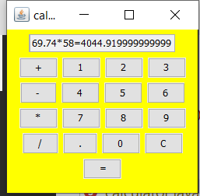

**Slip_No:15**

Q.15 Create a table Student with the fields roll number, name, percentage Design a JFrame with the above fields and buttons for a)Insert b) Modify c) Delete d) Search e) View All f) Exit

**JFrame File:**

import java.sql.*;

import javax.swing.JOptionPane;

public class slip15 extends javax.swing.JFrame {

    /**

     * Creates new form slip15

     */

    public slip15() {

        initComponents();

    }

    /**

     * This method is called from within the constructor to initialize the form.

     * WARNING: Do NOT modify this code. The content of this method is always

     * regenerated by the Form Editor.

     */

    @SuppressWarnings("unchecked")

    // <editor-fold defaultstate="collapsed" desc="Generated Code">

    private void initComponents() {

        jLabel1 = new javax.swing.JLabel();

        jLabel2 = new javax.swing.JLabel();

        jLabel3 = new javax.swing.JLabel();

        jButton1 = new javax.swing.JButton();

        jButton2 = new javax.swing.JButton();

        jButton3 = new javax.swing.JButton();

        jButton4 = new javax.swing.JButton();

        jButton5 = new javax.swing.JButton();

        jButton6 = new javax.swing.JButton();

        jTextField1 = new javax.swing.JTextField();

        jTextField2 = new javax.swing.JTextField();

        jTextField3 = new javax.swing.JTextField();

        jLabel4 = new javax.swing.JLabel();

        setDefaultCloseOperation(javax.swing.WindowConstants.EXIT_ON_CLOSE);

        jLabel1.setFont(new java.awt.Font("Times New Roman", 1, 18)); // NOI18N

        jLabel1.setText("Percentage: ");

        jLabel2.setFont(new java.awt.Font("Times New Roman", 1, 18)); // NOI18N

        jLabel2.setText("Roll no: ");

        jLabel3.setFont(new java.awt.Font("Times New Roman", 1, 18)); // NOI18N

        jLabel3.setText("Name: ");

        jButton1.setFont(new java.awt.Font("Times New Roman", 1, 14)); // NOI18N

        jButton1.setText("Insert");

        jButton1.addActionListener(new java.awt.event.ActionListener() {

            public void actionPerformed(java.awt.event.ActionEvent evt) {

                jButton1ActionPerformed(evt);

            }

        });

        jButton2.setFont(new java.awt.Font("Times New Roman", 1, 14)); // NOI18N

        jButton2.setText("Modify");

        jButton2.addActionListener(new java.awt.event.ActionListener() {

            public void actionPerformed(java.awt.event.ActionEvent evt) {

                jButton2ActionPerformed(evt);

            }

        });

        jButton3.setFont(new java.awt.Font("Times New Roman", 1, 14)); // NOI18N

        jButton3.setText("Search");

        jButton3.addActionListener(new java.awt.event.ActionListener() {

            public void actionPerformed(java.awt.event.ActionEvent evt) {

                jButton3ActionPerformed(evt);

            }

        });

        jButton4.setFont(new java.awt.Font("Times New Roman", 1, 14)); // NOI18N

        jButton4.setText("Delete");

        jButton4.addActionListener(new java.awt.event.ActionListener() {

            public void actionPerformed(java.awt.event.ActionEvent evt) {

                jButton4ActionPerformed(evt);

            }

        });

        jButton5.setFont(new java.awt.Font("Times New Roman", 1, 14)); // NOI18N

        jButton5.setText("View");

        jButton5.addActionListener(new java.awt.event.ActionListener() {

            public void actionPerformed(java.awt.event.ActionEvent evt) {

                jButton5ActionPerformed(evt);

            }

        });

        jButton6.setFont(new java.awt.Font("Times New Roman", 1, 14)); // NOI18N

        jButton6.setText("EXIT");

        jButton6.addActionListener(new java.awt.event.ActionListener() {

            public void actionPerformed(java.awt.event.ActionEvent evt) {

                jButton6ActionPerformed(evt);

            }

        });

        javax.swing.GroupLayout layout = new javax.swing.GroupLayout(getContentPane());

        getContentPane().setLayout(layout);

        layout.setHorizontalGroup(

            layout.createParallelGroup(javax.swing.GroupLayout.Alignment.LEADING)

            .addGroup(layout.createSequentialGroup()

                .addGap(47, 47, 47)

                .addGroup(layout.createParallelGroup(javax.swing.GroupLayout.Alignment.LEADING)

                    .addGroup(javax.swing.GroupLayout.Alignment.TRAILING, layout.createSequentialGroup()

                        .addComponent(jButton1)

                        .addPreferredGap(javax.swing.LayoutStyle.ComponentPlacement.RELATED, javax.swing.GroupLayout.DEFAULT_SIZE, Short.MAX_VALUE)

                        .addGroup(layout.createParallelGroup(javax.swing.GroupLayout.Alignment.LEADING)

                            .addComponent(jButton6)

                            .addComponent(jButton5))

                        .addGap(107, 107, 107))

                    .addGroup(javax.swing.GroupLayout.Alignment.TRAILING, layout.createSequentialGroup()

                        .addGap(0, 30, Short.MAX_VALUE)

                        .addComponent(jLabel4, javax.swing.GroupLayout.PREFERRED_SIZE, 282, javax.swing.GroupLayout.PREFERRED_SIZE)

                        .addGap(57, 57, 57))

                    .addGroup(layout.createSequentialGroup()

                        .addGroup(layout.createParallelGroup(javax.swing.GroupLayout.Alignment.LEADING)

                            .addGroup(layout.createSequentialGroup()

                                .addGap(2, 2, 2)

                                .addGroup(layout.createParallelGroup(javax.swing.GroupLayout.Alignment.LEADING)

                                    .addComponent(jLabel1)

                                    .addComponent(jLabel3, javax.swing.GroupLayout.PREFERRED_SIZE, 74, javax.swing.GroupLayout.PREFERRED_SIZE)

                                    .addComponent(jLabel2, javax.swing.GroupLayout.PREFERRED_SIZE, 74, javax.swing.GroupLayout.PREFERRED_SIZE))

                                .addPreferredGap(javax.swing.LayoutStyle.ComponentPlacement.RELATED)

                                .addGroup(layout.createParallelGroup(javax.swing.GroupLayout.Alignment.LEADING)

                                    .addComponent(jTextField1, javax.swing.GroupLayout.PREFERRED_SIZE, 160, javax.swing.GroupLayout.PREFERRED_SIZE)

                                    .addComponent(jTextField2, javax.swing.GroupLayout.PREFERRED_SIZE, 160, javax.swing.GroupLayout.PREFERRED_SIZE)

                                    .addComponent(jTextField3, javax.swing.GroupLayout.PREFERRED_SIZE, 160, javax.swing.GroupLayout.PREFERRED_SIZE)))

                            .addGroup(layout.createSequentialGroup()

                                .addComponent(jButton2)

                                .addGap(18, 18, 18)

                                .addGroup(layout.createParallelGroup(javax.swing.GroupLayout.Alignment.LEADING)

                                    .addComponent(jButton3)

                                    .addComponent(jButton4))))

                        .addContainerGap(javax.swing.GroupLayout.DEFAULT_SIZE, Short.MAX_VALUE))))

        );

        layout.setVerticalGroup(

            layout.createParallelGroup(javax.swing.GroupLayout.Alignment.LEADING)

            .addGroup(javax.swing.GroupLayout.Alignment.TRAILING, layout.createSequentialGroup()

                .addContainerGap(64, Short.MAX_VALUE)

                .addGroup(layout.createParallelGroup(javax.swing.GroupLayout.Alignment.BASELINE)

                    .addComponent(jLabel2, javax.swing.GroupLayout.PREFERRED_SIZE, 30, javax.swing.GroupLayout.PREFERRED_SIZE)

                    .addComponent(jTextField1, javax.swing.GroupLayout.PREFERRED_SIZE, 25, javax.swing.GroupLayout.PREFERRED_SIZE))

                .addPreferredGap(javax.swing.LayoutStyle.ComponentPlacement.UNRELATED)

                .addGroup(layout.createParallelGroup(javax.swing.GroupLayout.Alignment.LEADING)

                    .addGroup(layout.createSequentialGroup()

                        .addComponent(jLabel3, javax.swing.GroupLayout.PREFERRED_SIZE, 30, javax.swing.GroupLayout.PREFERRED_SIZE)

                        .addPreferredGap(javax.swing.LayoutStyle.ComponentPlacement.RELATED)

                        .addGroup(layout.createParallelGroup(javax.swing.GroupLayout.Alignment.BASELINE)

                            .addComponent(jLabel1, javax.swing.GroupLayout.PREFERRED_SIZE, 30, javax.swing.GroupLayout.PREFERRED_SIZE)

                            .addComponent(jTextField3, javax.swing.GroupLayout.PREFERRED_SIZE, 25, javax.swing.GroupLayout.PREFERRED_SIZE))

                        .addPreferredGap(javax.swing.LayoutStyle.ComponentPlacement.UNRELATED)

                        .addGroup(layout.createParallelGroup(javax.swing.GroupLayout.Alignment.BASELINE)

                            .addComponent(jButton1)

                            .addComponent(jButton3)

                            .addComponent(jButton5))

                        .addPreferredGap(javax.swing.LayoutStyle.ComponentPlacement.RELATED)

                        .addGroup(layout.createParallelGroup(javax.swing.GroupLayout.Alignment.BASELINE)

                            .addComponent(jButton6)

                            .addComponent(jButton4)

                            .addComponent(jButton2))

                        .addPreferredGap(javax.swing.LayoutStyle.ComponentPlacement.UNRELATED)

                        .addComponent(jLabel4, javax.swing.GroupLayout.PREFERRED_SIZE, 30, javax.swing.GroupLayout.PREFERRED_SIZE))

                    .addComponent(jTextField2, javax.swing.GroupLayout.PREFERRED_SIZE, 25, javax.swing.GroupLayout.PREFERRED_SIZE))

                .addContainerGap())

        );

        pack();

    }// </editor-fold>

    private void jButton5ActionPerformed(java.awt.event.ActionEvent evt) {

                // TOO add your handling code here:

    try{

        Connection con;

        con = DriverManager.getConnection("jdbc:mysql://localhost:3306/mca","root","");

        Statement stmt=con.createStatement();

        ResultSet rs=stmt.executeQuery("select * from student");

        String s="";

        while(rs.next())

        {

            s=s.concat(String.valueOf(rs.getInt(1)+rs.getString(2)+rs.getFloat(3)));

        }

  jLabel4.setText(s);

    }catch(SQLException e){System.out.println(e);}

    }

    private void jButton1ActionPerformed(java.awt.event.ActionEvent evt) {

              try{

        Connection con=DriverManager.getConnection("jdbc:mysql://localhost:3306/mca","root","");

        int x = Integer.parseInt(jTextField1.getText());

        String y=jTextField2.getText();

        float z = Float.parseFloat(jTextField3.getText());

        PreparedStatement p=con.prepareStatement("INSERT INTO student VAlUES (?,?,?)");

        p.setInt(1, x);

        p.setString(2, y);

        p.setFloat(3, z);

        p.executeUpdate();

        JOptionPane.showMessageDialog(this, "record inserted sucessfully...");

        }catch(Exception e){System.out.println(e);}        // TODO add your handling code here:

    }

    private void jButton6ActionPerformed(java.awt.event.ActionEvent evt) {

        // TODO add your handling code here:

            System.exit(0);

    }

    private void jButton4ActionPerformed(java.awt.event.ActionEvent evt) {

            String s=JOptionPane.showInputDialog(this,"Enter roll no..");

            int x=Integer.parseInt(s);

        try

        {

            Connection con=DriverManager.getConnection("jdbc:mysql://localhost:3306/mca","root","");

            Statement stmt=con.createStatement();

            PreparedStatement p=con.prepareStatement("delete from student where rollno=?");

            p.setInt(1, x);

            int r=p.executeUpdate();

            if(r>=1)

            JOptionPane.showMessageDialog(this, "record delete sucessfully...");

            else

            JOptionPane.showMessageDialog(this, "record not found...");

            }catch(Exception e){System.out.println(e);}

    }

    private void jButton3ActionPerformed(java.awt.event.ActionEvent evt) {

         String s=JOptionPane.showInputDialog(this,"Enter roll no..");

        int x=Integer.parseInt(s);

        try

        {

            Connection con=DriverManager.getConnection("jdbc:mysql://localhost:3306/mca","root","");

            Statement stmt=con.createStatement();

            ResultSet rs=stmt.executeQuery("select * from student where rollno="+x);

            rs.next();

            System.out.println(rs.getString(2));

            jTextField1.setText(String.valueOf(rs.getInt(1)));

            jTextField2.setText(rs.getString(2));

            jTextField3.setText(String.valueOf(rs.getFloat(3)));

            }catch(Exception e){System.out.println(e);}

        // TODO add your handling code here:

    }

    private void jButton2ActionPerformed(java.awt.event.ActionEvent evt) {

try{

                Connection con=DriverManager.getConnection("jdbc:mysql://localhost:3306/mca","root","");

                String str = "update student set rollno='"+jTextField1.getText()+"',name='"+jTextField2.getText()+"',percentage='"+jTextField3.getText()+"' where rollno='"+jTextField1.getText()+"'";

                Statement s=con.createStatement();

                s.executeUpdate(str);

                JOptionPane.showMessageDialog(this,"successfully updated");

            }catch(Exception e){

                System.out.println("The error is:"+e);

            }        // TODO add your handling code here:

    }

    /**

     * @param args the command line arguments

     */

    public static void main(String args[]) {

        /* Set the Nimbus look and feel */

        //<editor-fold defaultstate="collapsed" desc=" Look and feel setting code (optional) ">

        /* If Nimbus (introduced in Java SE 6) is not available, stay with the default look and feel.

         * For details see http://download.oracle.com/javase/tutorial/uiswing/lookandfeel/plaf.html

         */

        try {

            for (javax.swing.UIManager.LookAndFeelInfo info : javax.swing.UIManager.getInstalledLookAndFeels()) {

                if ("Nimbus".equals(info.getName())) {

                    javax.swing.UIManager.setLookAndFeel(info.getClassName());

                    break;

                }

            }

        } catch (ClassNotFoundException ex) {

            java.util.logging.Logger.getLogger(slip15.class.getName()).log(java.util.logging.Level.SEVERE, null, ex);

        } catch (InstantiationException ex) {

            java.util.logging.Logger.getLogger(slip15.class.getName()).log(java.util.logging.Level.SEVERE, null, ex);

        } catch (IllegalAccessException ex) {

            java.util.logging.Logger.getLogger(slip15.class.getName()).log(java.util.logging.Level.SEVERE, null, ex);

        } catch (javax.swing.UnsupportedLookAndFeelException ex) {

            java.util.logging.Logger.getLogger(slip15.class.getName()).log(java.util.logging.Level.SEVERE, null, ex);

        }

        //</editor-fold>

        /* Create and display the form */

        java.awt.EventQueue.invokeLater(new Runnable() {

            public void run() {

                new slip15().setVisible(true);

            }

        });

    }

    // Variables declaration - do not modify

    private javax.swing.JButton jButton1;

    private javax.swing.JButton jButton2;

    private javax.swing.JButton jButton3;

    private javax.swing.JButton jButton4;

    private javax.swing.JButton jButton5;

    private javax.swing.JButton jButton6;

    private javax.swing.JLabel jLabel1;

    private javax.swing.JLabel jLabel2;

    private javax.swing.JLabel jLabel3;

    private javax.swing.JLabel jLabel4;

    private javax.swing.JTextField jTextField1;

    private javax.swing.JTextField jTextField2;

    private javax.swing.JTextField jTextField3;

    // End of variables declaration

}

**Connection File:**

package student;

import java.sql.*;

public class student {

    /**

     * @param args the command line arguments

     */

    public static void main(String[] args) {

        try

    {

        Connection con=DriverManager.getConnection("jdbc:mysql://localhost:3306/mca","root","");

        Statement stmt=con.createStatement();

        ResultSet rs=stmt.executeQuery("select * from student");

        while(rs.next())

        {

            System.out.println(rs.getInt(1)+" "+rs.getString(2)+" "+rs.getFloat(3));

            con.close();

        }

    }catch(SQLException e){System.out.println(e);}

    }

}

Output:

**JFrame:**

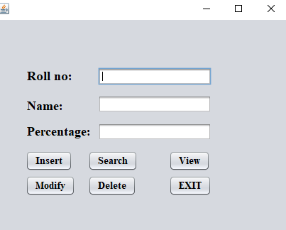

**INSERT:**

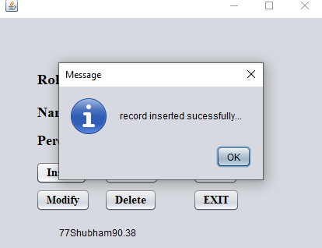

**AFTER INSERT:**

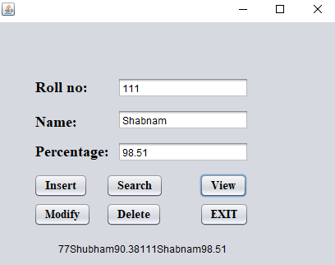

**SEARCH:**

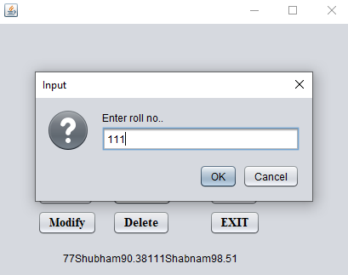

**DELETE:**

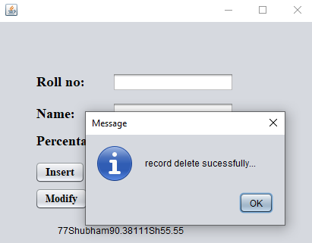

**AFTER DELETE:**

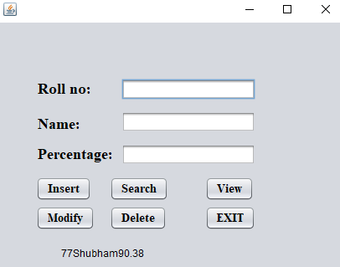

**MODIFY:**

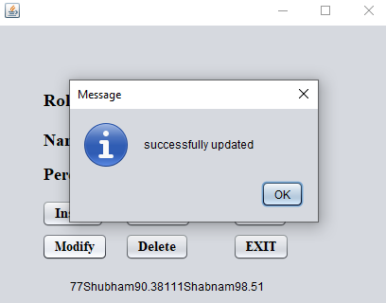

**AFTER MODIFY:**

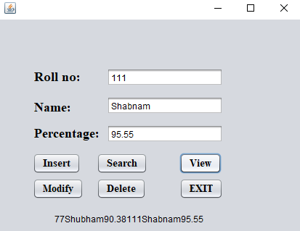

**Slip 16:**

Create a table book (id, name , genre).Design a screen in swing that accepts book id, name and genre from textfield. There are two buttons ‘Display’ that shows the book details in jtable and Search button that highlights the row in jtable after accepting the bookid from a dialog box.

package javaapplication4;

import java.sql.Connection;

import java.sql.DriverManager;

import java.sql.Statement;

import javax.swing.*;

import java.sql.*;

import javax.swing.table.*;

import java.awt.Color;

/**

 *

 * @author BHAVESH

 */

public class slip16 extends javax.swing.JFrame {

    /**

     * Creates new form slip16

     */

    public slip16() {

        initComponents();

    }

    /**

     * This method is called from within the constructor to initialize the form.

     * WARNING: Do NOT modify this code. The content of this method is always

     * regenerated by the Form Editor.

     */

    @SuppressWarnings("unchecked")

    // <editor-fold defaultstate="collapsed" desc="Generated Code">

    private void initComponents() {

        jLabel1 = new javax.swing.JLabel();

        jLabel2 = new javax.swing.JLabel();

        jLabel3 = new javax.swing.JLabel();

        jTextFieldGenre = new javax.swing.JTextField();

        jTextFieldName = new javax.swing.JTextField();

        jTextFieldId = new javax.swing.JTextField();

        jButtonSearch = new javax.swing.JButton();

        jButtonDisplay = new javax.swing.JButton();

        jButtonAdd = new javax.swing.JButton();

        jScrollPane1 = new javax.swing.JScrollPane();

        jTable1 = new javax.swing.JTable();

        jLabel4 = new javax.swing.JLabel();

        setDefaultCloseOperation(javax.swing.WindowConstants.EXIT_ON_CLOSE);

        setPreferredSize(new java.awt.Dimension(1450, 750));

        getContentPane().setLayout(null);

        jLabel1.setFont(new java.awt.Font("Verdana", 1, 18)); // NOI18N

        jLabel1.setText("Genre             :");

        getContentPane().add(jLabel1);

        jLabel1.setBounds(30, 250, 150, 24);

        jLabel2.setFont(new java.awt.Font("Verdana", 1, 36)); // NOI18N

        jLabel2.setText("BOOK");

        getContentPane().add(jLabel2);

        jLabel2.setBounds(400, 20, 140, 50);

        jLabel3.setFont(new java.awt.Font("Verdana", 1, 18)); // NOI18N

        jLabel3.setText("Book Name    :");

        getContentPane().add(jLabel3);

        jLabel3.setBounds(30, 180, 150, 24);

        jTextFieldGenre.setFont(new java.awt.Font("Verdana", 1, 14)); // NOI18N

        getContentPane().add(jTextFieldGenre);

        jTextFieldGenre.setBounds(220, 250, 160, 30);

        jTextFieldName.setFont(new java.awt.Font("Verdana", 1, 14)); // NOI18N

        getContentPane().add(jTextFieldName);

        jTextFieldName.setBounds(220, 180, 160, 30);

        jTextFieldId.setFont(new java.awt.Font("Verdana", 1, 14)); // NOI18N

        getContentPane().add(jTextFieldId);

        jTextFieldId.setBounds(220, 120, 160, 30);

        jButtonSearch.setFont(new java.awt.Font("Verdana", 1, 24)); // NOI18N

        jButtonSearch.setText("SEARCH");

        jButtonSearch.addActionListener(new java.awt.event.ActionListener() {

            public void actionPerformed(java.awt.event.ActionEvent evt) {

                jButtonSearchActionPerformed(evt);

            }

        });

        getContentPane().add(jButtonSearch);

        jButtonSearch.setBounds(730, 320, 180, 70);

        jButtonDisplay.setFont(new java.awt.Font("Verdana", 1, 24)); // NOI18N

        jButtonDisplay.setText("DISPLAY");

        jButtonDisplay.addActionListener(new java.awt.event.ActionListener() {

            public void actionPerformed(java.awt.event.ActionEvent evt) {

                jButtonDisplayActionPerformed(evt);

            }

        });

        getContentPane().add(jButtonDisplay);

        jButtonDisplay.setBounds(470, 320, 180, 70);

        jButtonAdd.setFont(new java.awt.Font("Verdana", 1, 24)); // NOI18N

        jButtonAdd.setText("ADD BOOK");

        jButtonAdd.addActionListener(new java.awt.event.ActionListener() {

            public void actionPerformed(java.awt.event.ActionEvent evt) {

                jButtonAddActionPerformed(evt);

            }

        });

        getContentPane().add(jButtonAdd);

        jButtonAdd.setBounds(110, 320, 180, 70);

        jTable1.setModel(new javax.swing.table.DefaultTableModel(

            new Object [][] {

            },

            new String [] {

                "Book ID", "Book Name", "Genre"

            }

        ));

        jScrollPane1.setViewportView(jTable1);

        getContentPane().add(jScrollPane1);

        jScrollPane1.setBounds(450, 120, 520, 190);

        jLabel4.setFont(new java.awt.Font("Verdana", 1, 18)); // NOI18N

        jLabel4.setText("Book ID         :");

        getContentPane().add(jLabel4);

        jLabel4.setBounds(30, 120, 150, 24);

        pack();

    }// </editor-fold>

    private void jButtonAddActionPerformed(java.awt.event.ActionEvent evt) {

      try

         {

                  Connection con=DriverManager.getConnection("jdbc:mysql:///slip16","root","");

                  int x=Integer.parseInt(jTextFieldId.getText());

                  String y=jTextFieldName.getText();

                  String z=jTextFieldGenre.getText();

                  PreparedStatement p=con.prepareStatement("Insert into Book values(?, ?, ?)");

                  p.setInt(1,x);

                  p.setString(2, y);

                  p.setString(3, z);

                  p.executeUpdate();

                  JOptionPane.showMessageDialog(this,"Record Inserted Successfully......");

          }

         catch(Exception e)

         {

            System.out.println(e);

         }

    }

    private void jButtonDisplayActionPerformed(java.awt.event.ActionEvent evt) {

       try

        {

            //Class.forName("com.mysql.jdbc.Driver");

             Connection con = DriverManager.getConnection("jdbc:mysql:///slip16","root","");

             Statement s =con.createStatement();

             String sql="select * from book";

             ResultSet rs=s.executeQuery(sql);

             while(rs.next())

             {

                String ID=String.valueOf(rs.getInt("Book_Id"));

                String Name=rs.getString("Book_Name");

                String Genre=rs.getString("Genre");

                  String tbData[]={ID,Name,Genre};

                  DefaultTableModel tblModel=(DefaultTableModel)jTable1.getModel();

                 tblModel.addRow(tbData);

             }

        }

        catch(Exception e)

        {

               JOptionPane.showMessageDialog(null, e.getMessage());

        }

    }

    private void jButtonSearchActionPerformed(java.awt.event.ActionEvent evt) {

        Function f=new Function();

        ResultSet rs=null;

           rs=f.find(JOptionPane.showInputDialog(this, "Enter Book ID : "));

        //rs=f.find(jTextFieldSearch.getText());

        try

        {

            if(rs.next())

            {

                //jTextFieldD.setText(rs.getString("Source"));

                JOptionPane.showMessageDialog(null, "Data Found");

            }

            else

            {

                JOptionPane.showMessageDialog(null, "Data Not Found");

            }

        }

        catch(Exception ex)

        {

            JOptionPane.showMessageDialog(null, ex.getMessage());

        }

         /*  try

        {

              Connection con = DriverManager.getConnection("jdbc:mysql:///slip16","root","");

             Statement s =con.createStatement();

              String a=JOptionPane.showInputDialog(this, "Enter Book ID : ");

             String sql="select * from book";

             ResultSet rs=s.executeQuery(sql);

             while(rs.next())

             {

                String ID=String.valueOf(rs.getInt("Book_Id"));

                String Name=rs.getString("Book_Name");

                String Genre=rs.getString("Genre");

                  String tbData[]={ID,Name,Genre};

                  DefaultTableModel tblModel=(DefaultTableModel)jTable1.getModel();

                 tblModel.addRow(tbData);

             }

            jTable1.addRowSelectionInterval(3,3);

            jTable1.setForeground(Color.BLUE);

        }

        catch(Exception e)

        {

               //JOptionPane.showMessageDialog(null, e.getMessage());

        }*/

    }

public class Function

{

       Connection con=null;

       ResultSet rs=null;

       PreparedStatement ps=null;

        public ResultSet find(String s)

        {

                try

                {

                        con = DriverManager.getConnection("jdbc:mysql:///slip16","root","");

                         ps=con.prepareStatement("select * from book where Book_Id = ?");

                         ps.setString(1,s);

                        rs=ps.executeQuery();

                }

                catch(Exception ex)

                {

                        JOptionPane.showMessageDialog(null, ex.getMessage());

                }

                return rs;

        }

}

    /**

     * @param args the command line arguments

     */

    public static void main(String args[]) {

        /* Set the Nimbus look and feel */

        //<editor-fold defaultstate="collapsed" desc=" Look and feel setting code (optional) ">

        /* If Nimbus (introduced in Java SE 6) is not available, stay with the default look and feel.

         * For details see http://download.oracle.com/javase/tutorial/uiswing/lookandfeel/plaf.html

         */

        try {

            for (javax.swing.UIManager.LookAndFeelInfo info : javax.swing.UIManager.getInstalledLookAndFeels()) {

                if ("Nimbus".equals(info.getName())) {

                    javax.swing.UIManager.setLookAndFeel(info.getClassName());

                    break;

                }

            }

        } catch (ClassNotFoundException ex) {

            java.util.logging.Logger.getLogger(slip16.class.getName()).log(java.util.logging.Level.SEVERE, null, ex);

        } catch (InstantiationException ex) {

            java.util.logging.Logger.getLogger(slip16.class.getName()).log(java.util.logging.Level.SEVERE, null, ex);

        } catch (IllegalAccessException ex) {

            java.util.logging.Logger.getLogger(slip16.class.getName()).log(java.util.logging.Level.SEVERE, null, ex);

        } catch (javax.swing.UnsupportedLookAndFeelException ex) {

            java.util.logging.Logger.getLogger(slip16.class.getName()).log(java.util.logging.Level.SEVERE, null, ex);

        }

        //</editor-fold>

        /* Create and display the form */

        java.awt.EventQueue.invokeLater(new Runnable() {

            public void run() {

                new slip16().setVisible(true);

            }

        });

    }

    // Variables declaration - do not modify

    private javax.swing.JButton jButtonAdd;

    private javax.swing.JButton jButtonDisplay;

    private javax.swing.JButton jButtonSearch;

    private javax.swing.JLabel jLabel1;

    private javax.swing.JLabel jLabel2;

    private javax.swing.JLabel jLabel3;

    private javax.swing.JLabel jLabel4;

    private javax.swing.JScrollPane jScrollPane1;

    private javax.swing.JTable jTable1;

    private javax.swing.JTextField jTextFieldGenre;

    private javax.swing.JTextField jTextFieldId;

    private javax.swing.JTextField jTextFieldName;

    // End of variables declaration

}

Output:

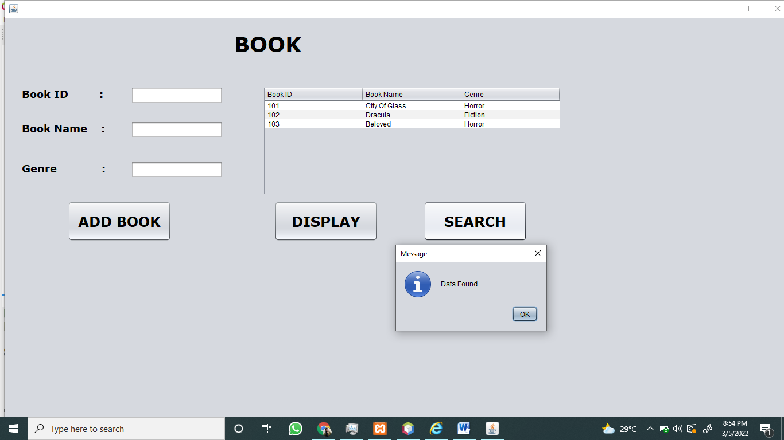

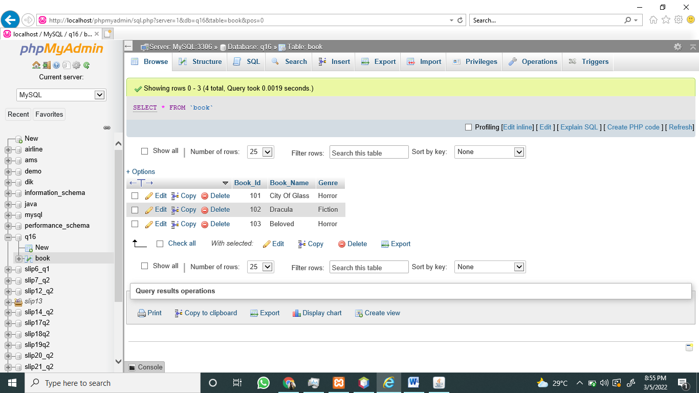

**Slip 17:**

Create an Applet which displays a message in the center of the screen. The message indicates the events taking place on the applet window. Handle events like mouse click, mouse moves, mouse dragged, mouse pressed. The message should update each time an event occurs. The message should give details of the event such as which mouse button was pressed (Hint: Use repaint(), MouseListener, MouseMotionListener)

import java.awt.*;

import java.applet.*;

import java.awt.event.*;

/*

<applet code="Q17.class" width=400 height=200>

</applet>

*/

public class Q17 extends Applet implements MouseMotionListener,MouseListener,KeyListener

{

 String msg="";

 public void init()

 {

  setBackground(Color.cyan);

  addMouseMotionListener(this);

  addMouseListener(this);

  addKeyListener(this);

 }

 public void paint(Graphics g)

 {

  g.drawString(msg,10,10);

 }

 public void mouseDragged(MouseEvent e)

 {

  msg="Mouse Dragged.";

  repaint();

 }

 public void mouseMoved(MouseEvent e)

 {

  msg="Mouse Moved.";

  repaint();

 }

 public void mouseClicked(MouseEvent e)

 {

  msg="Mouse Button "+e.getButton()+"clicked.";

  repaint();

 }

 public void mousePressed(MouseEvent e)

 {

  msg="Mouse Button "+e.getButton()+"pressed.";

  repaint();

 }

 public void mouseReleased(MouseEvent e)

 {

  msg="Mouse Button Released.";

  repaint();

 }

 public void mouseEntered(MouseEvent e)

 {

 }

 public void mouseExited(MouseEvent e)

 {

 }

 public void keyTyped(KeyEvent e)

 {

  msg="Key Typed "+ e.getKeyChar();

  repaint();

 }

 public void keyPressed(KeyEvent e)

 {

  msg="Key pressed "+ e.getKeyChar();

  repaint();

 }

 public void keyReleased(KeyEvent e)

 {

 }

}

Output:







**Q18.** Design a servlet which counts how many times a user has visited a web page. If the user is visiting the page for the first time then display a message “Welcome”. If the user is revisiting the page, then display the number of times page is visited (Use Cookies)

**VisitServlet.java**

import java.io.*;

import jakarta.servlet.*;

import jakarta.servlet.http.*;

//javax will not work in tomcat 10 replace with jakarta also add classpath while compiling

//javac -classpath <classpath> <programname>.java

//javac -classpath servlet-api.jar VisitServlet.java

public class VisitServlet extends HttpServlet

{

  static int i=1;

  public void doGet(HttpServletRequest request,HttpServletResponse response)throws IOException,ServletException

  {

      response.setContentType("text/html");

      PrintWriter out=response.getWriter();

      String k=String.valueOf(i);

      Cookie c=new Cookie("visit",k);

      response.addCookie(c);

      int j=Integer.parseInt(c.getValue());

      if(j==1)

      {

          out.println("Welcome to web page ");

      }

      else        {

          out.println("You are visited at "+i+" times");

      }

      i++;

  }

}

**Web.xml**

<?xml version="1.0" encoding="ISO-8859-1"?>

<web-app>

<servlet>

        <servlet-name>VisitServlet</servlet-name>

        <servlet-class>VisitServlet</servlet-class>

    </servlet>

<servlet-mapping>

        <servlet-name>VisitServlet</servlet-name>

        <url-pattern>/servlet/VisitServlet</url-pattern>

    </servlet-mapping>

</web-app>

Output:

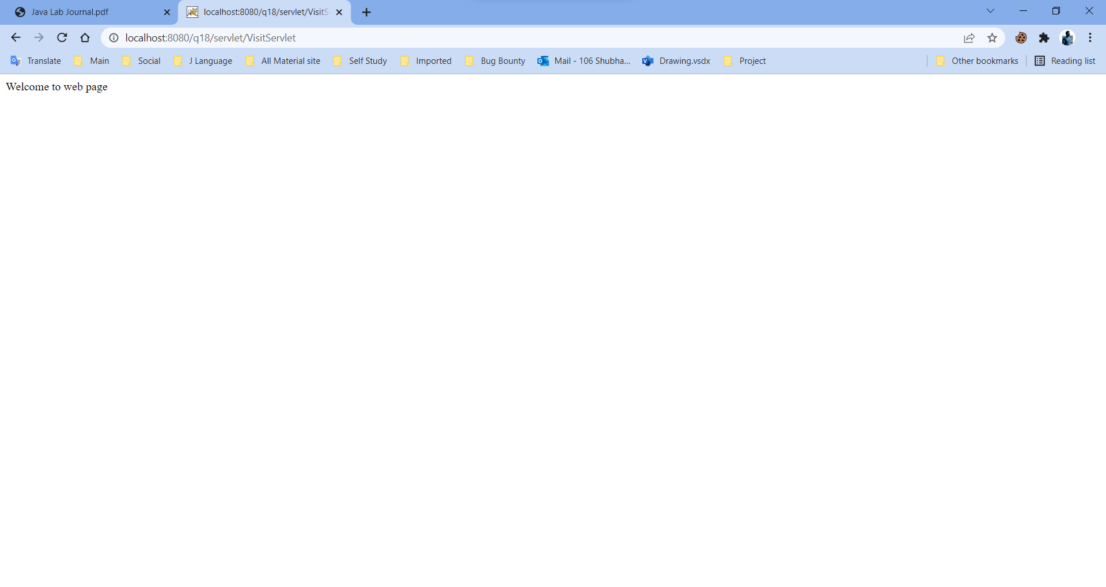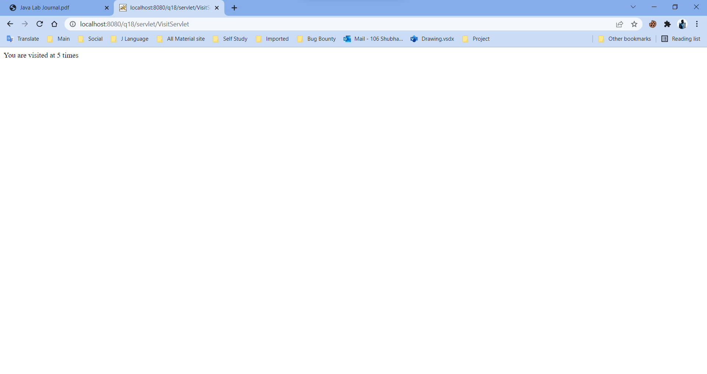

**Q19. Create a JSP page which accepts user name in a text box and greet the user according to the time on server side. Example: Input : User Name ABC Output : Good Morning ABC/Good Afternoon ABC/ Good Evening ABC**

**Name.jsp**

<%@page contentType="text/html" pageEncoding="UTF-8"%>

<!DOCTYPE html>

<html>

    <body>

        <form action="greet.jsp" method="post">

            Enter Your Name : <input type="text" name="name"><br>

            <input type="submit" value="Submit">

        </form>

    </body>

</html>

**Greet.jsp**

<%@page import="java.util.Calendar"%>

<%@page contentType="text/html" pageEncoding="UTF-8"%>

<%

    String name = request.getParameter("name");

   Calendar rightnow = Calendar.getInstance();

   int time = rightnow.get(Calendar.HOUR_OF_DAY);

    if(time > 0 && time <= 12)

    {

        out.println("Good Morning"+" "+name);

    }

      else if(time < 12 && time >=16)

      {

          out.println("Good Afternoon "+" "+name);

      }

      else

      {

          out.println("Good Night"+" "+name);

      }

%>

**Output:**

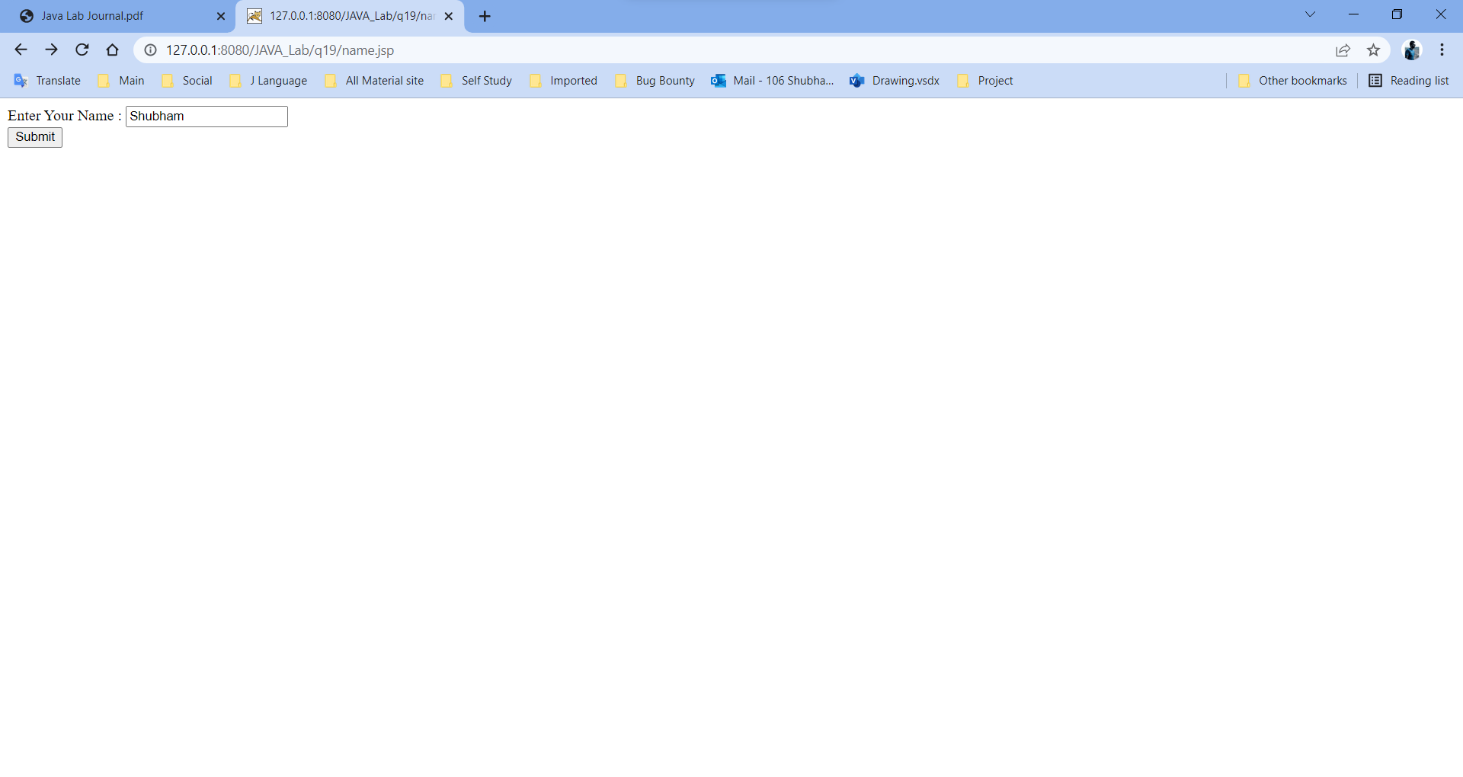

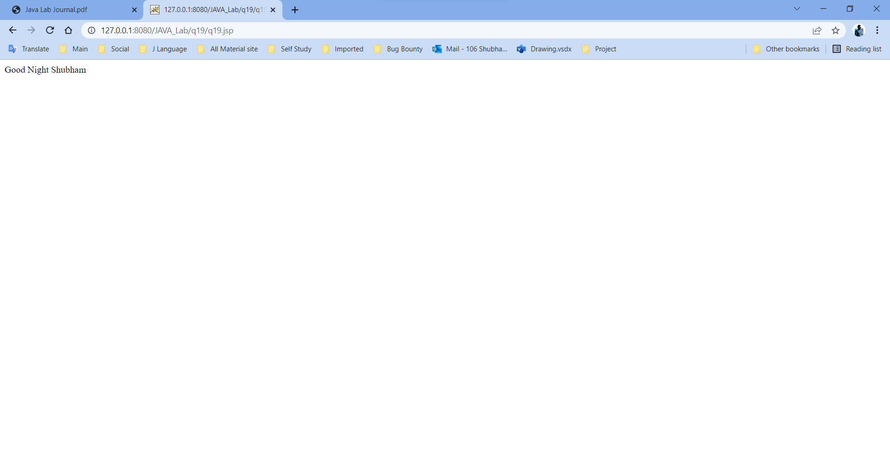

**Q20. Create a JSP page for an online multiple choice test. The questions are randomly selected from a database and displayed on the screen. The choices are displayed using radio buttons. When the user clicks on next, the next question is displayed. When the user clicks on submit, display the total score on the screen.**

**exam.jsp**

<%@page import="java.sql.*,java.util.*"%>

<%

    Class.forName("com.mysql.jdbc.Driver");

    Connection con=DriverManager.getConnection("jdbc:mysql://localhost:3306/practice","root","Shubham");

    Set s = new TreeSet();

    while(true){

        int n = (int)(Math.random()*11+1);

        s.add(n);

        if(s.size()==5) break;

    }

    PreparedStatement ps = con.prepareStatement("select * from questions where qid=?");

%>

<form method='post' action='accept_ans.jsp'>

<table width='70%' align='center'>

<%

    int i=0;

    Vector v = new Vector(s);

    session.setAttribute("qids",v);

    int qid = Integer.parseInt(v.get(i).toString());

    ps.setInt(1,qid);

    ResultSet rs = ps.executeQuery();

    rs.next();

%>

<tr>

    <td><b>Question:<%=i+1%></b></td>

</tr>

<tr>

    <td><pre><b><%=rs.getString(2)%></pre></b></td>

</tr>

<tr>

    <td>

    <b>

    <input type='radio' name='op' value=1><%=rs.getString(3)%><br>

    <input type='radio' name='op' value=2><%=rs.getString(4)%><br>

    <input type='radio' name='op' value=3><%=rs.getString(5)%><br>

    <input type='radio' name='op' value=4><%=rs.getString(6)%><br><br>

    </b>

    </td>

</tr>

<tr>

    <td align='center'>

    <input type='submit' value='Next' name='ok'>

    <input type='submit' value='Submit' name='ok'>

    </td>

</tr>

</table>

<input type='hidden' name='qno' value=<%=qid%>>

<input type='hidden' name='qid' value=<%=i+1%>>

</form>

</body>

**accept_ans.jsp**

<%@page import="java.sql.*,java.util.*"%>

<%

    Class.forName("com.mysql.jdbc.Driver");

    Connection con=DriverManager.getConnection("jdbc:mysql://localhost:3306/practice","root","Shubham");

    Vector answers = (Vector)session.getAttribute("answers");

    if(answers==null)

        answers = new Vector();

    int qno = Integer.parseInt(request.getParameter("qno"));

    int ans = Integer.parseInt(request.getParameter("op"));

    int i = Integer.parseInt(request.getParameter("qid"));

    answers.add(qno+" "+ans);

    session.setAttribute("answers",answers);

    String ok = request.getParameter("ok");

    if(ok.equals("Submit") || i==5){

        response.sendRedirect("result.jsp");

        return;

    }

    PreparedStatement ps = con.prepareStatement("select * from questions where qid=?");

%>

<form method='post' action='accept_ans.jsp'>

<table width='70%' align='center'>

<%

    Vector v = (Vector)session.getAttribute("qids");

    int qid = Integer.parseInt(v.get(i).toString());

    ps.setInt(1,qid);

    ResultSet rs = ps.executeQuery();

    rs.next();

%>

<tr>

<td><b>Question:<%=i+1%></b></td>

</tr>

<tr>

<td><pre><b><%=rs.getString(2)%></pre></b></td>

</tr>

<tr>

<td>

<b>

<input type='radio' name='op' value=1><%=rs.getString(3)%><br>

<input type='radio' name='op' value=2><%=rs.getString(4)%><br>

<input type='radio' name='op' value=3><%=rs.getString(5)%><br>

<input type='radio' name='op' value=4><%=rs.getString(6)%><br><br>

</b>

</td>

</tr>

<tr>

    <td align='center'>

    <input type='submit' value='Next' name='ok'>

    <input type='submit' value='Submit' name='ok'>

    </td>

</tr>

</table>

<input type='hidden' name='qno' value=<%=qid%>>

<input type='hidden' name='qid' value=<%=i+1%>>

</form>

</body>

**result.jsp**

<%@page import="java.sql.*,java.util.*,java.text.*"%>

<%

    Class.forName("com.mysql.jdbc.Driver");

    Connection con=DriverManager.getConnection("jdbc:mysql://localhost:3306/practice","root","Shubham");

    Vector v = (Vector)session.getAttribute("answers");

    if(v==null){

%>

<h1>No questions answered</h1>

<%

        return;

    }

    PreparedStatement ps = con.prepareStatement("select ans from questions where qid=?");

    int tot=0;

    for(int i=0;i<v.size();i++){

        String str = v.get(i).toString();

        int j = str.indexOf(' ');

        int qno = Integer.parseInt(str.substring(0,j));

        int gans = Integer.parseInt(str.substring(j+1));

        ps.setInt(1,qno);

        ResultSet rs = ps.executeQuery();

        rs.next();

        int cans = rs.getInt(1);

        if(gans==cans) tot++;

    }

    session.removeAttribute("qids");

    session.removeAttribute("answers");

    session.removeAttribute("qid");

%>

<h3>Score:<%=tot%></h1>

<center><a href='exam.jsp'>Restart</a></center>

</body>

**database.sql**

create table questions(qid serial primary key, question text, option1 text, option2 text, option3 text, option4 text, ans int);

insert into questions(question,option1,option2,option3,option4,ans) values('Who is prime minister of India?','Rahul Gandhi','Narendra Modi','Sonia Gandhi','Manmohan Singh',2),('Who is finance minister of India','Rahul Gandhi','P Chidambaram','Manmohan Singh','Arun Jately',4),('What is square root of 16?','2','4','1','256',4),('Who is chief minister of Maharashtra','Uddhav Tharakey','Devendra Fadanavis','Raj Thakarey','Sharad Pawar',2),('What is full for of LIFO?','Last In First Out','Late In First Out','Long In First Out','Large In First Out',1),('Which is capital of India','Delhi','Maharashtra','Kolkata','Goa',1), ('What is currency of India','Dollar','Rupee','Pound','Yen',2),('Who Invented C?','Kim Thompson','Bill Joy','Dennis Ritche','Balaguru Swamy',3),('Where was Java invented?','Microsoft','Oracle','Sun Microsystem','Intel',3),('What is cube root of 8?','2','3','4','5',1),('What is full form of FIFO','Fast In Fast Out','First in First Out','Fast In First Out','First In Fast Out',2);

**Output:**

