API: Spring Boot, Jpa, H2

Store longest palindrom value <http://localhost:8080/storeLongestPalindromValue>

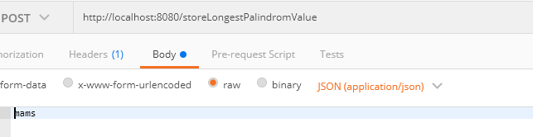

Check the values in h2 db

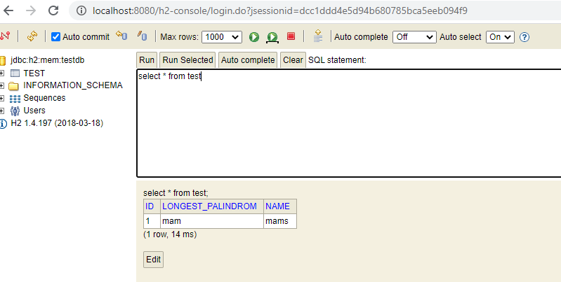

Retreive the longest palindrom value