Q. How is NGD different from SGD ?
Ans. SGD in a curved manifold with non-orthonormal co-ordinate system is essentially NGD. For example, in case of Neural Nets, if we use the weights W of the network as the basis to represent the function space S, then S is a curved manifold with non-othonormal basis vectors W. In Eucledean space with orthonormal basis vectors, the direction of steepest descent is given by the gradient of loss function [-▼L ( w )]. In a curved manifold space S with non-orthonormal basis vectors, the direction of steepest descent is given by [inverse(G) • (-▼L ( w ))], where G is the Riemannian metric tensor, which turns out to be a Fischer efficient estimator (gives asymptotically best result).

Q. What is Fisher Information?
Ans. The Fisher information is a way of measuring the amount of information that an observable random variable X carries about an unknown parameter θ upon which the probability of X depends. Let f(X; θ) be the probability density function (or probability mass function) for X conditional on the value of θ. This is also the likelihood functionfor θ. It describes the probability that we observe a given sample X, given a known value of θ. If f is sharply peaked with respect to changes in θ, it is easy to indicate the “correct” value of θ from the data, or equivalently, that the data X provides a lot of information about the parameter θ. If the likelihood f is flat and spread-out, then it would take many, many samples like X to estimate the actual “true” value of θ that would be obtained using the entire population being sampled. This suggests studying some kind of variance with respect to θ.
Formally, the partial derivative with respect to θ of the natural logarithm of the likelihood function is called the “score”. Under certain regularity conditions, it can be shown that the expected value (the first moment) of the score is 0:[4]
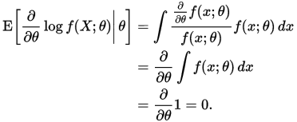

The variance (which equals the second raw moment) is defined to be the Fisher information:
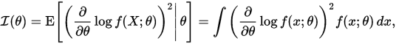

If log f(x; θ) is twice differentiable with respect to θ, and under certain regularity conditions,[4] then the Fisher information may also be written as[5]
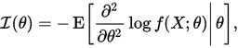

(Try to derive this second form from the first)

Q. What is the relation between Riemann metrix tensor and Fisher Information matrix?
Ans. When there are N parameters, so that θ is a N × 1 vector then the Fisher information takes the form of an N × N matrix. This matrix is called the Fisher information matrix (FIM) and has typical elemen

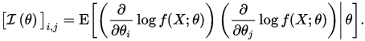

The FIM is a N × N positive semidefinite symmetric matrix. If it is positive definite, then it defines a Riemannian metric on the N-dimensional parameter space. The topic information geometry uses this to connect Fisher information to differential geometry, and in that context, this metric is known as the Fisher information metric.

Q. How is loss function modelled for Neural Networks?
Ans.

Q. What are the equations for NGD in case of Neural Networks? How to calculate Riemann metric tensor for this case?
Ans.

