Part a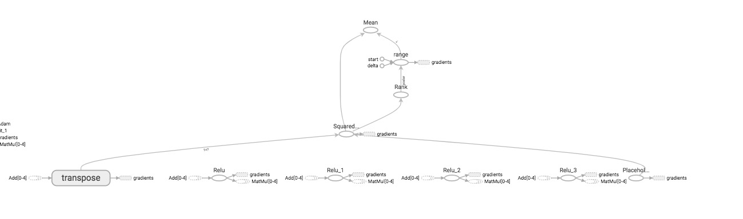

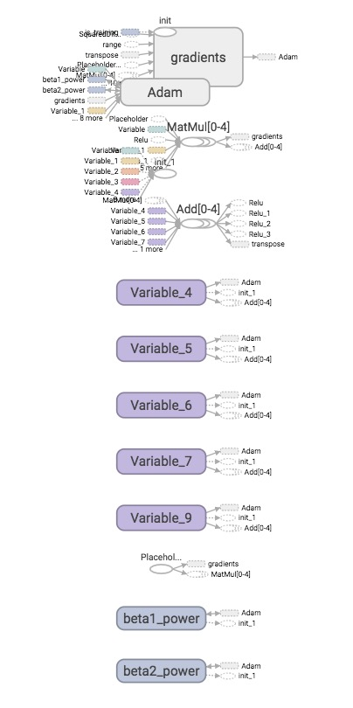

Part b- tanh & leaky relu

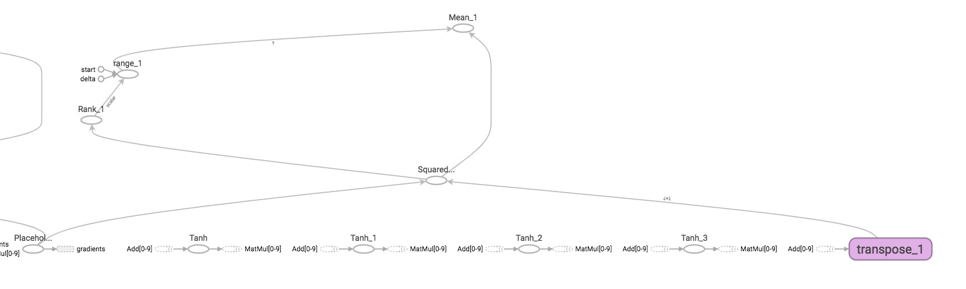

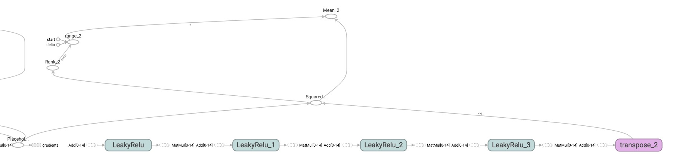

Part c cost function

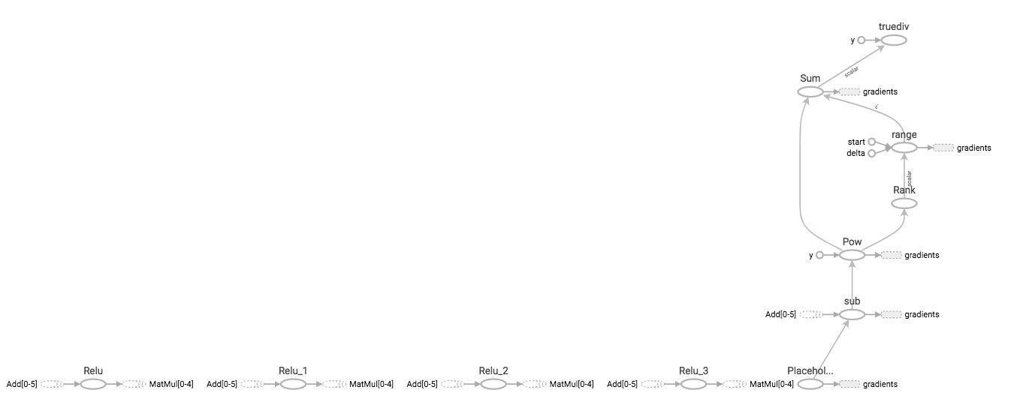

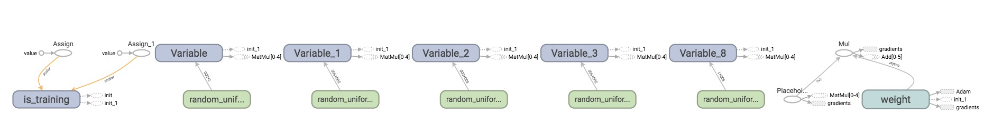

Part d change epochs

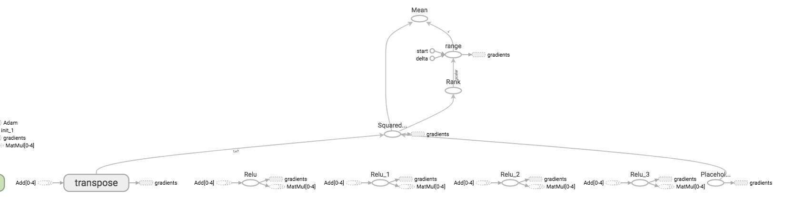

Part e- Gradient estimation

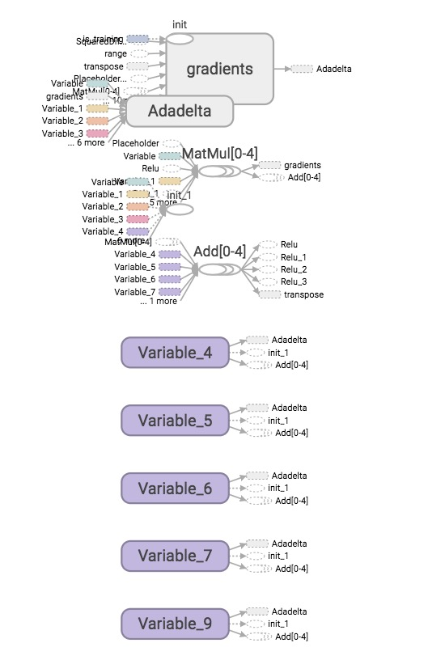

Part f-network architecture

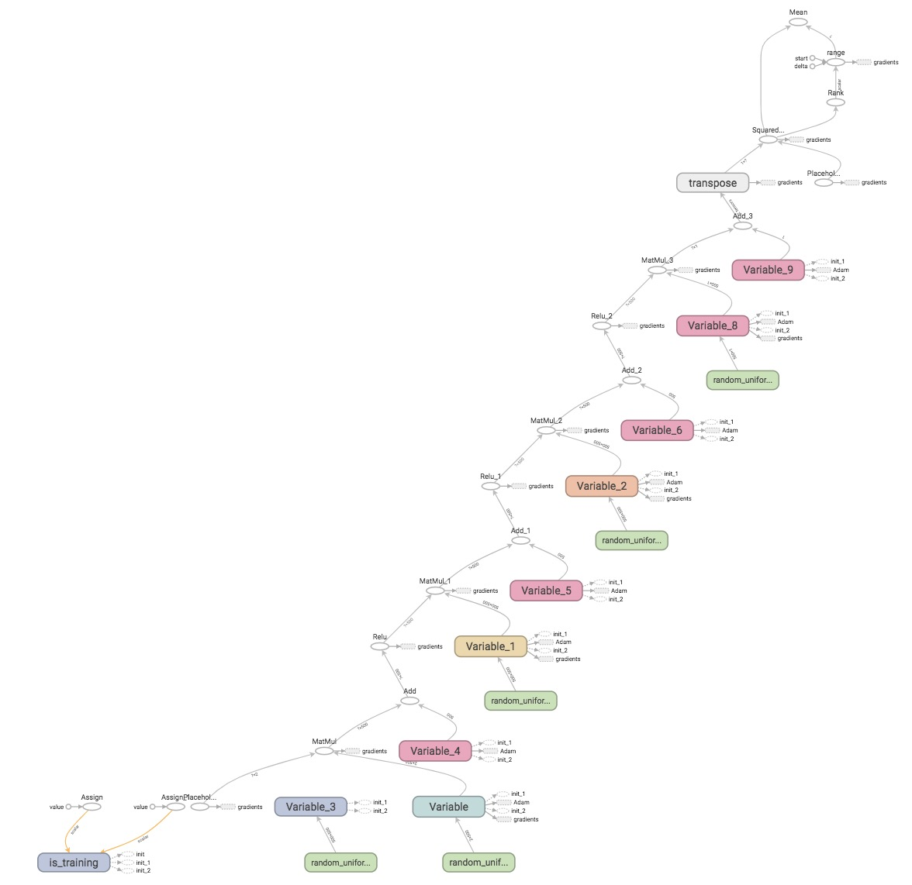

Part g-initialization

