**Vivaan Mittal**

**CSE-3C**

**G1**

**2K20CSUN01124**

**DATABASE MANAGEMENT SYSTEM**

**LAB-0**

**Q.1 Create and display 5 records for students using file operations in C.**

**Solution: -**

**Code: -**

#include<stdio.h>

#include<stdlib.h>

#include <string.h>

#define MAX_LINE_LENGTH 80

struct student{

int sno;

char name[50];

int marks;

}student;

void add(int n){

FILE *ptr;

int i;

ptr=fopen("data1.txt","a");

if(ptr==NULL){

printf("Fill Can Not be Opened");

exit(1);

}

for(i=0;i<n;i++){

printf("Enter the Roll No=");

scanf("%d",&student.sno);

printf("Enter the Name=");

scanf("%s",&student.name);

printf("Enter the Marks = ");

scanf("%d",&student.marks);

fprintf(ptr,"%d %s %d \n",student.sno,student.name,student.marks);

}

fclose(ptr);

}

void read(){

FILE *ptr;

int i;

ptr=fopen("data1.txt","r");

char line[MAX_LINE_LENGTH] = {0};

if(ptr==NULL){

printf("Fill Can Not be Opened");

exit(1);

}

while (fgets(line, MAX_LINE_LENGTH, ptr))

{

printf("%s",line);

}

fclose(ptr);

}

void main(){

add(5);

read();

}

**Output: -**

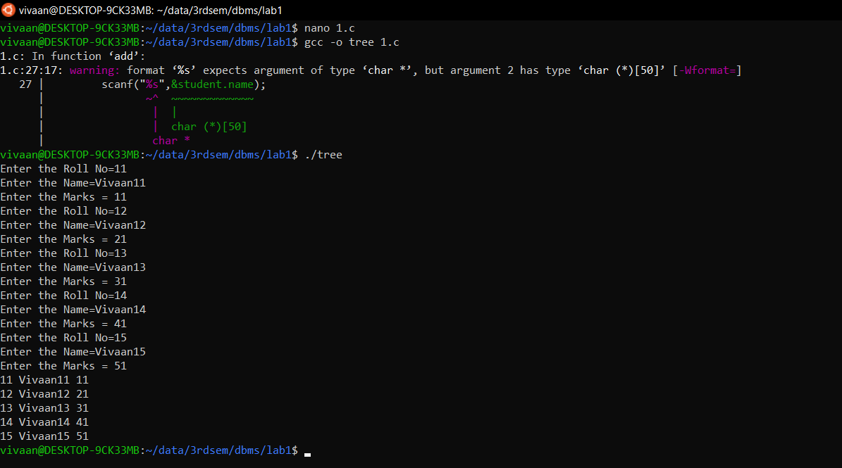

**Q.2 Using file operations create, display, modify insert and delete records for employee system.**

**Solution: -**

**Code: -**

#include<stdio.h>

#include<stdlib.h>

#include <string.h>

#define MAX_LINE_LENGTH 80

struct employee{

int sno;

char name[50];

int sal;

}employee;

void create(){

FILE *ptr;

int i,n;

printf("Enter the number of record you want to enter = ");

scanf("%d",&n);

ptr=fopen("data1.txt","w");

if(ptr==NULL){

printf("Fill Can Not be Opened");

exit(1);

}

for(i=0;i<n;i++){

printf("Enter the Roll No=");

scanf("%d",&employee.sno);

printf("Enter the Name=");

scanf("%s",&employee.name);

printf("Enter the Sal = ");

scanf("%d",&employee.sal);

fprintf(ptr,"%d %s %d \n",employee.sno,employee.name,employee.sal);

}

fclose(ptr);

}

void add(){

FILE *ptr;

int i,n;

printf("Enter the number of record you want to enter = ");

scanf("%d",&n);

ptr=fopen("data1.txt","a");

if(ptr==NULL){

printf("Fill Can Not be Opened");

exit(1);

}

for(i=0;i<n;i++){

printf("Enter the Roll No=");

scanf("%d",&employee.sno);

printf("Enter the Name=");

scanf("%s",&employee.name);

printf("Enter the Sal = ");

scanf("%d",&employee.sal);

fprintf(ptr,"%d %s %d \n",employee.sno,employee.name,employee.sal);

}

fclose(ptr);

}

void read(){

FILE *ptr;

int i;

ptr=fopen("data1.txt","r");

char line[MAX_LINE_LENGTH] = {0};

if(ptr==NULL){

printf("Fill Can Not be Opened");

exit(1);

}

while (fgets(line, MAX_LINE_LENGTH, ptr))

{

printf("%s",line);

//if (line[strlen(line) - 1] != '\n')

//printf("\n");

}

fclose(ptr);

}

void modify(){

FILE *ptr;

FILE *tptr;

int i,found=0;

ptr=fopen("data1.txt","r");

tptr=fopen("temp.txt","w");

char rno[10]={0};

char line[MAX_LINE_LENGTH] = {0};

char ch;

printf("Enter the Roll No to modify = ");

scanf("%s",&rno);

while(fgets(line, MAX_LINE_LENGTH, ptr)){

char fnum[10]="";

for(i=0;i<MAX_LINE_LENGTH;i++){

ch=line[i];

if(ch ==' '){

break;

}

strncat(fnum, &ch, 1);

}

if(strcmp(rno,fnum)==0){

found=1;

printf("Found\n");

printf("Enter the Roll No=");

scanf("%d",&employee.sno);

printf("Enter the Name=");

scanf("%s",&employee.name);

printf("Enter the Sal = ");

scanf("%d",&employee.sal);

fprintf(tptr,"%d %s %d \n",employee.sno,employee.name,employee.sal);

}

else{

fprintf(tptr,"%s",line);

}

}

if (!found){

printf("Not found \n");

}

fclose(ptr);

fclose(tptr);

if(found==1){

FILE *nptr;

FILE *ntptr;

nptr=fopen("data1.txt","w");

ntptr=fopen("temp.txt","r");

while (fgets(line, MAX_LINE_LENGTH, ntptr)){

fprintf(nptr,"%s",line);

}

fclose(nptr);

fclose(ntptr);

}

}

void delete(){

FILE *ptr;

FILE *tptr;

int i,found=0;

ptr=fopen("data1.txt","r");

tptr=fopen("temp.txt","w");

char rno[10]={0};

char line[MAX_LINE_LENGTH] = {0};

char ch;

printf("Enter the Roll No to Delete = ");

scanf("%s",&rno);

while(fgets(line, MAX_LINE_LENGTH, ptr)){

char fnum[10]="";

for(i=0;i<MAX_LINE_LENGTH;i++){

ch=line[i];

if(ch ==' '){

break;

}

strncat(fnum, &ch, 1);

}

if(strcmp(rno,fnum)==0){

found=1;

printf("Found\n");

}

else{

fprintf(tptr,"%s",line);

}

}

if (!found){

printf("Not found \n");

}

fclose(ptr);

fclose(tptr);

if(found==1){

FILE *nptr;

FILE *ntptr;

nptr=fopen("data1.txt","w");

ntptr=fopen("temp.txt","r");

while (fgets(line, MAX_LINE_LENGTH, ntptr)){

fprintf(nptr,"%s",line);

}

fclose(nptr);

fclose(ntptr);

}

}

void main(){

printf("Enter Your Function : -\n");

printf("0. Create\n");

printf("1. Add\n");

printf("2. Display\n");

printf("3. Modify\n");

printf("4. delete\n");

printf("5. Exit\n");

int num=10;

while(num!=5){

printf("\n\n\n\nEnter the Number :-");

scanf("%d",&num);

if(num==0){

create();

}

else if (num==1){

add();

}

else if(num==2){

read();

}

else if(num==3){

modify();

}

else if(num==4){

delete();

}

printf("\n\n\n\n");

}

}

**Output: -**

