CodeOven
Project Technical Documentation
Test Cases • ER Diagram • Data Flow Diagrams • Flowchart • Data Dictionary

Browser-based multi-language online IDE built with PHP, MySQL & CodeMirror

1. Introduction
CodeOven is a browser-based online IDE that lets users create multi-file, multi-language coding projects, edit them with a full-featured code editor (CodeMirror 5), preview HTML/CSS/JS projects live, compile and run Python/C++/Java code on the server, and download completed projects as a ZIP archive. This document records the test cases used to verify the system, along with the ER diagram, Data Flow Diagrams (Level 0 & 1), a process flowchart for the core "Run Code" feature, and a data dictionary for the database schema.

2. Test Cases
The table below lists the key functional test cases covering authentication, project/file management, code editing, code execution, downloads, and preferences.
TC ID | Test Case | Test Steps | Expected Result | Status
TC-01 | User Signup | Enter unique username, email, password on signup page; submit. | Account created in tbl_users; default row added to tbl_preferences; redirected to login. | Pass
TC-02 | Signup — Duplicate Username/Email | Sign up using a username or email that already exists. | Form is rejected with "Username or email already exists." | Pass
TC-03 | User Login — Valid Credentials | Enter correct username & password; submit. | Session created (session_regenerate_id), user redirected to dashboard. | Pass
TC-04 | User Login — Invalid Credentials | Enter wrong password. | Login rejected; no session created; error shown. | Pass
TC-05 | Forgot Password / OTP | Request password reset; enter emailed OTP within expiry window. | otp_code validated against tbl_users; user allowed to set a new password. | Pass
TC-06 | Forgot Password — Expired OTP | Enter OTP after otp_expiry has passed. | OTP rejected; user prompted to request a new one. | Pass
TC-07 | Guest Mode Access | Open the editor without logging in. | Editor loads fully; files are stored in browser localStorage; Run/Download prompt for login. | Pass
TC-08 | Create New Project | Click New Project, enter a unique name, choose "web" template. | Row inserted in tbl_projects; starter index.html/style.css/script.js created in tbl_files. | Pass
TC-09 | Create Project — Duplicate Name | Create a project with a name that already exists for this user. | Request rejected: "A project with that name already exists." | Pass
TC-10 | Rename / Delete Project | Rename a project, then delete a project. | tbl_projects updated; delete cascades to remove all rows in tbl_files for that project. | Pass
TC-11 | Create / Rename / Delete File | Add a new file (e.g. app.py); rename it; delete it. | tbl_files row inserted with correct auto-detected language; rename updates name+language; delete removes row. | Pass
TC-12 | Invalid File Name | Create a file named "../secret" or containing "/". | Rejected by is_safe_filename(): "Please enter a valid file name." | Pass
TC-13 | Save File (Auto-save) | Edit a file's content and wait for auto-save / click Save. | api/save_file.php updates file_content and updated_at; project's updated_at is touched. | Pass
TC-14 | Multi-tab Editing | Open 3 files in separate tabs, edit each, switch between tabs. | Each tab keeps an independent CodeMirror Doc / undo history; no cross-tab data loss. | Pass
TC-15 | Live Preview (HTML/CSS/JS) | Edit index.html/style.css/script.js in a web-template project. | Preview pane reflects changes correctly. | Pass
TC-16 | Run Python Code | Create a .py file with a print statement and stdin read; click Run. | python3 executes the file; stdout/stderr/exit code/duration shown in console panel. | Pass
TC-17 | Run C++ Code — Success | Create a valid .cpp file; click Run. | g++ compiles successfully; binary executes; output shown in console. | Pass
TC-18 | Run C++ Code — Compile Error | Introduce a syntax error in the .cpp file; click Run. | Compilation fails; compiler error text returned as stderr; no execution attempted. | Pass
TC-19 | Run Java Code | Create a .java file with "public class Main"; click Run. | javac compiles Main.java; entry class auto-detected; java Main executes and shows output. | Pass
TC-20 | Run — Infinite Loop / Timeout | Run a program with an infinite loop. | Process is killed after RUN_TIMEOUT_SECONDS; response flags timed_out = true. | Pass
TC-21 | Run Without Login | Attempt to run code while in guest mode. | api/run.php returns Unauthorized (guest:true); UI prompts to log in. | Pass
TC-22 | Download Project (.zip) | Click "Download Project" for a project with multiple files. | ZipArchive bundles all tbl_files rows for the project; browser downloads a .zip file. | Pass
TC-23 | Download — ZIP Extension Missing | Attempt download on a server without the PHP zip extension. | HTTP 500 with a clear message to enable the zip extension in php.ini. | Pass
TC-24 | Save & Load Preferences | Change theme to dark, layout to horizontal, font size to 18; reload page. | tbl_preferences upserted (ON DUPLICATE KEY UPDATE); preferences restored correctly on reload. | Pass
TC-25 | Logout | Click Logout while logged in. | Session variables cleared, session cookie invalidated, session destroyed; redirected to login. | Pass

3. Entity–Relationship (ER) Diagram
The schema consists of four tables: tbl_users, tbl_projects, tbl_files, and tbl_preferences. A user can own many projects and files (1:N), each project can hold many files (1:N), and each user has exactly one preferences row (1:1).
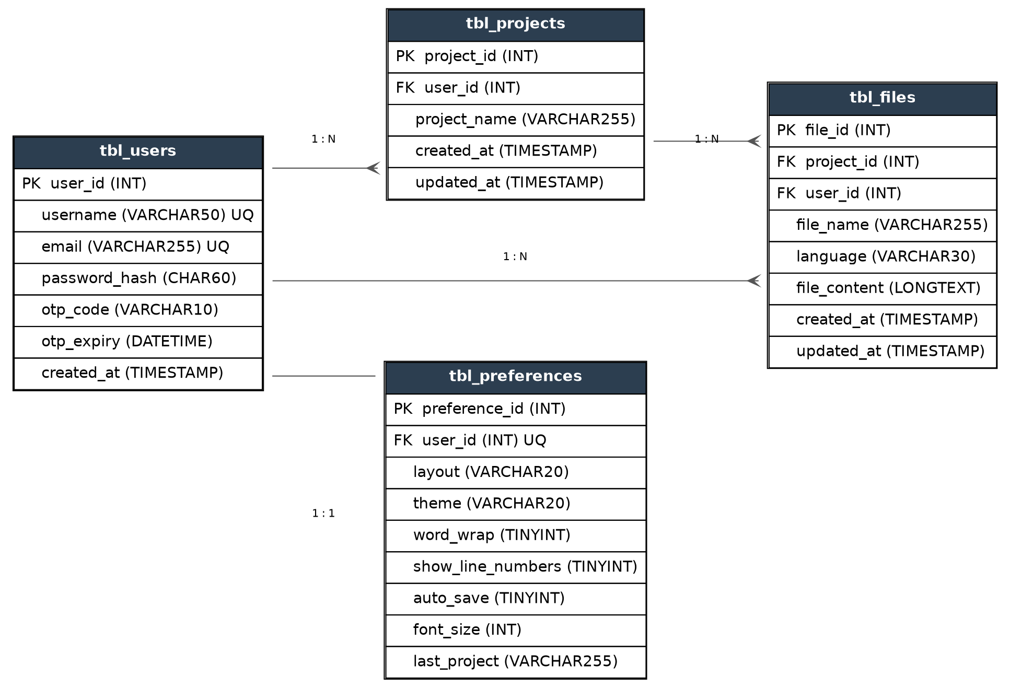

4. Data Flow Diagrams (DFD)

4.1 Level 0 — Context Diagram
The context diagram shows CodeOven as a single process exchanging data with the User (external entity), the MySQL database, and the host OS's compilers/interpreters.
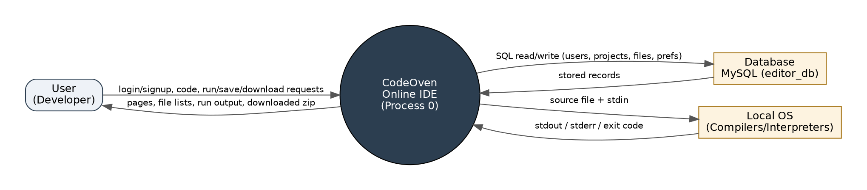

4.2 Level 1 — Detailed DFD
The Level 1 DFD decomposes the system into seven sub-processes: Authenticate, Manage Projects, Manage Files, Edit & Auto-save, Compile & Run Code, Download Project, and Manage Preferences, each reading from/writing to its relevant data store.
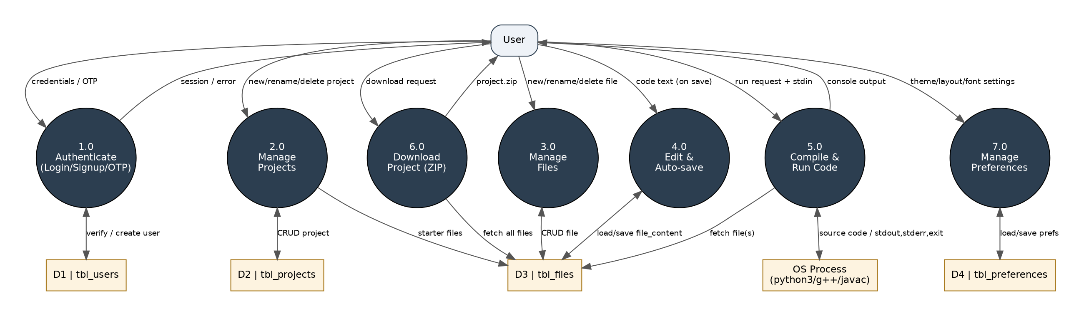

5. Flowchart — Compile & Run Code
This flowchart details the logic of the /api/run.php endpoint, the most complex feature of the system: determining the entry file, branching by language, compiling where required, executing with a timeout, and returning captured output to the browser.
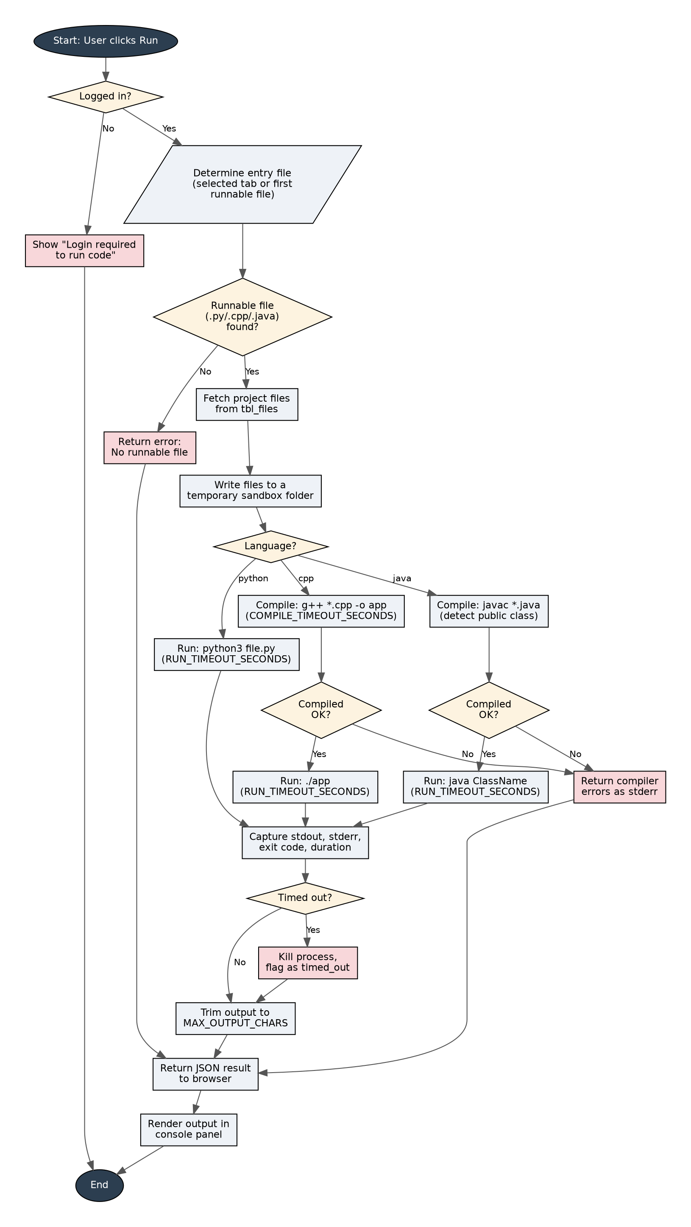

6. Data Dictionary

6.1 tbl_users
Field | Type | Key | Constraints / Notes
user_id | INT | PK | AUTO_INCREMENT
username | VARCHAR(50) | UQ | NOT NULL, unique across users
email | VARCHAR(255) | UQ | NOT NULL, unique across users
password_hash | CHAR(60) | — | bcrypt hash via PHP password_hash()
otp_code | VARCHAR(10) | — | Nullable; used for password-reset OTP flow
otp_expiry | DATETIME | — | Nullable; expiry timestamp for otp_code
created_at | TIMESTAMP | — | DEFAULT CURRENT_TIMESTAMP

6.2 tbl_projects
Field | Type | Key | Constraints / Notes
project_id | INT | PK | AUTO_INCREMENT
user_id | INT | FK | References tbl_users(user_id), ON DELETE CASCADE
project_name | VARCHAR(255) | — | NOT NULL; unique per user (uniq_user_project)
created_at | TIMESTAMP | — | DEFAULT CURRENT_TIMESTAMP
updated_at | TIMESTAMP | — | ON UPDATE CURRENT_TIMESTAMP

6.3 tbl_files
Field | Type | Key | Constraints / Notes
file_id | INT | PK | AUTO_INCREMENT
project_id | INT | FK | References tbl_projects(project_id), ON DELETE CASCADE
user_id | INT | FK | References tbl_users(user_id), ON DELETE CASCADE
file_name | VARCHAR(255) | — | NOT NULL; unique per project (uniq_project_file)
language | VARCHAR(30) | — | DEFAULT 'plaintext'; auto-detected from extension
file_content | LONGTEXT | — | NOT NULL; the file's source code
created_at | TIMESTAMP | — | DEFAULT CURRENT_TIMESTAMP
updated_at | TIMESTAMP | — | ON UPDATE CURRENT_TIMESTAMP

6.4 tbl_preferences
Field | Type | Key | Constraints / Notes
preference_id | INT | PK | AUTO_INCREMENT
user_id | INT | FK / UQ | References tbl_users(user_id); one row per user
layout | VARCHAR(20) | — | DEFAULT 'vertical'; 'horizontal' or 'vertical'
theme | VARCHAR(20) | — | DEFAULT 'light'; 'light' or 'dark'
word_wrap | TINYINT(1) | — | DEFAULT 1 (boolean)
show_line_numbers | TINYINT(1) | — | DEFAULT 1 (boolean)
auto_save | TINYINT(1) | — | DEFAULT 1 (boolean)
font_size | INT | — | DEFAULT 14; clamped 10–32
last_project | VARCHAR(255) | — | Nullable; name of last-opened project
updated_at | TIMESTAMP | — | ON UPDATE CURRENT_TIMESTAMP

