Industrial Internship Report on
”Quality Prediction in a Mining Process”
Prepared by
Vivaan Mahida

Executive Summary
This report provides details of the Industrial Internship provided by upskill Campus and The IoT Academy in collaboration with Industrial Partner UniConverge Technologies Pvt Ltd (UCT). This internship was focused on a project/problem statement provided by UCT. We had to finish the project including the report in 6 weeks’ time.
My project was Quality Prediction in a Mining Process. The primary goal was to use high-frequency industrial IIoT sensor data from an iron ore flotation plant to predict % Silica Concentrate (impurity) in real time. Through temporal feature engineering (lags and rolling statistics) and advanced tree-based ensemble modeling (LightGBM, XGBoost, Random Forest), we achieved high minute-level prediction accuracy (R² = 0.6071, RMSE = 0.7196), validated a 1-hour early-warning forecast horizon, and proved that process control variables alone enable high-accuracy predictions without relying on manual laboratory iron measurements.
This internship gave me a very good opportunity to get exposure to Industrial problems and design/implement solution for that. It was an overall great experience to have this internship.

TABLE OF CONTENTS
1 Preface 3
2 Introduction 4
2.1 About UniConverge Technologies Pvt Ltd 4
2.2 About upskill Campus 8
2.3 Objective 9
2.4 Reference 9
2.5 Glossary 10
3 Problem Statement 11
4 Existing and Proposed solution 12
5 Proposed Design/ Model 13
5.1 High Level Diagram (if applicable) 13
5.2 Low Level Diagram (if applicable) 13
5.3 Interfaces (if applicable) 13
6 Performance Test 14
6.1 Test Plan/ Test Cases 14
6.2 Test Procedure 14
6.3 Performance Outcome 14
7 My learnings 15
8 Future work scope 16

Preface
Week-by-Week Project Summary:
• Week 1 (Problem Onboarding & Domain Analysis): Studied froth flotation operations, physical process variables (airflow rates, column levels, pH, chemical reagents), and defined machine learning objectives.
• Week 2 (Data Cleaning & Exploration): Processed 737,453 raw industrial sensor rows, handled sampling rate disparities (20s sensors vs 1h lab measurements), and analyzed feature correlations.
• Week 3 (Temporal Feature Engineering): Built 1-minute and 1-hour uniform resampled datasets, engineered autoregressive lag features (1 to 60 minutes), rolling statistics (mean, std), and cyclical time encodings.
• Week 4 (Model Development & Experiments): Trained XGBoost, LightGBM, and Random Forest regressors across three experiments: minute-level prediction, multi-step horizon analysis, and iron feature ablation.
• Week 5 (Evaluation & Validation): Evaluated models using RMSE, MAE, and R² metrics, established 1-hour forecast reliability limits, and enforced chronological train/test splits.
• Week 6 (Dashboard & Reporting): Built a standalone interactive Plotly HTML dashboard, finalized technical documentation, and published the open-source codebase to GitHub.
Relevance of Internship in Career Development:
Industrial internships are essential for bridging academic theory and enterprise application. Working with real-world sensor data under production constraints provides crucial exposure to software design patterns, time-series validation protocols, and industrial problem solving.
Project Overview:
The project focuses on predicting product quality (% Silica Concentrate) in an iron ore flotation plant. By replacing periodic 1-hour lab delays with minute-level machine learning predictions, plant engineers receive an early warning to adjust process parameters, saving valuable ore and reducing waste.
Opportunity Provided by USC & UCT:
I extend my sincere appreciation to upskill Campus, The IoT Academy, and UniConverge Technologies Pvt Ltd for facilitating this hands-on industrial internship.
Program Structure:
The program was structured into weekly milestones covering domain orientation, exploratory data analysis, feature engineering, model optimization, dashboard creation, and final reporting.
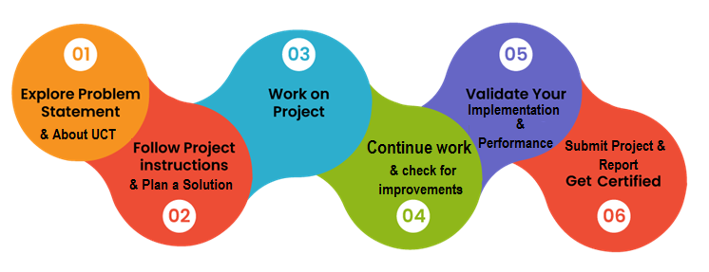
Learnings & Overall Experience:
Gained mastery in time-series feature engineering, gradient boosting (LightGBM/XGBoost), Plotly visualization, and industrial IIoT process control.
Acknowledgments:
Special thanks to the technical mentors and coordinators at UniConverge Technologies Pvt Ltd, upskill Campus, and The IoT Academy for their continuous guidance and feedback.
Message to Juniors & Peers:
Always take time to understand the physical domain behind industrial data, enforce strict validation to avoid temporal data leakage, and present results in business-ready visual formats.

Introduction

About UniConverge Technologies Pvt Ltd
A company established in 2013 and working in Digital Transformation domain and providing Industrial solutions with prime focus on sustainability and RoI.
For developing its products and solutions it is leveraging various Cutting Edge Technologies e.g. Internet of Things (IoT), Cyber Security, Cloud computing (AWS, Azure), Machine Learning, Communication Technologies (4G/5G/LoRaWAN), Java Full Stack, Python, Front end etc.
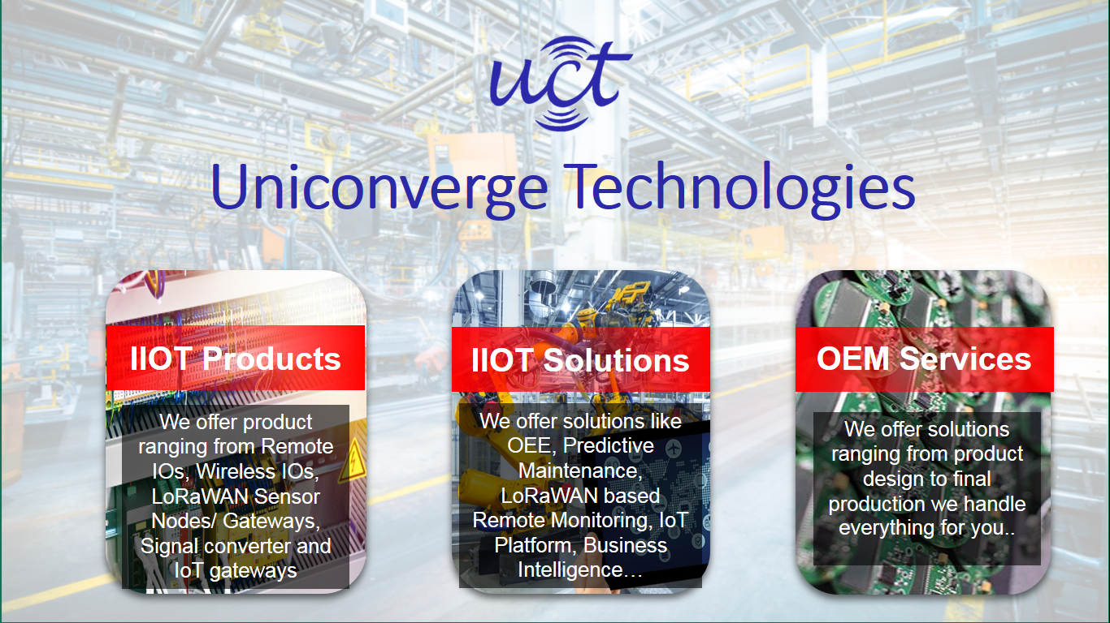
- UCT IoT Platform ()
UCT Insight is an IOT platform designed for quick deployment of IOT applications on the same time providing valuable “insight” for your process/business. It has been built in Java for backend and ReactJS for Front end. It has support for MySQL and various NoSql Databases.
- It enables device connectivity via industry standard IoT protocols - MQTT, CoAP, HTTP, Modbus TCP, OPC UA
- It supports both cloud and on-premises deployments.
It has features to
• Build Your own dashboard
• Analytics and Reporting
• Alert and Notification
• Integration with third party application(Power BI, SAP, ERP)
• Rule Engine

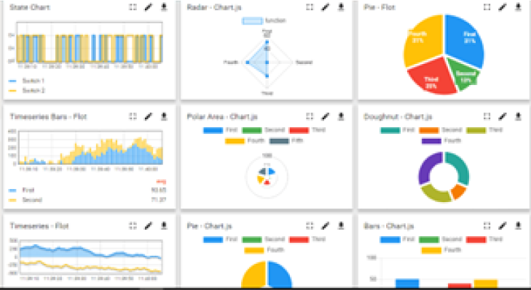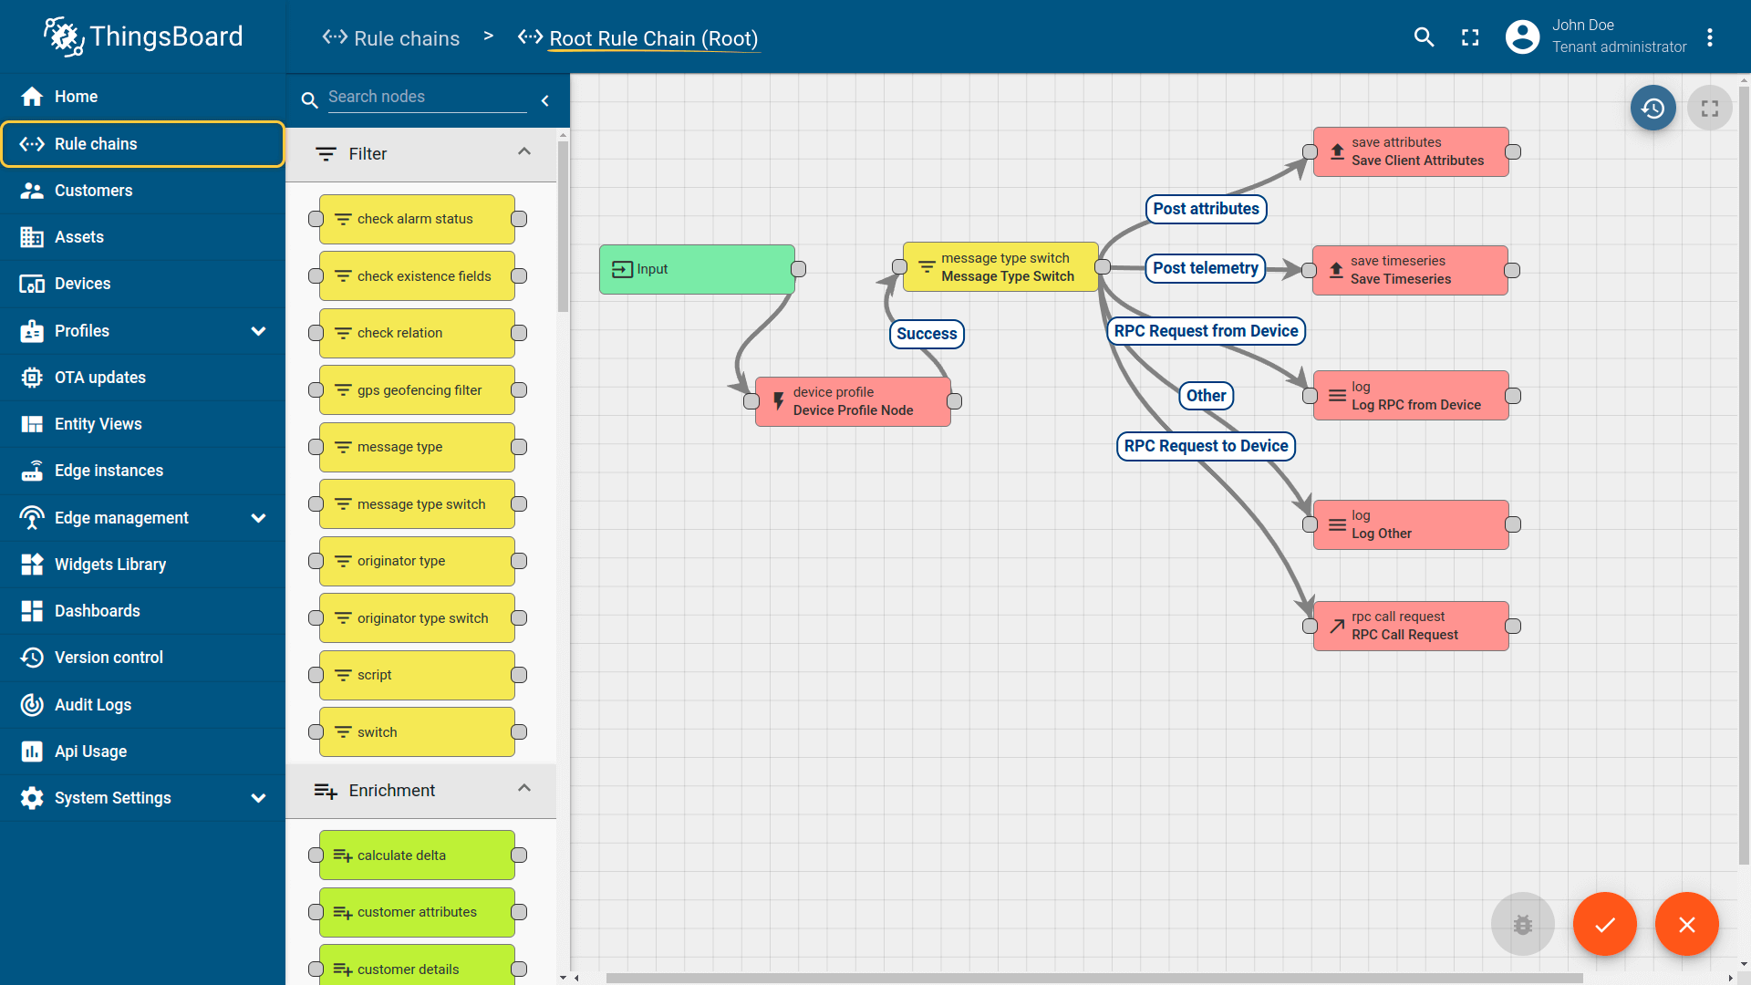

- Smart Factory Platform ()
Factory watch is a platform for smart factory needs.
It provides Users/ Factory
- with a scalable solution for their Production and asset monitoring
- OEE and predictive maintenance solution scaling up to digital twin for your assets.
- to unleased the true potential of the data that their machines are generating and helps to identify the KPIs and also improve them.
- A modular architecture that allows users to choose the service that they what to start and then can scale to more complex solutions as per their demands.
Its unique SaaS model helps users to save time, cost and money.
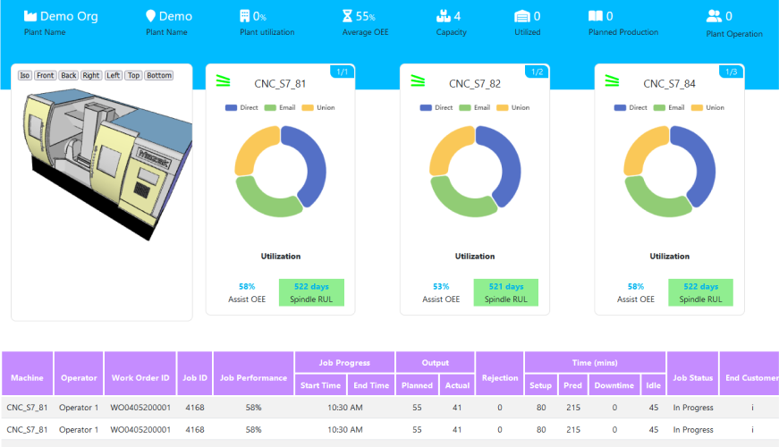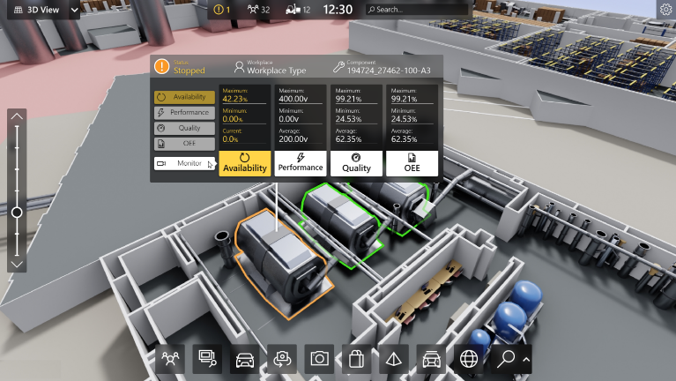

- 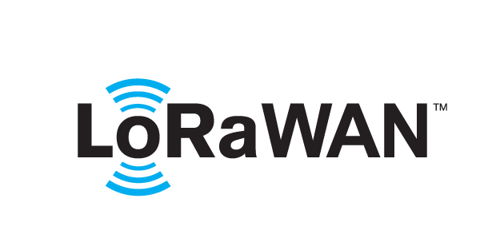 based Solution
UCT is one of the early adopters of LoRAWAN teschnology and providing solution in Agritech, Smart cities, Industrial Monitoring, Smart Street Light, Smart Water/ Gas/ Electricity metering solutions etc.
- Predictive Maintenance
UCT is providing Industrial Machine health monitoring and Predictive maintenance solution leveraging Embedded system, Industrial IoT and Machine Learning Technologies by finding Remaining useful life time of various Machines used in production process.
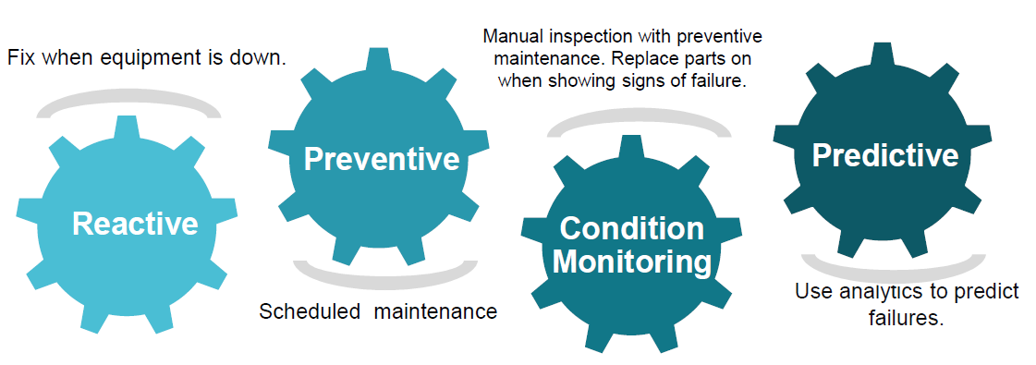

About upskill Campus (USC)
upskill Campus along with The IoT Academy and in association with Uniconverge technologies has facilitated the smooth execution of the complete internship process.
USC is a career development platform that delivers personalized executive coaching in a more affordable, scalable and measurable way.

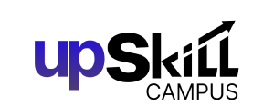


Seeing need of upskilling in self paced manner along-with additional support services e.g. Internship, projects, interaction with Industry experts, Career growth Services
https://www.upskillcampus.com/
upSkill Campus aiming to upskill 1 million learners in next 5 year

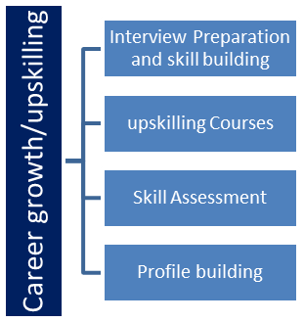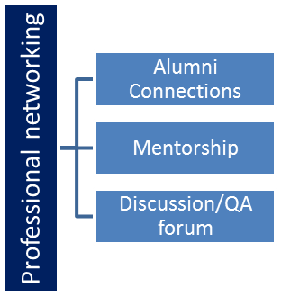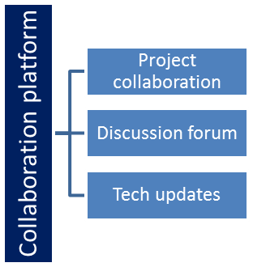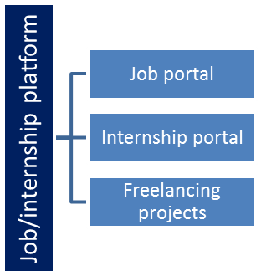

The IoT Academy
The IoT academy is EdTech Division of UCT that is running long executive certification programs in collaboration with EICT Academy, IITK, IITR and IITG in multiple domains.

Objectives of this Internship program
The objective for this internship program was to
☛ get practical experience of working in the industry.
☛ to solve real world problems.
☛ to have improved job prospects.
☛ to have Improved understanding of our field and its applications.
☛ to have Personal growth like better communication and problem solving.

Reference
[1]
[2]
[3]

Glossary
Terms | Acronym
% Silica Concentrate | Target impurity variable in iron ore concentrate; lower values indicate higher ore quality.
Flotation Plant | Industrial facility using chemical reagents and air bubbles to separate iron minerals from silica sand.
Tailings | Waste product discharged into environmental ponds when iron ore is lost during processing.
Lag Feature | Time-series feature derived from historical past values (e.g., target value at t-5 minutes).
RMSE / MAE / R² | Statistical metrics measuring Root Mean Squared Error, Mean Absolute Error, and Variance Explained.

Problem Statement
Problem Statement & Background:
In iron ore flotation plants, reagents (Starch and Amina) and air bubbles are injected into flotation columns to float valuable iron minerals while allowing silica (sand) impurities to sink as waste tailings. The primary quality goal is to minimize the percentage of Silica Concentrate (% Silica Concentrate) in the final pulp.
However, measuring % Silica Concentrate currently requires physical sampling and chemical lab analysis, which is performed ONLY ONCE PER HOUR. This creates a 59-minute operational blind spot. If process fluctuations or chemical imbalances cause a silica spike, engineers discover it too late, resulting in sub-standard ore output or valuable iron being lost to environmental tailings ponds.
Core Research Questions Addressed:
1. Is it possible to predict % Silica Concentrate every minute using continuous IIoT sensor data?
2. How many hours ahead can we reliably forecast % Silica Concentrate to enable proactive operational control?
3. Is it possible to predict % Silica Concentrate without using the highly correlated % Iron Concentrate column (enabling true lab-free real-time operation)?

Existing and Proposed solution

Limitations of Existing Solutions:
• Manual Laboratory Testing: Operations rely on periodic 1-hour lab testing, introducing 60 minutes of feedback latency.
• Reactive Control: Operators react after quality degradation has already occurred.
• Linear Rule Systems: Traditional control systems use static linear rules that fail to capture non-linear interactions across 7 flotation columns.
Proposed Machine Learning Solution:
We developed an automated time-series ML pipeline that ingests continuous 20-second sensor readings (airflows, column levels, pH, chemical flows), resamples data into 1-minute intervals, generates temporal lag and rolling features, and predicts % Silica Concentrate using LightGBM and XGBoost.
Value Addition & Impact:
• Minute-Level Quality Visibility: Real-time quality predictions every minute.
• 1-Hour Early Warning: 60-minute advance notice to adjust chemical dosing and airflows.
• Lab Independence: Accurate predictions without requiring lab-tested % Iron Concentrate.
• Waste & Cost Reduction: Minimizes iron ore loss to tailings, saving costs and protecting the environment.

Code submission (Github link):
https://github.com/vivaanmahida/upskillcampus/blob/main/QualityPredictionInAMiningProcess.py

Report submission (Github link):
https://github.com/vivaanmahida/upskillcampus/blob/main/QualityPredictionInAMiningProcess_Vivaan_USC_UCT.pdf

Proposed Design/ Model

System Design & Architecture:
The solution follows a modular 4-stage data engineering and machine learning pipeline:
1. Data Preprocessor (QualityPredictionInAMiningProcess.py): Cleans sensor data, handles timestamps, and resamples 20s data into 1-minute and 1-hour uniform grids.
2. Feature Engineer: Computes autoregressive lag features (target_lag_1 to target_lag_60), rolling window statistics (5m to 60m mean/std), cyclical time encodings, and multi-step target horizons (1h to 12h ahead).
3. Model Trainer: Executes chronological train/test splits (80% train, 20% test) and trains XGBoost, LightGBM, and Random Forest regressors across 3 experiments.
4. Dashboard Generator: Encapsulates model outputs, feature importances, and predictions into a standalone Plotly HTML dashboard (dashboard/index.html).

High Level Diagram (if applicable)

Figure 1: HIGH LEVEL DIAGRAM OF THE SYSTEM

Low Level Diagram (if applicable)

Interfaces (if applicable)
Update with Block Diagrams, Data flow, protocols, FLOW Charts, State Machines, Memory Buffer Management.

Performance Test

Constraints & Performance Evaluation:
Key Constraints Addressed:
• Temporal Data Leakage: Evaluated models using strict chronological time splits (80% train, 20% test) rather than random cross-validation.
• Edge Latency: Inference executes in milliseconds per sample, making it suitable for edge deployment on IIoT gateways.
• Accuracy Benchmark: Target R² > 0.50 for minute-level prediction and RMSE below baseline standard deviation (1.12%).
Experimental Performance Outcomes:
1. Experiment A — Minute-Level Quality Prediction (Q1):
- LightGBM (Best Model): RMSE = 0.7196 | MAE = 0.5301 | R² = 0.6071 ✅
- XGBoost Regressor: RMSE = 0.7534 | MAE = 0.5760 | R² = 0.5692
- Random Forest: RMSE = 0.7775 | MAE = 0.5995 | R² = 0.5412
2. Experiment B — Multi-Step Forecast Horizon Analysis (Q2):
- 1 Hour Ahead: RMSE = 0.8467 | MAE = 0.6503 | R² = 0.4558 (Operational / Usable ⚠️)
- 2 Hours Ahead: RMSE = 0.9435 | MAE = 0.7406 | R² = 0.3242 (Weak Signal)
- 4 Hours Ahead: RMSE = 1.0809 | MAE = 0.8809 | R² = 0.1133 (Unreliable ❌)
3. Experiment C — Iron Feature Ablation Study (Q3):
- XGBoost WITH % Iron Concentrate: RMSE = 0.7534 | R² = 0.5692
- XGBoost WITHOUT % Iron Concentrate: RMSE = 0.7548 | R² = 0.5677 ✅
- Key Finding: Removing % Iron Concentrate results in negligible accuracy loss (ΔRMSE = +0.0014), proving true lab independence!

Test Plan/ Test Cases

Test Procedure

Performance Outcome

My learnings

Summary of Overall Learnings:
• Time-Series ML: Hands-on experience structuring high-frequency sensor data, engineering lag features, and enforcing chronological validation.
• Gradient Boosting: Tuning hyperparameter bounds and early stopping for LightGBM and XGBoost on industrial tabular data.
• Domain Knowledge: Deep understanding of froth flotation plant dynamics and IIoT process control.
• Full-Stack Visualization: Creating single-file interactive Plotly HTML dashboards for enterprise stakeholders.
• Professional Standards: Git/GitHub version control workflows and comprehensive technical documentation.

Future work scope

Future Work & Potential Scope:
1. Deep Learning Sequence Models: Explore Temporal Convolutional Networks (TCN) or LSTM architectures for multi-hour forecasting.
2. UCT Smart Factory Integration: Deploy trained LightGBM models to UCT Insight platform via MQTT/REST endpoints for live edge inference.
3. Automated Tuning: Integrate Optuna for automated continuous hyperparameter tuning as sensor calibration drifts.
4. Prescriptive Control Feedback: Extend predictive models to prescribe optimal column airflow and chemical dosing setpoints.

