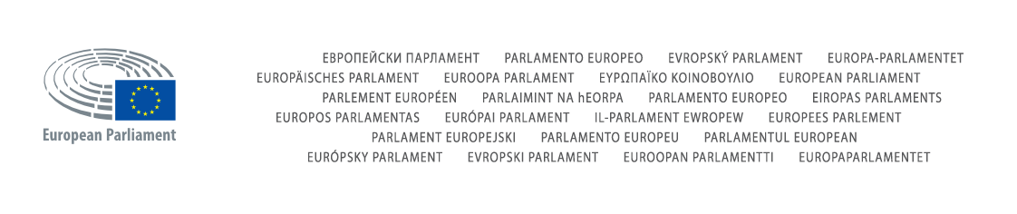

Directorate for Development and Support (DES)

|  |
| --- |
| **Initial Environment Request**  **CONCEPT - OPERATIONS**  TRILOEDI |

**Details of the IER**

|  |  |  |
| --- | --- | --- |
| **Step** | **Date** | **Comment** |
| **Charter received by CONCEPT** |  |  |
| **Validation CONCEPT** |  |  |
| **Transmission to OPERATIONS** |  |  |

|  |  |  |
| --- | --- | --- |
| **Contacts** | | |
| **Contact requester** |  |  |
| **Contact CONCEPT** |  |  |
| **Contact OPERATIONS** | [**OPERATIONS.ServiceDesk@europarl.europa.eu**](mailto:OPERATIONS.ServiceDesk@europarl.europa.eu) |  |
| **Contact DPO** | **Data-Protection@europarl.europa.eu** |  |

|  |  |
| --- | --- |
| **Project description** | |
| **Description** |  |

|  |  |  |
| --- | --- | --- |
| **N°** | **Reference document** | **Comment** |
| [1] | PMM4EP_TE_CHP_EN_v1.0 | Project Charter |
| [2] |  |  |
| [3] |  |  |

|  |  |
| --- | --- |
| **Request validation** | |
| **Validation CONCEPT** | **OK** |
| **Validation OPERATIONS** |  |

**Contextual information**

|  |  |
| --- | --- |
| **Estimated planning** | |
| **Milestone(s)** | **Date** |
| Development start | October 2016 |
| Deployment in PreProduction (first deliverables) | Q1 2017 |
| Deployment in Production | Q4 2017 |
|  |  |
|  |  |

|  |  |
| --- | --- |
| **Criticality** | |
| Global project risk level | High: , Medium: , Low: |
| **Triangle of constraints** | |
| Time | High: , Medium: , Low: |
| Cost | High: , Medium: , Low: |
| Scope | High: , Medium: , Low: |

**Initial Environment Requirements**

|  |  |
| --- | --- |
| **SCM (Source Control Management)** | |
| SCM required | **Y** |
| **If required, please choose one of the following** | |
| Internal SVN (Subversion) | **Y** |
| External SVN (Subversion) (only for outsourced or externalized projects) | **Y** |

|  |  |
| --- | --- |
| **Database** | |
| Database required | **Y** |
| **If required, please specify** | |
| Multiple Schemas | **N** |
| Comma-separated schema name(s) | Triloedit |