Technical Architecture Document
PURE-XML
Parliament Unique Repository
for XML text production

Approval
Name | Role  MOA/MOE | Date  Approval | Approval  Y/N | Address  DG or Company
Olivier Leboeuf (OLE) | MOA-Project Owner | 07/01/2013 | Y | ITEC
Gianluigi Alari (GAL) | MOE-Project Manager | 07/01/2013 | Y | ITEC
CIRCULATION
Name -Telephone number |  | DG or Company | ERICA code
Franck Chalaux (FCH) |  | ITEC | C
Claudio Fabiani (CFA) |  | ITEC | C
Olivier Leboeuf (OLE) |  | ITEC | C
Olivier Fabbri (OFA) |  | ITEC | C
Jesus Cerro (JCE) |  | ITEC | C
Updates
Version | Date | Sections changed | Description | Author(s)
0.1 | 20/03/2012 | All | Initial Draft creation | PPA
1.0 | 06/04/2012 | All | Final version | PPA,CTR
1.1 | 07/04/2012 | All | Updated mainly with version numbers | JCE, BBO
2.0 | 25/07/2012 |  | Management console added | KPA
2.1 | 28/09/2012 | 2.4.1, 2.4.2 | Corrections requested by IMS ALSA | KPA
2.2 | 22/11/2012 |  | Removed elements concerning the PURE-XML Management console, which now are included in a separate DTA document. | KPA
2.3 | 07/01/2013 | Approval Table | Added approval info as per IMS mail of 03/01/2013 | GAL
2.4 | 09/01/2013 | Versions of tools | Update of tool versions, following ALSA recommendations:  EP Foundry Cache (instead of ECache 2.5.1)  HornetQ 2.2.14 (instead of 2.2.5)  JDBC 11 (instead of 10)  Tomcat 6.0.x (instead of 6.0.18) | KPA
Table of content
1. General Introduction 4
1.1. Purpose 4
1.2. Usage conventions 4
1.3. Applicable and Reference Documents 4
1.4. Glossary 4
1.5. Procedure 'Technical Architecture' 5
2. Architecture - Description 6
2.1. Basic information 6
2.2. Network Architecture Schema 6
2.3. Software Architecture 7
2.4. Required Standard Runtimes 8
2.5. Non-standard server-side softwares list 8
2.6. Integration 9
2.7. Security 10
2.8. High availability 11
3. Specific Development Tools 12

General Introduction

Purpose
This document contains a description of the PURE-XML project for submission to the IT correspondent of the DIT for its opinion on the technological/technical assumptions on which it is based. It is essential for this opinion to be sought in order to ensure that the elements on which the project's success will depend (methods, architectures, tools, components, etc.) are valid and authorised within the EP.

Usage conventions
The parts in yellow indicate the area where information should be entered, and must remain in yellow to highlight information connected with the project.
Where a chapter or section is not considered to be applicable, put ‘NOT APPLICABLE’.
Click on the Show/Hide button in the toolbar to display/hide guidance on filling in this document.
Guidance displayed.

Applicable and Reference Documents
This chapter sets out the reference documents on which this guide is based.

Applicable Documents
This section details the applicable documents used in drafting this document. The applicable documents are standards, specimen plans which need to be applied and whose application is verifiable.
N° | Title | Remarks
[1] | PURE-XML_CHP_EN_v12.doc | Project Charter
[2] | PURE-XML_DEB_ v0-1.doc | Needs study
[3] | PURE-XML_IRA_v0-1.xls | PURE-XML Initial Risk Assessment

Reference Documents
This section details the reference documents used in drafting this document. Reference documents help in defining the project but are not directly applicable (e.g. software reference manuals, sample files from outside firms, meeting papers).
N° | Title | Remarks
[1]
[2]

Glossary
The glossary is available at ICTASnet : - Zone 'Vos indispensables'-Glossaire.
Abbreviation | Description
DTA | Technical Architecture Document
RHR | Runtime Hosting Request
JRMP | Java Remote Method Protocol
STOMP | Simple Text Oriented Message

Procedure 'Technical Architecture'

Sending a Technical Architecture Document (DTA)
The DTA and RHR(s) documents have to be sent to the IT correspondent of the DIT.

Validation of the DTA
As soon as the DTA is completely validated then the DTA is sent to ITO to continue the treatment along with one or multiple Runtime Hosting Requests (RHR).

ICTAS support
During the project, ICTAS can support the team project (MOA+MOE) but on request only.
ICTAS provides relevant information (standard, methods) in the Quality Assurance Manual and the appropriate documents (templates) for the project.

ITO support
ITO deals with the DTA as soon as it is validated by ICTAS.
ITO initiates a meeting with the stakeholders of the project in order to organise the technological environments necessary for the project.
For more information see ITO Website.

Architecture - Description

Basic information
This chapter describes the deliverables (applications, components, integration component) of the product in the EP's network using a synthetic schema.
Service | Required
Intranet | Yes
DMZ | No
VLAN dedicated | No
Internet access through the EP portal | No
Other | No

Network Architecture Schema
PURE-XML is the XML repository for the text production in the frame of the e-Parliament program. All the applications (including the management console) that will need to use the repository will have to access it via its API (Java binding or Web Services binding).

Insert a synthetic schema representing general software components in their respective network zones (application servers, applications, products...etc), as well as their interactions and the protocols used for these interactions.

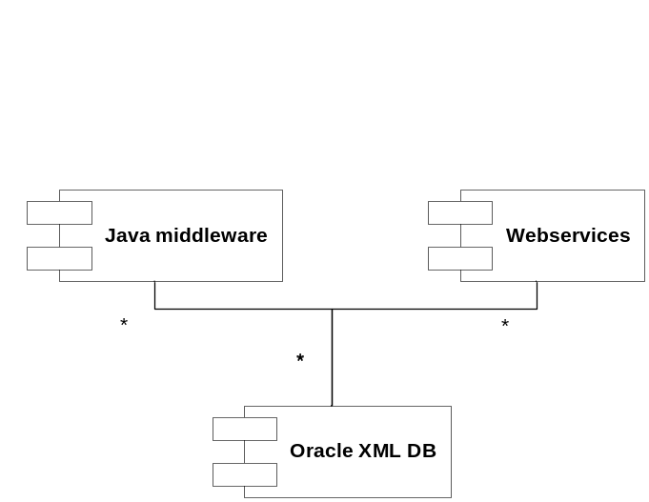
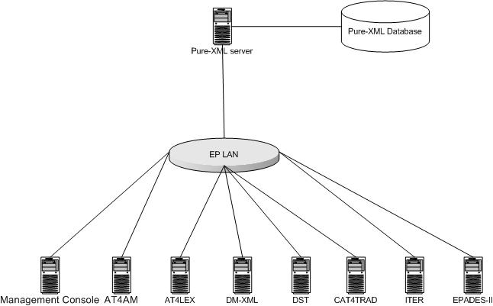

The PURE-XML application is composed of the following components:

- Repository connector
- Repository (Repository objects’ CRUD functions)
- Changelog management
- Access Control management
- Relationship management
- Versioning management
- Content types management
- Tags management
- Locking management
- Notifications management

Software Architecture
This chapter describes the software architecture according to the following schema:
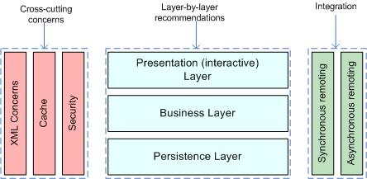
List the technologies/libraries used.
Client User interface |  | -
Server Presentation layer |  | -
Server Business layer |  | Spring
Server Persistence Layer |  | JPA / HIBERNATE 4.1.1 Oracle 11gR2 with XML DB
Synchronous Remoting (WS, RMI) |  | Y (Spring HTTP Invoker, support for WS in the future)
Asynchronous Remoting (JMS) |  | HornetQ 2.2.14
XML Handling |  | Standards Java APIs and Oracle 11gR2 with XML DB
 | Cache |  | EP Foundry Cache
 | Security |  | JAAS and Basic authentification
 | Framework |  | Spring 3.1.0.RELEASE
 | Software management tool |  | Apache Maven 3.0.4
 | Application Server |  | Tomcat 6.0.x
 | Programming Language |  | Java 1.6.0_31

Required Standard Runtimes
This chapter lists the various required server-side softwares (for example, Tomcat, HornetQ...etc), and their runtime codes (allowing to map this document with multiple Runtime Hosting Request(RHR).
List of required operational environment and associated 8 characters Code:

Existing  (Y/N) | Standard Runtime | Code  (8 char) | Environment(s)  DEV, PPO, FOR, PROD, INT
N | Tomcat 6.0.x | PUREXML | DEV, INT, PPO, PROD
N | HornetQ 2.2.14 | PUREXML | DEV, INT, PPO, PROD

Please note that one separate RHR document will be needed for each new runtime.

Non-standard server-side softwares list
This chapter lists the various required non-standard server-side softwares.
Please note that this non-standard software are most likely not to be accepted quickly, though may trigger special attention and dedicated handling.
Fill in this chapter as accurately as possible.

Non-Standard Server-side software | Explanation of the need
- | -

Integration
This chapter describes integration of the product with other applications or services (Database, directory, etc.) and contracts and protocols used.

Applications integration schema
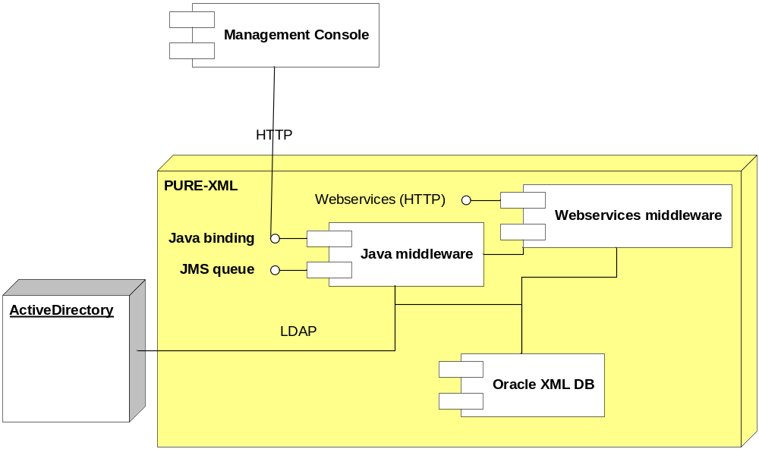This section has to contain a schema describing interactions between applications. You have to precise the protocols used, and information needed to describe the exchanges (synchronous (remoting, web services), asynchronous (JMS, etc.).

Client applications will be able to use the PURE-XML repository either via the Java binding or the Web services binding of its API. Asynchronous repository events will be published via JMS technology.
In the above diagram, the management console is a client application that uses the Java binding.
The following client applications have been identified in the frame of the e-Parliament program:
- Management Console
- AT4AM
- DST
- CAT4TRAD
- DM-XML
- AT4LEX
- DISP

All the above applications will access PURE-XML only via its API (Java bindings).

Application integration criticality
Reference | Protocol | Synchronicity | Frequency | Business Criticality
 | LDAP | Synchronous | High | High
 | HTTP | Synchronous | High | High
 | TCP | Asynchronous | High | High

The application is mission critical since it will serve content repository services for structured legislative texts created and managed in the context of the Parliament legislative processes.

System

List of required system services
Database | Oracle 11gR2 with XML DB
File system (direct access, sharing, FTP, ...) | Direct access
Directory (Active Directory, other) | Active Directory/LDAP
Mails (Sending mails from an application) | No
Messaging Broker (JMS) | HornetQ 2.2.14
Application Server | Tomcat 6.0.x
JDBC | Oracle OCI driver 11.2.0.3.0

System services schema (optional)
For clarity (and mostly if you have asked for multiple runtimes), please provide a schematic vision of the interaction between system services and applications.

Security
This chapter describes the needs for security (secure client access, integration, confidentiality (signature) data exchanged or stored, business services implemented, etc.).

Authentication mechanism
The client applications will provide username and user group that PURE-XML will accept as valid. Username and user group will not be validated against LDAP. Client applications will be authenticated by PURE-XML against LDAP.

Authorization mechanism
The internal access control module is based on group membership of the authenticated user. PURE-XML will provide groups/permissions per authenticated user, which will allow a fine grained access control to specific parts of the application’s API and repository objects. User access will be limited on both functional level and repository object level.

Specific confidentiality needs
None.

High availability
The PURE-XML service is mission critical, therefore a high availability setup is recommended. In order to ensure high availability, the following additional services should be provided:
- Reverse proxy server
- RAID configuration, setup for high availability, for the HornetQ filesystem
- Oracle RAC. If in EP premises the database is set up to work on single servers, high availability on the database level is not guaranteed.

Specific Development Tools
The purpose is to mention only components which need a special or specific attention
The ICTAS Unit provides standard tools for the development of applications.
Mention here licence-limited tools you may need (restricted use product):
Oxygen XML | Y
Modelling tool UML | Y
Maven | Y
Source management (SVN) | Y
Full Application server | Y
Non standard tools and justification:

E: Examination, R: Responsible, I: Information, C: Contribution, A: Approval
Runtime: for example: Tomcat, HornetQ...etc
Environment (DEV, PPO, FOR, PROD, INT...etc)
An identifier helping to point this relation in the Application Integration Schema
Frequency of the interaction (e.g. once every night for a batch, thousands of calls per minute if directly related to end user input or interaction)

