Diode Analysis

By Mason Andrews

With lab partner: Cameron Kirk

Background

Semiconductors are a type of material that can be used to either allow or halt the flow of electrons.

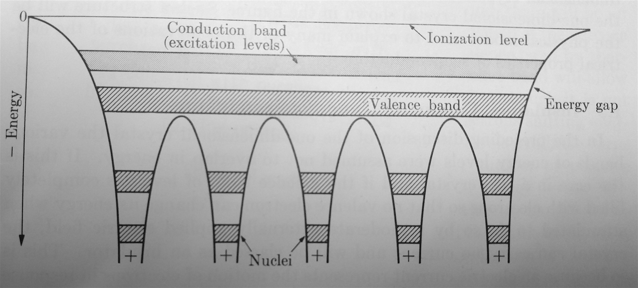

Figure 1

Allowable energy levels in a 1 dimensional crystal

Figure 1 shows a representation of how a 1 dimensional semiconductor crystal works. The top is split into two bands and below that is a few wells. The wells represent individual atoms. Each of the shaded areas in a well represents the possible energy levels for the different electron shells. (This figure is simply an abstraction of that.) The bottom layer, labeled valence band, represents the valence shell of the electrons. Because this band its connected across multiple wells it shows that electrons within this band are able to interact with other energy wells. This is showing the electrons used for chemical bonds. So, these electrons are kept in an area where both atoms can share it. The conduction band is an area where the electron is no longer bound to one energy well and its free to move around as if it were just a conductor. This area between the two is called the energy gap or band gap. No electrons can exist between these two bands and it usually takes a lot of energy to move to a higher band.

We can use doping to change how either band works. The N type semiconductor (one doped to have more donor electrons) effectively lowering its conduction band and thus that band lies closer to the fermi level. The P type semiconductor (one doped to have more electron holes) effectively raises its valence band and thus that band lies closer to the fermi level.

When you put these two together you get a P-N junction diode. This has the effect of allowing a voltage to pass when in one direction and effectively stopping the voltage in the reverse direction.

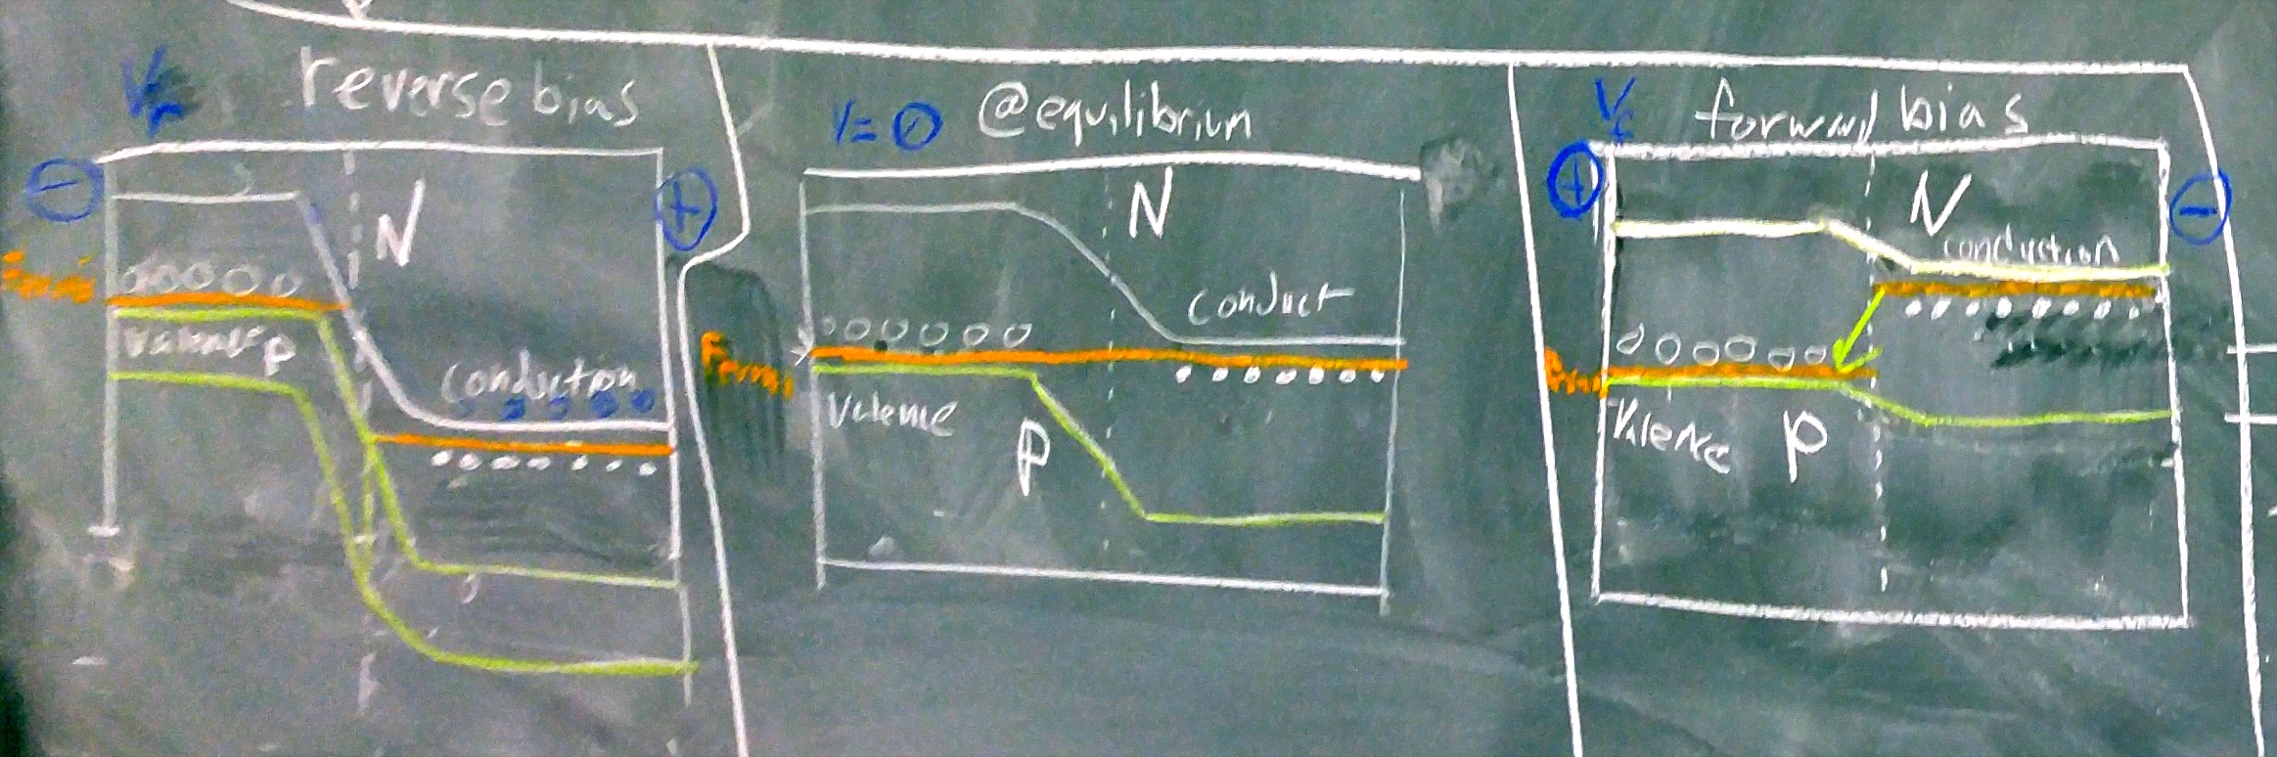

Figure 2

Energy bands of a P-N junction in reverse bias, equilibrium, and forward bias voltage

When the voltage goes in the forward direction, as shown in the right most drawing in figure 2, the donor electrons from the N type semiconductor fills the holes in the P type semiconductors and thus allows a current to flow mostly unimpeded. When a voltage is applied in the reverse direction, as shown in the left most drawing in figure 2, the electrons are able to fill the holes in the P type semiconductor. However, there is still a wall of surplus electrons in the N type semiconductor effectively preventing any current from flowing through. In either case there will be some wasted power and some current because if it passes or not is a matter of probability. So even in the forward direction some electrons will not have the right probability and thus will be turned into waste heat. In the reverse direction, some electrons can still tunnel through the barrier though. At equilibrium, as shown by the middle drawing in figure 2, the fermi level is constant throughout.

**Methods**

To start our trial, my lab partner and I decided to pull up the spec sheet for our diode and use a powers supply and multimeter to measure the current at different voltages on the spec sheet. We used the Ohm Measuring feature of the multimeter to see how resistive the diode is. We would then use this with Ohms law (Equation 1) to see what voltages we would need and get at different currents. However, when we tried to measure the resistance it would fluctuate even while we measured it and when measured at different times. It would usually be at 290k Ohms ± 30 Ohms. For calculations, we only used 1 significant figure. We were unable to collect any measurements because the power supply wasn’t able to provide such small voltages easily and it would heat up very quickly. We also noticed that the current being drawn was much lower than our multimeter was able to read.

V = I R

Equation 1: Ohms Law

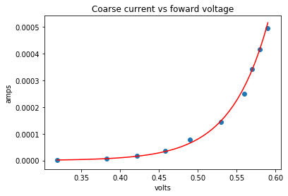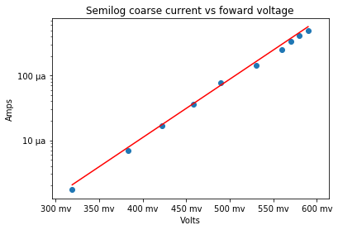We realized we could fix both the overheating and measurement errors by putting in a diode. If we put in a resistor then we could measure the voltage drop across that element to calculate the current and it would lower the current and thus power. The higher the resistor was the lower the current would be but also the lower the voltage drop would be. If you get high enough you would also have very noticeable effect from the internal resistance of the multimeter. Conversely, if it was too low then it both wouldn’t create much of a voltage drop and it wouldn’t do much to limit the current, so we would encounter overheating problems again.

Graph 1 Graph 2

This plot has 2 linear sides This is plotted with log y

These two graphs (Graph 1 & Graph 2) shows the result of our rough measurement along with a linear fitting when the y axis is logarithmic. This is both what it looks like when there is and isn’t a logarithmic scale. The

Y = 20.67 x - 19.77

Equation 2: The linear equation for Graphs 1&2

Equation 3: The ideal diode equation

Equation 4: The diode equation in the recombination regime

Since we didn’t take note of the temperature we can’t do much with Equation 2. If we did, then we could compare it with Equation 4 to calculate the charge of an electron. However, this does show that we can use this equation since by visual inspection the points are fairly close to the equation and that proves it can be represented by a linear equation. Since we are plotting voltage vs current we can use compare the slope with e/2kT from equation 4. Temperature is the only controllable variable in that so we ought to be able to show the link between temperature and how the diode works with that relationship. I only have equation 3 to show how an ideal diode would react. However, since no ideal diodes exist we use equation 4 as the closest approximation without imperfect diode.

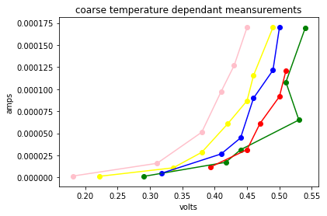

Graph 3: coarse temperature controlled forward voltage

Graph 3 shows a very coarse temperature controlled trial. We superglued a hotplate and thermometer to a hotplate and set the hotplate to different temperatures. This is a very suboptimal way of doing this. The hotplate had a massive 5 degrees C swing at each setting on top of it taking a long time for it to react to different settings. These were done at random temperatures with random values collected. They each had to be measured very quickly to have any chance of getting accurate results. The green and red lines were at 26 and 28 degrees C respectively. With a 5 degree swing they are and should look nearly indistinguishable. The following temperatures were 40, 50, and 70 degrees C. However, this serves its purpose in showing that temperature does change the slope and by visual inspection (since the error too big to make it useful).

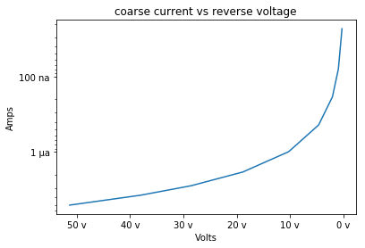

Graph 4: reverse voltage with semilog plot

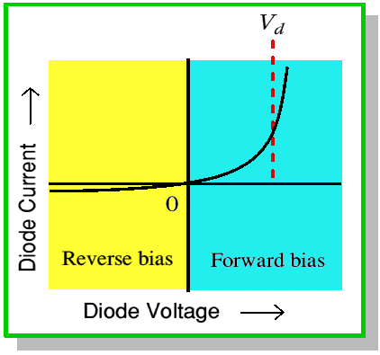

Graph 5: the ideal way a diode should react in forward and reverse bias voltage

This graph 4 doesn’t need to have a logarithmic side since it is to show the relationship to graph 5. Both are exponential functions.

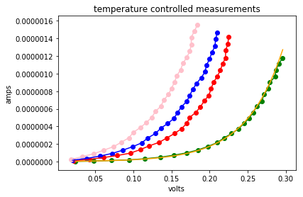

Graph 6

|  |  |
| --- | --- |
| Linear equations of Graph 6 | |
| 24°C | 20.75 x - 19.72 |
| 49°C | 21.63 x - 18.34 |
| 56°C | 21.32 x - 17.83 |
| 67°C | 22.4 x - 17.36 |

Chart 1

Discussion

By plotting the exponential functions on a logarithmic scale we were able to linearize the data to that. From this we can show that temperature meaningfully changed the way a diode works as you would expect from the diode equation. You could also use this data to verify Boltzman’s constant and the charge of an electron. However, that would require more data collection, sampling of that data, and some fitting procedure to account for the impurities in the material.

Bibliography

•Lesely Loyd (2015) *Ideal Diode Equation*, <https://slideplayer.com/slide/5796147/>

•Neudeck, G. (1983). *The PN junction diode* (Modular series on solid state devices ; v. 2). Reading, Mass.: Addison-Wesley.

•Kip, A. (1968). *Fundamentals of electricity and magnetism* (2d ed., McGraw-Hill series in fundamentals of physics). New York: McGraw-Hill.

•Melissinos, Adrian C., and Jim Napolitano. Experiments in Modern Physics. Academic Press, 2011.