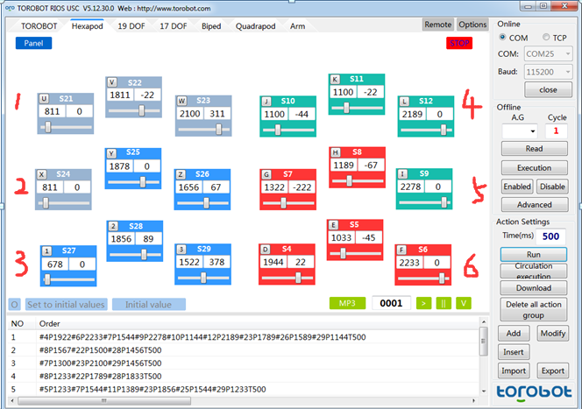

Go forward: (Three-step gait mode)

#4P1922#6P2233#7P1544#9P2278#10P1144#12P2189#23P1789#26P1589#29P1144T500 //initial position

#8P1567#22P1500#28P1456T500 //Lift the foot 1 3 5

#7P1300#23P2100#29P1456T500 // foot 1 3 5 move forward

#8P1233#22P1789#28P1833T500 // foot 1 3 5 put down

#5P1233#7P1544#11P1389#23P1856#25P1544#29P1233T500 // Lift the foot 2 4 6 , while the servo 7 23 29 back to its original location

#4P1767#10P967#26P1856T500 // foot 2 4 6 move forward

#5P1033#11P1100#25P1878T500 // foot 2 4 6 put down

Other more posture we continue to update,Thanks!!