1. What is the IP address and TCP port number used by the client computer (source) that is transferring the file to gaia.cs.umass.edu?

Ans : Source Address: 2402:3a80:893:264b:c121:ec7c:6347:39bd
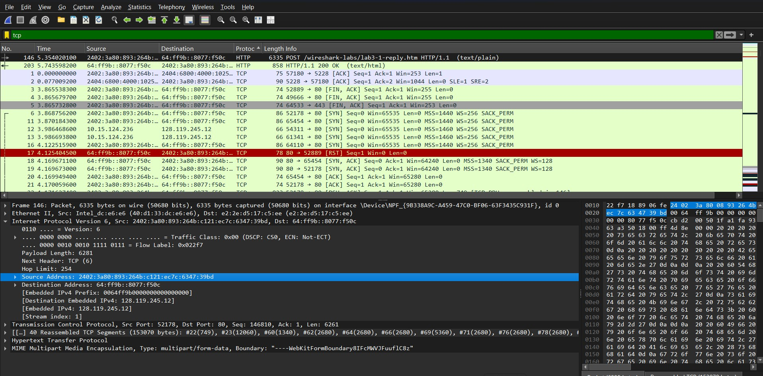

Source Port : 52178
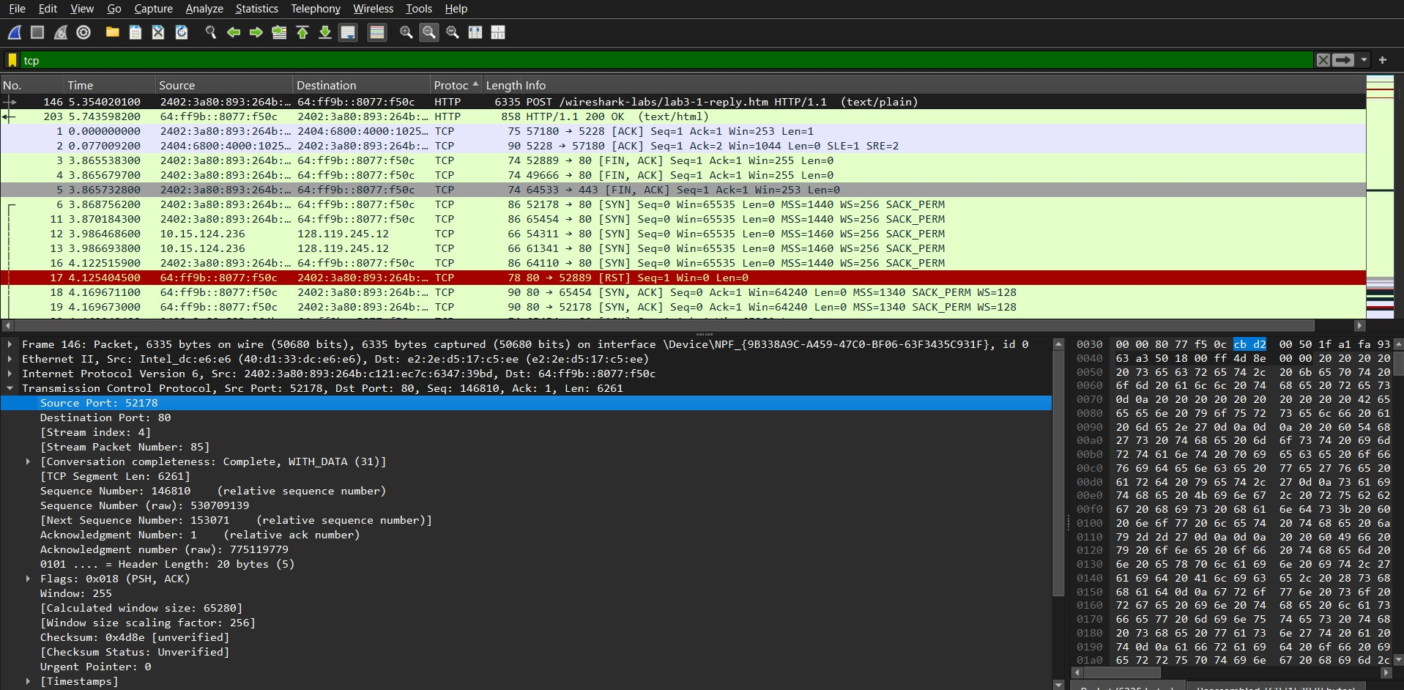
What is the IP address of gaia.cs.umass.edu? On what port number is it sending and receiving TCP segments for this connection? Source ip: 128.119.245.12
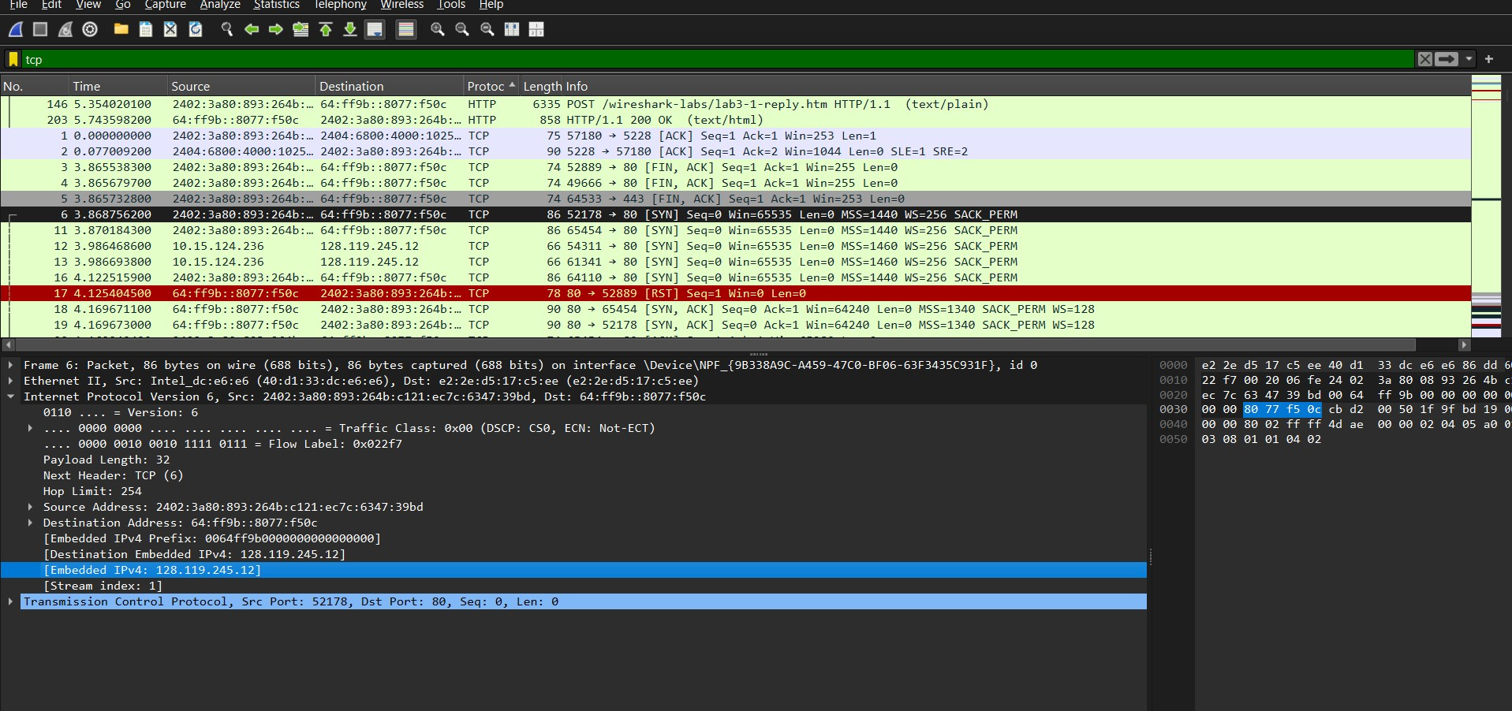
Source Port: 80
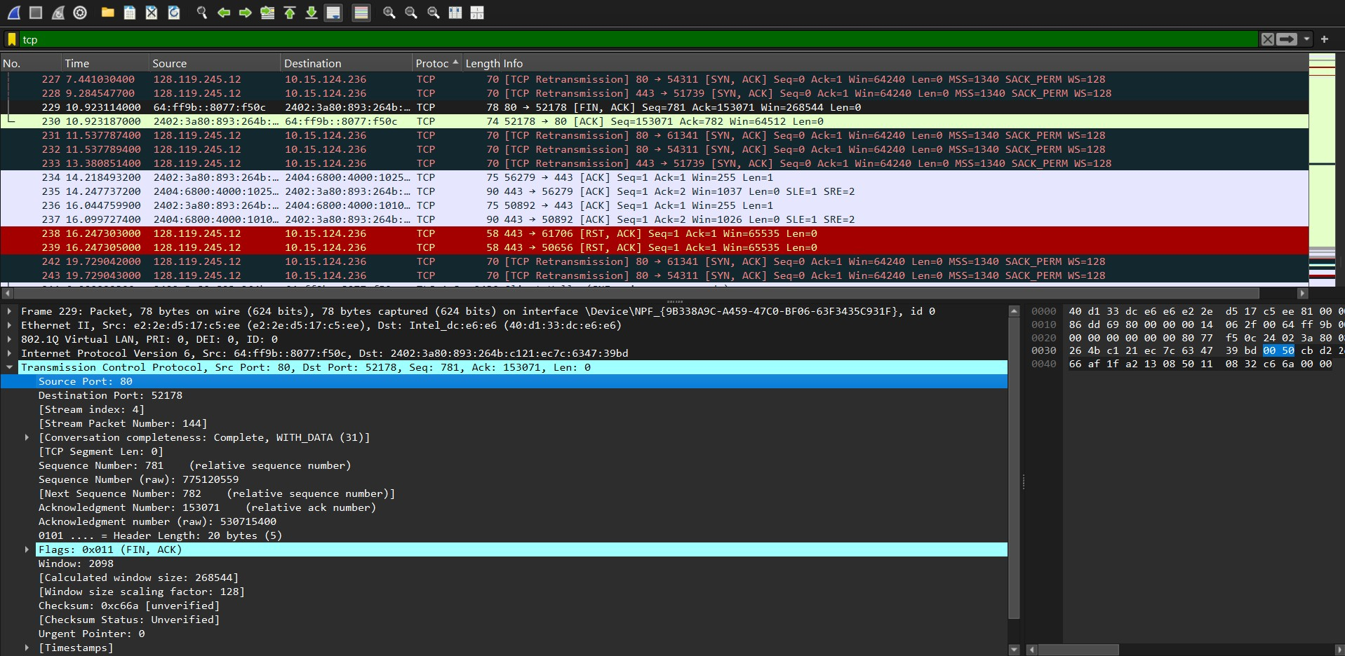

What is the IP address and TCP port number used by your client computer (source) to transfer the file to gaia.cs.umass.edu?

Source Address: 2402:3a80:893:264b:c121:ec7c:6347:39bd

Source Port : 52178
What is the sequence number of the TCP SYN segment that is used to initiate the TCP connection between the client computer and gaia.cs.umass.edu? What is it in the segment that identifies the segment as a SYN segment?

Sequence Number: 0 (relative sequence number) Flags: 0x002 (SYN)
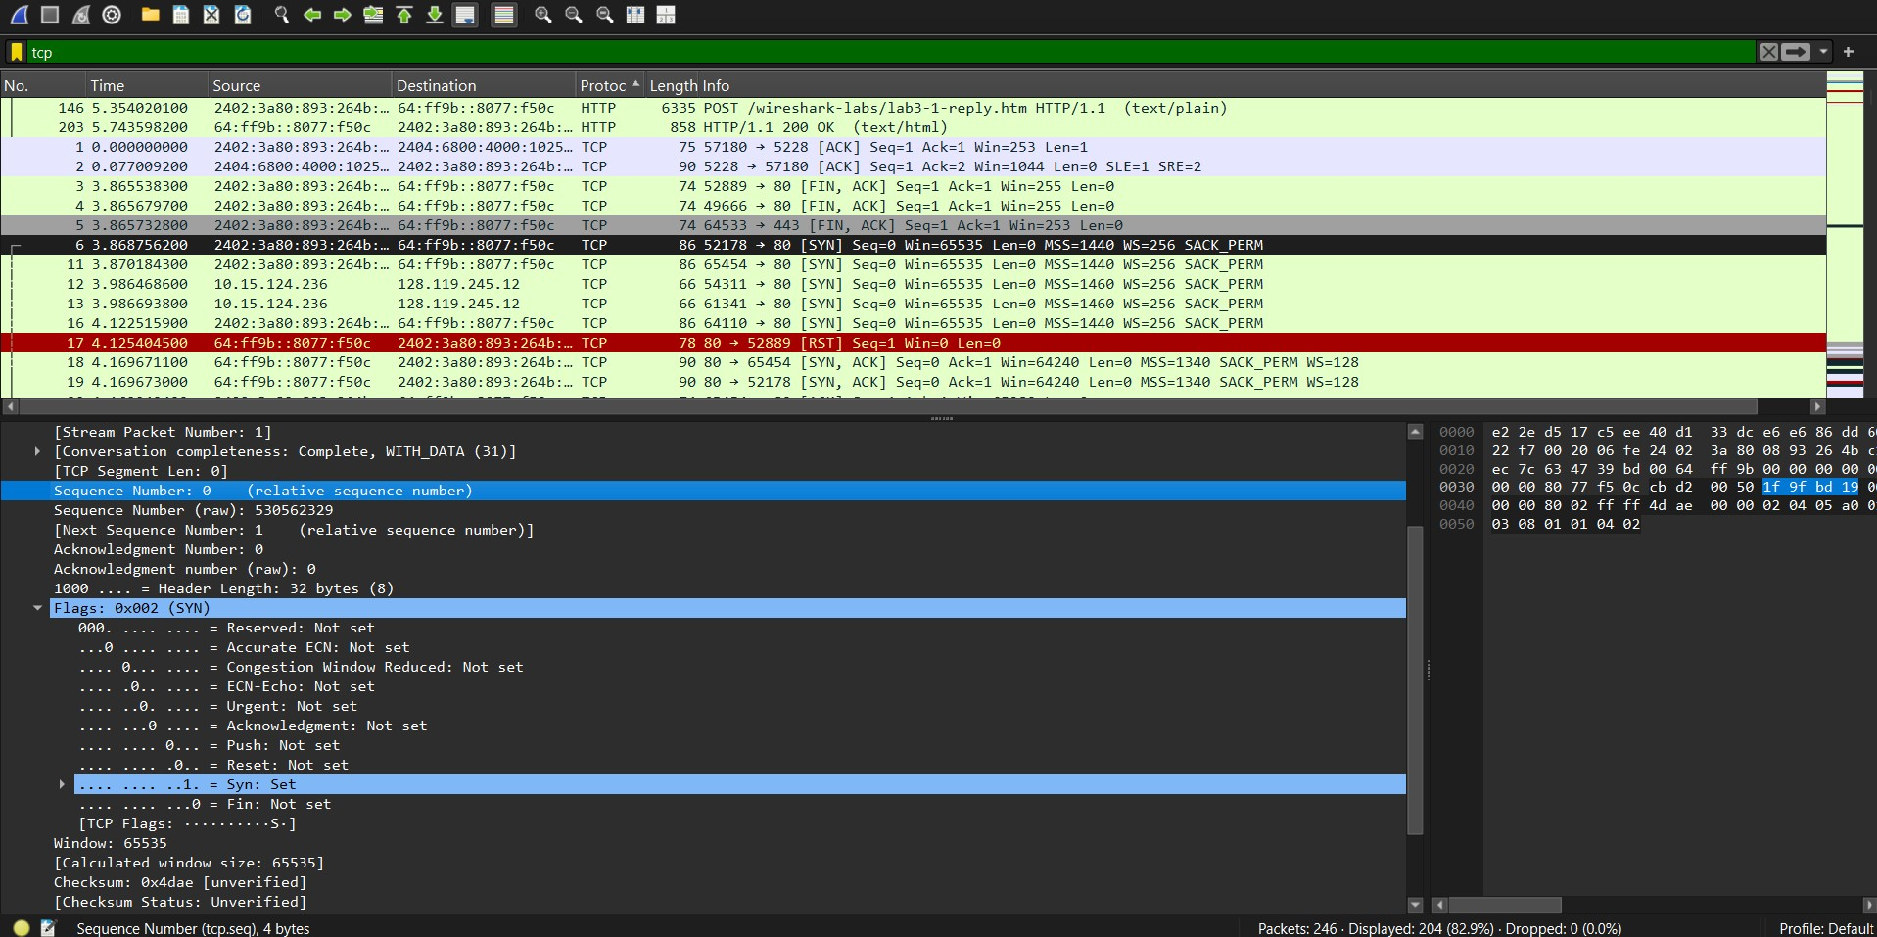

5. What is the sequence number of the SYNACK segment sent by gaia.cs.umass.edu to the client computer in reply to the SYN? What is the value of the Acknowledgement field in the SYNACK segment? How did gaia.cs.umass.edu determine that value? What is it in the segment that identifies the segment as a SYNACK segment?

- Sequence Number: 0 (relative sequence number)
- Acknowledgment Number: 1 (relative ack number)
- ACK = 1 because the client sent a SYN packet with Sequence Number 0. The server acknowledges the next expected Sequence Number, so it sends ACK = 1.
- Flags: 0x012 (SYN, ACK)

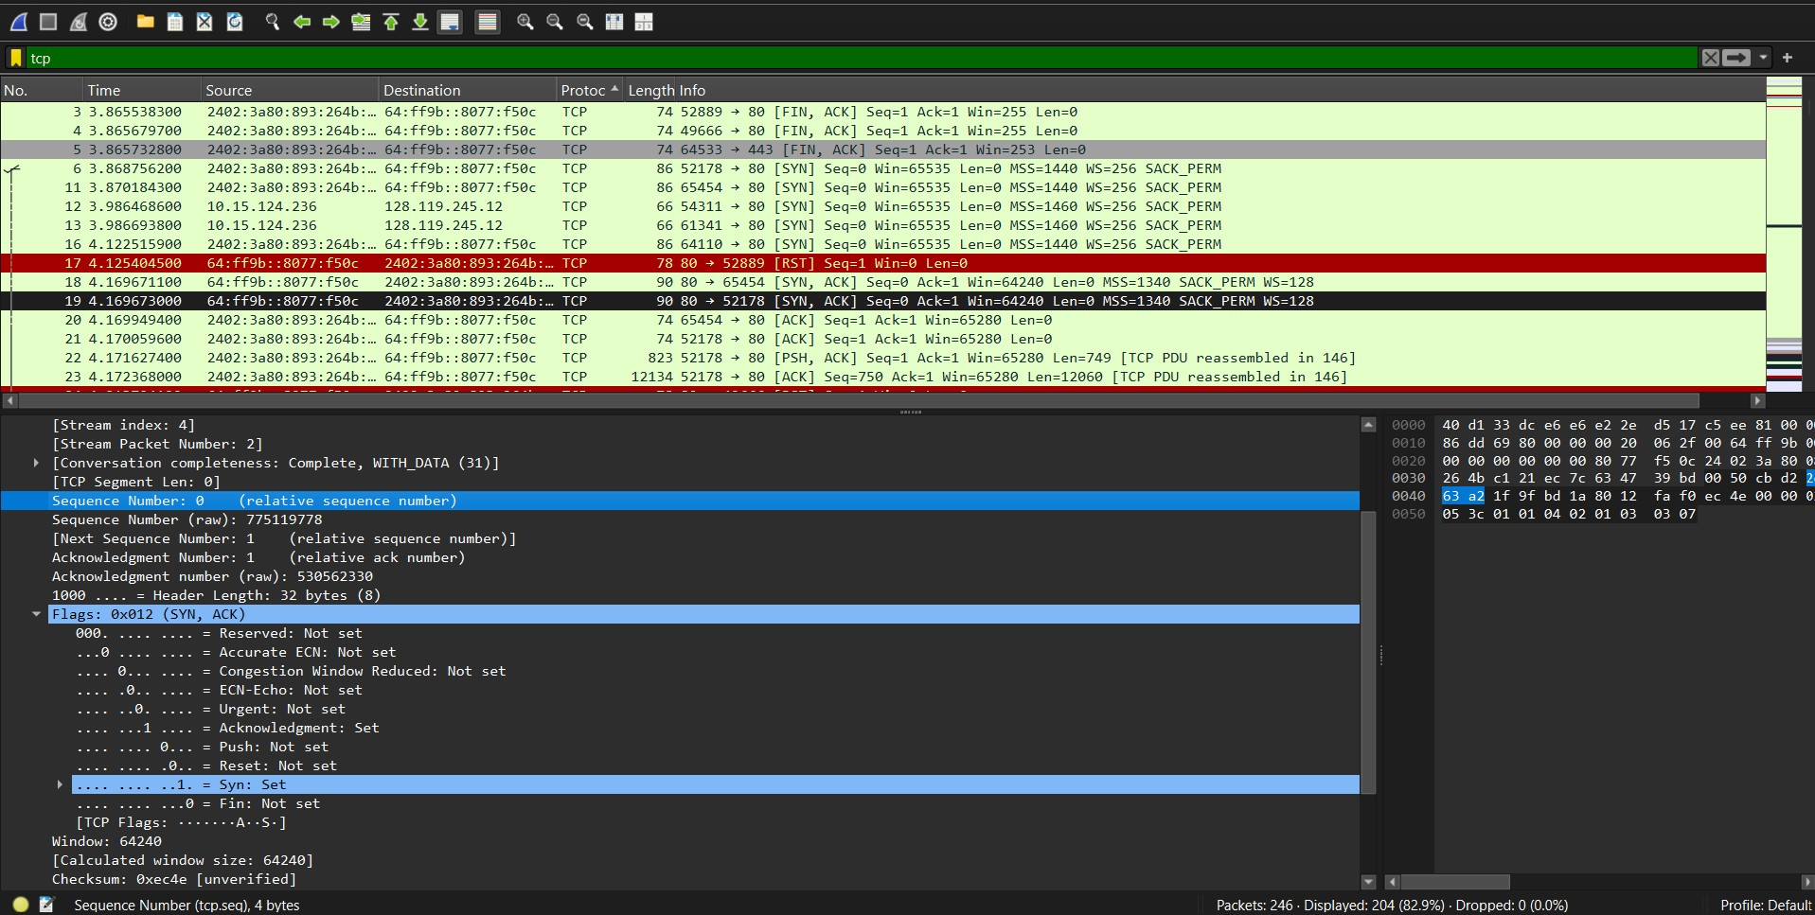

- Find the TCP packet that contains the HTTP POST command. What is its Sequence Number?

Sequence Number: 146810 (relative sequence number)
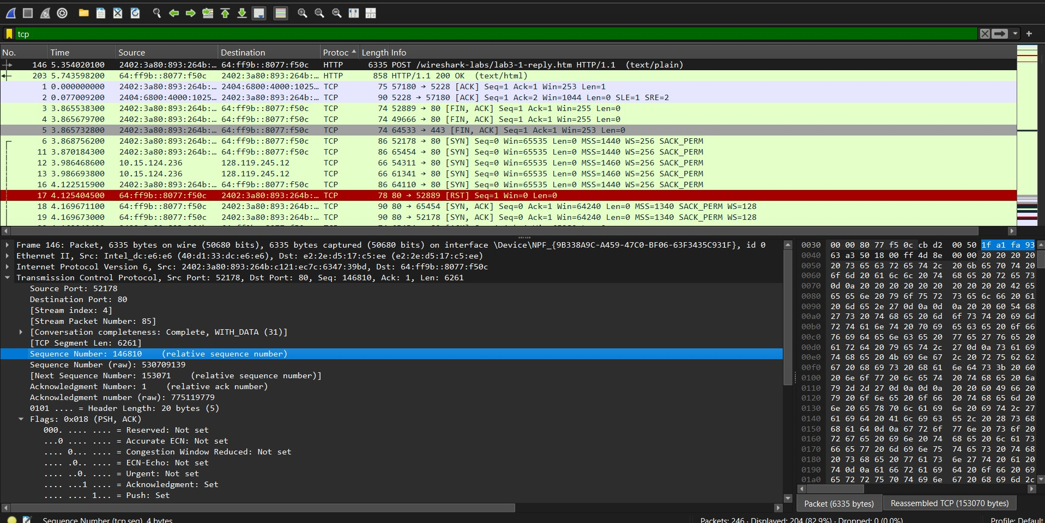

- What is the length of each of the first six TCP segments?

[TCP Segment Len: 749]
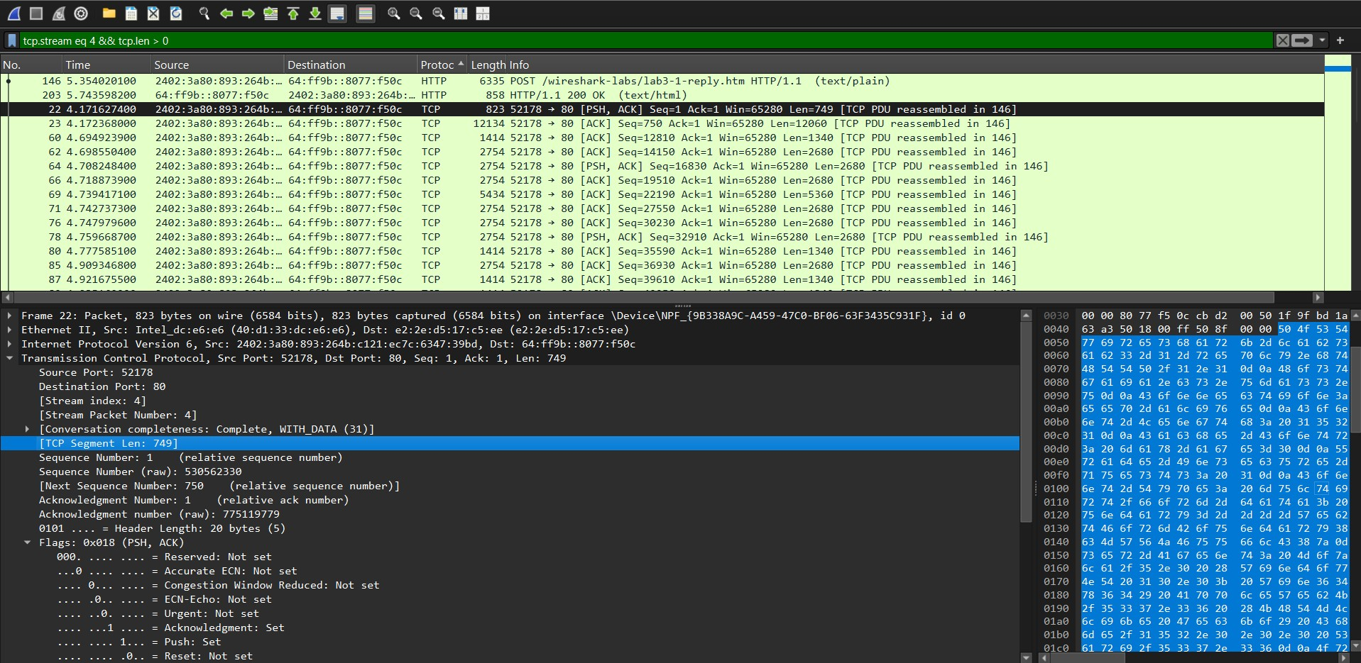
[TCP Segment Len: 12060]
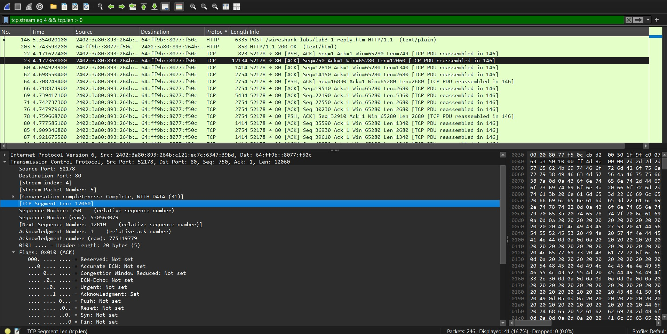

[TCP Segment Len: 1340]
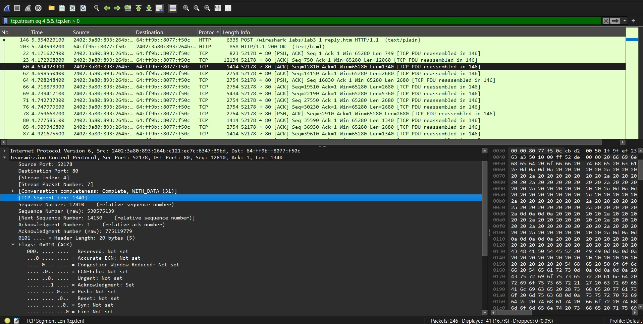

[TCP Segment Len: 2680]
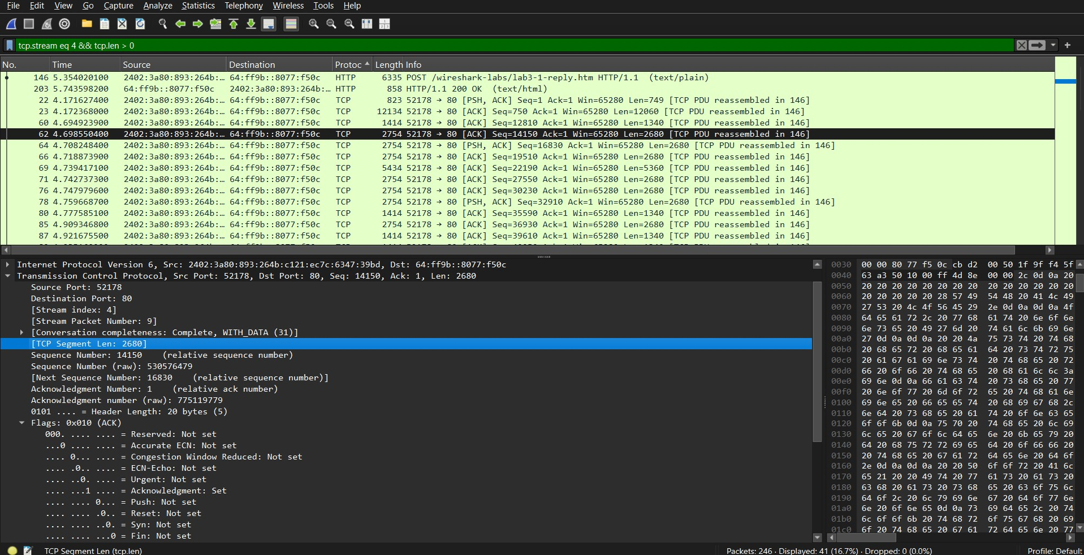

[TCP Segment Len: 5360]
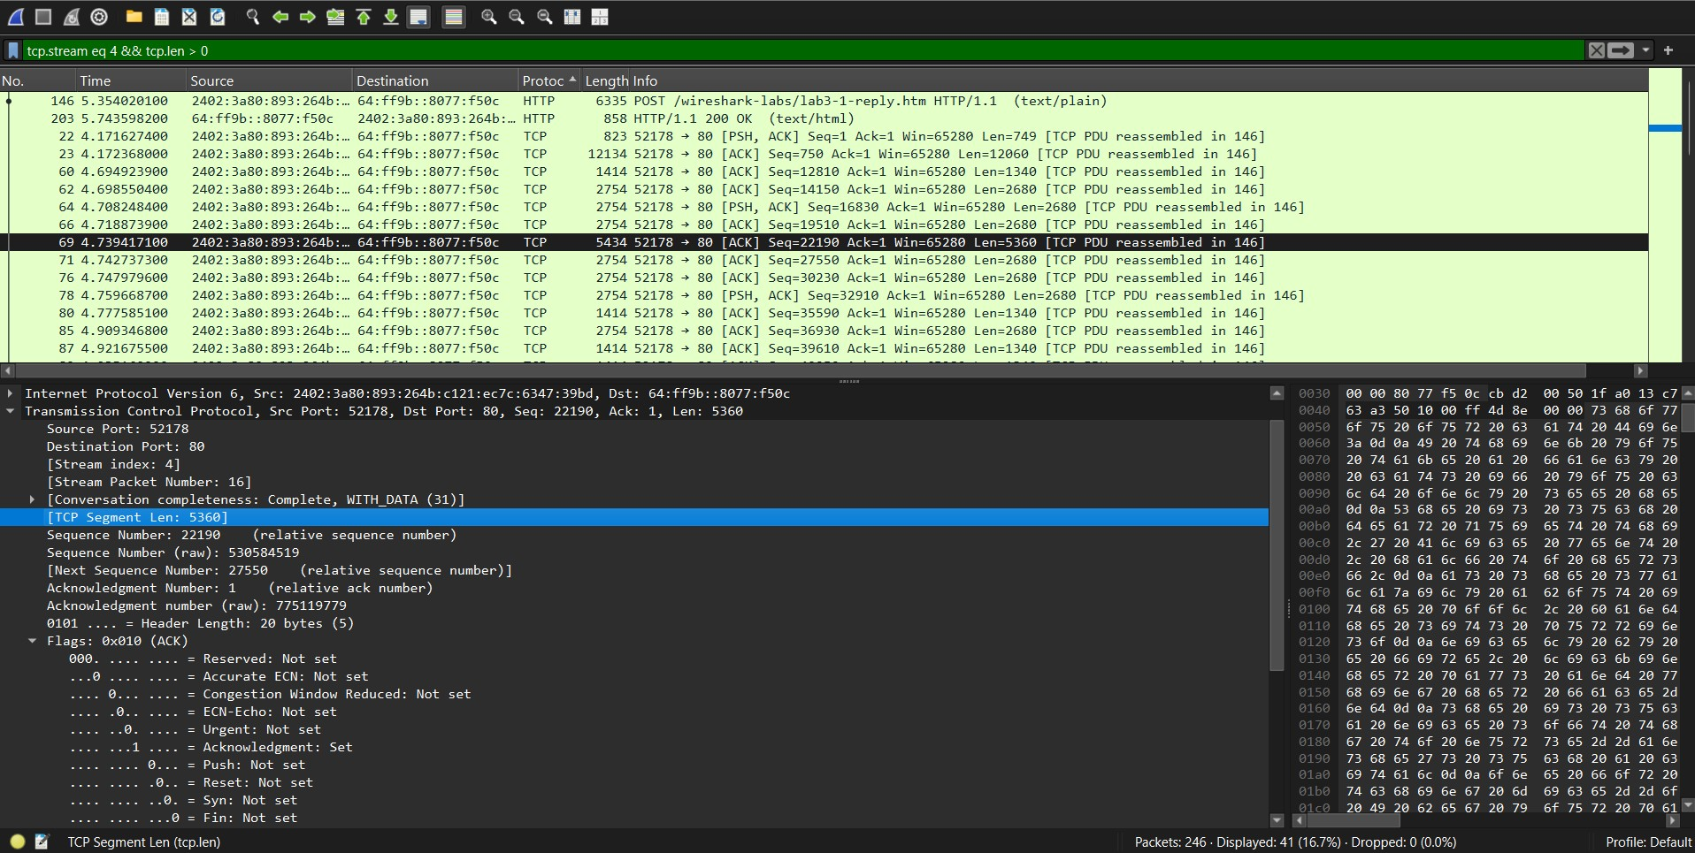

[TCP Segment Len: 2680]
