Name: Vivan Goradia
Roll No.: 2292
Div: FA3(D)
1. Use the filtering functionality of Wireshark by typing “dns” in
the filtering field, new window will appear:

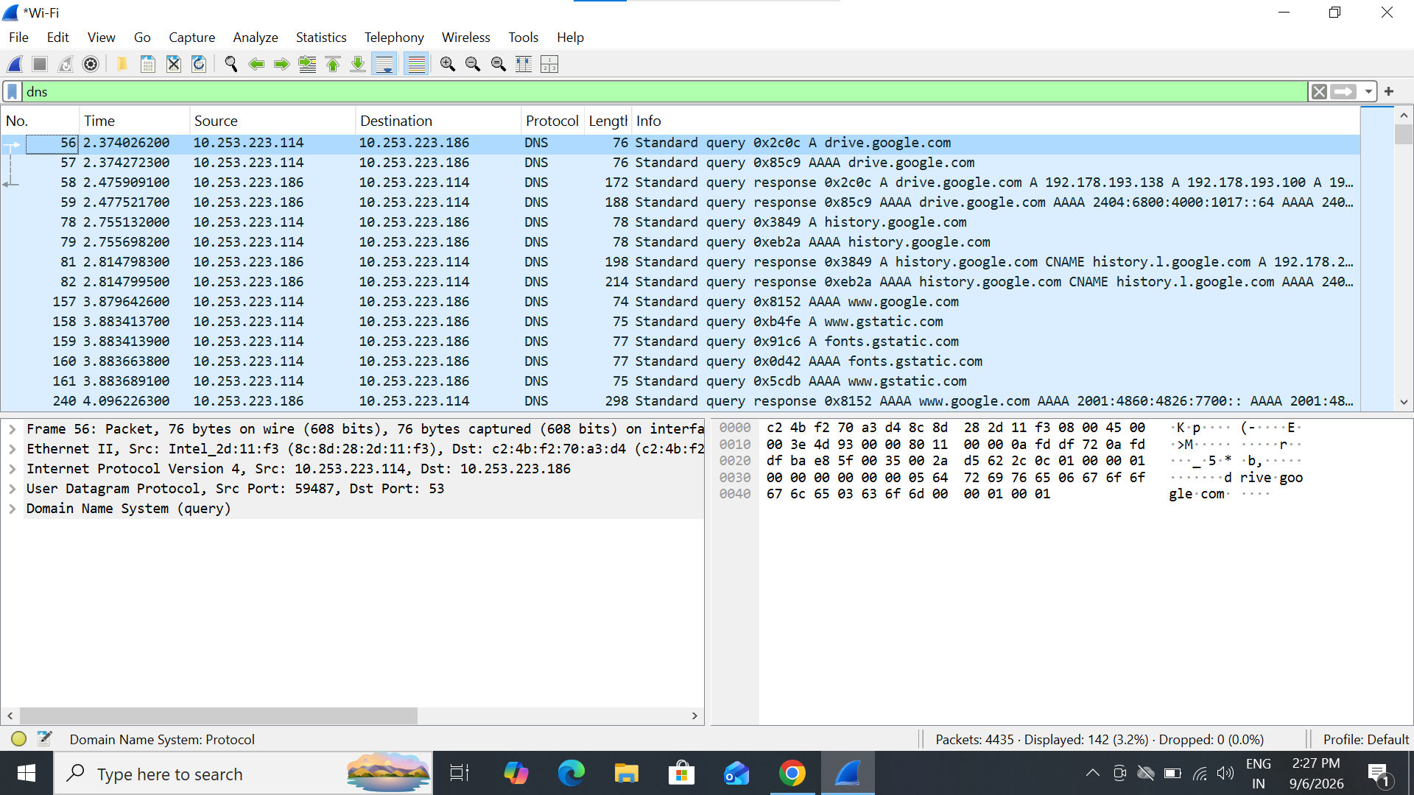

Name: Vivan Goradia
Roll No.: 2292
Div: FA3(D)
2. Let’s try now to find out what are those packets contain by
following one of the conversations (also called network flows),
select one of the packets and press the right mouse button, you
should see another screen appear.

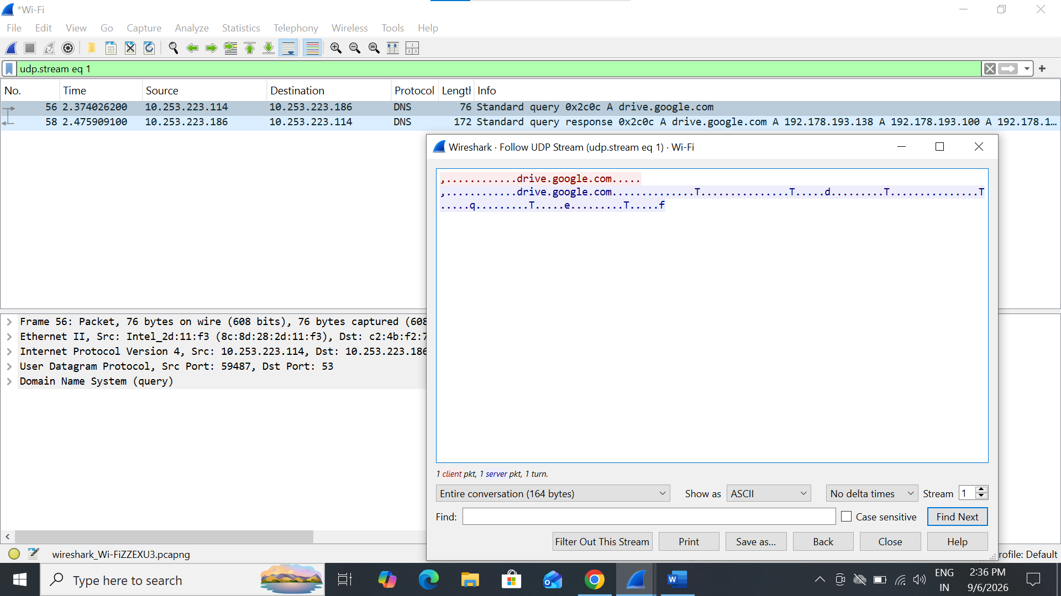

Name: Vivan Goradia
Roll No.: 2292
Div: FA3(D)
3. At Command prompt; Nslookuphttps://www.amazon.com/

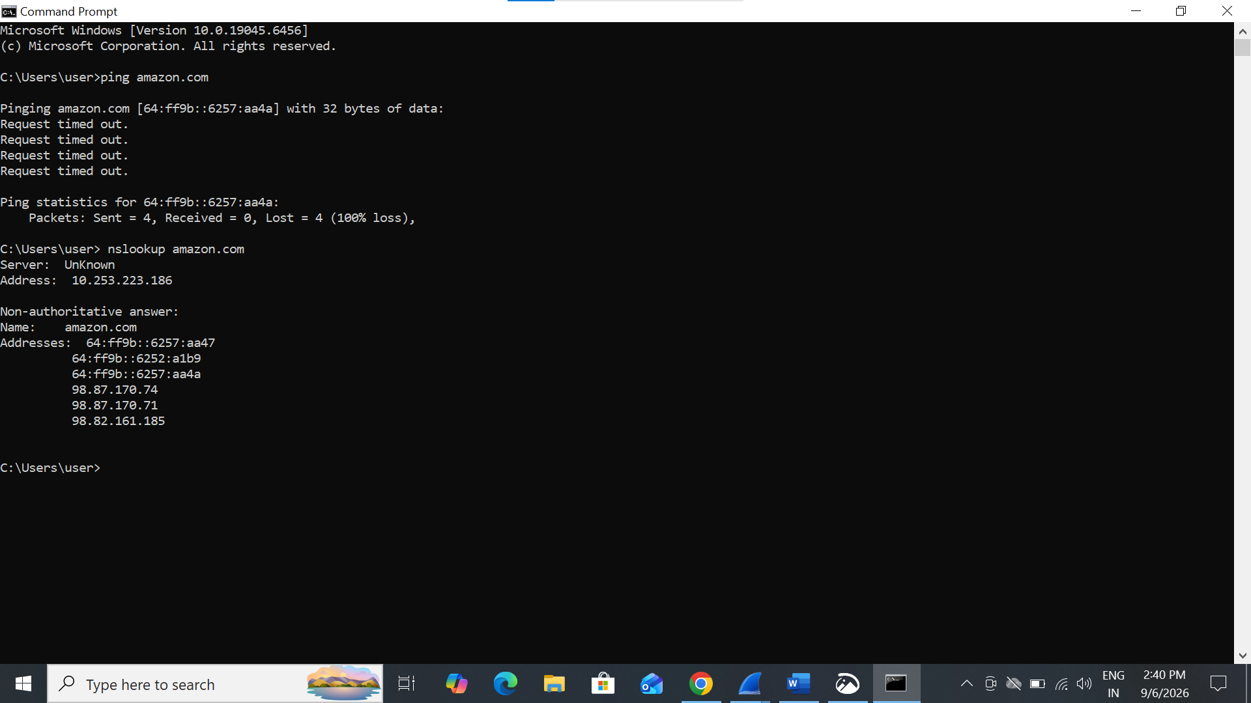

Name: Vivan Goradia
Roll No.: 2292
Div: FA3(D)
4. Locate the DNS Query and Response message, Are they sent on
UDP or TCP.
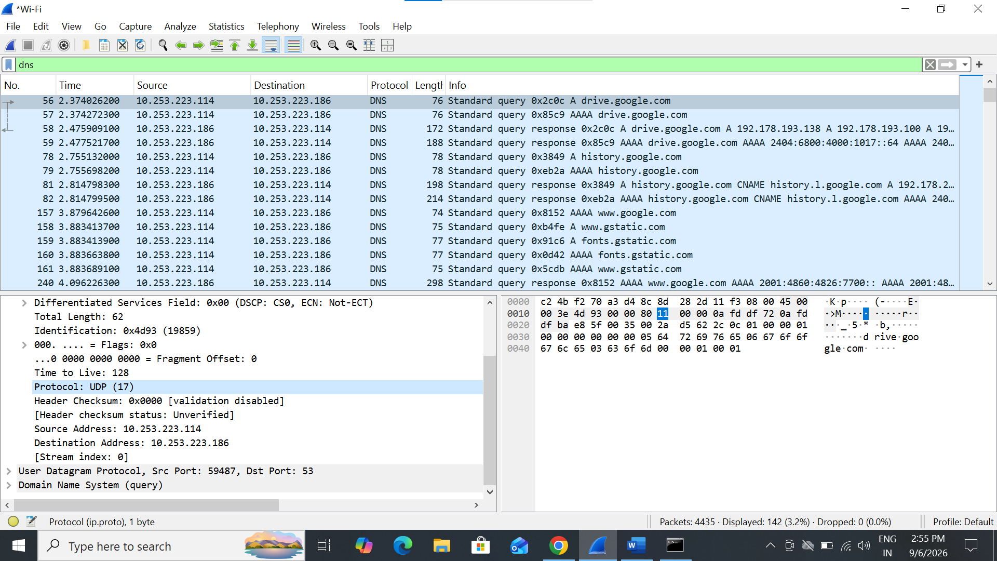
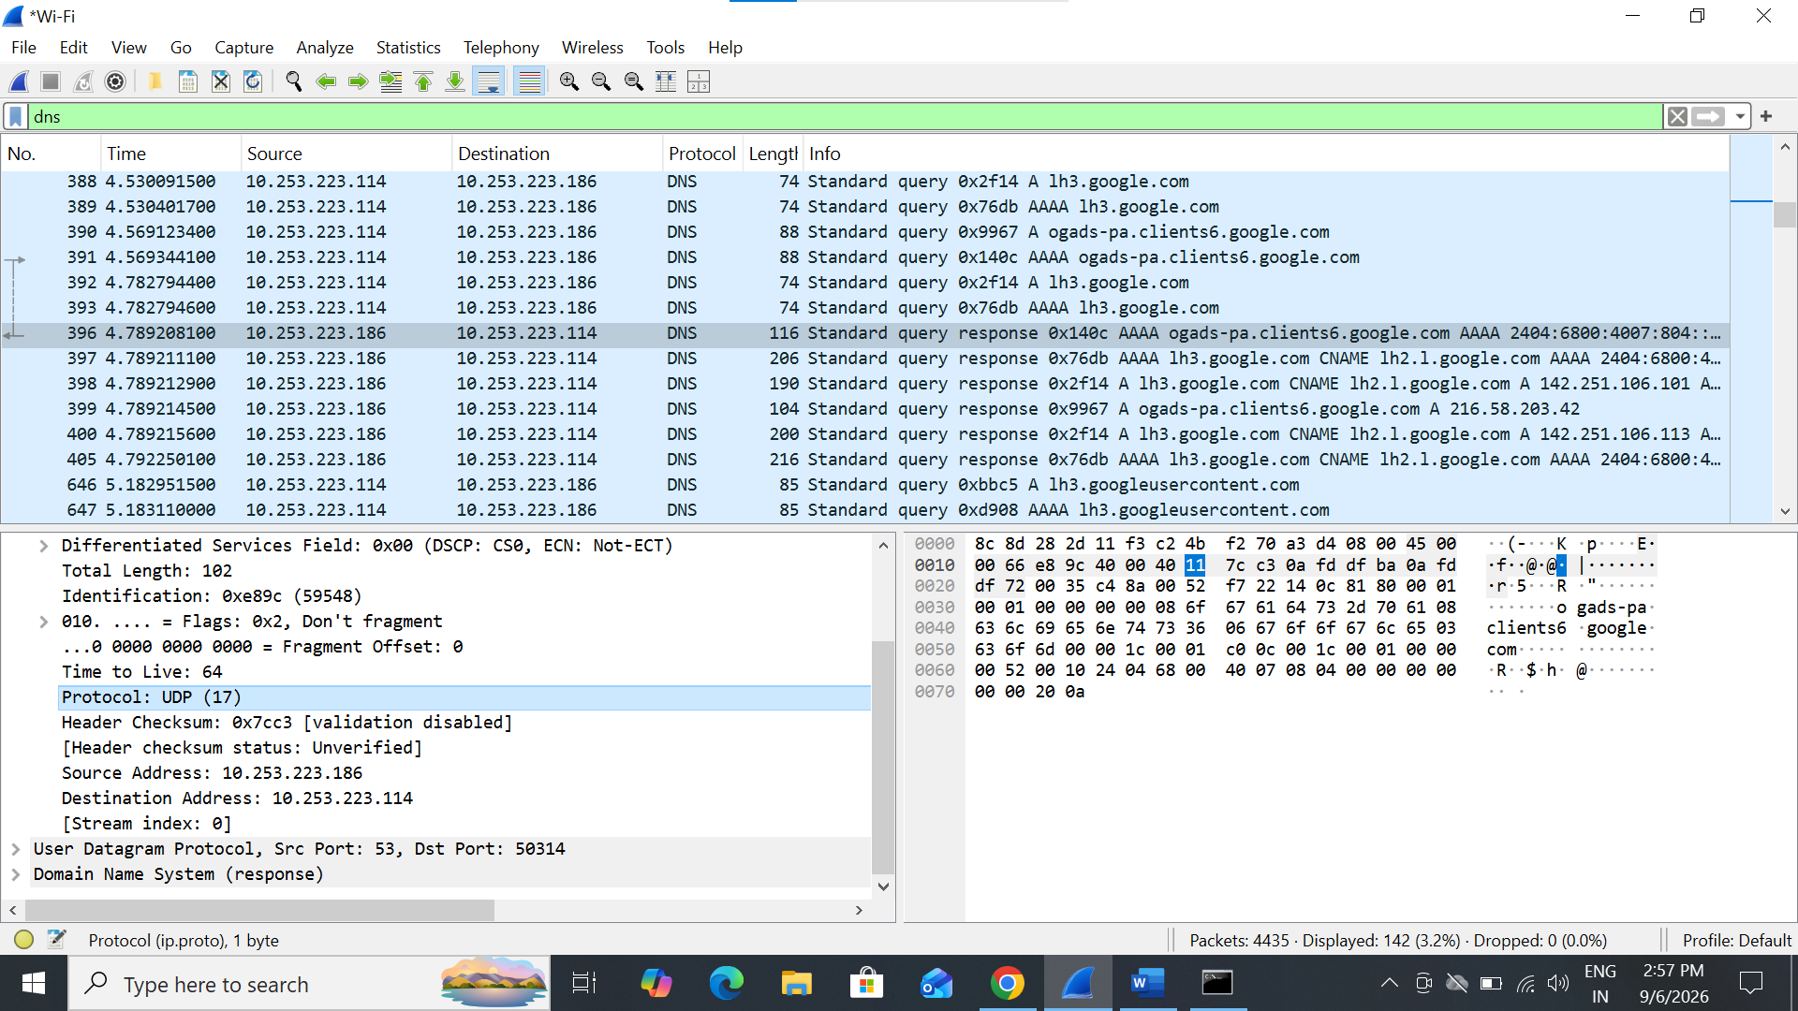
Name: Vivan Goradia
Roll No.: 2292
Div: FA3(D)
5. What is the destination port for the DNS query message ? What
is the source port of of DNS response message?
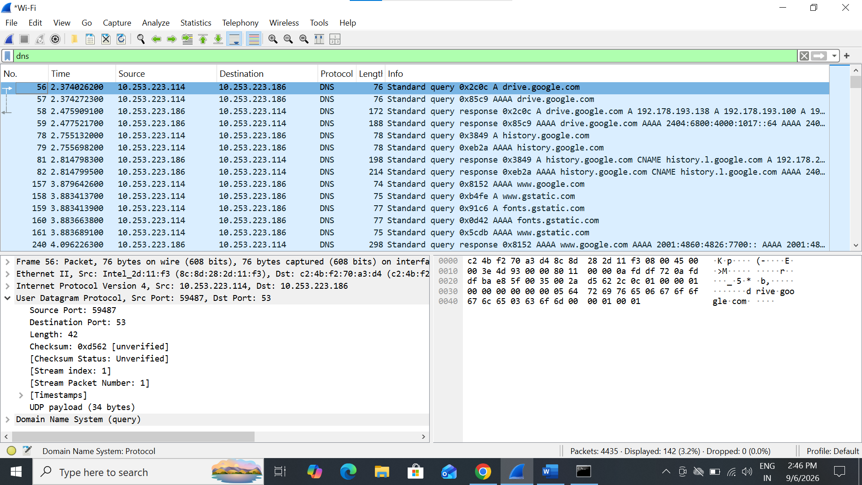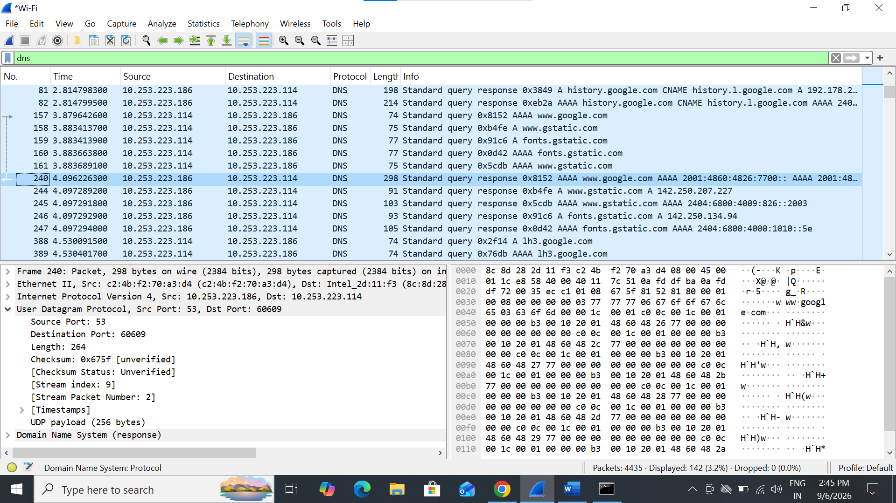

Name: Vivan Goradia
Roll No.: 2292
Div: FA3(D)
6. What is the source IP address of the DNS Query message? Is it the
IP address of your computer? Verify using ipconfig. Are these two
IP address the same?
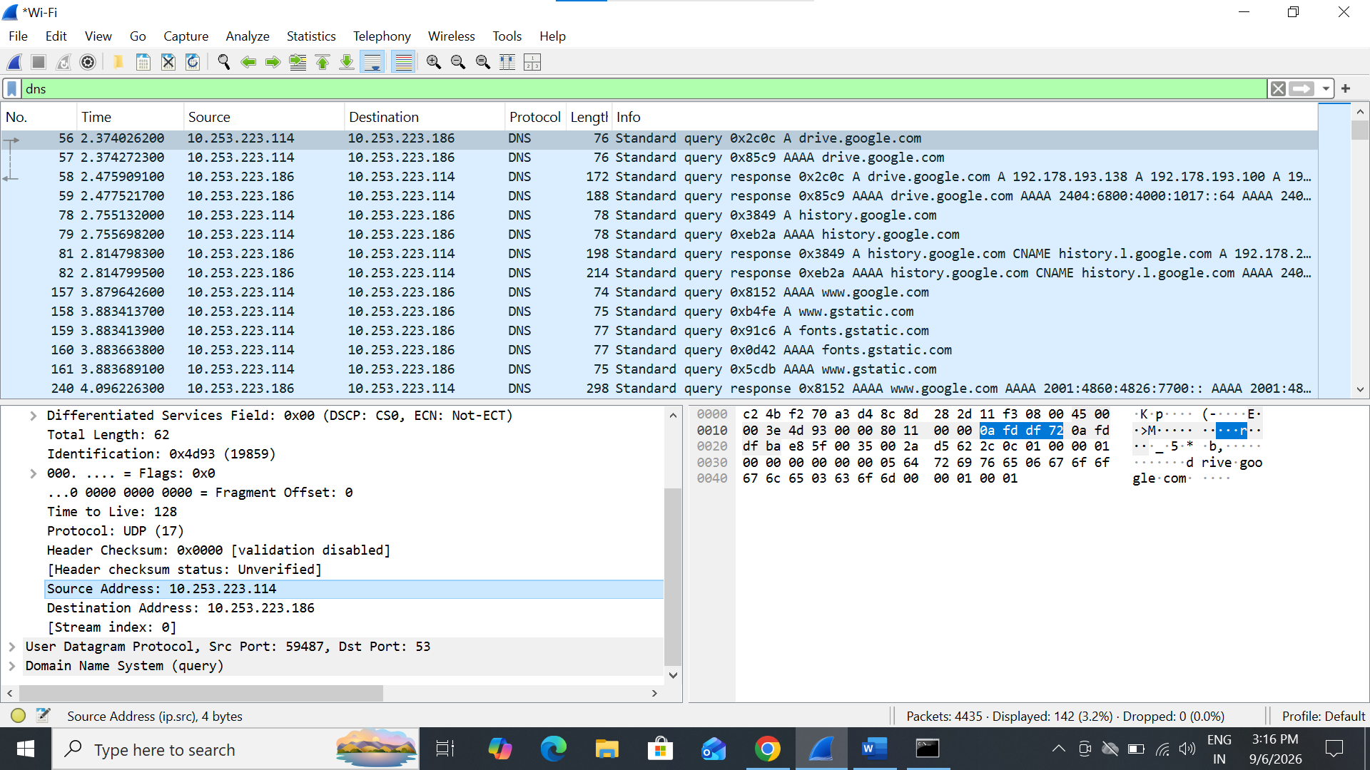
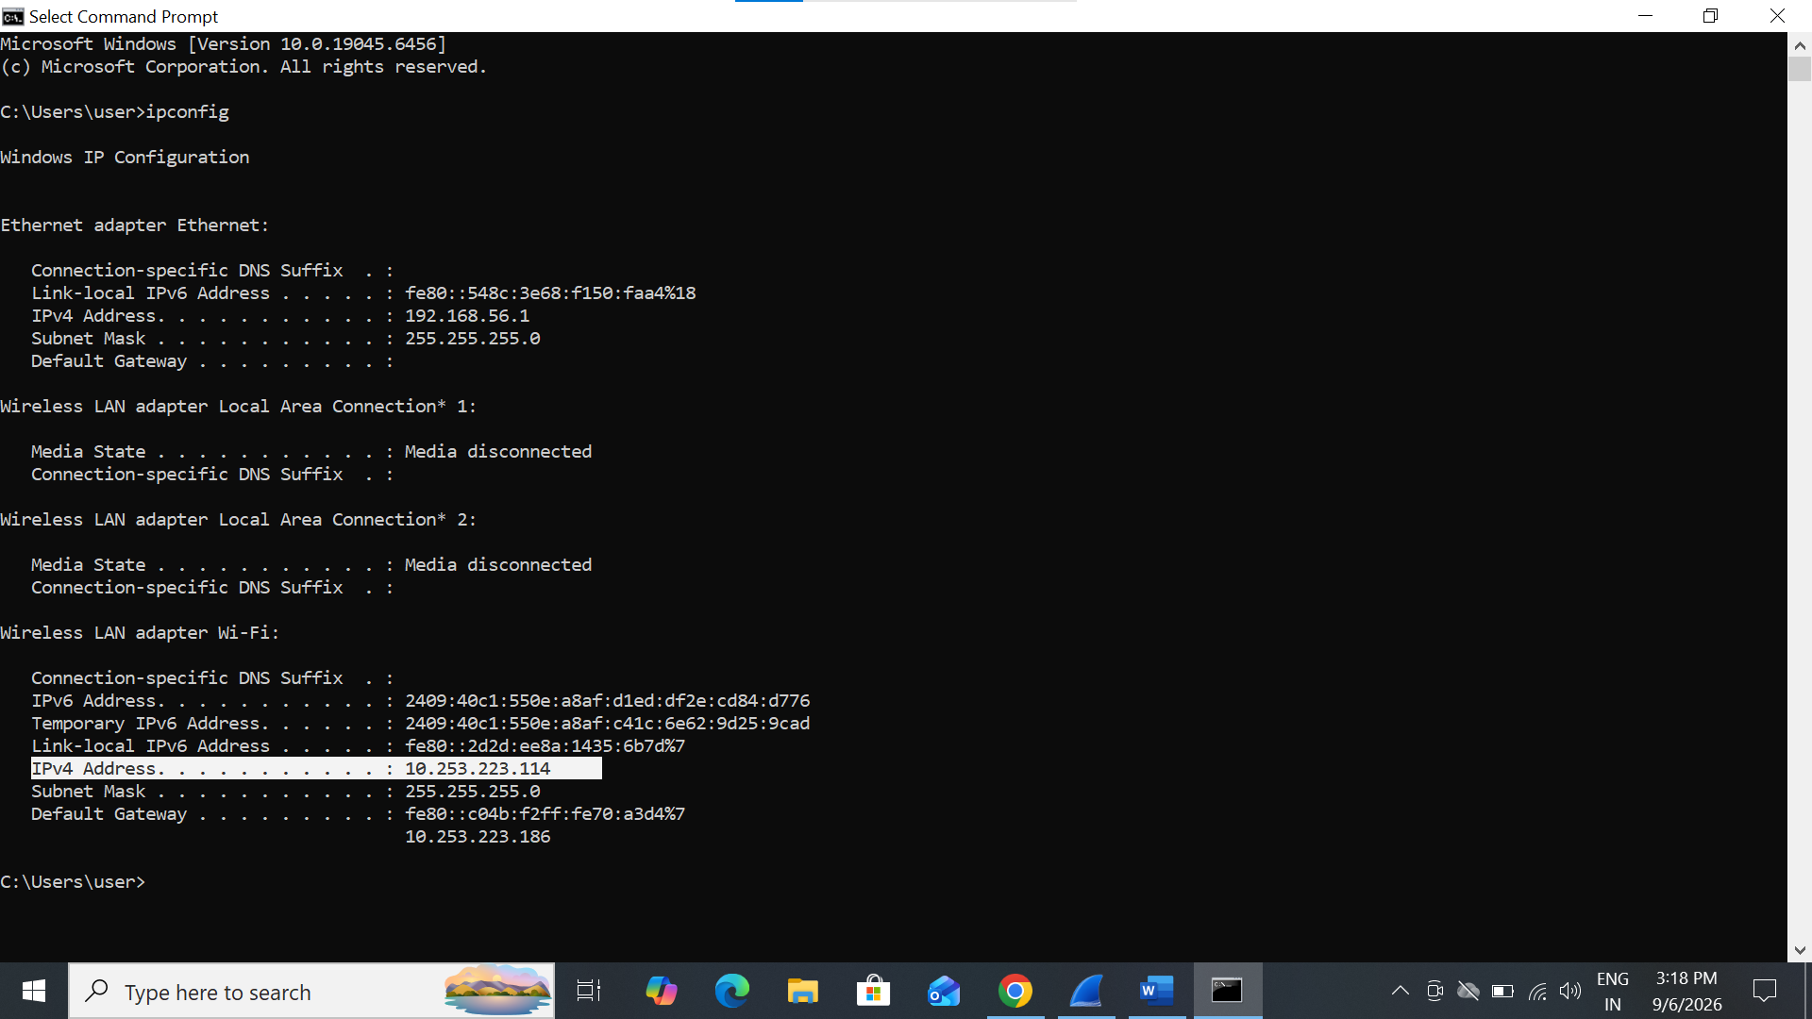
Name: Vivan Goradia
Roll No.: 2292
Div: FA3(D)
7. What is the destination IP address of the DNS Query message? Is it
the IP address of your local DNS server? Verify using ipconfig. Are
these two IP address the same?
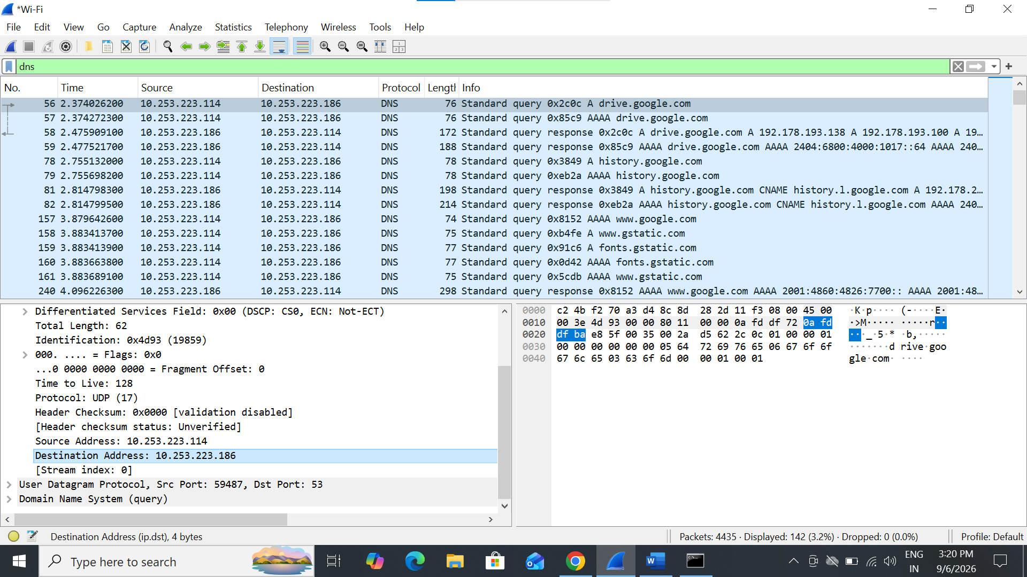
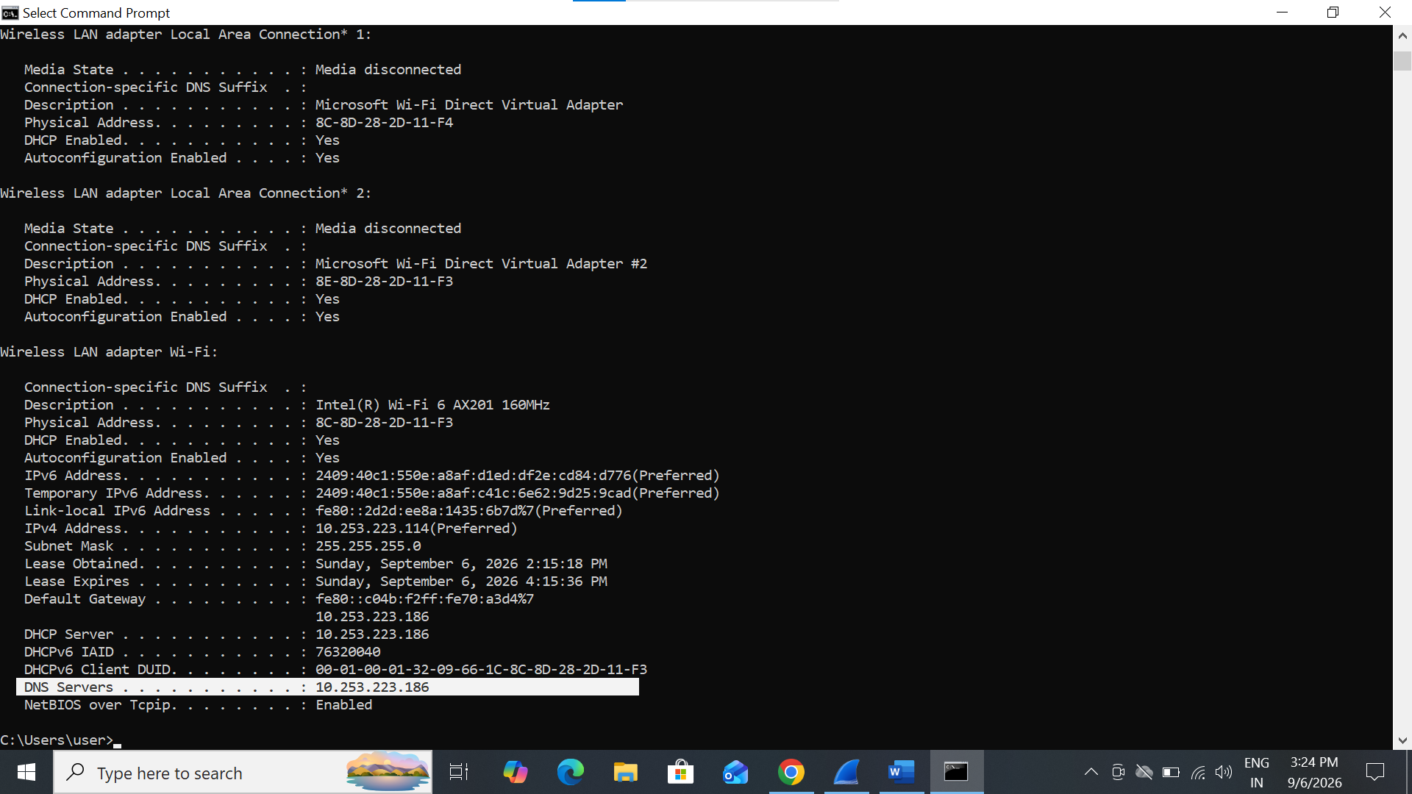
Name: Vivan Goradia
Roll No.: 2292
Div: FA3(D)

8. Examine the DNS query message. What “Type” of DNS query is
it? Does the query message contain any “answers”?

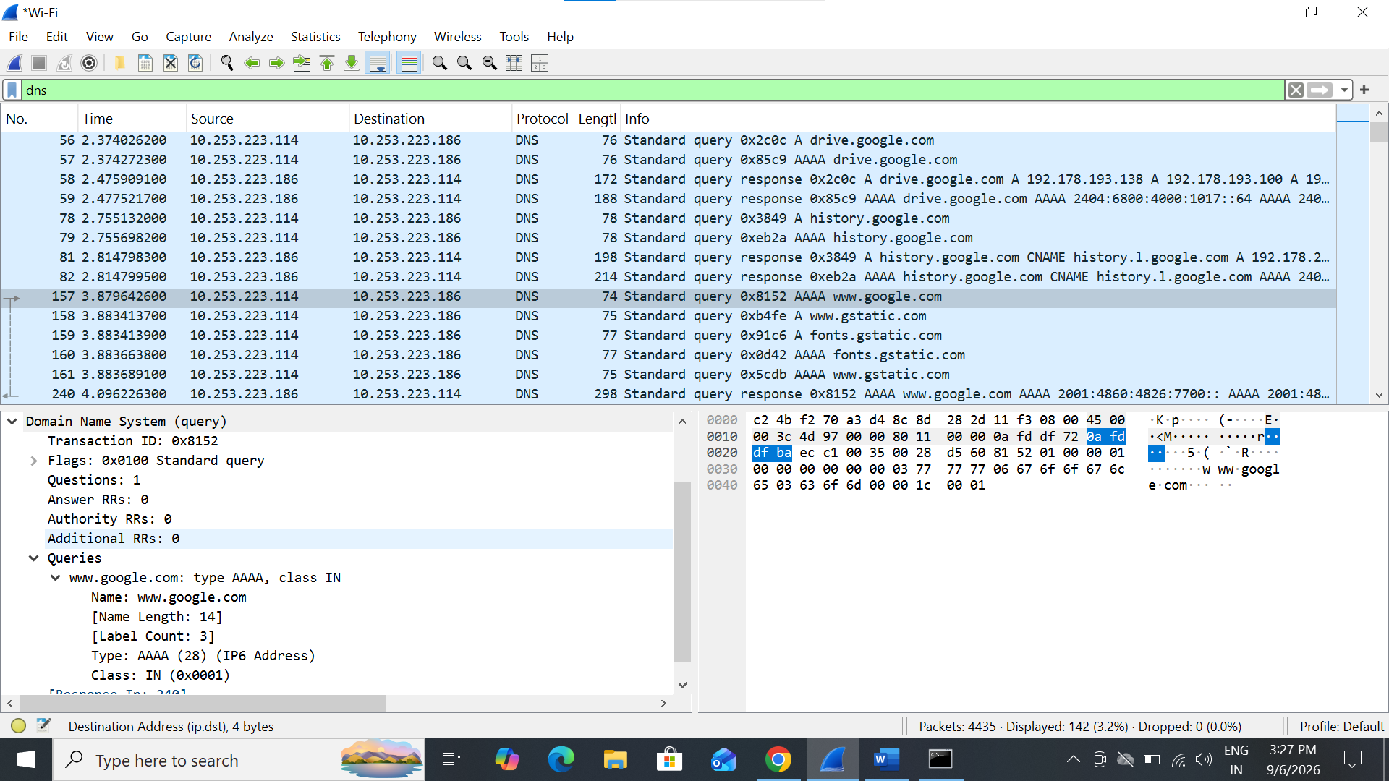

Name: Vivan Goradia
Roll No.: 2292
Div: FA3(D)
9. Examine the DNS response message. How many “answers” are
provided? What do each of these answers contain?
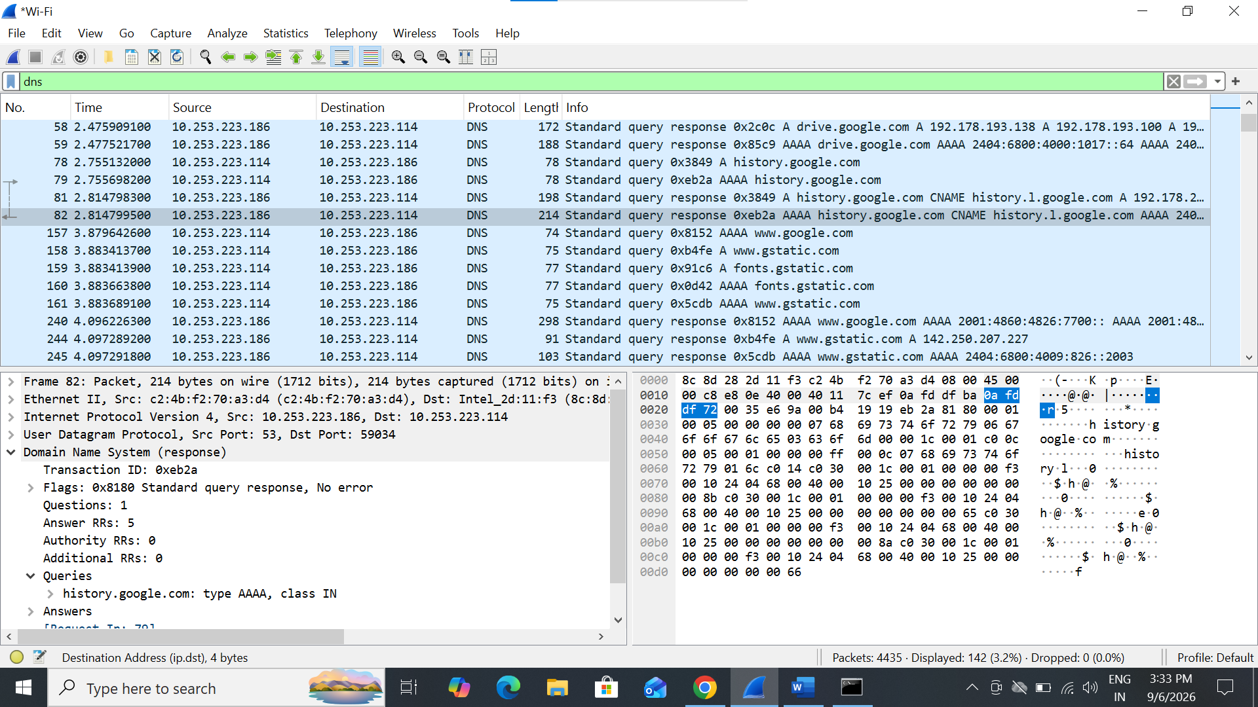
EXTENDED ANSWER:
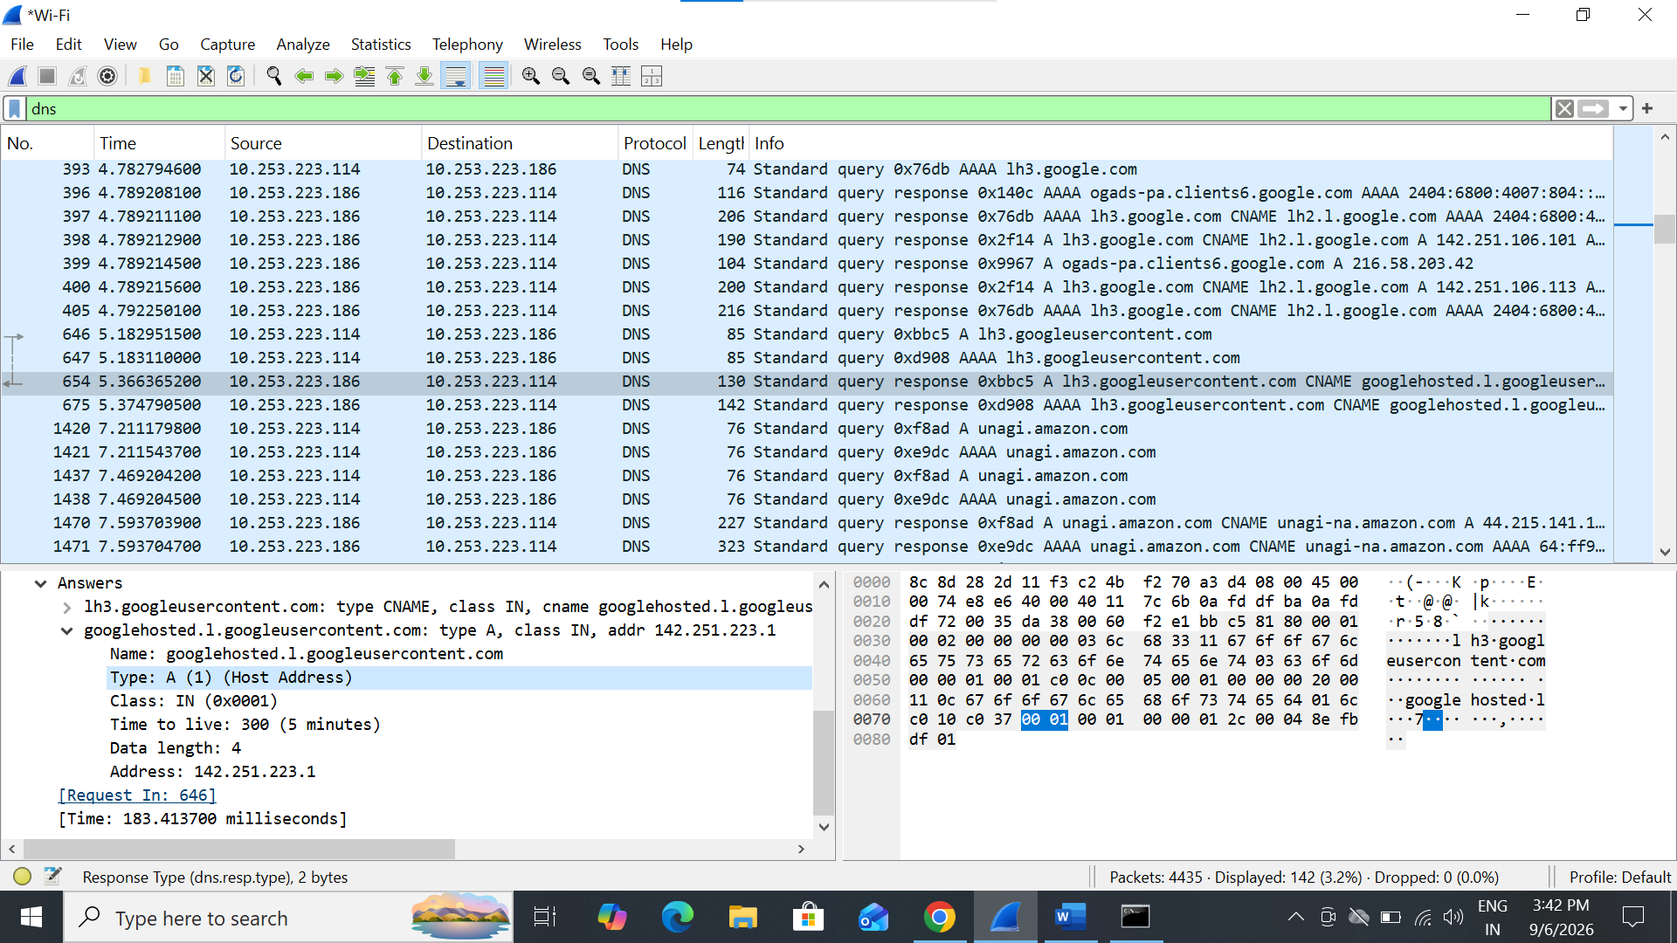
Name: Vivan Goradia
Roll No.: 2292
Div: FA3(D)
10. What Protocol use in Payload? How many bytes use in Payload?

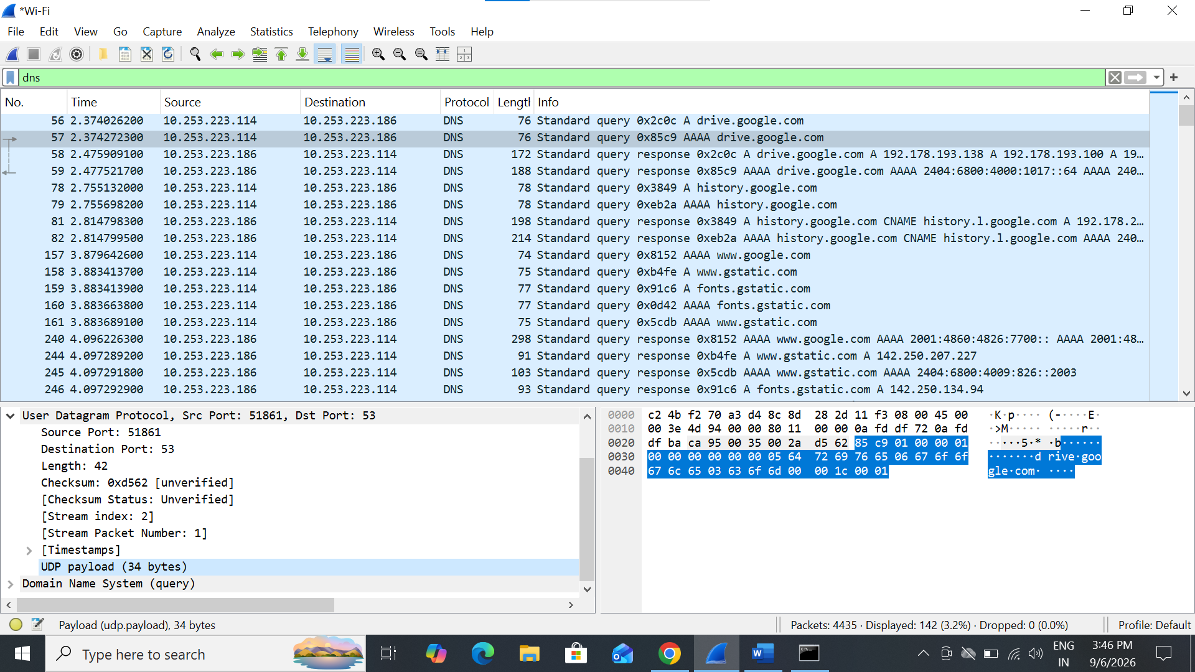

Name: Vivan Goradia
Roll No.: 2292
Div: FA3(D)
11.Find stream index and stream packet number of DNS Response.

