UDP is a connectionless transport layer protocol. It sends data directly without creating a connection or waiting for acknowledgements. This makes UDP fast but less reliable than TCP. In this practical, we will capture UDP packets in Wireshark and study their header fields and data.
https://www.myntra.com/
UDP Protocol:
1. Select one UDP packet from your trace. From this packet, determine how many fields there are in the UDP header.Name these fields.
Determine the length (in bytes) of the each of the udp header fields.
Total:8 bytes header
Four fields:source port(2 bytes)
Destination port(2 bytes)
Length(2 bytes)
checksum (2 bytes)
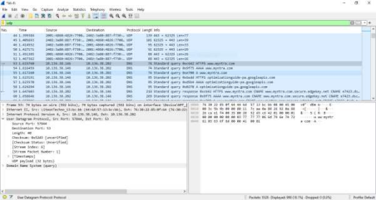
2. The value in the Length field is the length of what? (You can consult the text for this answer). Verify your claim with your captured UDP packet.
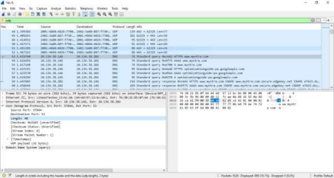
Ans :- Length = UDP Payload + UDP header bytes
Here length is 40, UDP Payload is 32 and the UDP header is always 8
bytes. So 32 + 8 = 40(Length).
3. What is the maximum number of bytes that can be included in a UDP payload? (Hint: the answer to this question can be determined by your answer to 2. above)
ANS: The maximum number of bytes that can be in the payload is 2^16-1 the bytes already being used by the header field (8 bytes). Maximum payload is 65535-8= 65527 bytes UDP Maximum Payload: 65,527 bytes (due to UDP header subtraction).
UDP Length :- 16 bytes, Maximum Length = 216 – 1 = 65535
Payload = Maximum Length – UDP Header
= 65535 – 8 = 65527
4.What is the largest possible source port number? (Hint: see the hint in 3.) Ans: The largest possible source port number is (2^16 – 1) = 65535
5. What is the protocol number for UDP? Give your answer in both hexadecimal and decimal notation. To answer this question, you’ll need to look into the Protocol field of the IP datagram containing this UDP segment .
:- Decimal :- 17 , Hexadecimal :- 11
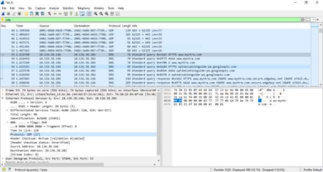
6. Examine a pair of UDP packets. The first packet is sent by your host, and the second packet is the reply to the first packet. Compare the source and destination port numbers of both packets. What is the relationship between them?
