**Overview:**

In this lab, the data distribution in ‘vehicles.csv’ is analysed and visualized on a histogram and scatterplot. We performed bootstrapping on the data to find the upper and lower bounds of the standard deviation.

The scatterplot:

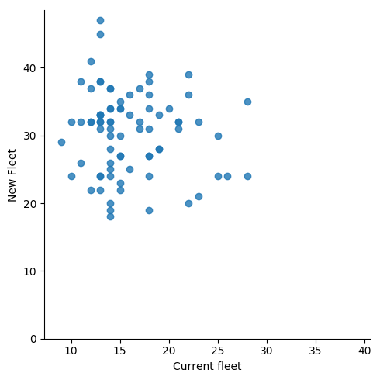

Histograms of Current Fleet:

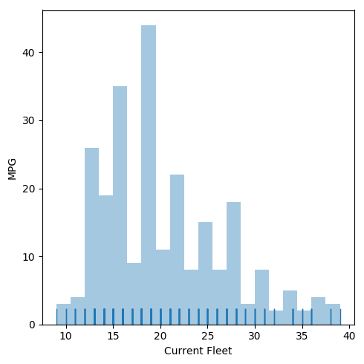

Histograms of New Fleet:

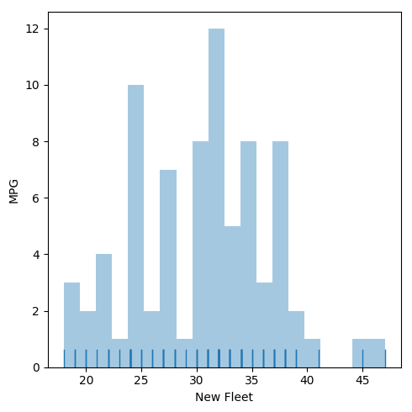

Bootstrapping Results:

Current Fleet:

The standard deviation for the current fleet is 6.401805.

-- Median: 15.000000 -- MAD: 2.000000.

New Fleet:

The standard deviation for the new fleet is = 6.06893054515.

-- Median: 32.000000 -- MAD: 4.000000.