**Experiment Title.**

**Student Name:** ANAMIKA SINGH  **UID:**19MCA8115

**Branch:** MCA(Leet) **Section/Group:**C(Group 1)

**Semester:** 5  **Date of Performance:**31/7/2020

# Subject Name: WEB APPLICATION DEVELOPMENT USING VISUAL STUDIO LAB

# Subject Code: CAA-814

1. **Aim/Overview of the practical:**

Aim of this practical is how to know the concept of properties in C#, conditions and generics.

1. **Task to be done**

WAP to demonstrate Properties and Conditions are:-

1. UID>0
2. Name is not null
3. Marks>50

Create a class of generic type in which you have to declare private fields and in the main function you have to assign the type to that is string.

1. **Concept Used:**
2. In first program I use the if else statement and also use properties(GET and SET).
3. In second program I use the generic concept.
4. **Code for experiment/practical:**

**Ans 1:**

**using System.IO;**

**using System;**

**class A**

**{**

**private string name;**

**private int marks, uid;**

**public int a_uid{**

**get{**

**return uid;**

**}**

**set{**

**uid=value;**

**}**

**}**

**public string a_name{**

**get{**

**return name;**

**}**

**set{**

**name=value;**

**}**

**}**

**public int a_marks{**

**get{**

**return marks;**

**}**

**set{**

**marks=value;**

**}**

**}**

**}**

**class Program**

**{**

**static void Main()**

**{**

**A a = new A();**

**a.a_uid = Convert.ToInt16(Console.ReadLine());**

**a.a_name = Console.ReadLine();**

**a.a_marks = Convert.ToInt16(Console.ReadLine());**

**if(a.a_uid>0)**

**{**

**if(a.a_name!=null)**

**{**

**if(a.a_marks>50)**

**{**

**Console.WriteLine("Satisfied!!");**

**}**

**else**

**Console.WriteLine("Not satisfied!!");**

**}**

**else**

**Console.WriteLine("Not satisfied!!");**

**}**

**Console.WriteLine("Not satisfied!!");**

**}**

**}**

**Ans 2:**

using System;

usingSystem.Collections.Generic;

usingSystem.Linq;

usingSystem.Text;

namespace ConsoleApplication12

{

publicclassabc<T> {

private T message;

public T value

{

get

{

returnthis.message;

}

set

{

this.message = value;

}

}

}

classProgram

{

staticvoid Main(string[] args)

{

abc<string>pr = newabc<string>();

pr.value = "Hello SWATI";

Console.WriteLine("You entered this text::::::::::::"+pr.value);

Console.ReadKey();

}

}

}

1. **Result/Output/Writing Summary:**

**OUTPUT 1:**

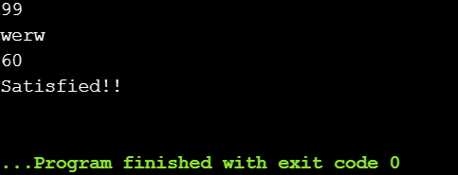

**OUTPUT 2:**

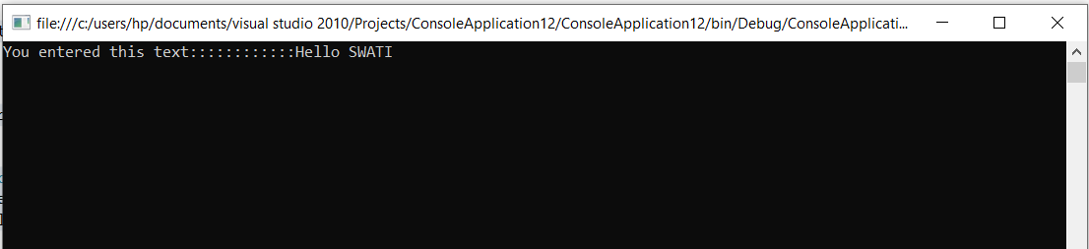

**Learning outcomes (What I have learnt):**

**1.**How we use generics.

**2.**How we use GET and SET.

**3.**How we implement condition in program.

**Evaluation Grid:**

|  |  |  |  |
| --- | --- | --- | --- |
| Sr. No. | Parameters | Marks Obtained | Maximum Marks |
| 1. | Demonstration and Performance (Pre Lab Quiz) |  | 5 |
| 2. | Worksheet |  | 10 |
| 3. | Post Lab Quiz |  | 5 |