Performance Test Report

Date | Jul 8, 2019 7:37:29 PM
Project | EditorNeoLoad
Scenario | scenario1
Comment
Notes

Summary
Results summary
Name | 19:37 - 8 Jul 2019 | Project | EditorNeoLoad
Description |  | Scenario | scenario1
Description |  | Load Policy | • The population Population1 is constant with 2 users for 1 iteration(s).
Status | Passed | Load Policy
Start date | Jul 8, 2019 7:37:29 PM | Load Policy
End date | Jul 8, 2019 7:41:07 PM | Stop Policy | • Population Population1: immediate.
Duration | 00:03:37 | Stop Policy | • Population Population1: immediate.
Termination reason | Execution policy | Filters | None
LG Hosts | l​o​c​a​l​h​o​s​t​:​7​1​0​0​ | Debug | Disabled
Statistics Summary
Total pages | 408 |  | Average pages/s | 1.9
Total requests | 408 |  | Average requests/s | 1.9
Total users launched | 2 |  | Average Request response time | 0.034 s
Total iterations completed | 2 |  | Average Page response time | 0.034 s
Total throughput | 7.3 MB |  | Average throughput | 0.27 Mb/s
Total request errors | 0 |  | Error rate | 0 %
Total action errors | 0 |  | Alerts total duration | 0 %

= No SLA | = Passed | = Warning | = Failed

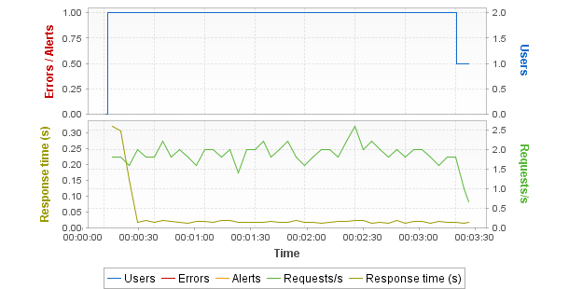
Hot spots
Top 5 errors
No errors on pages
Top 5 alerts
No alerts
First critical alerts
No alerts
Top 5 average response time (Pages)
User Path | Parent | Page | Duration
UserPath | Actions | Home Page | 1.31
UserPath | loop | Edit Post | 0.031
UserPath | Actions | Log In Page | 0.029
UserPath | loop | Open Predefined Date | 0.028
UserPath | loop | Open Edit Post Page | 0.027
Top 5 maximum response time (Pages)
User Path | Parent | Page | Duration
UserPath | Actions | Home Page | 1.31
UserPath | loop | Open Edit Post Page | 1.06
UserPath | loop | Open Predefined Date | 0.765
UserPath | loop | Edit Post | 0.413
UserPath | loop | Open First Post | 0.24
Errors
Request errors
No errors
Action errors
No errors
Alerts
No alerts
General statistics
Min | Avg | Max | Count | Err | % of Err | SLA Profile
All User Paths
5.63 | 6.91 | 8.19 | 2 | 0 | 0 | -
All pages
0.003 | 0.033 | 1.31 | 408 | 0 | 0 | -
All requests
0.003 | 0.033 | 1.31 | 408 | 0 | 0 | -
Transaction statistics
Min | Avg | Max | Count | Err | % of Err | Perc 50 | Perc 95 | Perc 99 | Std Dev | Avg-90% | SLA Profile
Empty list

Scenario
Summary
Name | 19:37 - 8 Jul 2019 | Project | EditorNeoLoad
Description |  | Scenario | scenario1
Description |  | Load Policy | • The population Population1 is constant with 2 users for 1 iteration(s).
Status | Passed | Load Policy
Start date | Jul 8, 2019 7:37:29 PM | Load Policy
End date | Jul 8, 2019 7:41:07 PM | Stop Policy | • Population Population1: immediate.
Duration | 00:03:37 | Stop Policy | • Population Population1: immediate.
Termination reason | Execution policy | Filters | None
LG Hosts | l​o​c​a​l​h​o​s​t​:​7​1​0​0​ | Debug | Disabled
Populations
Population1
User Path | Percentage | WAN Emulation | Signal strength | Bandwidth ↑ | Latency ↑ | Packet loss % ↑ | Bandwidth ↓ | Latency ↓ | Packet loss % ↓ | Browser | Handle cookies | Connections | Handle cache
UserPath | 100.0% | Unlimited |  | Unlimited | 0ms | 0% | Unlimited | 0ms | 0% | Recorded one | Yes | 6 | As recorded
User Paths
Name | Description | On failed assertion | On error | Think time | Thinktime range
UserPath |  | Do nothing | Do nothing | 1000ms | 50%
Rendezvous
Enabled | Name | Policy | Value | Timeout
Empty list

Execution context
Name | 19:37 - 8 Jul 2019 |  | Project | EditorNeoLoad
Description |  |  | Scenario | scenario1
Description |  |  | Load Policy | • The population Population1 is constant with 2 users for 1 iteration(s).
Status | Passed |  | Load Policy
Start date | Jul 8, 2019 7:37:29 PM |  | Load Policy
End date | Jul 8, 2019 7:41:07 PM |  | Stop Policy | • Population Population1: immediate.
Duration | 00:03:37 |  | Stop Policy | • Population Population1: immediate.
Termination reason | Execution policy |  | Filters | None
LG Hosts | l​o​c​a​l​h​o​s​t​:​7​1​0​0​ |  | Debug | Disabled
NeoLoad version |  | 6.10.0;build=20190514-29
Graphs granularity |  | Standard
Application proxy
Name | Description
Empty list
Zone application proxies
Zone | Name | Description
Empty list
Constant variables
Name | Value | Description
Empty list
User Paths settings
UserPath
Error policy: | Do nothing
Assertion policy: | Do nothing
Thinktime policy: | replaced by 1000ms. (with random delay of +/- 50%)
Pacing: | No pacing

Servers
Servers
Host | Port | HTTP/2 ready | HTTP/2 used
10.17.173.11 | 80 | No | No

Populations
Graphs
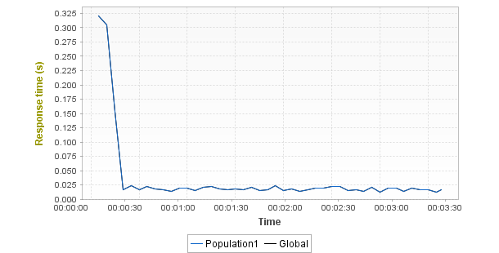
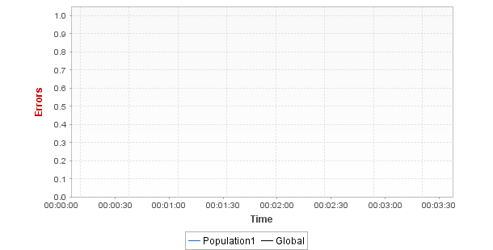
Statistics
Population | Total requests | Average requests/s | Avg. Page res. time | Error rate
Population1 | 408 (100%) | 1.9 | 0.034s (0%) | 0% ( - %)
Global | 408 (100%) | 1.9 | 0.034s | 0%

User Paths
User Paths
Min | Avg | Max | Count | Err | % of Err | SLA Profile
UserPath
5.63 | 6.91 | 8.19 | 2 | 0 | 0 | -

Transactions
Shared Containers
Min | Avg | Max | Count | Err | % of Err | Perc 50 | Perc 95 | Perc 99 | Std Dev | Avg-90% | SLA Profile
Empty list
UserPath
Min | Avg | Max | Count | Err | % of Err | Perc 50 | Perc 95 | Perc 99 | Std Dev | Avg-90% | SLA Profile
UserPath
5.63 | 6.91 | 8.19 | 2 | 0 | 0 | - | - | - | - | - | -
Init
0 | 0 | 0 | 2 | 0 | 0 | - | - | - | - | - | -
Actions
5.63 | 6.91 | 8.19 | 2 | 0 | 0 | - | - | - | - | - | -
End
0 | 0 | 0 | 2 | 0 | 0 | - | - | - | - | - | -

Push messages
Shared Containers
Min | Avg | Max | Count | Err | % of Err | SLA Profile
Empty list
UserPath
Min | Avg | Max | Count | Err | % of Err | SLA Profile
Empty list

Pages
Shared Containers
Min | Avg | Max | Count | Err | % of Err | SLA Profile
Empty list
UserPath
Min | Avg | Max | Count | Err | % of Err | SLA Profile
UserPath
5.63 | 6.91 | 8.19 | 2 | 0 | 0 | -
Actions
5.63 | 6.91 | 8.19 | 2 | 0 | 0 | -
Home Page
1.3 | 1.31 | 1.31 | 2 | 0 | 0 | -
Log In Page
0.014 | 0.029 | 0.045 | 2 | 0 | 0 | -
Log In
0.004 | 0.008 | 0.013 | 2 | 0 | 0 | -
Open Predefined Date
0.007 | 0.028 | 0.765 | 100 | 0 | 0 | -
Open First Post
0.01 | 0.025 | 0.24 | 100 | 0 | 0 | -
Open Edit Post Page
0.003 | 0.027 | 1.06 | 100 | 0 | 0 | -
Edit Post
0.009 | 0.031 | 0.413 | 100 | 0 | 0 | -
Log Out
0.003 | 0.004 | 0.005 | 2 | 0 | 0 | -

SLA per User Path
Shared Containers
SLA | Value | Severity
Empty list
UserPath
SLA | Value | Severity
UserPath
Actions
Home Page
Log In Page
Log In
Open Predefined Date
Open First Post
Open Edit Post Page
Edit Post
Log Out

Media Contents
UserPath
Count | Errors | Bitrate | Played Time | Lag Duration | Lag Ratio | Fill Buffer Duration
Empty list

Monitors
Controller
Performance Counters
Min | Avg | Max | Med | Avg-90% | Std Dev
Controller/User Load
0 | 1.95 | 2 | 2 | 2 | 0.231
Controller/Throughput
0 | 0.267 | 0.881 | 0.264 | 0.261 | 0.171
Controller/Alerts
0 | 0 | 0 | 0 | 0 | -
Controller/Critical Alerts
0 | 0 | 0 | 0 | 0 | -
Controller/Warning Alerts
0 | 0 | 0 | 0 | 0 | -
Controller/CPU Load
0 | 5.01 | 36 | 4 | 4.57 | 3.68
Controller/Memory Used
6 | 25.9 | 38 | 33 | 26.3 | 12.5
Controller/Thread Count
558 | 579.4 | 588 | 577 | 579.3 | 4.77
Controller/Connected
1 | 1 | 1 | 1 | 1 | 0
Controller/Total Disconnections
0 | 0 | 0 | 0 | 0 | 0
Controller/Total Reconnections
0 | 0 | 0 | 0 | 0 | 0
Controller/Network/Segments sent/sec.
0 | 912.7 | 9,701 | 0 | 547.7 | 2,255
Controller/Network/Segments retransmitted/sec.
0 | 0 | 0 | 0 | 0 | 0
Controller/Network/eth4 (Intel(R) Ethernet Connection (7...gabits received/sec.
0.033 | 0.219 | 8.12 | 0.111 | 0.114 | 0.822
Controller/Network/eth4 (Intel(R) Ethernet Connection (7...)/Megabits sent/sec.
0 | 0.046 | 0.459 | 0.024 | 0.035 | 0.068
Controller/NeoLoad Web/Megabits received/sec.
0 | 0 | 0 | 0 | 0 | -
Controller/NeoLoad Web/Megabits sent/sec.
0 | 0 | 0 | 0 | 0 | -
Controller/Default zone/User Load
0 | 1.95 | 2 | 2 | 2 | 0.231
Controller/Default zone/Population1/User Load
1 | 1.96 | 2 | 2 | 2 | 0.189
Controller/Default zone/Population1/UserPath/User Load
1 | 1.96 | 2 | 2 | 2 | 0.189
LG localhost:7100
Performance Counters
Min | Avg | Max | Med | Avg-90% | Std Dev
LG localhost:7100/CPU Load
0 | 5 | 37 | 4 | 4.56 | 3.72
LG localhost:7100/Memory Used
0 | 6.21 | 8 | 7 | 6.38 | 1.64
LG localhost:7100/Throughput
0 | 0.267 | 0.881 | 0.264 | 0.261 | 0.171
LG localhost:7100/User Load
0 | 1.95 | 2 | 2 | 2 | 0.231
LG localhost:7100/Thread Count
0 | 64.1 | 66 | 64 | 64.3 | 4.39
LG localhost:7100/Http client/Thread Pool used
0 | 0.136 | 0.14 | 0.135 | 0.137 | 0.01
LG localhost:7100/Http client/Task Pool used
0 | 0 | 0 | 0 | 0 | 0
LG localhost:7100/Controller Connection/Disconnections
0 | 0 | 0 | 0 | 0 | -
LG localhost:7100/Controller Connection/Reconnections
0 | 0 | 0 | 0 | 0 | -
LG localhost:7100/Controller Connection/Ping Duration (ms)
1 | 2.8 | 5 | 2 | 2.76 | 1.55
LG localhost:7100/Network/Segments sent/sec.
0 | 86.3 | 7,054 | 0 | 0 | 626.9
LG localhost:7100/Network/Segments retransmitted/sec.
0 | 0 | 0 | 0 | 0 | 0
LG localhost:7100/Network/eth4 (Intel(R) Ethernet Connec...gabits received/sec.
0.033 | 0.219 | 8.06 | 0.11 | 0.114 | 0.823
LG localhost:7100/Network/eth4 (Intel(R) Ethernet Connec...)/Megabits sent/sec.
0 | 0.046 | 0.454 | 0.025 | 0.035 | 0.068

Main graphs
Average page response time

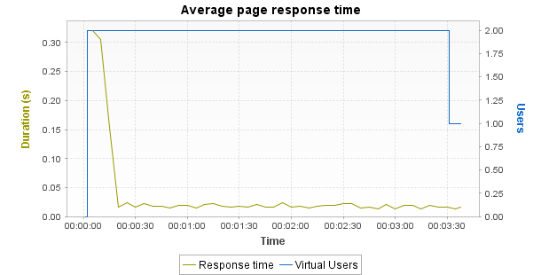

Min | Average | Max
0.013 | 0.034 | 0.321

Notes: Displays the average response time, in seconds, of all pages during the test.
Average request response time

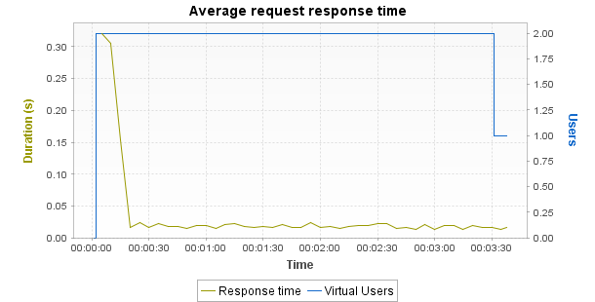

Min | Average | Max
0.013 | 0.034 | 0.321

Notes: Displays the average response time, in seconds, of all requests during the test.
Average response time (Transactions)

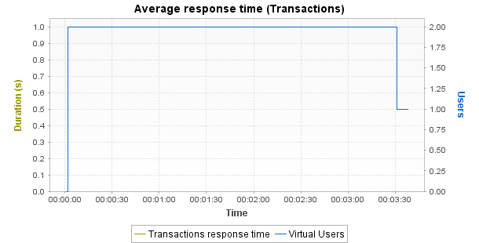

Min | Average | Max | Median | Avg-90% | Std. Dev.
0 | 0 | 0 | 0 | 0 | 0

Notes: Displays the average response time, in seconds, of all Transactions during the test.
Requests per second

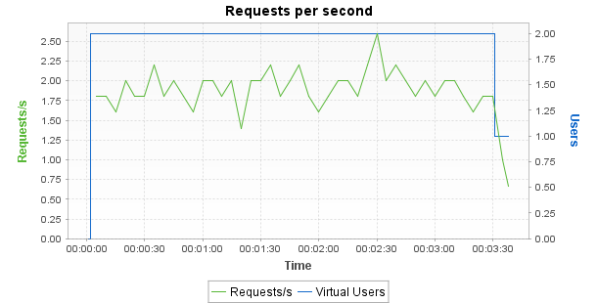

Min | Average | Max
0.7 | 1.9 | 2.6

Notes: Displays the number of requests per second.
Errors

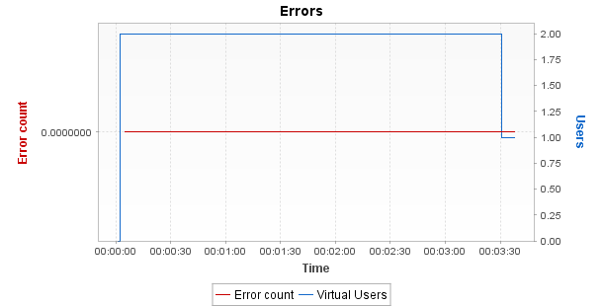

Min | Average | Max
0 | 0 | 0

Notes: Displays the number of errors per sampling interval.
Throughput

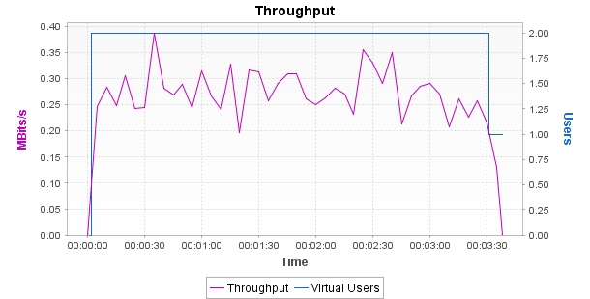

Min | Average | Max
0 | 0.26 | 0.39

Notes: Displays the number of megabits of data per second returned by the server.
Response time against load

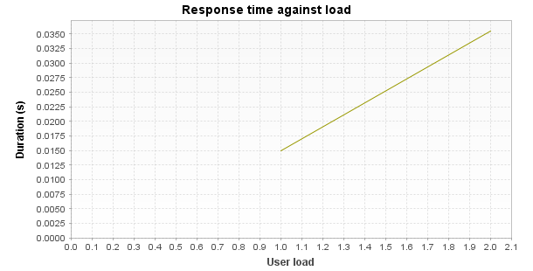

Min | Average | Max
0.015 | 0.025 | 0.036

Notes: Displays the average response time, in seconds, of all pages according to the number of simultaneous Virtual Users.

