Evidences

When the Application starts, we ask for Product details (Creating the Product)

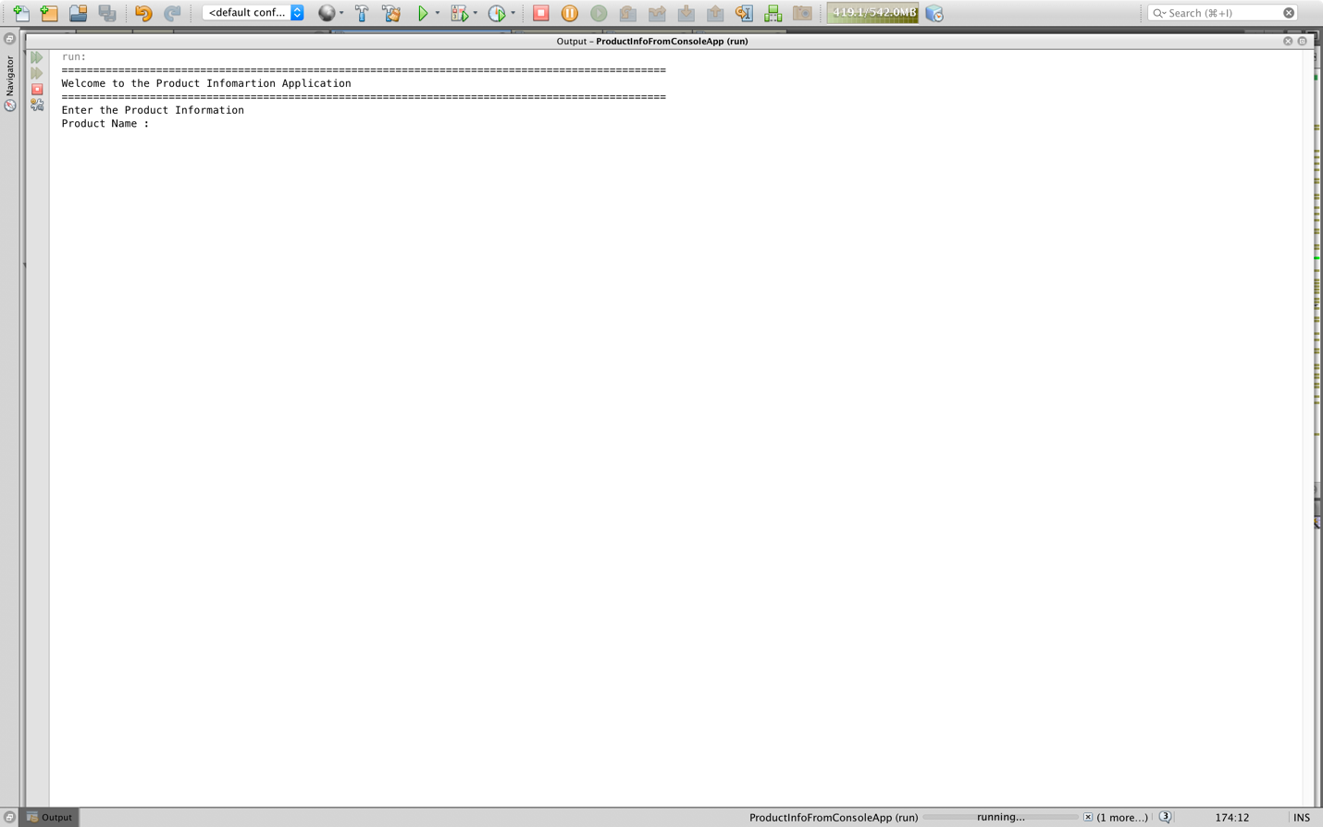

After Create, showing the values on the screen

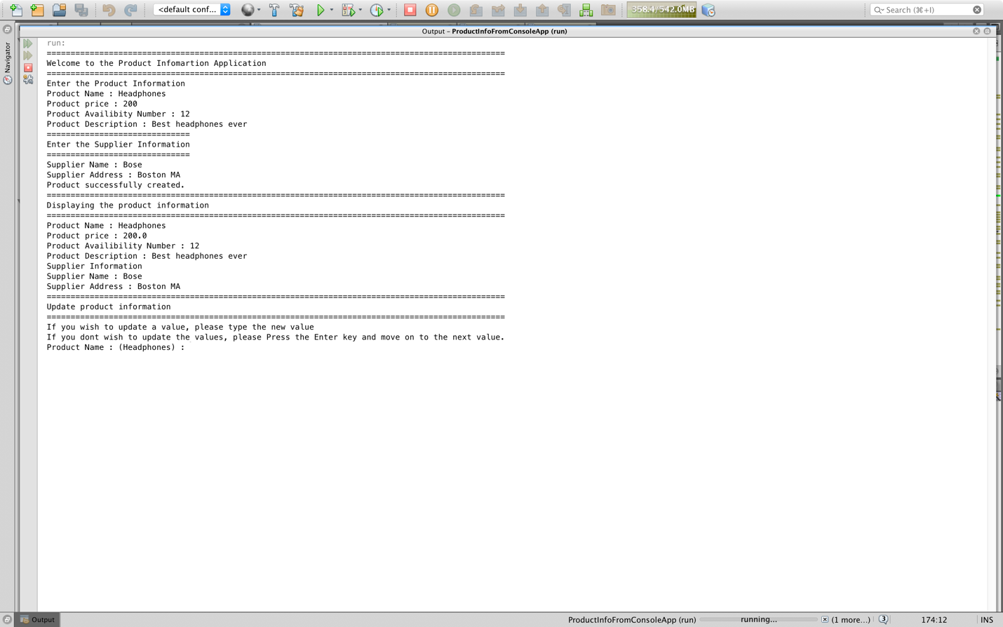

After Update, showing the modified values on the screen

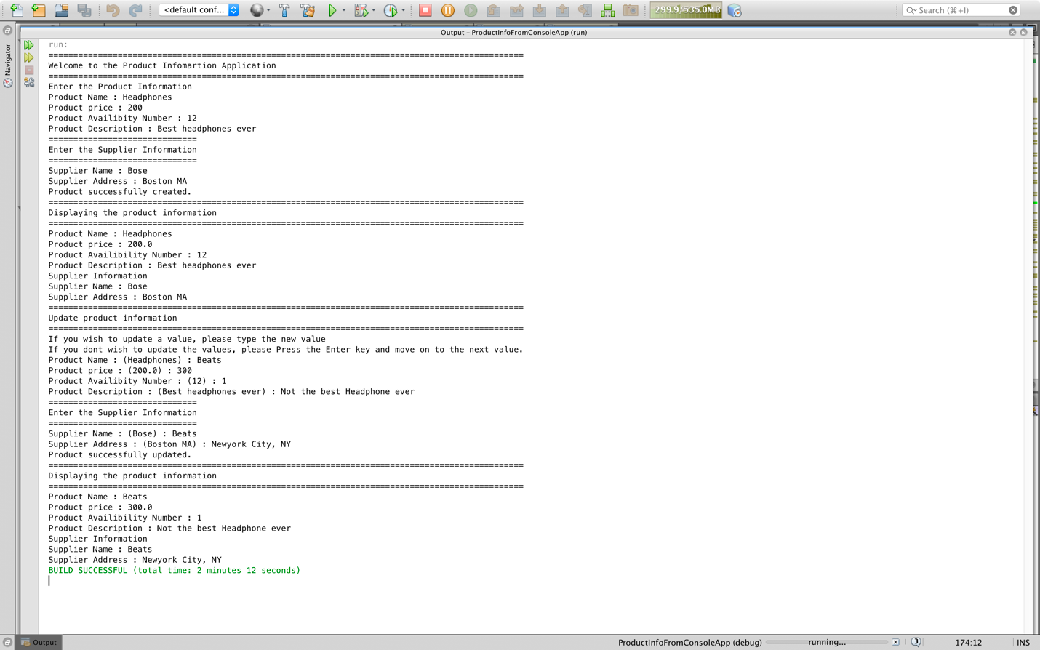

Validation Error. Asking the user to re-enter the values

