***SUBSCRIBERS GALORE: EXPLORING WORLD’S TOP YOUTUBE CHANNELS***

* **INTRODUCTION**
* *Overview :*

*A Subscriber to a channel on the video –sharing YouTube is a user who has chosen to receive the channel’s “Subscribe” button, and each user’s subscription feed consists of videos published by channels to which the users is subscribed.*

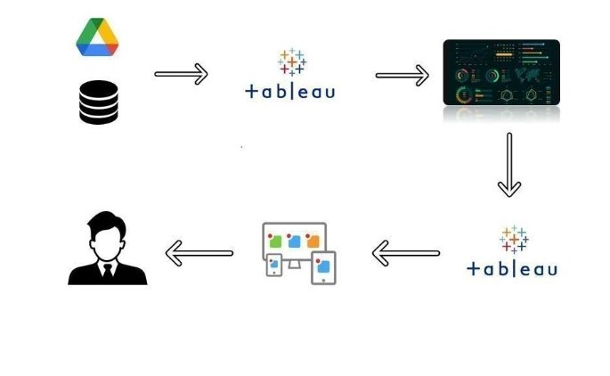

* ***The purpose of exploring a top most YouTube channels is to think or take about the features, content , visibility and etc., in order to find out more about it.***
* **The main purpose of YouTube is to provide a platform for users to watch, share, and create videos**.

***2. PROBLEM DEFINITION AND DESIGN THINKING***

* ***EMPATHY MAP :***

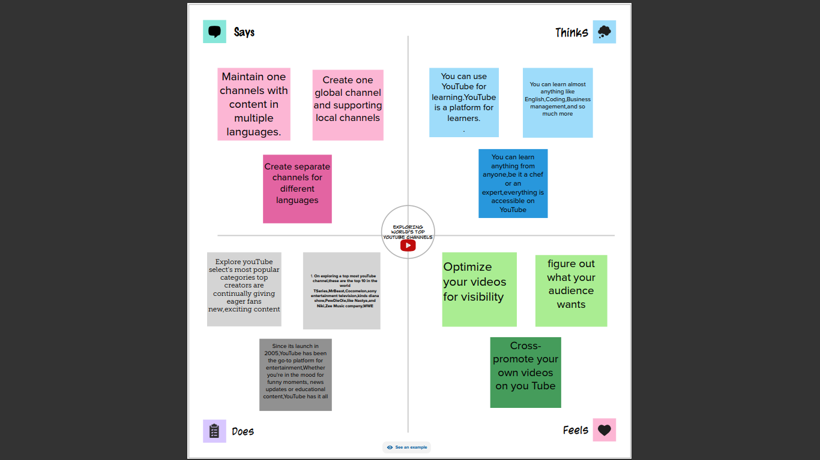

***BENEFITS OF EMPATHY MAP :***

* *Empathy maps are most useful at the beginning of the design process after user research but before requirements and concepting,” writes Jennifer Leigh Brown, SVP and marketing communications director at Fulton Bank. “The mapping process can help synthesize research observations and reveal deeper insights about a user’s needs*.
* *Empathy mapping can be used to create audience personas or create a bridge between existing personas and product solutions.*
* *BRAINSTROMING MAP*

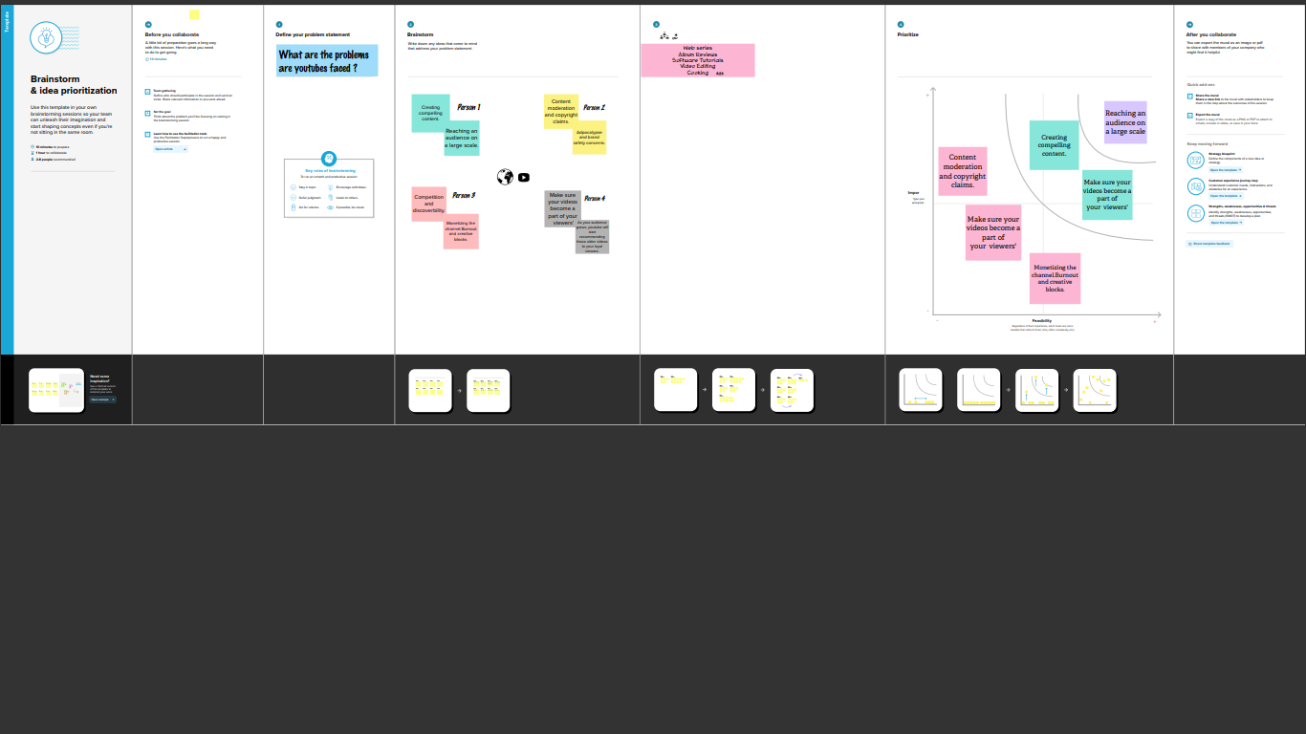

***BENEFITS OF BRAINSTORMING:***

* *The benefits of brainstorming are numerous. Brainstorming builds involvement, commitment, loyalty, and enthusiasm. Participating in the sessions stimulates and unlocks people’s creative talents. Brainstorming also builds self-esteem because people are being asked for their participation and their ideas.*

DEMIRTS OF BRAINSTORMING :

*Can take to much time if the group is not properly control and allowed to run for too long.*

*Rising expectations of the brainstorming group by considering ideas that will never be implemented.*

*Result*

*For empATHy map*

*# An empathy map helps describe th4e aspects of a users a experience, needs and pain pointds. This template allows you to quickly sunderstand your user experience and mindset.*

*For Brainstorming:*

*Braainstorming provides a free and open environment volume over value, out of the box ideas are welcome and built upon, and all participants any are encouragred to collabrate, helping each other develop a rich amount of creative solutions.*

*Applications:*

*#empathy mas are flexible . they can be useful at various times throughout the design process , including. Before research has happened, to plan and shape future studies. During research to capture .*

*Brainstorming:*

*This usually used in beginninin sdtage of aprojet when the possibilities for the projecvt havve not yet been cvlearly defined. It is also a very useful way to come up with creative ideas in product development or production methods. Advertising and marketing objectives are also a popular applications.*

*Conclusion:*

Creating Dashboard, Story using Tableau and analyzing subscriber galore: exploring world top

YouTube channels.

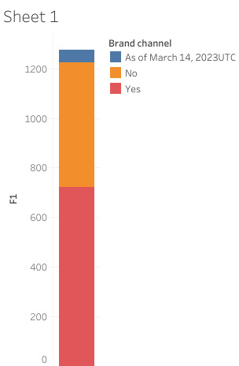

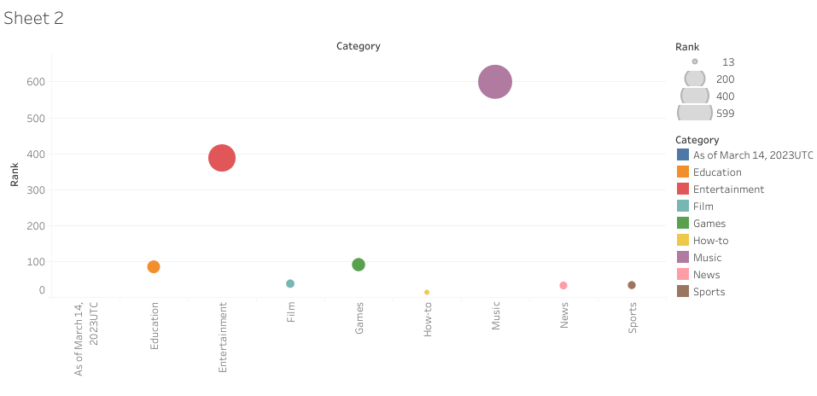

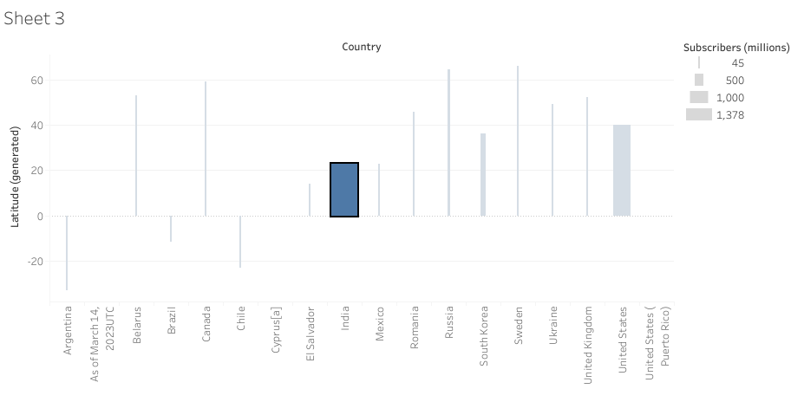

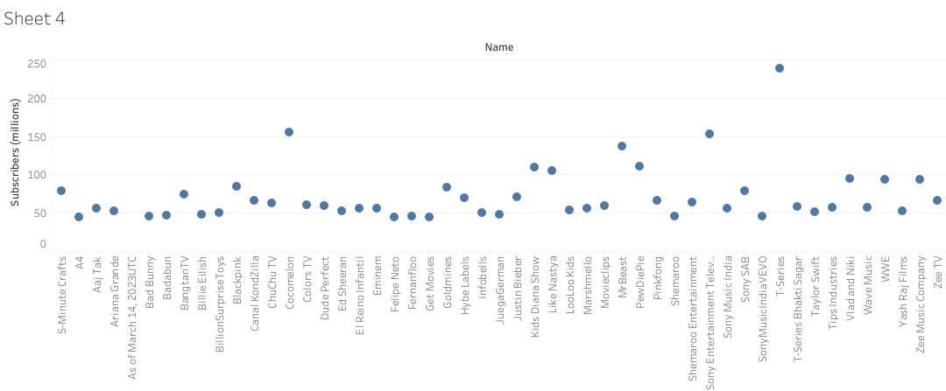 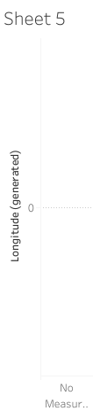

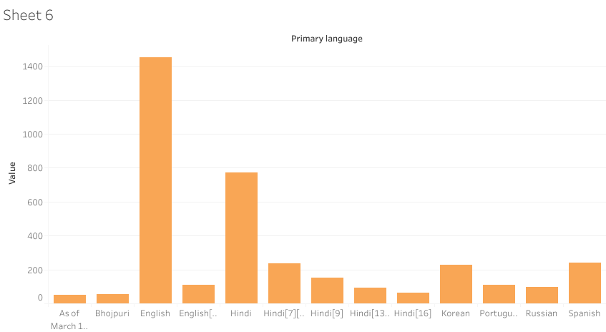

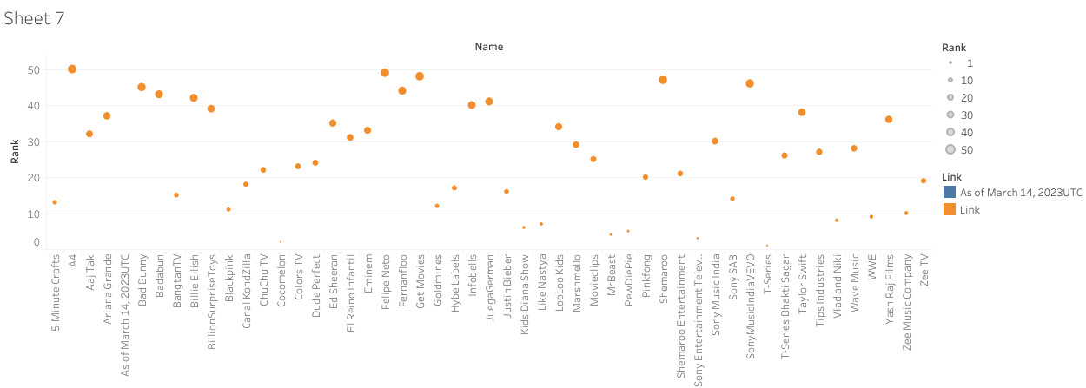

DASHBOARD OF THE PROJECT:

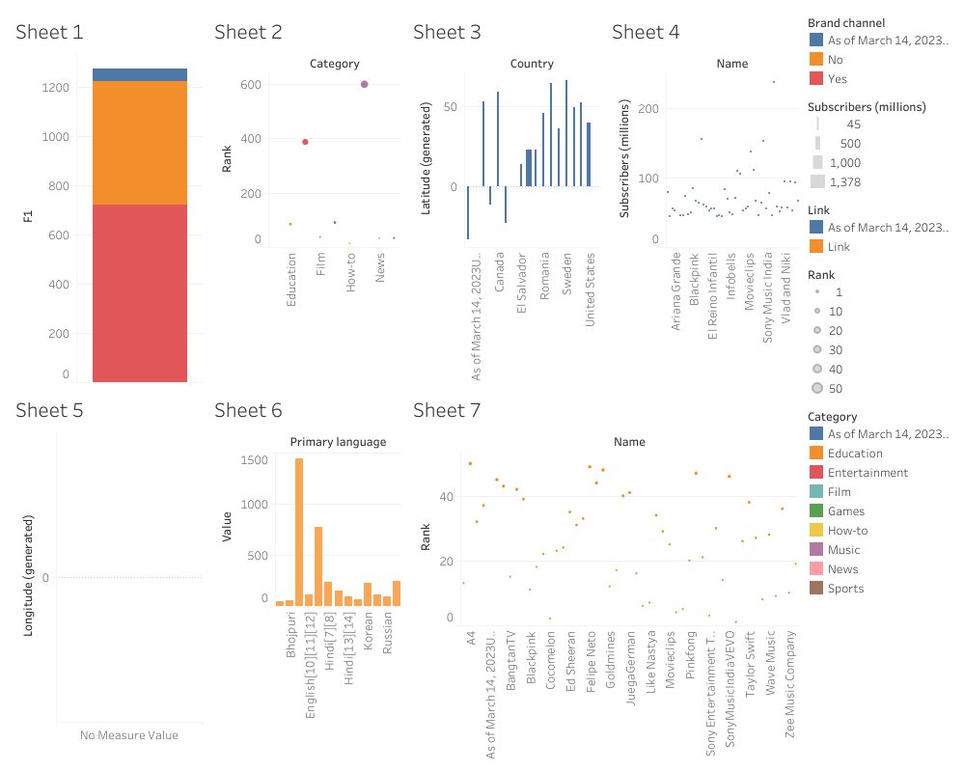

STORY OF THE SUBSCRIBER GALORER:

