Hardware Connection Details
This document describes the complete hardware connections for the Sports Equipment Monitoring System using Arduino Uno, MPU6050 gyroscope, ADXL345 accelerometer, HC-05 Bluetooth module, and a 16x2 LCD display.

1. Arduino Uno
Arduino Uno acts as the central microcontroller. It interfaces with sensors and LCD using the I2C protocol and communicates wirelessly via Bluetooth.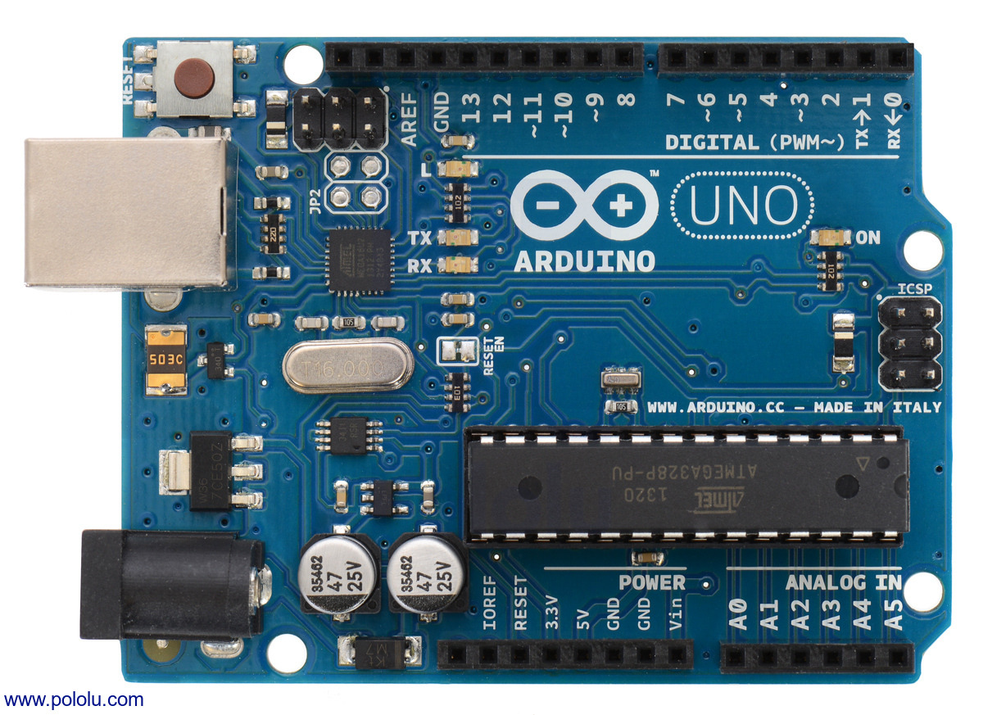

2. MPU6050 (Gyroscope)
MPU6050 Pin | Arduino Uno Pin
VCC | 5V
GND | GND
SDA | A4
SCL | A5

The MPU6050 uses the I2C protocol. SDA and SCL lines are shared with other I2C devices.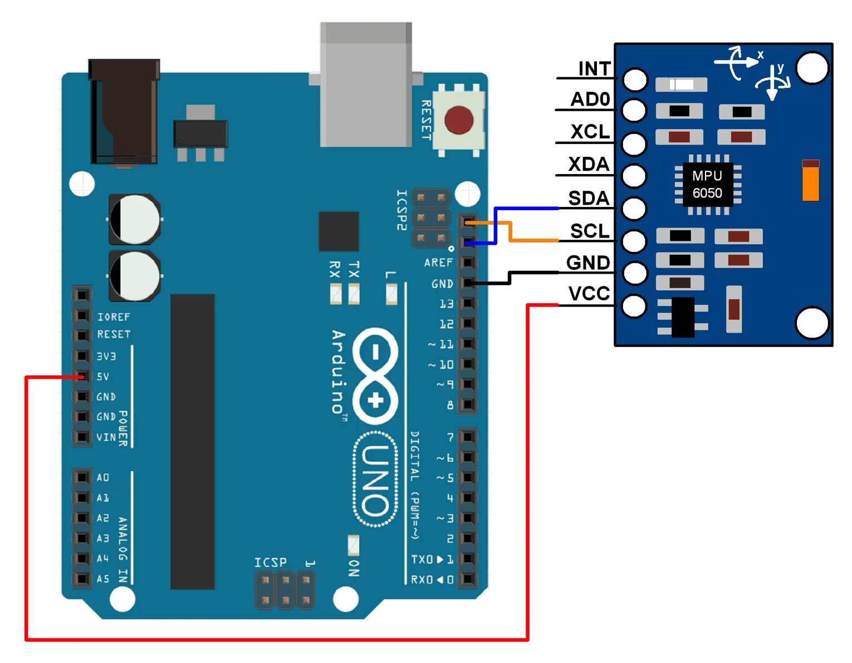

3. ADXL345 Accelerometer (I2C Mode)
ADXL345 Pin | Arduino Uno Pin
VCC | 3.3V
GND | GND
SDA | A4
SCL | A5
CS | 3.3V (I2C Mode)
SDO | GND (I2C Address 0x53)
The ADXL345 operates at 3.3V and communicates using I2C protocol.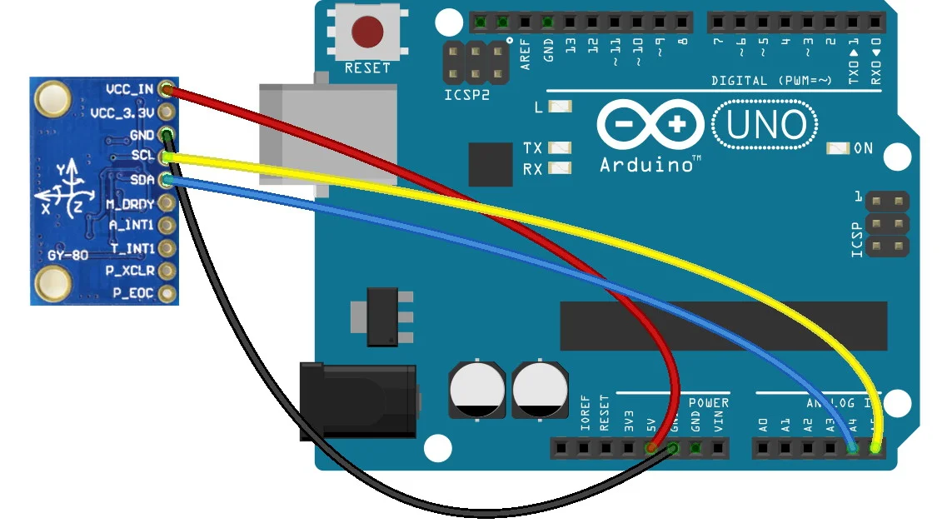

4. HC-05 Bluetooth Module
HC-05 Pin | Arduino Uno Pin
VCC | 5V
GND | GND
TXD | RX (D0) / SoftwareSerial RX
RXD | TX (D1) via voltage divider
The HC-05 module enables wireless communication. A voltage divider is recommended on RXD pin.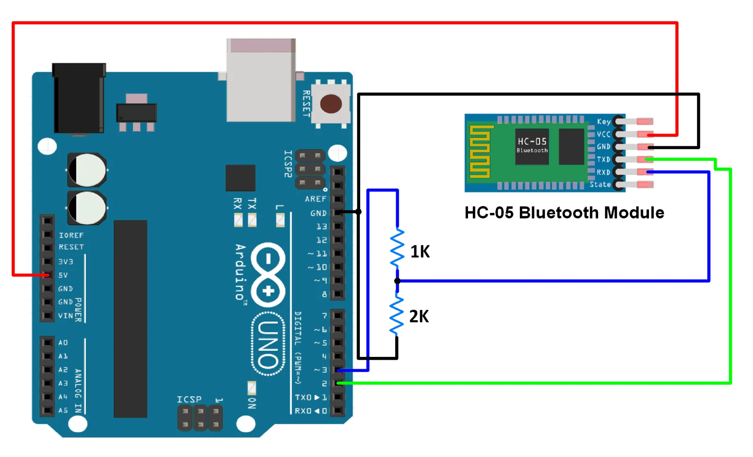

5. 16x2 LCD Display (I2C Module)
LCD Pin | Arduino Uno Pin
VCC | 5V
GND | GND
SDA | A4
SCL | A5
The 16x2 LCD with I2C module displays sensor readings and system status. It shares the I2C bus with MPU6050 and ADXL345.