Week 1 Task
Project Planning and Architecture Design
AI Resume Analyzer & Job Matcher
Prepared by: Vivek Kumar (B.Tech CSE, 4th Year)

1. Project Overview

1.1 Real-World Problem
Job seekers, especially freshers, apply to many roles with one generic resume. Applicant Tracking Systems (ATS) and recruiters filter resumes in seconds, and candidates rarely learn why they were rejected. Professional resume reviews are costly and not available to every student.

1.2 Proposed Solution
AI Resume Analyzer & Job Matcher is a web application where a user uploads a PDF resume and receives structured feedback: strengths, weaknesses, missing skills and an overall score. The user can also paste a job description to see how well the resume matches it, and generate likely interview questions based on the resume and the role.

1.3 Objectives
- Give instant, structured, AI-based feedback on a resume.
- Compare a resume against a job description and show match percentage and skill gaps.
- Generate role-specific interview questions for practice.
- Store past analyses so users can track improvement.

1.4 Scope
In scope: user registration and login, PDF resume upload and text extraction, AI analysis, job matching, interview question generation, saved history and a dashboard. Out of scope: resume editing or template building, job board integration, payments, mobile app, and support for formats other than PDF.

2. Requirements Analysis

2.1 Functional Requirements
ID | Requirement
FR1 | The system shall allow users to register and log in securely.
FR2 | The system shall allow a logged-in user to upload a resume in PDF format.
FR3 | The system shall extract text from the uploaded PDF.
FR4 | The system shall analyse the resume using an AI model and return a score, strengths, weaknesses and suggestions.
FR5 | The system shall accept a job description and return a match percentage, matched skills and missing skills.
FR6 | The system shall generate interview questions from the resume and job role.
FR7 | The system shall save every analysis and let users view or delete past results.
FR8 | The system shall show a dashboard with the user's resumes and recent analyses.

2.2 Non-Functional Requirements
Category | Requirement
Performance | Text extraction under 2 seconds; AI response within about 10 seconds for a typical resume.
Security | Passwords hashed with bcrypt, JWT-protected routes, parameterised SQL queries, API keys stored in environment variables.
Usability | Simple, responsive interface; clear error messages for invalid or oversized files.
Reliability | Graceful handling of AI API failures with retry and a friendly message.
Maintainability | Layered code (routes, controllers, services) and consistent REST naming.
Privacy | Resumes are visible only to their owner and can be deleted on request.
Portability | Runs on any system with Node.js and MySQL.

3. System Architecture and Design

3.1 Design Strategy
The application follows a three-tier, client-server architecture with a layered backend. The presentation tier is a React single-page application. The application tier is a Node.js and Express REST API split into routes, controllers, middleware and services. The data tier is a MySQL database. The Google Gemini API is an external service used only by the service layer, so the AI provider can be replaced without touching the rest of the system.

3.2 Architecture Diagram
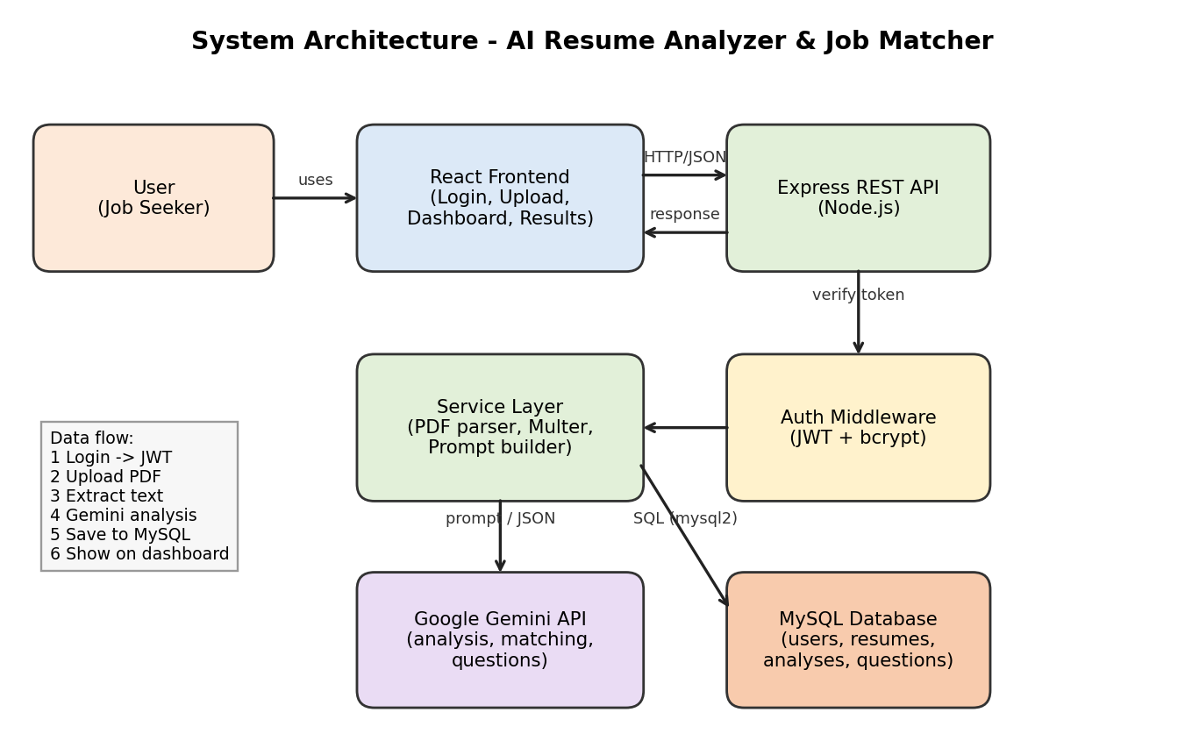
Figure 1: High-level system architecture

3.3 High-Level Components
Component | Responsibility
React Frontend | Login and register pages, resume upload, analysis result view, job match form, dashboard.
Express REST API | Receives HTTP requests, validates input, calls services and returns JSON.
Auth Middleware | Verifies the JWT on protected routes; passwords hashed with bcrypt.
Service Layer | PDF text extraction, file handling with Multer, prompt building and Gemini API calls.
Gemini API | Produces resume analysis, job match results and interview questions as structured JSON.
MySQL Database | Persistent storage of users, resumes, analyses and interview questions.

3.4 Data Flow
- Level 0: The user sends a resume and an optional job description to the system and receives an analysis, match result and interview questions.
- Level 1, step 1: The user logs in; the API validates credentials and returns a JWT.
- Level 1, step 2: The user uploads a PDF; Multer stores it and the PDF parser extracts the text.
- Level 1, step 3: The service layer builds a prompt from the resume text (and job description) and calls Gemini.
- Level 1, step 4: The JSON response is validated, saved in MySQL and returned to the React frontend for display.

3.5 Interaction Between Modules
Each module talks only to its neighbour: the frontend calls the API, controllers call services, and services call the database or Gemini. Controllers never talk to Gemini directly, which keeps responsibilities separate and the code easy to test.

3.6 Database Design
Table | Main Columns
users | id (PK), name, email (unique), password_hash, created_at
resumes | id (PK), user_id (FK), file_name, file_path, extracted_text, uploaded_at
analyses | id (PK), resume_id (FK), job_description, score, result_json, created_at
interview_questions | id (PK), analysis_id (FK), question, category

3.7 Technology Stack
React with JavaScript (frontend); Node.js and Express (backend); MySQL with mysql2 (database); bcrypt and JWT (authentication); Multer and a PDF parser (file handling); Google Gemini API (AI); VS Code, Postman and Git/GitHub (tools).

4. Project Timeline and Roadmap
Phase | Activities | Milestone / Deliverable
Week 1 | Problem research, scope, requirements, architecture and this planning document | Approved planning document and architecture diagram
Week 2 | Set up repository, database schema, Express server, register and login with JWT | Working authentication API
Week 3 | Resume upload, PDF text extraction, Gemini integration for analysis | Resume analysis endpoint
Week 4 | Job matching, interview question generation, saved analyses | Complete backend with tests in Postman
Week 5 | React frontend: pages, dashboard, result views, API integration | Working end-to-end application
Week 6 | Testing, bug fixes, security review, README, deployment and demo | Final release on GitHub

5. Assumptions, Constraints and Risks

5.1 Assumptions
- Users upload text-based (not scanned image) PDF resumes in English.
- Users have a stable internet connection and a modern browser.
- The Gemini API remains available with a free or low-cost tier during development.

5.2 Constraints
- Solo development by one student, so scope is limited to the core features.
- Only publicly available resources and no proprietary datasets are used.
- AI usage is limited by API rate limits and quotas.

5.3 Risks and Mitigation
Risk | Level | Mitigation
AI returns invalid or inconsistent JSON | High | Strict prompt format, JSON validation, retry once, fallback error message.
API quota or downtime | Medium | Rate limiting, caching saved results, provider abstraction in the service layer.
PDF text extraction fails on complex layouts | Medium | Show a clear message, allow re-upload, limit file size and type.
Leak of personal data in resumes | High | JWT-protected routes, owner-only access, delete option, no logging of resume text.
Schedule slip | Medium | Prioritise core features first; keep interview questions as the last feature.
Exposed API keys | High | Store in .env, add to .gitignore, never commit.

6. Conclusion
This document defines the problem, scope, requirements, architecture, data design, timeline and risks for the AI Resume Analyzer & Job Matcher. The layered design and phased roadmap make the project feasible for one developer within the planned six weeks and provide a clear foundation for implementation.

