**Assignment #1 – ADME and rates**

**Due: Thursday 2024-02-01, 11:59pm** **Enter answers in this document**  
**Submit your solution as a word doc**

* Use this document to insert your solutions, then submit. Expand the space between each question as needed to incorporate your solution.

* Fonts: use Arial 12 for text.

* Do not write or draw by hand parts of the assignments for this class (e.g. equations or schematics). You can use freely available software for these. For example, drawing schematics in Powerpoint and then pasting them into this document as pictures or objects. Make sure that any images are clear and readable! That means checking the resolution and making sure the size of text on the images is similar to the rest of the text in the document. I also strongly suggest learning to use Equation Editor, MathType or similar to enter equations, you will find it very valuable.

**Name:**

**Question 1 (70 points):** Read chapter 1 of Rosenbaum and chapter 1 of Jambhekar (both chapters are posted on Blackboard, in the Module 1 folder). Jambhekar has a good description of ADME and rates. Rosenbaum has a good description of the distinction between PD and PK. Chapter 3 of Jambhekar (also posted) has some good discussion of the different components of modeling pharmacokinetics, such as volume of distribution and clearance rate constants. Chapter 3 also gets a little more into the math of a one-compartment model, more than we will need for this course but it may be helpful for you in developing your ‘PK intuition’.

***In your own words, answer the questions below. Where prose answers are requested, a few sentences will be sufficient.***

**1a.** (10 pts) Define the therapeutic window of a drug and explain why a narrow therapeutic window makes a drug less likely to make it to market (i.e. less likely to be approved).

**1b.** (12 pts) Rosenbaum Table 1.1 gives examples of dose size and dose frequency for different drugs. Jambhekar Table 3.1 gives examples of elimination half lives for different drugs. Complete the following table:

|  |  |  |  |
| --- | --- | --- | --- |
| Drug | Common brand name and typical indication* | Dose Frequency (hrs) | Elimination half life (hrs) |
| ibuprofen |  |  |  |
| cetirizine |  |  |  |
| chloroquine | Aralen; malaria | 168 (1 week) | 984 |
| bevacizumab |  |  |  |
| sunitinib |  |  |  |
| ranibizumab |  |  |  |
| vancomycin |  |  |  |

*indication means the typical pathology/disease being treated. Just provide one brand name (the most common one in the US, if it exists) and one indication if there are several.

Where can you get the data? The FDA mandates that this data be available on the label of a drug. You may be familiar with the labels of drugs that are printed on the bottle; there’s actually a longer and more detailed label available online at <http://www.accessdata.fda.gov/scripts/cder/daf/>.

A simpler place to start, though, is <https://www.drugbank.ca> which maintains a simpler data page for each drug. For example, type vancomycin into the FDA site and you’ll get several results including some discontinued drug formulations. The full label information is there for some of these and not others. In the long-form label (for vancomycin, a 13-page PDF!) dosing is in section 2 and pharmacokinetics in section 12.3. Truthfully, the FDA site is best for more recent drugs. For most drugs the better place to start is the Canadian site. Type vancomycin into it and then scroll down to the pharmacology to find half-life information. Finding the dose scheduling is a little trickier; in the ‘References’ section, you will find links to the FDA label and to drugs.com, both of which will give dose and dose frequency information.

**1c.** (5 pts) Once you’ve completed the table in 1b, explain why the difference in elimination half-lives between the drugs in the table above leads to the difference in dose scheduling between these drugs.

**1d.** (12 pts) An oral pill has been developed for a drug that is normally delivered by intravenous bolus. Describe how each of the four elements of ADME (Absorption, Distribution, Metabolism, and Excretion) would likely be affected by this change and why. Describe whether you expect the dose in the oral pill to be higher or lower than the intravenous bolus and why. Describe whether you expect the onset of action to be earlier or later and why. For this problem, ignore potential differences caused by drug formulations.

**1e.** (11 pts) Considering the differences in ADME between oral and intravenous formulations, draw two concentration-time graphs of what you would expect to see in each scenario, assuming the site of action for the drug is in the blood. When drawing the time axis, use relative time between the formulations, rather than exact numbers. Annotate the graphs to show when you would expect each process of ADME to be occurring. Make sure to label your axes and title each graph.

**1f.** (10 pts) Define the volume of distribution of a drug, and explain why the volume of distribution of a drug can be larger than the volume of the person taking the drug (*see* Jambhekar Fig 3.9).

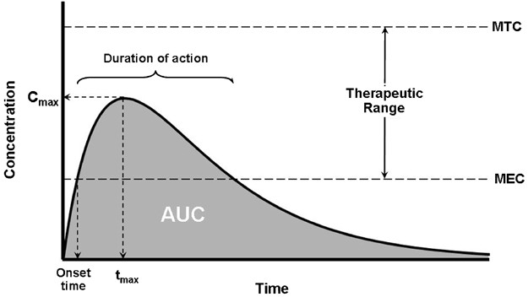

**1g.** (10 pts) Using as an example the typical curve for plasma drug concentration following oral delivery (right), note what would happen to the key features of the curve (indicated in the top row of the table) if each of the elements in the left column (dose, volume, or rates) were to be different?

|  |  |  |  |  |  |
| --- | --- | --- | --- | --- | --- |
|  | Onset time | Duration of action | Cmax | tmax | AUC |
| *answer bank =>* | *earlier, same, later* | *shorter, same, longer* | *increases, same, decreases* | *earlier, same, later* | *increases, same, decreases* |
| Dose goes up |  |  |  |  |  |
| Volume of distribution goes up |  |  |  |  |  |
| Absorption rate goes up |  |  |  |  |  |
| Clearance rate goes up |  |  |  |  |  |
| Metabolism goes up |  |  |  |  |  |

**Question 2 (20 points):** The following figure details average or typical timelines, costs, and failure rates associated with each step of the drug development process:

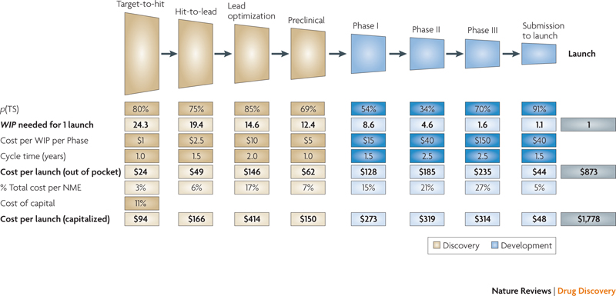

The figure comes from a published paper, Paul et al, “How to improve R&D productivity: the pharmaceutical industry’s grand challenge” *Nature Reviews Drug Discovery* 9:203 (2010)

Reading from the top down, the characteristics are:

*p(TS)* – probability of successful transition from this stage to the next (%)

WIP – Work in Progress (how many drug candidates need to be under study at this stage to get 1 drug to market)

Cost per WIP per Phase (millions of dollars)

Cycle time (years) – length of this phase

Cost per launch (out of pocket) = WIP * Cost per WIP (millions of dollars); cost at the time of spending for that phase, for all the drug candidates needed to get 1 to market

% Total cost per NME – cost of this phase as % total cost (per new molecular entity)

Cost of capital – because it’s a long process, the out-of-pocket costs for early phases ‘cost more’ (due to inflation, etc) than the out of pocket costs for later phases.

Cost per launch (capitalized) – Cost per launch (above) adjusted for time of spending.

**2a.** (10 pts) Look at Clinical Phases I, II, III (in blue); the cost associated with each phase (to get one launched drug) escalates from $128 million to $185 million to $235 million, even though the number of drugs being tested goes from 8.6 to 4.6 to 1.6. Why are the costs escalating so much even though the number of drugs being tested is going down? (note: you don’t need to read the paper to answer this question. Just think about the figure above and the discussions of drug development in the first lecture. Also, inflation or cost of capital is not the answer).

**2b.** (10 pts) Based on the figure above, explain *in your own words* why ‘fast failure’ is a potentially desirable approach to drug development.

**Question 3 (10 points):** Read pages 4-8 of the “NIH White Paper by the QSP Workshop Group – October 2011” (attached on Blackboard in “Introduction”, and take a look at Figure 2 on page 11. Read other parts of the white paper as you wish. Figure 2 is reproduced here (left). *In your own words*, explain why the data in this figure makes a case for the incorporation of more approaches that use modeling and simulation of pharmacology (in combination with careful measurement).