CostGuard
An Autonomous Cloud Cost-Optimization Agent
Updated Solution Design Document — Problem Statement P3: "The Cloud Bill That Wouldn't Stop Growing"
PRAGYAAN 2.0 — Agentic AI Hackathon
Prepared for the pre-hackathon submission (18-Sep-2026) — Revised after solution review

1. Executive Summary
CostGuard is an autonomous cloud cost-optimization system that investigates unexpected cloud spend, decides on a safe corrective action, executes it through a mocked cloud control API, and verifies the outcome before reporting back in plain language. It uses an agentic workflow rather than a single end-to-end LLM call: AI reasoning handles diagnosis, contextual trade-offs, action selection and explanation, while a separate deterministic policy layer enforces every hard safety constraint (capacity limits, latency, availability, health and data freshness). This separation is the core design decision: the LLM may propose an imperfect action, but no action can reach the cloud-control API until the deterministic guardrail layer approves it.
The design directly answers all four provided test inputs: routine cost cleanup (A), a rising-traffic protection case (B), a stale-observation trap (C), and a failed-execution recovery case (D). Each is treated as a distinct branch in the agent's decision flow rather than a special case bolted on afterward. The core MVP is request-triggered autonomous optimization; continuous background monitoring is treated as a future enhancement rather than a required dependency.

2. Problem Statement (Recap)
Build an autonomous cloud cost-optimization agent that monitors a simulated cloud environment, investigates unexpected spending, chooses safe actions, executes them through APIs, and verifies whether the action actually improved the situation. The agent receives natural-language requests and structured cloud state; AI must play a meaningful role in deciding what to investigate and what action to take, while deterministic backend code enforces safety constraints.

3. Solution Overview
CostGuard is organised as an eight-stage logical workflow coordinated by a lightweight state-machine orchestrator. The stages describe responsibilities rather than requiring eight independent LLM calls. Closely related reasoning stages may be handled by the same agent/model call, while deterministic freshness, safety, execution and verification controls remain separate. This preserves the agentic behavior while reducing unnecessary model-call overhead and keeping stale-data, failure and 'no safe action' branches explicit.
Design principles
- Reasoning vs. enforcement are separated: the LLM proposes and explains; deterministic Python code approves or vetoes.
- Every action must be independently verifiable after the fact — the agent never trusts its own decision without re-checking reality.
- ● Doing nothing is a valid, explicit action, not a fallback for a confused agent — 'no_action' carries the same evidence and justification requirement as any other action.
- ● Stale or conflicting data is treated as a first-class risk, not ignored. The agent must be able to say 'I don't trust this observation enough to act on it.'
- ● Failures are expected, not exceptional — the execution layer assumes the API can fail and always has a safe next step: retry, a different approved action, or escalation.

4. System Architecture
The diagram below shows the eight processing stages, the mock Cloud Control API the agent acts through, and the shared memory/state store that gives the agent continuity across requests.
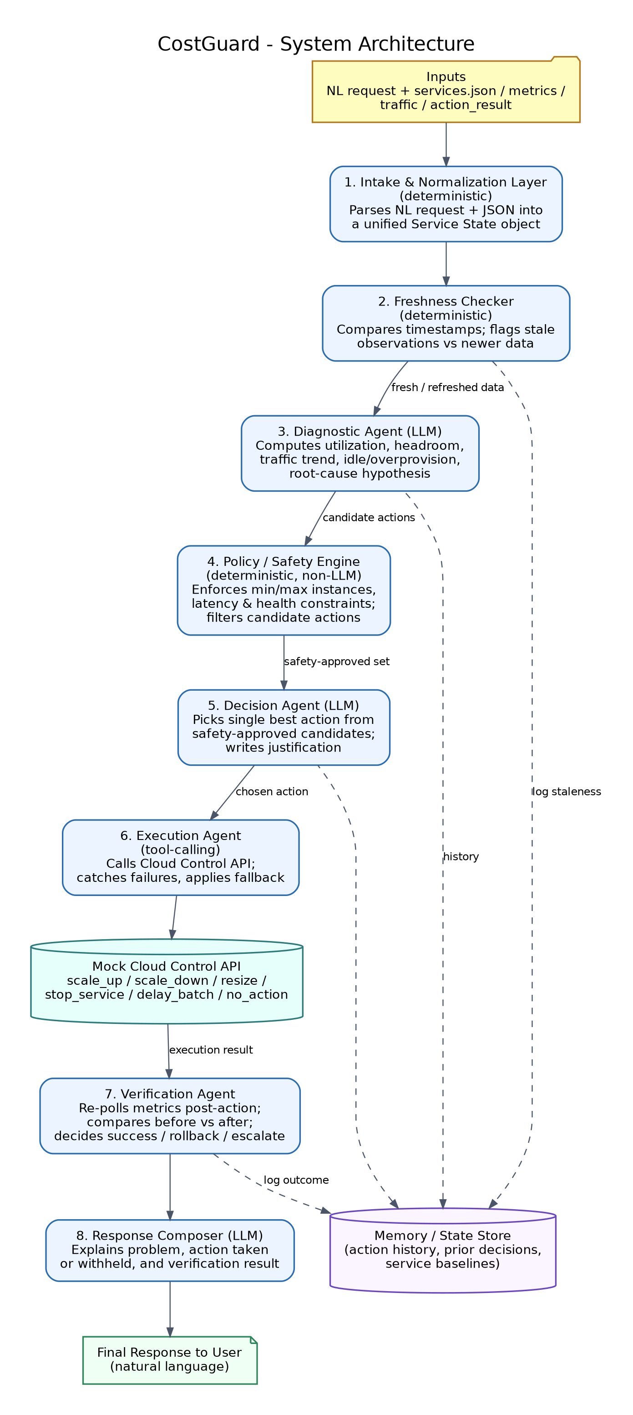
Figure 1 — CostGuard system architecture

4.1 Stage-by-stage responsibilities
# | Stage | Type | Responsibility
1 | Intake & Normalization | Deterministic | Parses the NL request and any JSON payloads (services.json, metric.json, latest_traffic.json, action_result.json) into one unified Service State object per service.
2 | Freshness Checker | Deterministic | Flags observations older than a threshold, or contradicted by a newer companion file (e.g. latest_traffic.json), before any decision is made.
3 | Diagnostic Agent | LLM | Computes utilization, headroom against min/max instances and max_latency_ms, traffic trend, idle time, and forms a root-cause hypothesis with candidate actions.
4 | Policy / Safety Engine | Deterministic | Hard-codes capacity, latency, and health rules. Filters the LLM's candidates down to only the ones that cannot break an SLA or a limit.
5 | Decision Agent | LLM | Picks the single best action from the safety-approved set, trading off cost savings against risk, and writes a justification.
6 | Execution Agent | Tool-calling | Calls the mock Cloud Control API and catches failures (timeouts, capacity_unavailable, etc.) so a failure never crashes the pipeline.
7 | Verification Agent | LLM + deterministic checks | Re-polls metrics after a short simulated delay, compares before vs. after, and classifies the outcome as verified, rolled back, or escalated.
8 | Response Composer | LLM | Turns the full trace into the natural-language answer: problem observed, action taken or withheld, and verification result.

5. Why an Agentic Approach (Not a Fixed Script)
A fixed if-else script can express "if CPU < 20% then scale down" but cannot weigh several competing signals at once (idle detection vs. traffic trend vs. staleness vs. a previous failed attempt), cannot explain its reasoning in language a human can audit, and breaks the moment a new scenario appears that its author didn't anticipate.
What the agent decides or does on its own
- Interprets an open-ended natural-language goal ("reduce cost without breaking latency") and turns it into concrete, measurable checks.
- Chooses which tool to call next based on what it finds — e.g. it only calls the "refresh data" tool when it detects staleness, it doesn't call it every time.
- Weighs cost savings against SLA risk per service, rather than applying one rule to every service uniformly.
- Recovers from a failed action by picking a different safe action or escalating, instead of stopping.
- Decides, based on verification results, whether to accept the outcome or roll back — a judgment call, not a fixed check.

6. Agent Decision Flow
The flowchart traces one request end-to-end, including the two branches that matter most for this problem: a staleness check right after intake, and a verification loop right before the final response.
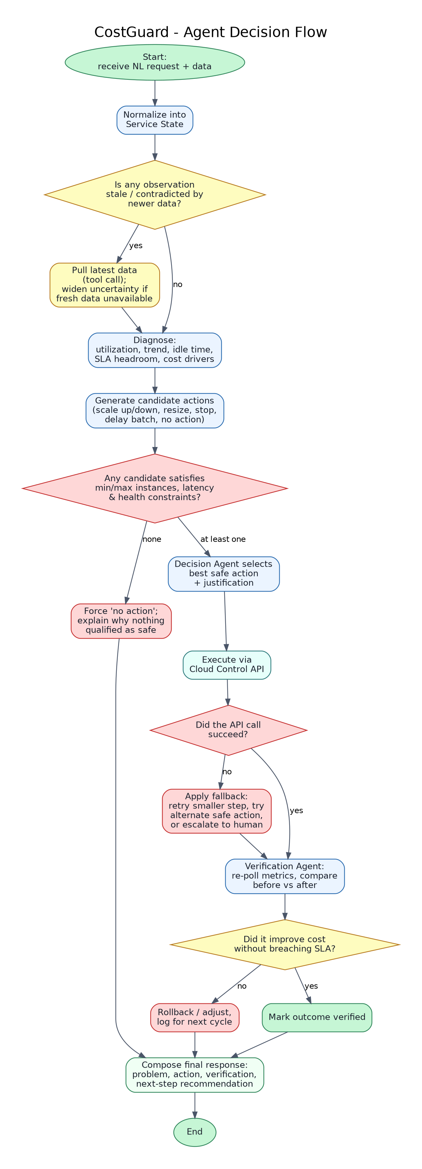
Figure 2 — End-to-end agent decision flow

7. Safety & Guardrail Design
The Policy / Safety Engine is ordinary, deterministic code — no model call happens inside it. It receives the LLM's candidate action(s) and either passes them through, adjusts the magnitude (e.g. caps a requested instance count), or rejects them outright with a machine-readable reason.
Guardrail | Rule enforced
Capacity bounds | Any scale action is clipped to stay within [min_instances, max_instances] for that service.
Latency protection | A scale-down or resize is rejected if a simple headroom projection puts latency_ms above max_latency_ms; a scale-up is prioritised over a scale-down whenever current latency is within 15% of the max.
Health gate | No cost-saving action is approved for a service where healthy is false; only protective actions (scale up, no action) are allowed.
Idle detection | A service is only eligible for stop_service / scale-to-minimum when requests_per_minute is 0 (or near-zero) across the observation window, not from a single reading.
Staleness gate | Any action that reduces capacity is blocked if the input data is flagged stale by the Freshness Checker, until fresher data is fetched or a conservative fallback is used.
One irreversible action at a time | The Execution Agent issues exactly one action per service per cycle, so the Verification Agent always has a clean before/after comparison.

8. Handling the Four Reference Scenarios
Test A — Cost optimization (orders-api, reports-worker)
reports-worker shows 0 requests/minute, 9% CPU and 4 instances — a strong candidate for cost optimization. However, because the safety policy requires evidence across an observation window, the agent first checks recent traffic/history rather than treating one zero-traffic reading as proof of idleness. If the observation window confirms near-zero traffic, the Policy Engine allows a scale-to-minimum action (4 → 1). orders-api is actively serving traffic, so a scale-down is treated as a conservative candidate rather than automatically executed; sufficient recent history and projected latency headroom are required. The system then executes at most one approved capacity-changing action per service per cycle and verifies the result.
Test B — Rising traffic (orders-api)
requests_per_minute has roughly doubled (2100 → 4200) and latency (260ms) is closing in on the 300ms ceiling at only 4 instances. The Diagnostic Agent flags a trend, not just a snapshot, so the Decision Agent scales up (e.g. to 6) even though this increases cost — protecting the latency SLA takes priority over cost-cutting in this branch. See the full walkthrough in Section 9.
Test C — Stale observation (checkout-api)
metric.json is timestamped 08:00, but latest_traffic.json — timestamped 10:30 — shows requests/minute jumping from 900 to 5200. The Freshness Checker treats the 2.5-hour-old CPU/latency reading as unreliable given that contradiction, and blocks any cost-reduction action on it. The agent's response for this case is to decline to reduce cost, explain that the traffic snapshot is materially newer and inconsistent with the cached load figures, and request a fresh full metrics pull rather than guessing.
Test D — Failed action (payment-api)
payment-api is at 91% CPU and 410ms latency against a 300ms cap — an unambiguous scale-up case — but the returned action_result shows status 'failed' with error 'capacity_unavailable'. The Verification Agent detects that instances did not actually change, so the outcome is not silently accepted as success. The recovery path re-evaluates the current state and may retry with a smaller safe scale-up or use another action explicitly supported by the mock API, such as resize. If no safe supported action is available, the system escalates to a human operator with the SLA breach clearly stated rather than reporting false success. Traffic shedding or rate-limiting is not part of the core PS action set and is excluded from the MVP.

9. Example Walkthrough
Below is the full trace for Test Input B, one representative case chosen because it shows the agent choosing to increase cost (the opposite of the request's usual intent) because the safety constraint — latency — takes precedence.
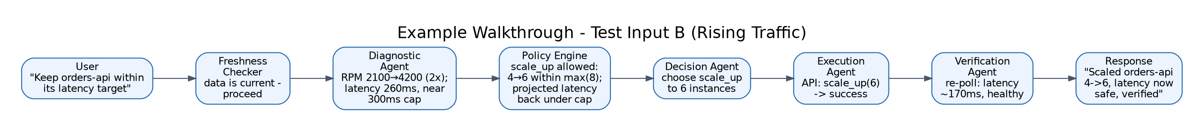
Figure 3 — Trace of a single request through all eight stages

10. Memory & State
Each service keeps a short rolling history (its last few observations and the actions taken on it) in a lightweight state store (SQLite for the hackathon build). This lets the Diagnostic Agent distinguish a genuine traffic trend from a single noisy reading, and lets the Verification Agent know what 'before' looked like even if the request arrives asynchronously from the action. Action history also supports future flapping detection and dampening. Rollback is an optional recovery capability, not a mandatory PS action; any rollback must pass through the same deterministic safety checks before execution.

10.4 Recommended Implementation Simplification

The eight stages are logical responsibilities, not a requirement for eight separate model calls. A practical MVP can use one orchestrated reasoning agent for diagnosis and action selection with structured outputs, plus deterministic freshness, policy, execution and verification components. This preserves the agentic behavior while reducing latency, API cost and debugging complexity.

10.3 Monitoring Scope

The MVP is request-triggered rather than a continuously running 24/7 monitor. A user submits a natural-language objective and the current/supplied cloud state; CostGuard investigates that state, acts if safe, and verifies the result. Rolling history provides temporal context for trends and stale-data detection. Continuous background monitoring and automatic alert generation are future extensions and are not required by the supplied PS.

10.2 Audit Trail & Explainability

CostGuard maintains an auditable event trace for each request: data retrieval, freshness decision, diagnosis, candidate actions, safety validation, chosen action, API result, verification result and final response. The interface can display this trace stage-by-stage so a judge can see what the agent investigated, why it acted, and whether the action actually improved the state.

10.1 Cost Impact & Evidence

Every completed optimization reports measurable before/after impact where the simulator provides enough information: estimated hourly cost, estimated savings, instance-count change, latency change, health status and the constraints checked. The UI should make the business outcome visible rather than showing only an action name. Example: Before $111/hour → After $74/hour → Estimated saving $37/hour, while latency remains below the configured maximum.

13. Tech Stack
Layer | Technology | Why
Orchestration | LangGraph (Python) state machine | Needs real branching (staleness, failure, no-safe-action) — a single prompt-chain can't express that cleanly.
Reasoning agents | Claude Sonnet (or equivalent LLM), orchestrated by LangGraph | Handles contextual diagnosis, action selection and explanation; closely related reasoning stages can share a model call instead of requiring separate agents.
Safety / Policy Engine | Plain Python, rule-based | Must be deterministic and independently testable — no model call inside this layer.
Mock Cloud Control API | FastAPI service | Simulates scale_up/scale_down/resize/stop_service/delay_batch/no_action with injectable failures.
State / memory store | SQLite | Simple, file-based, enough for per-service history during the hackathon.
Interface | Streamlit app | Lets a judge paste a request + JSON and watch the trace, evidence and before/after cost impact.
Hosting | Local machine (hackathon); containerizable for production | No infra dependency needed for a same-day build.

12. MVP Scope vs. Future Enhancements

Core MVP: natural-language request handling, API/tool-based investigation, AI diagnosis and action selection, deterministic safety validation, supported cloud actions, stale-data handling, failed-action handling, verification, cost-impact reporting, audit trace and explicit no-action decisions.

Future enhancements: continuous background monitoring, automatic alert generation, advanced predictive cost forecasting, broader cloud-provider integrations and richer rollback strategies. These are intentionally outside the core MVP so the demonstration remains reliable and directly aligned with the supplied PS.

14. Honest Status for the Hackathon Build
In line with the hackathon's own guidance to be blunt about what's real: this document is a design. Sections 12–13 of the filled .md template record, at submission time, which pieces are working end-to-end, which are mocked, and which are still just designed — that's the accurate, judgeable state of the build, not a promise of a finished product.

15. Why This Design Fits the Judging Criteria
- Meaningful AI role: the LLM does the actual judgment calls (root cause, trade-off, verification), not just text formatting around a script.
- Deterministic safety: every hard constraint from the problem statement (min/max instances, latency, health) is enforced in code the LLM cannot override.
- All four test inputs map to explicit, distinct branches — nothing is hand-waved.
- Verification is a real step, not a formality: a "successful" action that didn't actually help is treated as a failure.
- Failure handling (Test D) and data trust (Test C) are designed in from the start, not patched on.

