1.To check the gem version.

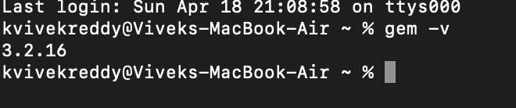

2.Help commands.

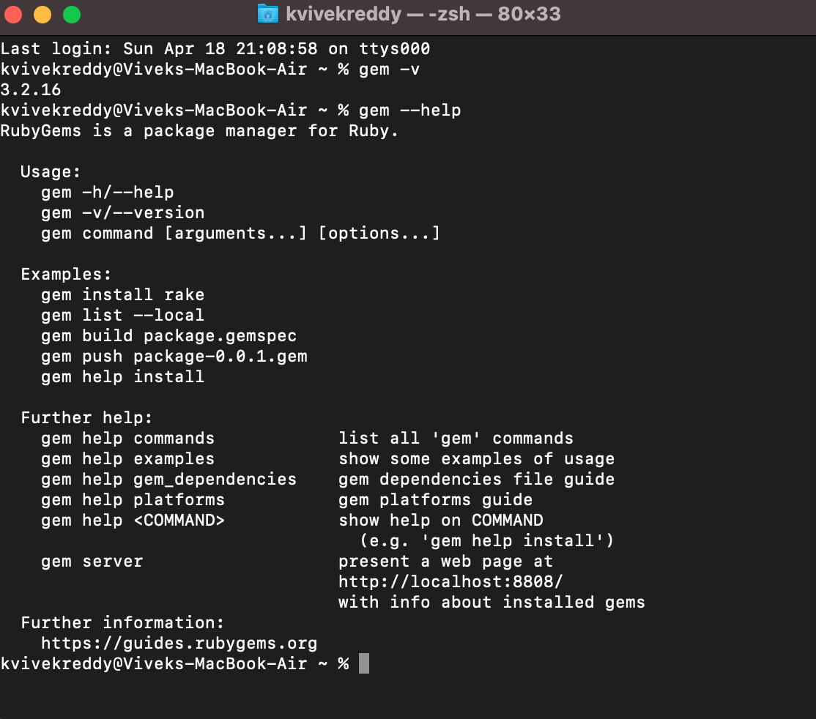

3.Updating gem version.



4.Checking updated gem version.



5.Gem list.

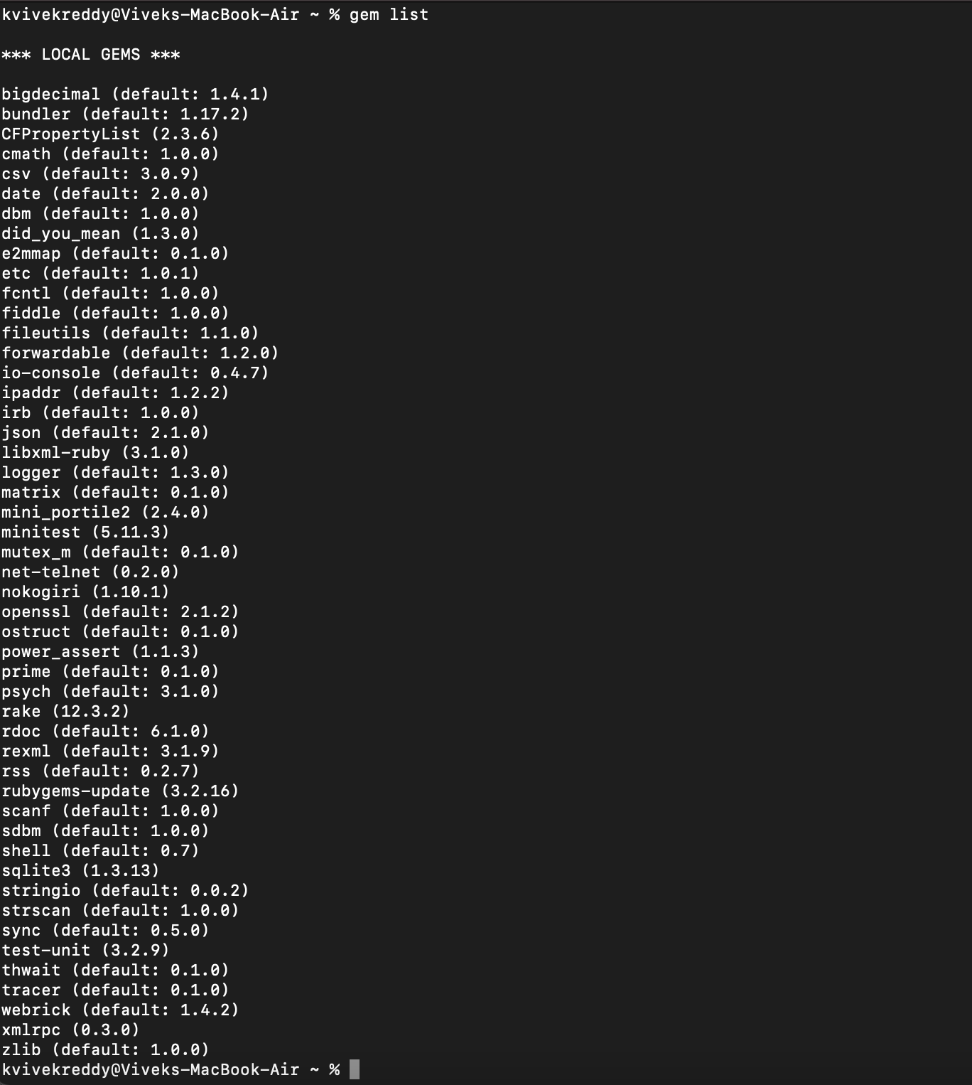

6.Install or update the applications of gems.

